Part II: Machine Learning

## Google Colab Setup

Since training the models is quite expensive and time consuming on regular CPUs, we move the training process to Google Colab using GPUs.

from google.colab import drive  
drive.mount('/content/drive/')

Mounted at /content/drive/

First, we install all requirements of the project, without nilmtk and nilm-metadata.

!pip install -r ./drive/MyDrive/Energy/req_all_but_nilmtk.txt

Next, we have cloned the repos of nilmtk and nilm_metadata from GitHub to install the packages from the folder as editables. The reason behind is the time consuming installation of nilmtk which wastes “computing units” although no meaningful computation is done.

!pip install -e ./drive/MyDrive/Energy/packages/nilm_metadata

For nilmtk, we have removed the outdated pins on numpy, pandas, matplotlib and networkx within setup.py to fasten the installation process from 60 minutes to down to a few minutes, which saves “computing units” on Colab. Most of the time was used to build a wheel of the outdated pandas=0.25.3.

# nilmtk > setup.py  
setup(  
 # ...  
 install_requires=[  
 "pandas", #"pandas==0.25.3",  
 "numpy", # "numpy >= 1.13.3, < 1.20.0",  
 "networkx", #"networkx==2.1",  
 "scipy",  
 "tables",  
 "scikit-learn>=0.21.2",  
 "hmmlearn>=0.2.1",  
 "pyyaml",  
 "matplotlib", #"matplotlib==3.1.3",  
 "jupyterlab"  
 ],  
 # ...  
)

# Run the line below twice to get nilmtk installed  
!pip install -e ./drive/MyDrive/Energy/packages/nilmtk  
!pip install -e ./drive/MyDrive/Energy/packages/nilmtk

After the installation, *restart the Colab Runtime*.

Moreover, we have a Python version mismatch on Colab. nilmtk wants us to have python=3.8, but Colab uses python=3.9+. The networkx package might lead to problems, when dag.py is called, since gcd moved:

# networkx > dag.py  
# ...  
from fractions import gcd # for python 3.8  
from math import gcd # for python 3.9+  
# ...

An update to dag.py is necessary, if the code below shows an error. *Restart the Colab Runtime afterwards.*

# shouldn't error if the steps above are followed  
from nilmtk import DataSet

## NILMTK API

It’s possible to use custom hand-crafted deep learning models and training procedures. However, nilmtk comes pre-packaged with a quite useful model training API, which we are going to use.

# Check if Google Drive is used  
from pathlib import Path  
gdrive = Path("./drive/MyDrive/Energy/data").exists()

# Load Data  
from nilmtk import DataSet  
  
data_path = "./drive/MyDrive/Energy/data" if gdrive else "./data"  
file_path = f"{data_path}/REFIT.h5" # google drive  
refit = DataSet(file_path)

# Helper function  
def ndir(x):  
 """ Show properties and methods with no magic methods """  
 return [x for x in dir(x) if not x.__contains__("__")]

# Load API and joblib (more efficient pickle replacement)  
from nilmtk.api import API  
import joblib  
import matplotlib.pyplot as plt  
  
import warnings  
warnings.filterwarnings("ignore")

### Models

Unfortunately, we have failed to install nilmtk-contrib, most likely due to a versioning problem of nilmtk. As a work-around, we have copied the three models seq2point, seq2seq and BERT verbatim from the GitHub repository. In the BERT code, we made slight adjustments to the import statements of keras, to reflect our newer version of tensorflow.

Also, we have added a learning rate parameter for the Adam optimizer, to see if variations of the learning rate lead to better results.

Looking at the code of the models, we see that the models take care of any pre-processing itself.

# bert.py  
"""  
This code is copied verbatim from the nitlmk-contrib repo  
https://github.com/nilmtk/nilmtk-contrib/blob/master/nilmtk_contrib/disaggregate/bert.py  
  
LICENCE: Apache License 2.0  
  
-- Changes made --  
  
* Due to the error:  
 AttributeError: module 'tensorflow.compat.v2.__internal__' has no attribute 'dispatch'  
 => We switched the imports `from keras` to `from tensorflow.keras`  
  
* Changed the variable file_path for the weights to reflect appliance name  
  
* Added learning rate parameter, updated optimizer in model.compile()  
"""  
  
from __future__ import print_function, division  
from warnings import warn  
  
from nilmtk.disaggregate import Disaggregator  
from tensorflow.keras.layers import Conv1D, Dense, Dropout, Reshape  
from tensorflow.keras.layers import Flatten,Input,GlobalAveragePooling1D, AveragePooling1D  
import os  
import pandas as pd  
import numpy as np  
import pickle  
from collections import OrderedDict  
  
from tensorflow.keras.optimizers import SGD  
from tensorflow.keras.models import Sequential, load_model  
from tensorflow.keras.layers import Layer,MultiHeadAttention,LayerNormalization,Embedding  
import matplotlib.pyplot as plt  
from sklearn.model_selection import train_test_split  
from tensorflow.keras.callbacks import ModelCheckpoint  
import tensorflow.keras.backend as K  
import random  
random.seed(10)  
np.random.seed(10)  
import tensorflow as tf  
gpus=tf.config.experimental.list_physical_devices("GPU")  
for gpu in gpus:  
 tf.config.experimental.set_memory_growth(gpu,True)  
  
class SequenceLengthError(Exception):  
 pass  
  
class ApplianceNotFoundError(Exception):  
 pass  
  
#This code is inspired from :  
# https://github.com/keras-team/keras-io/blob/master/examples/nlp/text_classification_with_transformer.py  
  
class TransformerBlock(Layer):  
 def __init__(self, embed_dim, num_heads, ff_dim, rate=0.1):  
 super(TransformerBlock, self).__init__()  
 self.att = MultiHeadAttention(num_heads=num_heads, key_dim=embed_dim)  
 self.ffn = Sequential(  
 [Dense(ff_dim, activation="relu"), Dense(embed_dim),]  
 )  
 self.layernorm1 = LayerNormalization(epsilon=1e-6)  
 self.layernorm2 = LayerNormalization(epsilon=1e-6)  
 self.dropout1 = Dropout(rate)  
 self.dropout2 = Dropout(rate)  
  
 def call(self, inputs, training):  
 attn_output,att_weights = self.att(inputs, inputs,return_attention_scores=True)  
 attn_output = self.dropout1(attn_output, training=training)  
 out1 = self.layernorm1(inputs + attn_output)  
 ffn_output = self.ffn(out1)  
 ffn_output = self.dropout2(ffn_output, training=training)  
 return self.layernorm2(out1 + ffn_output)  
  
 def get_config(self):  
 config = super().get_config().copy()  
 config.update({  
 'att' : self.att,  
 'ffn' : self.ffn,  
 'layernorm1': self.layernorm1,  
 'layernorm2': self.layernorm2,  
 'dropout1': self.dropout1,  
 'dropout2': self.dropout2,  
 })  
 return config  
  
class TokenAndPositionEmbedding(Layer):  
 def __init__(self, maxlen, vocab_size, embed_dim):  
 super(TokenAndPositionEmbedding, self).__init__()  
 self.token_emb = Embedding(input_dim=vocab_size, output_dim=embed_dim)  
 self.pos_emb = Embedding(input_dim=maxlen, output_dim=embed_dim)  
  
 def call(self, x):  
 maxlen = tf.shape(x)[-1]  
 positions = tf.range(start=0, limit=maxlen, delta=1)  
 positions = self.pos_emb(positions)  
 x = self.token_emb(x)  
 return x + positions  
  
 def get_config(self):  
 config = super().get_config().copy()  
 config.update({  
 'token_emb' : self.token_emb,  
 'pos_emb' : self.pos_emb,  
 })  
 return config   
  
  
class LPpool(Layer):  
 def __init__(self, pool_size, strides=None, padding='same'):  
 super(LPpool,self).__init__()  
 self.avgpool=tf.keras.layers.AveragePooling1D(pool_size,strides,padding)  
  
 def call(self, x):  
 x = tf.math.pow(tf.math.abs(x), 2)  
 x = self.avgpool(x)  
 x = tf.math.pow(x, 1.0 / 2)  
 return x  
  
 def get_config(self):  
 config = super().get_config().copy()  
 config.update({  
 'avgpool' : self.avgpool,  
 })  
 return config  
  
class BERT(Disaggregator):  
  
 def __init__(self, params):  
  
 self.MODEL_NAME = "BERT"  
 self.chunk_wise_training = params.get('chunk_wise_training',False)  
 self.sequence_length = params.get('sequence_length',99)  
 self.n_epochs = params.get('n_epochs', 10)  
 self.models = OrderedDict()  
 self.mains_mean = 1800  
 self.mains_std = 600  
 self.batch_size = params.get('batch_size',512)  
 self.appliance_params = params.get('appliance_params',{})  
 if self.sequence_length%2==0:  
 print ("Sequence length should be odd!")  
 raise (SequenceLengthError)  
 self.learning_rate = 0.001 # added  
  
 def partial_fit(self,train_main,train_appliances,do_preprocessing=True,**load_kwargs):  
  
 print("...............BERT partial_fit running...............")  
 if len(self.appliance_params) == 0:  
 self.set_appliance_params(train_appliances)  
  
 if do_preprocessing:  
 train_main, train_appliances = self.call_preprocessing(  
 train_main, train_appliances, 'train')  
 train_main = pd.concat(train_main,axis=0)  
 train_main = train_main.values.reshape((-1,self.sequence_length,1))  
   
 new_train_appliances = []  
 for app_name, app_dfs in train_appliances:  
 app_df = pd.concat(app_dfs,axis=0)  
 app_df_values = app_df.values.reshape((-1,self.sequence_length))  
 new_train_appliances.append((app_name, app_df_values))  
 train_appliances = new_train_appliances  
  
 for appliance_name, power in train_appliances:  
 if appliance_name not in self.models:  
 print("First model training for ", appliance_name)  
 self.models[appliance_name] = self.return_network()  
 else:  
 print("Started Retraining model for ", appliance_name)  
  
 model = self.models[appliance_name]  
 if train_main.size > 0:  
 # Sometimes chunks can be empty after dropping NANS  
 if len(train_main) > 10:  
 # Do validation when you have sufficient samples  
 filepath = 'BERT-'+"_".join(appliance_name.split())+'.h5' # change  
 checkpoint = ModelCheckpoint(filepath,monitor='val_loss',verbose=1,save_best_only=True,mode='min')  
 train_x, v_x, train_y, v_y = train_test_split(train_main, power, test_size=.15,random_state=10)  
 model.fit(train_x,train_y,validation_data=(v_x,v_y),epochs=self.n_epochs,callbacks=[checkpoint],batch_size=self.batch_size)  
 model.load_weights(filepath)  
  
 def disaggregate_chunk(self,test_main_list,model=None,do_preprocessing=True):  
  
 if model is not None:  
 self.models = model  
  
 if do_preprocessing:  
 test_main_list = self.call_preprocessing(  
 test_main_list, submeters_lst=None, method='test')  
  
 test_predictions = []  
 for test_mains_df in test_main_list:  
  
 disggregation_dict = {}  
 test_main_array = test_mains_df.values.reshape((-1, self.sequence_length, 1))  
  
 for appliance in self.models:  
  
 prediction = []  
 model = self.models[appliance]  
 prediction = model.predict(test_main_array ,batch_size=self.batch_size)  
  
 #####################  
 # This block is for creating the average of predictions over the different sequences  
 # the counts_arr keeps the number of times a particular timestamp has occured  
 # the sum_arr keeps the number of times a particular timestamp has occured  
 # the predictions are summed for agiven time, and is divided by the number of times it has occured  
   
 l = self.sequence_length  
 n = len(prediction) + l - 1  
 sum_arr = np.zeros((n))  
 counts_arr = np.zeros((n))  
 o = len(sum_arr)  
 for i in range(len(prediction)):  
 sum_arr[i:i + l] += prediction[i].flatten()  
 counts_arr[i:i + l] += 1  
 for i in range(len(sum_arr)):  
 sum_arr[i] = sum_arr[i] / counts_arr[i]  
  
 #################  
 prediction = self.appliance_params[appliance]['mean'] + (sum_arr * self.appliance_params[appliance]['std'])  
 valid_predictions = prediction.flatten()  
 valid_predictions = np.where(valid_predictions > 0, valid_predictions, 0)  
 df = pd.Series(valid_predictions)  
 disggregation_dict[appliance] = df  
 results = pd.DataFrame(disggregation_dict, dtype='float32')  
 test_predictions.append(results)  
 return test_predictions  
  
 def return_network(self):  
 '''Creates the BERT module  
 '''  
 embed_dim = 32 # Embedding size for each token  
 num_heads = 2 # Number of attention heads  
 ff_dim = 32 # Hidden layer size in feed forward network inside transformer  
 vocab_size = 20000 #vocab for different patterns in reading  
 maxlen = self.sequence_length #maxlength for attention  
  
 model = Sequential()  
 model.add(Conv1D(16,4,activation="linear",input_shape=(self.sequence_length,1),padding="same",strides=1))  
 model.add(LPpool(pool_size=2))  
  
 #Token and Positional embedding and Encoder part of the transformer  
 model.add(TokenAndPositionEmbedding(maxlen, vocab_size, embed_dim))  
 model.add(TransformerBlock(embed_dim, num_heads, ff_dim))  
  
 #Fully connected layer  
 model.add(Flatten())  
 model.add(Dropout(0.1))  
 model.add(Dense(self.sequence_length))  
 model.add(Dropout(0.1))  
 model.summary()  
 model.compile(loss='mse',   
 optimizer=tf.keras.optimizers.Adam(self.learning_rate), # changed  
 metrics=['mse'])  
 return model  
  
 def call_preprocessing(self, mains_lst, submeters_lst, method):  
  
 if method == 'train':   
 processed_mains_lst = []  
 for mains in mains_lst:  
 new_mains = mains.values.flatten()  
 n = self.sequence_length  
 units_to_pad = n // 2  
 new_mains = np.pad(new_mains, (units_to_pad,units_to_pad),'constant',constant_values = (0,0))  
 new_mains = np.array([new_mains[i:i + n] for i in range(len(new_mains) - n + 1)])  
 new_mains = (new_mains - self.mains_mean) / self.mains_std  
 processed_mains_lst.append(pd.DataFrame(new_mains))  
 appliance_list = []  
 for app_index, (app_name, app_df_lst) in enumerate(submeters_lst):  
  
 if app_name in self.appliance_params:  
 app_mean = self.appliance_params[app_name]['mean']  
 app_std = self.appliance_params[app_name]['std']  
 else:  
 print ("Parameters for ", app_name ," were not found!")  
 raise ApplianceNotFoundError()  
  
  
 processed_app_dfs = []  
 for app_df in app_df_lst:   
 new_app_readings = app_df.values.flatten()  
 new_app_readings = np.pad(new_app_readings, (units_to_pad,units_to_pad),'constant',constant_values = (0,0))  
 new_app_readings = np.array([new_app_readings[i:i + n] for i in range(len(new_app_readings) - n + 1)])   
 new_app_readings = (new_app_readings - app_mean) / app_std # /self.max_val  
 processed_app_dfs.append(pd.DataFrame(new_app_readings))  
   
   
 appliance_list.append((app_name, processed_app_dfs))  
  
  
 return processed_mains_lst, appliance_list  
  
 else:  
 processed_mains_lst = []  
 for mains in mains_lst:  
 new_mains = mains.values.flatten()  
 n = self.sequence_length  
 units_to_pad = n // 2  
 #new_mains = np.pad(new_mains, (units_to_pad,units_to_pad),'constant',constant_values = (0,0))  
 new_mains = np.array([new_mains[i:i + n] for i in range(len(new_mains) - n + 1)])  
 new_mains = (new_mains - self.mains_mean) / self.mains_std  
 new_mains = new_mains.reshape((-1, self.sequence_length))  
 processed_mains_lst.append(pd.DataFrame(new_mains))  
 return processed_mains_lst  
  
 def set_appliance_params(self,train_appliances):  
  
 for (app_name,df_list) in train_appliances:  
 l = np.array(pd.concat(df_list,axis=0))  
 app_mean = np.mean(l)  
 app_std = np.std(l)  
 if app_std<1:  
 app_std = 100  
 self.appliance_params.update({app_name:{'mean':app_mean,'std':app_std}})

# seq2seq.py  
"""  
This code is copied verbatim from the nitlmk-contrib repo  
https://github.com/nilmtk/nilmtk-contrib/blob/master/nilmtk_contrib/disaggregate/seq2seq.py  
  
LICENCE: Apache License 2.0  
  
-- Changes made: --  
* Added learning rate parameter, updated optimizer in model.compile()  
  
"""  
  
from collections import OrderedDict  
import numpy as np  
import pandas as pd  
from nilmtk.disaggregate import Disaggregator  
from tensorflow.keras.callbacks import ModelCheckpoint  
from tensorflow.keras.layers import Conv1D, Dense, Dropout, Flatten  
from tensorflow.keras.models import Sequential  
  
  
class SequenceLengthError(Exception):  
 pass  
  
class ApplianceNotFoundError(Exception):  
 pass  
  
  
  
class Seq2Seq(Disaggregator):  
  
 def __init__(self, params):  
  
 self.MODEL_NAME = "Seq2Seq"  
 self.file_prefix = "{}-temp-weights".format(self.MODEL_NAME.lower())  
 self.chunk_wise_training = params.get('chunk_wise_training',False)  
 self.sequence_length = params.get('sequence_length',99)  
 self.n_epochs = params.get('n_epochs', 10)  
 self.models = OrderedDict()  
 self.mains_mean = 1800  
 self.mains_std = 600  
 self.batch_size = params.get('batch_size',512)  
 self.appliance_params = params.get('appliance_params',{})  
 if self.sequence_length%2==0:  
 print ("Sequence length should be odd!")  
 raise (SequenceLengthError)  
 self.learning_rate = 0.001 # added   
  
 def partial_fit(self, train_main, train_appliances, do_preprocessing=True, current_epoch=0, **load_kwargs):  
 print("...............Seq2Seq partial_fit running...............")  
 if len(self.appliance_params) == 0:  
 self.set_appliance_params(train_appliances)  
  
 if do_preprocessing:  
 train_main, train_appliances = self.call_preprocessing(  
 train_main, train_appliances, 'train')  
  
 train_main = pd.concat(train_main, axis=0)  
 train_main = train_main.values.reshape((-1, self.sequence_length, 1))  
 new_train_appliances = []  
 for app_name, app_dfs in train_appliances:  
 app_df = pd.concat(app_dfs, axis=0)  
 app_df_values = app_df.values.reshape((-1, self.sequence_length))  
 new_train_appliances.append((app_name, app_df_values))  
  
 train_appliances = new_train_appliances  
 for appliance_name, power in train_appliances:  
 if appliance_name not in self.models:  
 print("First model training for ", appliance_name)  
 self.models[appliance_name] = self.return_network()  
 else:  
 print("Started Retraining model for ", appliance_name)  
  
 model = self.models[appliance_name]  
 if train_main.size > 0:  
 # Sometimes chunks can be empty after dropping NANS  
 if len(train_main) > 10:  
 # Do validation when you have sufficient samples  
 filepath = self.file_prefix + "-{}-epoch{}.h5".format(  
 "_".join(appliance_name.split()),  
 current_epoch,  
 )  
 checkpoint = ModelCheckpoint(filepath,monitor='val_loss',verbose=1,save_best_only=True,mode='min')  
 model.fit(  
 train_main, power,  
 validation_split=.15,  
 epochs=self.n_epochs,  
 batch_size=self.batch_size,  
 callbacks=[ checkpoint ],  
 )  
 model.load_weights(filepath)  
  
   
 def disaggregate_chunk(self,test_main_list,model=None,do_preprocessing=True):  
 if model is not None:  
 self.models = model  
  
 if do_preprocessing:  
 test_main_list = self.call_preprocessing(  
 test_main_list, submeters_lst=None, method='test')  
  
 test_predictions = []  
 for test_mains_df in test_main_list:  
  
 disggregation_dict = {}  
 test_main_array = test_mains_df.values.reshape((-1, self.sequence_length, 1))  
  
 for appliance in self.models:  
  
 prediction = []  
 model = self.models[appliance]  
 prediction = model.predict(test_main_array ,batch_size=self.batch_size)  
  
 #####################  
 # This block is for creating the average of predictions over the different sequences  
 # the counts_arr keeps the number of times a particular timestamp has occured  
 # the sum_arr keeps the number of times a particular timestamp has occured  
 # the predictions are summed for agiven time, and is divided by the number of times it has occured  
   
 l = self.sequence_length  
 n = len(prediction) + l - 1  
 sum_arr = np.zeros((n))  
 counts_arr = np.zeros((n))  
 o = len(sum_arr)  
 for i in range(len(prediction)):  
 sum_arr[i:i + l] += prediction[i].flatten()  
 counts_arr[i:i + l] += 1  
 for i in range(len(sum_arr)):  
 sum_arr[i] = sum_arr[i] / counts_arr[i]  
  
 #################  
 prediction = self.appliance_params[appliance]['mean'] + (sum_arr * self.appliance_params[appliance]['std'])  
 valid_predictions = prediction.flatten()  
 valid_predictions = np.where(valid_predictions > 0, valid_predictions, 0)  
 df = pd.Series(valid_predictions)  
 disggregation_dict[appliance] = df  
 results = pd.DataFrame(disggregation_dict, dtype='float32')  
 test_predictions.append(results)  
  
 return test_predictions  
  
 def return_network(self):  
  
 model = Sequential()  
 # 1D Conv  
 model.add(Conv1D(30,10,activation="relu",input_shape=(self.sequence_length,1),strides=2))  
 model.add(Conv1D(30, 8, activation='relu', strides=2))  
 model.add(Conv1D(40, 6, activation='relu', strides=1))  
 model.add(Conv1D(50, 5, activation='relu', strides=1))  
 model.add(Dropout(.2))  
 model.add(Conv1D(50, 5, activation='relu', strides=1))  
 model.add(Dropout(.2))  
 model.add(Flatten())  
 model.add(Dense(1024, activation='relu'))  
 model.add(Dropout(.2))  
 model.add(Dense(self.sequence_length))  
 model.compile(loss='mse', optimizer=tf.keras.optimizers.Adam(self.learning_rate)) # changed  
  
 return model  
  
 def call_preprocessing(self, mains_lst, submeters_lst, method):  
  
 if method == 'train':   
 processed_mains_lst = []  
 for mains in mains_lst:  
 new_mains = mains.values.flatten()  
 n = self.sequence_length  
 units_to_pad = n // 2  
 new_mains = np.pad(new_mains, (units_to_pad,units_to_pad),'constant',constant_values = (0,0))  
 new_mains = np.array([new_mains[i:i + n] for i in range(len(new_mains) - n + 1)])  
 new_mains = (new_mains - self.mains_mean) / self.mains_std  
 processed_mains_lst.append(pd.DataFrame(new_mains))  
 #new_mains = pd.DataFrame(new_mains)  
 appliance_list = []  
 for app_index, (app_name, app_df_lst) in enumerate(submeters_lst):  
  
 if app_name in self.appliance_params:  
 app_mean = self.appliance_params[app_name]['mean']  
 app_std = self.appliance_params[app_name]['std']  
 else:  
 print ("Parameters for ", app_name ," were not found!")  
 raise ApplianceNotFoundError()  
  
  
 processed_app_dfs = []  
 for app_df in app_df_lst:   
 new_app_readings = app_df.values.flatten()  
 new_app_readings = np.pad(new_app_readings, (units_to_pad,units_to_pad),'constant',constant_values = (0,0))  
 new_app_readings = np.array([new_app_readings[i:i + n] for i in range(len(new_app_readings) - n + 1)])   
 new_app_readings = (new_app_readings - app_mean) / app_std # /self.max_val  
 processed_app_dfs.append(pd.DataFrame(new_app_readings))  
   
   
 appliance_list.append((app_name, processed_app_dfs))  
 #new_app_readings = np.array([ new_app_readings[i:i+n] for i in range(len(new_app_readings)-n+1) ])  
 #print (new_mains.shape, new_app_readings.shape, app_name)  
  
 return processed_mains_lst, appliance_list  
  
 else:  
 processed_mains_lst = []  
 for mains in mains_lst:  
 new_mains = mains.values.flatten()  
 n = self.sequence_length  
 units_to_pad = n // 2  
 #new_mains = np.pad(new_mains, (units_to_pad,units_to_pad),'constant',constant_values = (0,0))  
 new_mains = np.array([new_mains[i:i + n] for i in range(len(new_mains) - n + 1)])  
 new_mains = (new_mains - self.mains_mean) / self.mains_std  
 new_mains = new_mains.reshape((-1, self.sequence_length))  
 processed_mains_lst.append(pd.DataFrame(new_mains))  
 return processed_mains_lst  
  
 def set_appliance_params(self,train_appliances):  
  
 for (app_name,df_list) in train_appliances:  
 l = np.array(pd.concat(df_list,axis=0))  
 app_mean = np.mean(l)  
 app_std = np.std(l)  
 if app_std<1:  
 app_std = 100  
 self.appliance_params.update({app_name:{'mean':app_mean,'std':app_std}})

# seq2point.py  
"""  
This code is copied verbatim from the nitlmk-contrib repo  
https://github.com/nilmtk/nilmtk-contrib/blob/master/nilmtk_contrib/disaggregate/seq2point.py  
  
LICENCE: Apache License 2.0  
  
-- Changes made: --  
* Added learning rate parameter, updated optimizer in model.compile()  
  
"""  
  
from collections import OrderedDict  
import numpy as np  
import pandas as pd  
from nilmtk.disaggregate import Disaggregator  
from tensorflow.keras.callbacks import ModelCheckpoint  
from tensorflow.keras.layers import Conv1D, Dense, Dropout, Reshape, Flatten  
from tensorflow.keras.models import Sequential  
  
  
class SequenceLengthError(Exception):  
 pass  
  
class ApplianceNotFoundError(Exception):  
 pass  
  
class Seq2Point(Disaggregator):  
  
 def __init__(self, params):  
 """  
 Parameters to be specified for the model  
 """  
  
 self.MODEL_NAME = "Seq2Point"  
 self.models = OrderedDict()  
 self.file_prefix = "{}-temp-weights".format(self.MODEL_NAME.lower())  
 self.chunk_wise_training = params.get('chunk_wise_training',False)  
 self.sequence_length = params.get('sequence_length',99)  
 self.n_epochs = params.get('n_epochs', 10 )  
 self.batch_size = params.get('batch_size',512)  
 self.appliance_params = params.get('appliance_params',{})  
 self.mains_mean = params.get('mains_mean',1800)  
 self.mains_std = params.get('mains_std',600)  
 if self.sequence_length%2==0:  
 print ("Sequence length should be odd!")  
 raise (SequenceLengthError)  
 self.learning_rate = 0.001 # added  
  
 def partial_fit(self, train_main, train_appliances, do_preprocessing=True, current_epoch=0, **load_kwargs):  
 # If no appliance wise parameters are provided, then copmute them using the first chunk  
 if len(self.appliance_params) == 0:  
 self.set_appliance_params(train_appliances)  
  
 print("...............Seq2Point partial_fit running...............")  
 # Do the pre-processing, such as windowing and normalizing  
 if do_preprocessing:  
 train_main, train_appliances = self.call_preprocessing(  
 train_main, train_appliances, 'train')  
  
 train_main = pd.concat(train_main, axis=0)  
 train_main = train_main.values.reshape((-1, self.sequence_length, 1))  
 new_train_appliances = []  
 for app_name, app_df in train_appliances:  
 app_df = pd.concat(app_df, axis=0)  
 app_df_values = app_df.values.reshape((-1, 1))  
 new_train_appliances.append((app_name, app_df_values))  
 train_appliances = new_train_appliances  
  
 for appliance_name, power in train_appliances:  
 # Check if the appliance was already trained. If not then create a new model for it  
 if appliance_name not in self.models:  
 print("First model training for", appliance_name)  
 self.models[appliance_name] = self.return_network()  
 # Retrain the particular appliance  
 else:  
 print("Started Retraining model for", appliance_name)  
  
 model = self.models[appliance_name]  
 if train_main.size > 0:  
 # Sometimes chunks can be empty after dropping NANS  
 if len(train_main) > 10:  
 # Do validation when you have sufficient samples  
 filepath = self.file_prefix + "-{}-epoch{}.h5".format(  
 "_".join(appliance_name.split()),  
 current_epoch,  
 )  
 checkpoint = ModelCheckpoint(filepath,monitor='val_loss',verbose=1,save_best_only=True,mode='min')  
 model.fit(  
 train_main, power,  
 validation_split=0.15,  
 epochs=self.n_epochs,  
 batch_size=self.batch_size,  
 callbacks=[checkpoint],  
 )  
 model.load_weights(filepath)  
  
   
 def disaggregate_chunk(self,test_main_list,model=None,do_preprocessing=True):  
 if model is not None:  
 self.models = model  
  
 # Preprocess the test mains such as windowing and normalizing  
  
 if do_preprocessing:  
 test_main_list = self.call_preprocessing(test_main_list, submeters_lst=None, method='test')  
  
 test_predictions = []  
 for test_main in test_main_list:  
 test_main = test_main.values  
 test_main = test_main.reshape((-1, self.sequence_length, 1))  
 disggregation_dict = {}  
 for appliance in self.models:  
 prediction = self.models[appliance].predict(test_main,batch_size=self.batch_size)  
 prediction = self.appliance_params[appliance]['mean'] + prediction * self.appliance_params[appliance]['std']  
 valid_predictions = prediction.flatten()  
 valid_predictions = np.where(valid_predictions > 0, valid_predictions, 0)  
 df = pd.Series(valid_predictions)  
 disggregation_dict[appliance] = df  
 results = pd.DataFrame(disggregation_dict, dtype='float32')  
 test_predictions.append(results)  
 return test_predictions  
  
 def return_network(self):  
 # Model architecture  
 model = Sequential()  
 model.add(Conv1D(30,10,activation="relu",input_shape=(self.sequence_length,1),strides=1))  
 model.add(Conv1D(30, 8, activation='relu', strides=1))  
 model.add(Conv1D(40, 6, activation='relu', strides=1))  
 model.add(Conv1D(50, 5, activation='relu', strides=1))  
 model.add(Dropout(.2))  
 model.add(Conv1D(50, 5, activation='relu', strides=1))  
 model.add(Dropout(.2))  
 model.add(Flatten())  
 model.add(Dense(1024, activation='relu'))  
 model.add(Dropout(.2))  
 model.add(Dense(1))  
 model.compile(loss='mse', optimizer=tf.keras.optimizers.Adam(self.learning_rate)) # ,metrics=[self.mse])  
 return model  
  
 def call_preprocessing(self, mains_lst, submeters_lst, method):  
  
 if method == 'train':  
 # Preprocessing for the train data  
 mains_df_list = []  
 for mains in mains_lst:  
 new_mains = mains.values.flatten()  
 n = self.sequence_length  
 units_to_pad = n // 2  
 new_mains = np.pad(new_mains,(units_to_pad,units_to_pad),'constant',constant_values=(0,0))  
 new_mains = np.array([new_mains[i:i + n] for i in range(len(new_mains) - n + 1)])  
 new_mains = (new_mains - self.mains_mean) / self.mains_std  
 mains_df_list.append(pd.DataFrame(new_mains))  
  
 appliance_list = []  
 for app_index, (app_name, app_df_list) in enumerate(submeters_lst):  
 if app_name in self.appliance_params:  
 app_mean = self.appliance_params[app_name]['mean']  
 app_std = self.appliance_params[app_name]['std']  
 else:  
 print ("Parameters for ", app_name ," were not found!")  
 raise ApplianceNotFoundError()  
  
 processed_appliance_dfs = []  
  
 for app_df in app_df_list:  
 new_app_readings = app_df.values.reshape((-1, 1))  
 # This is for choosing windows  
 new_app_readings = (new_app_readings - app_mean) / app_std   
 # Return as a list of dataframe  
 processed_appliance_dfs.append(pd.DataFrame(new_app_readings))  
 appliance_list.append((app_name, processed_appliance_dfs))  
 return mains_df_list, appliance_list  
  
 else:  
 # Preprocessing for the test data  
 mains_df_list = []  
  
 for mains in mains_lst:  
 new_mains = mains.values.flatten()  
 n = self.sequence_length  
 units_to_pad = n // 2  
 new_mains = np.pad(new_mains,(units_to_pad,units_to_pad),'constant',constant_values=(0,0))  
 new_mains = np.array([new_mains[i:i + n] for i in range(len(new_mains) - n + 1)])  
 new_mains = (new_mains - self.mains_mean) / self.mains_std  
 mains_df_list.append(pd.DataFrame(new_mains))  
 return mains_df_list  
  
 def set_appliance_params(self,train_appliances):  
 # Find the parameters using the first  
 for (app_name,df_list) in train_appliances:  
 l = np.array(pd.concat(df_list,axis=0))  
 app_mean = np.mean(l)  
 app_std = np.std(l)  
 if app_std<1:  
 app_std = 100  
 self.appliance_params.update({app_name:{'mean':app_mean,'std':app_std}})  
 print (self.appliance_params)

Structure of the models:

* Seq2Seq is the smallest of the three models with about 447k parameters.
* According to the summary, BERT is the second largest model with 3.1M parameters. Though we are not sure, if keras is calculating the number of parameters correctly as it has some custom layers.
* The largest model seems to be the Seq2Point model with 3.6M parameters
* All models make heavy use of convolutional layers, which work very well for computer vision tasks.
* The BERT model uses a transformer architecture with the so-called “attention” mechanism

Seq2Point({"n_epochs": 5, "learning_rate": 0.001}).return_network().summary()

Model: "sequential_1"  
_________________________________________________________________  
 Layer (type) Output Shape Param #   
=================================================================  
 conv1d_5 (Conv1D) (None, 90, 30) 330   
   
 conv1d_6 (Conv1D) (None, 83, 30) 7230   
   
 conv1d_7 (Conv1D) (None, 78, 40) 7240   
   
 conv1d_8 (Conv1D) (None, 74, 50) 10050   
   
 dropout_3 (Dropout) (None, 74, 50) 0   
   
 conv1d_9 (Conv1D) (None, 70, 50) 12550   
   
 dropout_4 (Dropout) (None, 70, 50) 0   
   
 flatten_1 (Flatten) (None, 3500) 0   
   
 dense_2 (Dense) (None, 1024) 3585024   
   
 dropout_5 (Dropout) (None, 1024) 0   
   
 dense_3 (Dense) (None, 1) 1025   
   
=================================================================  
Total params: 3,623,449  
Trainable params: 3,623,449  
Non-trainable params: 0  
_________________________________________________________________

Seq2Seq({"n_epochs": 5, "learning_rate": 0.001}).return_network().summary()

Model: "sequential_2"  
_________________________________________________________________  
 Layer (type) Output Shape Param #   
=================================================================  
 conv1d_10 (Conv1D) (None, 45, 30) 330   
   
 conv1d_11 (Conv1D) (None, 19, 30) 7230   
   
 conv1d_12 (Conv1D) (None, 14, 40) 7240   
   
 conv1d_13 (Conv1D) (None, 10, 50) 10050   
   
 dropout_6 (Dropout) (None, 10, 50) 0   
   
 conv1d_14 (Conv1D) (None, 6, 50) 12550   
   
 dropout_7 (Dropout) (None, 6, 50) 0   
   
 flatten_2 (Flatten) (None, 300) 0   
   
 dense_4 (Dense) (None, 1024) 308224   
   
 dropout_8 (Dropout) (None, 1024) 0   
   
 dense_5 (Dense) (None, 99) 101475   
   
=================================================================  
Total params: 447,099  
Trainable params: 447,099  
Non-trainable params: 0  
_________________________________________________________________

BERT({"n_epochs": 5, "learning_rate": 0.001}).return_network().summary()

Model: "sequential_3"  
_________________________________________________________________  
 Layer (type) Output Shape Param #   
=================================================================  
 conv1d_15 (Conv1D) (None, 99, 16) 80   
   
 l_ppool (LPpool) (None, 50, 16) 0   
   
 token_and_position_embeddin (None, 50, 16, 32) 643168   
 g (TokenAndPositionEmbeddin   
 g)   
   
 transformer_block (Transfor (None, 50, 16, 32) 10656   
 merBlock)   
   
 flatten_3 (Flatten) (None, 25600) 0   
   
 dropout_11 (Dropout) (None, 25600) 0   
   
 dense_8 (Dense) (None, 99) 2534499   
   
 dropout_12 (Dropout) (None, 99) 0   
   
=================================================================  
Total params: 3,188,403  
Trainable params: 3,188,403  
Non-trainable params: 0  
_________________________________________________________________  
Model: "sequential_3"  
_________________________________________________________________  
 Layer (type) Output Shape Param #   
=================================================================  
 conv1d_15 (Conv1D) (None, 99, 16) 80   
   
 l_ppool (LPpool) (None, 50, 16) 0   
   
 token_and_position_embeddin (None, 50, 16, 32) 643168   
 g (TokenAndPositionEmbeddin   
 g)   
   
 transformer_block (Transfor (None, 50, 16, 32) 10656   
 merBlock)   
   
 flatten_3 (Flatten) (None, 25600) 0   
   
 dropout_11 (Dropout) (None, 25600) 0   
   
 dense_8 (Dense) (None, 99) 2534499   
   
 dropout_12 (Dropout) (None, 99) 0   
   
=================================================================  
Total params: 3,188,403  
Trainable params: 3,188,403  
Non-trainable params: 0  
_________________________________________________________________

### Building 5

The first builiding we try to analyse is building 5, as it is one of the more interesting ones according to our data analysis. On building 5, we model the tumble dryer and the computer.

refit.buildings[5].elec

MeterGroup(meters=  
 ElecMeter(instance=1, building=5, dataset='REFIT', site_meter, appliances=[])  
 ElecMeter(instance=2, building=5, dataset='REFIT', appliances=[Appliance(type='fridge freezer', instance=1)])  
 ElecMeter(instance=3, building=5, dataset='REFIT', appliances=[Appliance(type='tumble dryer', instance=1)])  
 ElecMeter(instance=4, building=5, dataset='REFIT', appliances=[Appliance(type='washing machine', instance=1)])  
 ElecMeter(instance=5, building=5, dataset='REFIT', appliances=[Appliance(type='dish washer', instance=1)])  
 ElecMeter(instance=6, building=5, dataset='REFIT', appliances=[Appliance(type='computer', instance=1)])  
 ElecMeter(instance=7, building=5, dataset='REFIT', appliances=[Appliance(type='television', instance=1)])  
 ElecMeter(instance=8, building=5, dataset='REFIT', appliances=[Appliance(type='microwave', instance=1)])  
 ElecMeter(instance=9, building=5, dataset='REFIT', appliances=[Appliance(type='kettle', instance=1)])  
 ElecMeter(instance=10, building=5, dataset='REFIT', appliances=[Appliance(type='toaster', instance=1)])  
)

Here, we specify the parameters needed for the API. For the Seq2Seq and Seq2Point, we use 20 epochs and for the computationally intensive BERT models we use only 10 epochs each. More epochs could lead to a better model performance, but we are constrained by Colab “computing units” and try to be economical. The second BERT model has also a slower learning rate (reduced by 50%) to see if it actually performs better than the default learning rate.

For the training process, we use a sample rate of 60 (which means one data point every minute), a training period of four months (April - July 2014) and a testing period of one month (August 2014).

building5_param = {  
 "power": {"mains": ["apparent","active"],"appliance": ["apparent","active"]},  
 "sample_rate": 60,  
 "appliances": [ "tumble dryer", "computer" ],  
 "methods": {"Seq2Point": Seq2Point({"n_epochs": 20}),   
 "Seq2Seq": Seq2Seq({"n_epochs": 20}),   
 "Bert": BERT({"n_epochs": 10}),  
 "Bert_slower": BERT({"n_epochs": 10, "learning_rate": 0.0005})  
 },  
 "display_predictions": True,  
 "train": {   
 "datasets": {  
 "Dataport": {  
 "path": file_path,  
 "buildings": {  
 5: {  
 "start_time": "2014-04-01",  
 "end_time": "2014-07-31"  
 }  
 }   
 }  
 }  
 },  
 "test": {  
 "datasets": {  
 "Dataport": {  
 "path": file_path,  
 "buildings": {  
 5: {  
 "start_time": "2014-08-01",  
 "end_time": "2014-08-31"  
 }  
 }  
 }  
 },  
 "metrics":["rmse"]  
 }  
 }

# Model Training. Saving results to a file  
if Path(f"{data_path}/building5.joblib").exists() == False:  
 building5_mod = API(building5_param)  
 results = {   
 "pred_overall": building5_mod.pred_overall,   
 "errors": building5_mod.errors,  
 "test_mains": building5_mod.test_mains,  
 "test_submeters": building5_mod.test_submeters  
 }  
 with open(f"{data_path}/building5.joblib", "wb") as f:  
 joblib.dump(results, f)

Joint Testing for all algorithms  
Loading data for Dataport dataset  
Dropping missing values  
Generating predictions for : Seq2Point  
85/85 [==============================] - 0s 2ms/step  
85/85 [==============================] - 0s 2ms/step  
Generating predictions for : Seq2Seq  
84/84 [==============================] - 0s 2ms/step  
84/84 [==============================] - 0s 2ms/step  
Generating predictions for : BERT  
84/84 [==============================] - 3s 36ms/step  
84/84 [==============================] - 3s 36ms/step  
Generating predictions for : BERT  
84/84 [==============================] - 3s 36ms/step  
84/84 [==============================] - 3s 36ms/step  
............ rmse ..............  
 Seq2Point Seq2Seq Bert Bert_slower  
tumble dryer 405.726374 400.311207 386.986838 387.437535  
computer 31.641851 28.285084 30.947019 30.834153

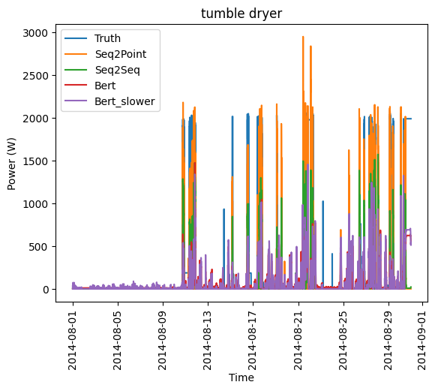

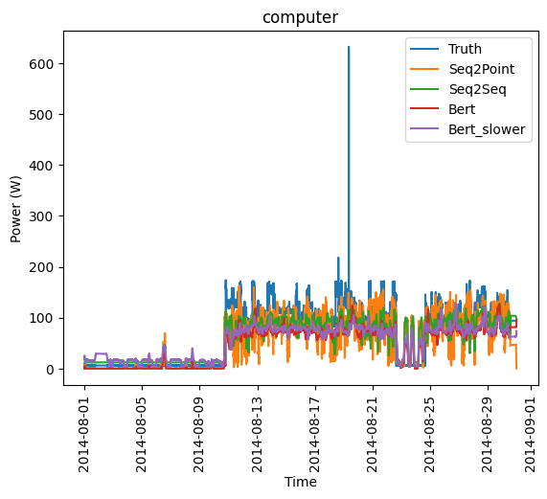

with open(f"{data_path}/building5.joblib", "rb") as f:  
 results = joblib.load(f)  
print(results["errors"])

[ Seq2Point Seq2Seq Bert Bert_slower  
tumble dryer 405.726374 400.311207 386.986838 387.437535  
computer 31.641851 28.285084 30.947019 30.834153]

Above, we report the rmse errors. The regular BERT performs best for the tumble dryer, while the Seq2Seq model is best for the computer. Interestingly, the slower learning rate for the BERT has not really materialized into a significantly better prediction performance.

Looking at the plots, the sequence models Seq2Point and Seq2Seq seem to better capture the spikes (variance), while the BERT predictions have less variance.

Zooming into an arbitrary window leads to the following plots:

a = 29000  
b = 30000  
col = 0 # Tumble Dryer  
  
plt.plot(results["test_submeters"][col][1][0][a:b], label = "Real")  
plt.plot(results["pred_overall"]["Seq2Point"].iloc[a:b,col], label = "Seq2Point")  
plt.plot(results["pred_overall"]["Seq2Seq"].iloc[a:b,col], label = "Seq2Seq")  
plt.plot(results["pred_overall"]["Bert"].iloc[a:b,col], label = "Bert")  
plt.plot(results["pred_overall"]["Bert_slower"].iloc[a:b,col], label = "Bert_slower")  
plt.title("Tumble Dryer")  
plt.legend()  
plt.plot()

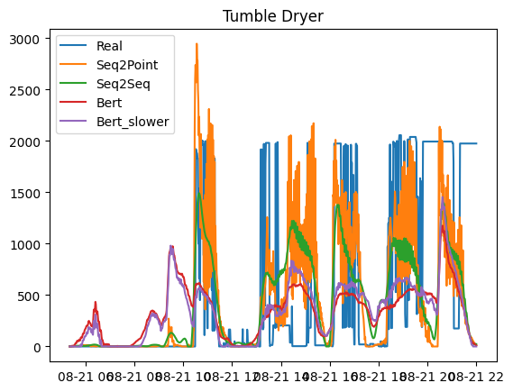

Again we see the same pattern: BERT models do capture the location of the spikes but not the complete magnitude. Moreover, it seems that the BERT models sometime capture random noise.

a = 29000  
b = 30000  
col = 1 # Computer  
  
plt.plot(results["test_submeters"][col][1][0][a:b], label = "Real")  
plt.plot(results["pred_overall"]["Seq2Point"].iloc[a:b,col], label = "Seq2Point")  
plt.plot(results["pred_overall"]["Seq2Seq"].iloc[a:b,col], label = "Seq2Seq")  
plt.plot(results["pred_overall"]["Bert"].iloc[a:b,col], label = "Bert")  
plt.plot(results["pred_overall"]["Bert_slower"].iloc[a:b,col], label = "Bert_slower")  
plt.title("Computer")  
plt.legend()  
plt.plot()

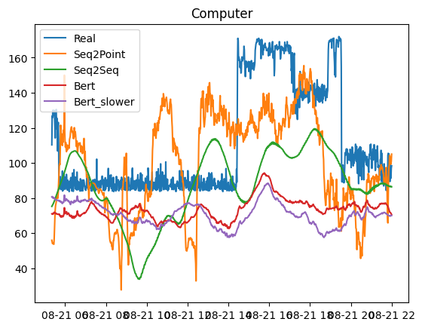

For the computer, the BERT models are much more consistent than the sequence models. The Seq2Seq and Seq2Point seem to struggle with noise in the time series leading to random spikes, making them rather impractical for the computer.

### Building 7

refit.buildings[7].elec

MeterGroup(meters=  
 ElecMeter(instance=1, building=7, dataset='REFIT', site_meter, appliances=[])  
 ElecMeter(instance=2, building=7, dataset='REFIT', appliances=[Appliance(type='fridge', instance=1)])  
 ElecMeter(instance=3, building=7, dataset='REFIT', appliances=[Appliance(type='freezer', instance=1)])  
 ElecMeter(instance=4, building=7, dataset='REFIT', appliances=[Appliance(type='freezer', instance=2)])  
 ElecMeter(instance=5, building=7, dataset='REFIT', appliances=[Appliance(type='tumble dryer', instance=1)])  
 ElecMeter(instance=6, building=7, dataset='REFIT', appliances=[Appliance(type='washing machine', instance=1)])  
 ElecMeter(instance=7, building=7, dataset='REFIT', appliances=[Appliance(type='dish washer', instance=1)])  
 ElecMeter(instance=8, building=7, dataset='REFIT', appliances=[Appliance(type='television', instance=1)])  
 ElecMeter(instance=9, building=7, dataset='REFIT', appliances=[Appliance(type='toaster', instance=1)])  
 ElecMeter(instance=10, building=7, dataset='REFIT', appliances=[Appliance(type='kettle', instance=1)])  
)

For building 7 we try to predict the kettle and the dish washer. Both appliances are used for a very short period of time only.

building7_param = {  
 "power": {"mains": ["apparent","active"],"appliance": ["apparent","active"]},  
 "sample_rate": 60,  
 "appliances": ["kettle", "dish washer"],  
 "methods": {"Seq2Point": Seq2Point({"n_epochs": 20}),   
 "Seq2Seq": Seq2Seq({"n_epochs": 20}),   
 "Bert": BERT({"n_epochs": 10}),  
 "Bert_slower": BERT({"n_epochs": 10, "learning_rate": 0.0005})  
 },  
 "display_predictions": True,  
 "train": {   
 "datasets": {  
 "Dataport": {  
 "path": file_path,  
 "buildings": {  
 7: {  
 "start_time": "2014-04-01",  
 "end_time": "2014-07-31"  
 }  
 }   
 }  
 }  
 },  
 "test": {  
 "datasets": {  
 "Dataport": {  
 "path": file_path,  
 "buildings": {  
 7: {  
 "start_time": "2014-08-01",  
 "end_time": "2014-08-31"  
 }  
 }  
 }  
 },  
 "metrics":["rmse"]  
 }  
 }

if Path(f"{data_path}/building7.joblib").exists() == False:  
 building7_mod = API(building7_param)  
 results = {   
 "pred_overall": building7_mod.pred_overall,   
 "errors": building7_mod.errors,  
 "test_mains": building7_mod.test_mains,  
 "test_submeters": building7_mod.test_submeters   
 }  
 with open(f"{data_path}/building7.joblib", "wb") as f:  
 joblib.dump(results, f)

Joint Testing for all algorithms  
Loading data for Dataport dataset  
Dropping missing values  
Generating predictions for : Seq2Point  
84/84 [==============================] - 0s 3ms/step  
84/84 [==============================] - 0s 2ms/step  
Generating predictions for : Seq2Seq  
84/84 [==============================] - 0s 2ms/step  
84/84 [==============================] - 0s 2ms/step  
Generating predictions for : BERT  
84/84 [==============================] - 3s 36ms/step  
84/84 [==============================] - 3s 36ms/step  
Generating predictions for : BERT  
84/84 [==============================] - 3s 36ms/step  
84/84 [==============================] - 3s 36ms/step  
............ rmse ..............  
 Seq2Point Seq2Seq Bert Bert_slower  
kettle 87.887507 86.512243 110.119227 112.316187  
dish washer 133.175607 125.308619 259.270627 264.857701

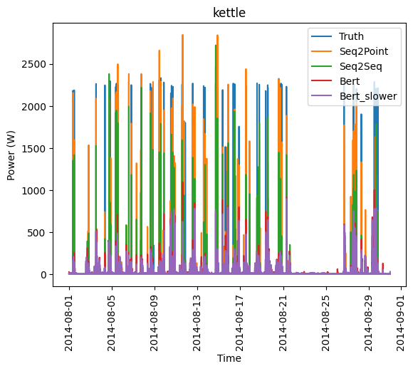

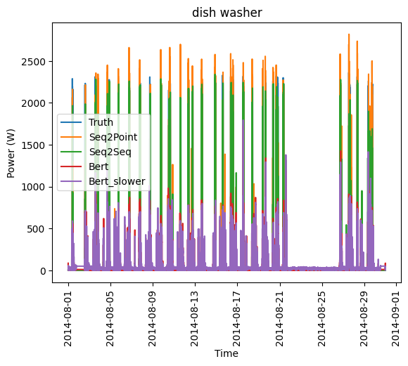

with open(f"{data_path}/building7.joblib", "rb") as f:  
 results = joblib.load(f)  
print(results["errors"])

[ Seq2Point Seq2Seq Bert Bert_slower  
kettle 87.887507 86.512243 110.119227 112.316187  
dish washer 133.175607 125.308619 259.270627 264.857701]

Looking at the errors, the Seq2Seq and Seq2Point clearly outperform the BERT transformer models. It’s likely that the outperformance is due to the architecture of the models.

a = 28250  
b = 28300  
col = 0 # Kettle  
  
plt.plot(results["test_submeters"][col][1][0][a:b], label = "Real")  
plt.plot(results["pred_overall"]["Seq2Point"].iloc[a:b,col], label = "Seq2Point")  
plt.plot(results["pred_overall"]["Seq2Seq"].iloc[a:b,col], label = "Seq2Seq")  
plt.plot(results["pred_overall"]["Bert"].iloc[a:b,col], label = "Bert")  
plt.plot(results["pred_overall"]["Bert_slower"].iloc[a:b,col], label = "Bert_slower")  
plt.title("Kettle")  
plt.legend()  
plt.plot()

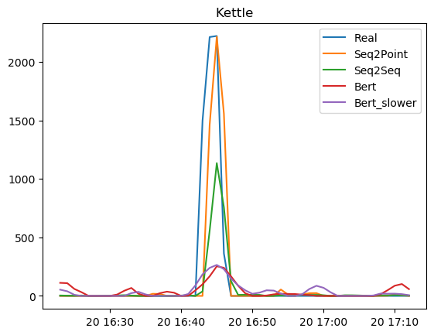

a = 6400  
b = 6500  
col = 1 # Dish Washer  
  
plt.plot(results["test_submeters"][col][1][0][a:b], label = "Real")  
plt.plot(results["pred_overall"]["Seq2Point"].iloc[a:b,col], label = "Seq2Point")  
plt.plot(results["pred_overall"]["Seq2Seq"].iloc[a:b,col], label = "Seq2Seq")  
plt.plot(results["pred_overall"]["Bert"].iloc[a:b,col], label = "Bert")  
plt.plot(results["pred_overall"]["Bert_slower"].iloc[a:b,col], label = "Bert_slower")  
plt.title("Dish Washer")  
plt.legend()  
plt.plot()

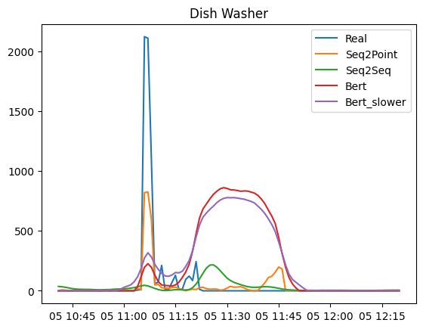

The transformer models predict a second “bump” for the dish washer probably due some random noise.

### Building 14

refit.buildings[14].elec

MeterGroup(meters=  
 ElecMeter(instance=1, building=14, dataset='REFIT', site_meter, appliances=[])  
 ElecMeter(instance=2, building=14, dataset='REFIT', appliances=[Appliance(type='fridge freezer', instance=1)])  
 ElecMeter(instance=3, building=14, dataset='REFIT', appliances=[Appliance(type='tumble dryer', instance=1)])  
 ElecMeter(instance=4, building=14, dataset='REFIT', appliances=[Appliance(type='washing machine', instance=1)])  
 ElecMeter(instance=5, building=14, dataset='REFIT', appliances=[Appliance(type='dish washer', instance=1)])  
 ElecMeter(instance=6, building=14, dataset='REFIT', appliances=[Appliance(type='computer', instance=1)])  
 ElecMeter(instance=7, building=14, dataset='REFIT', appliances=[Appliance(type='television', instance=1)])  
 ElecMeter(instance=8, building=14, dataset='REFIT', appliances=[Appliance(type='microwave', instance=1)])  
 ElecMeter(instance=9, building=14, dataset='REFIT', appliances=[Appliance(type='audio system', instance=1)])  
 ElecMeter(instance=10, building=14, dataset='REFIT', appliances=[Appliance(type='toaster', instance=1)])  
)

For building 14, we try the models on a varity of appliance patterns.

building14_param = {  
 "power": {"mains": ["apparent","active"],"appliance": ["apparent","active"]},  
 "sample_rate": 60,  
 "appliances": [ "fridge freezer", "washing machine", "television", "audio system" ],  
 "methods": {"Seq2Point": Seq2Point({"n_epochs": 20}),   
 "Seq2Seq": Seq2Seq({"n_epochs": 20}),   
 "Bert": BERT({"n_epochs": 10}),  
 "Bert_slower": BERT({"n_epochs": 10, "learning_rate": 0.0005})  
 },  
 "display_predictions": True,  
 "train": {   
 "datasets": {  
 "Dataport": {  
 "path": file_path,  
 "buildings": {  
 14: {  
 "start_time": "2014-04-01",  
 "end_time": "2014-07-31"  
 }  
 }   
 }  
 }  
 },  
 "test": {  
 "datasets": {  
 "Dataport": {  
 "path": file_path,  
 "buildings": {  
 14: {  
 "start_time": "2014-08-01",  
 "end_time": "2014-08-31"  
 }  
 }  
 }  
 },  
 "metrics":["rmse"]  
 }  
 }

if Path(f"{data_path}/building14.joblib").exists() == False:  
 building14_mod = API(building14_param)  
 results = {   
 "pred_overall": building14_mod.pred_overall,   
 "errors": building14_mod.errors,  
 "test_mains": building14_mod.test_mains,  
 "test_submeters": building14_mod.test_submeters   
 }  
 with open(f"{data_path}/building14.joblib", "wb") as f:  
 joblib.dump(results, f)

Joint Testing for all algorithms  
Loading data for Dataport dataset  
Dropping missing values  
Generating predictions for : Seq2Point  
85/85 [==============================] - 1s 6ms/step  
85/85 [==============================] - 1s 5ms/step  
85/85 [==============================] - 1s 4ms/step  
85/85 [==============================] - 1s 4ms/step  
Generating predictions for : Seq2Seq  
85/85 [==============================] - 0s 4ms/step  
85/85 [==============================] - 0s 3ms/step  
85/85 [==============================] - 0s 2ms/step  
85/85 [==============================] - 0s 2ms/step  
Generating predictions for : BERT  
85/85 [==============================] - 18s 215ms/step  
85/85 [==============================] - 19s 218ms/step  
85/85 [==============================] - 19s 215ms/step  
85/85 [==============================] - 18s 214ms/step  
Generating predictions for : BERT  
85/85 [==============================] - 18s 214ms/step  
85/85 [==============================] - 19s 215ms/step  
85/85 [==============================] - 18s 215ms/step  
85/85 [==============================] - 18s 214ms/step  
............ rmse ..............  
 Seq2Point Seq2Seq Bert Bert_slower  
fridge freezer 21.736150 25.764762 34.535043 38.285467  
washing machine 52.042083 61.049155 104.372881 104.982779  
television 29.410966 24.490124 26.568183 27.223311  
audio system 47.394926 50.714894 94.528559 90.211560

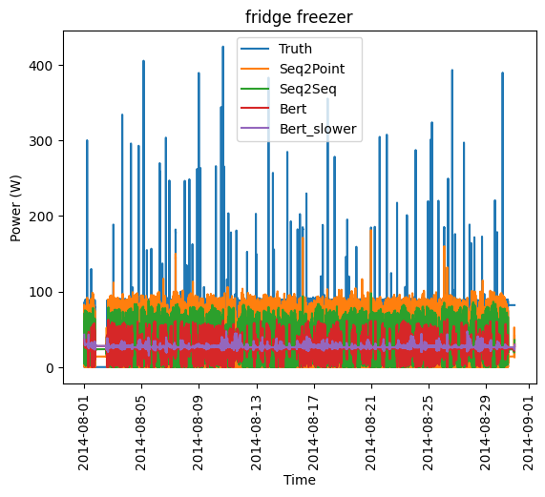

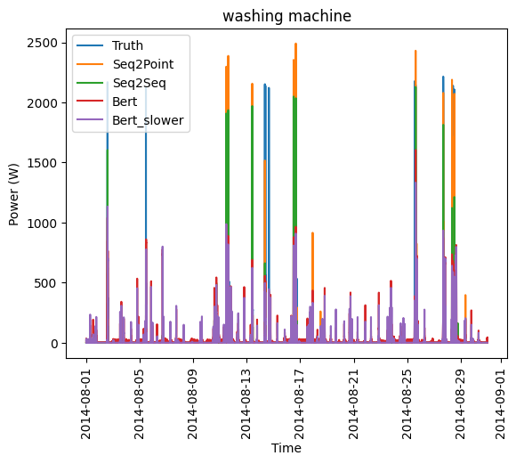

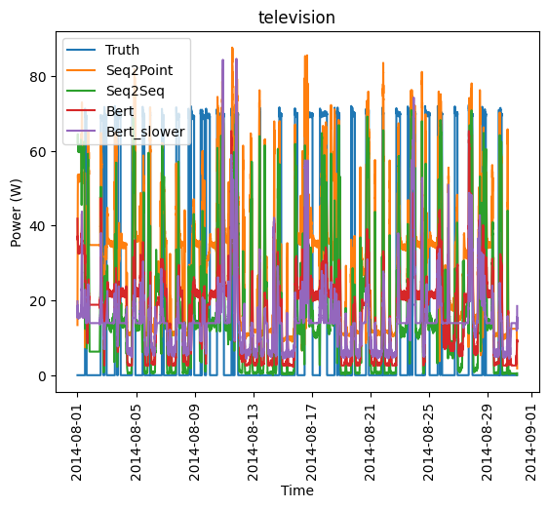

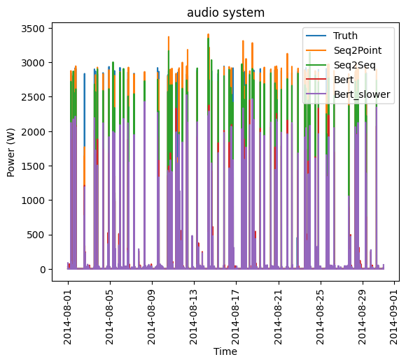

with open(f"{data_path}/building14.joblib", "rb") as f:  
 results = joblib.load(f)  
print(results["errors"])

[ Seq2Point Seq2Seq Bert Bert_slower  
fridge freezer 21.736150 25.764762 34.535043 38.285467  
washing machine 52.042083 61.049155 104.372881 104.982779  
television 29.410966 24.490124 26.568183 27.223311  
audio system 47.394926 50.714894 94.528559 90.211560]

The sequence models again outperform the transformer models on the RMSE metric. The transformer models seem to be able to time the spikes but not output a high magnitude.

a = 38000  
b = 42000  
col = 0 # Fridge Freezer  
  
plt.plot(results["test_submeters"][col][1][0][a:b], label = "Real")  
plt.plot(results["pred_overall"]["Seq2Point"].iloc[a:b,col], label = "Seq2Point")  
plt.plot(results["pred_overall"]["Seq2Seq"].iloc[a:b,col], label = "Seq2Seq")  
plt.plot(results["pred_overall"]["Bert"].iloc[a:b,col], label = "Bert")  
plt.plot(results["pred_overall"]["Bert_slower"].iloc[a:b,col], label = "Bert_slower")  
plt.title("Fridge Freezer")  
plt.legend()  
plt.plot()

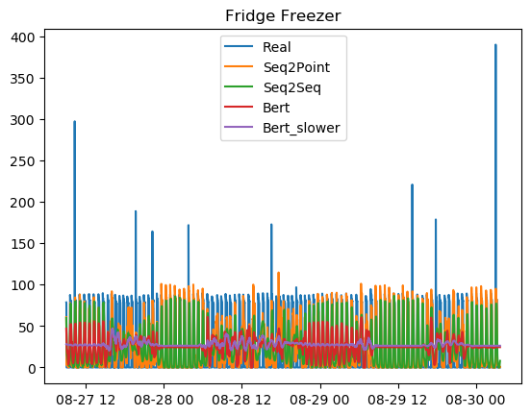

The fridge has an oscillating pattern, which works well for the sequence models but not for the transformer models. Sometimes the BERT predictions are oscillating and sometimes the prediction is a flat line only. Both architectures do not recognize the high magnitude spikes. A slower learning rate worsens the performance.

a = 35300  
b = 35600  
col = 1 # Washing Machine  
  
plt.plot(results["test_submeters"][col][1][0][a:b], label = "Real")  
plt.plot(results["pred_overall"]["Seq2Point"].iloc[a:b,col], label = "Seq2Point")  
plt.plot(results["pred_overall"]["Seq2Seq"].iloc[a:b,col], label = "Seq2Seq")  
plt.plot(results["pred_overall"]["Bert"].iloc[a:b,col], label = "Bert")  
plt.plot(results["pred_overall"]["Bert_slower"].iloc[a:b,col], label = "Bert_slower")  
plt.title("Washing Machine")  
plt.legend()  
plt.plot()

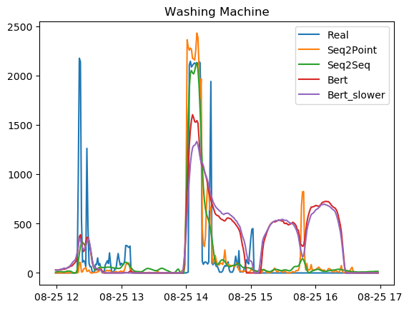

The washing mashine pattern is a typical example where the transformer models predict a second “bump” after a real high. Maybe due to the self-attention mechanism?

a = 29500  
b = 30500  
col = 2 # Television  
  
plt.plot(results["test_submeters"][col][1][0][a:b], label = "Real")  
plt.plot(results["pred_overall"]["Seq2Point"].iloc[a:b,col], label = "Seq2Point")  
plt.plot(results["pred_overall"]["Seq2Seq"].iloc[a:b,col], label = "Seq2Seq")  
plt.plot(results["pred_overall"]["Bert"].iloc[a:b,col], label = "Bert")  
plt.plot(results["pred_overall"]["Bert_slower"].iloc[a:b,col], label = "Bert_slower")  
plt.title("Television")  
plt.legend()  
plt.plot()

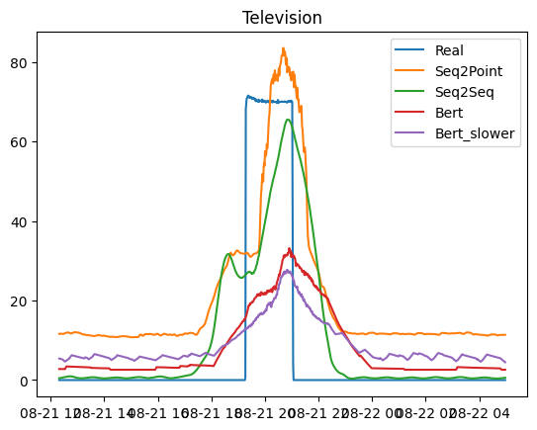

The sequence models respond faster to a high, while transformers are slower and with a lower magnitude.

a = 39300  
b = 39400  
col = 3 # Audio System  
  
plt.plot(results["test_submeters"][col][1][0][a:b], label = "Real")  
plt.plot(results["pred_overall"]["Seq2Point"].iloc[a:b,col], label = "Seq2Point")  
plt.plot(results["pred_overall"]["Seq2Seq"].iloc[a:b,col], label = "Seq2Seq")  
plt.plot(results["pred_overall"]["Bert"].iloc[a:b,col], label = "Bert")  
plt.plot(results["pred_overall"]["Bert_slower"].iloc[a:b,col], label = "Bert_slower")  
plt.title("Audio System")  
plt.legend()  
plt.plot()

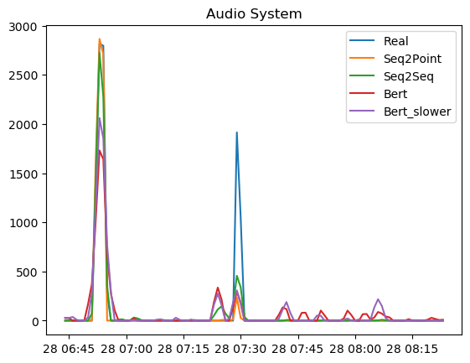

The audio system has a very short usage time and all models recognize the spikes. The BERT models fit some random noise and as a result, predict phantom spikes.

## Conclusion

* It’s not clear whether the transformer architecture is superior to the sequence models. Quite often, the transformers struggle with oscillating patterns or very high magnitudes. Also, their training is computationally much more expensive than sequence models.
* More epochs for the BERT models would have been better, but we were constrained by Google Colab computing units.
* There is room for a lot more experiments, for example by changing learning rates or the pre-processing functions.