0, Clone OEDS from Github/Gitlab
  - Open “Portainer-compose.yml” then substitute the path of grafana-datasources (line 19), grafana-dashboardproviders (line 25), and grafana-dashboards (line 31) with the path in OEDS local aboslute path (should be path of oeds + /data/provisioning)
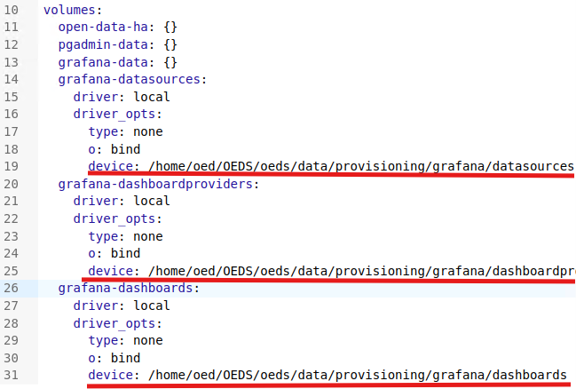

1, Create Configs:
  - Init-sql
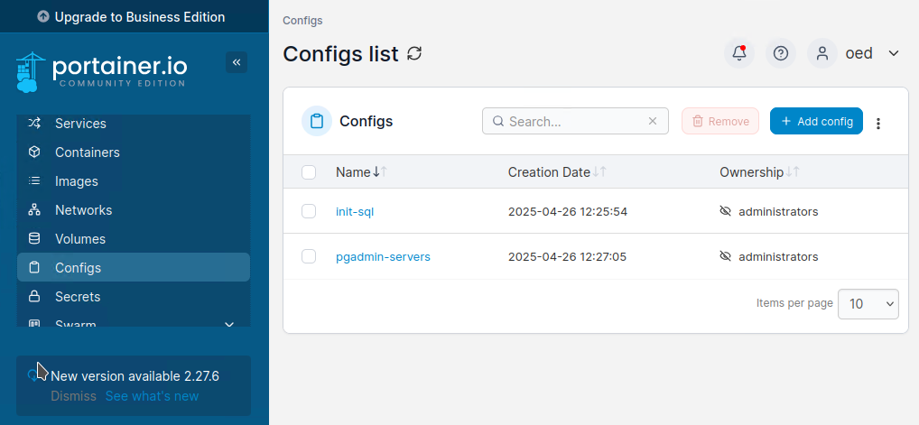
First in Portainer find Config, then click “Add config” button on upper right.
Set Name as init-sql, then paste the content of “init.sql” into Web editer,
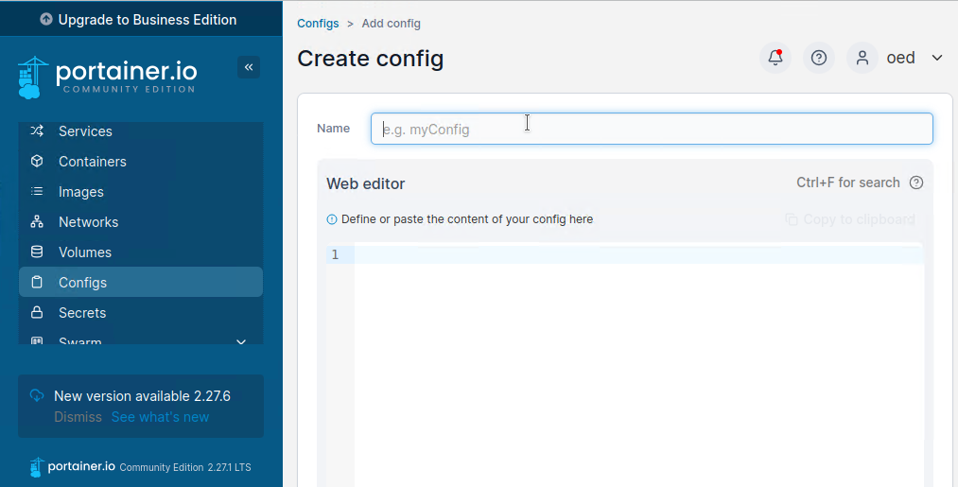
then click Create config button belove
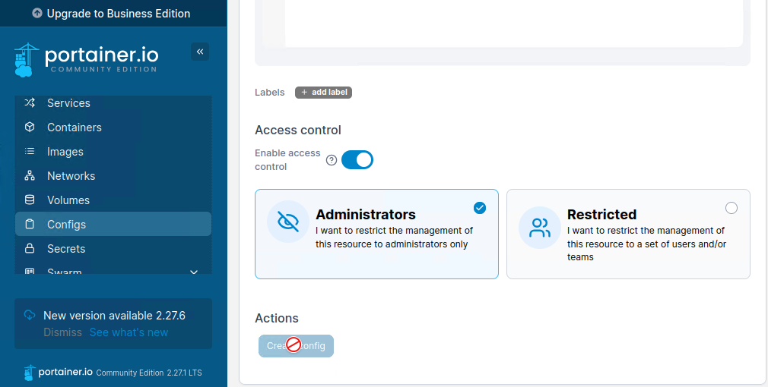

  - Pdadmin-servers
Do the same thing for config pgadmin-servers from data “servers.json” which locate at “oeds/data/provisioning/pgadmin/ servers.json” in oeds repository. Make sure two configs successfully created.
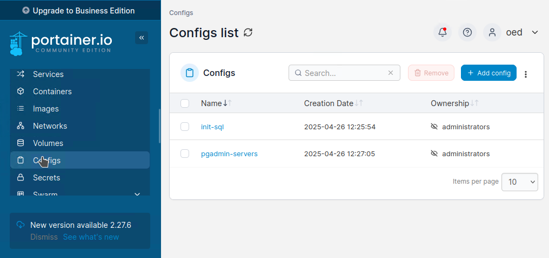

- Add stack
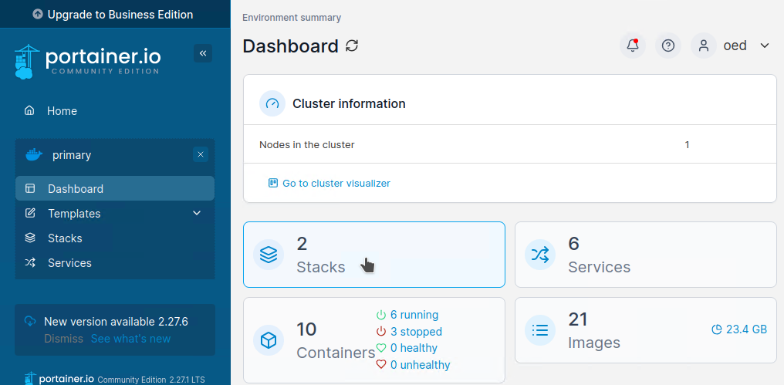
In Dashboard click Stacks
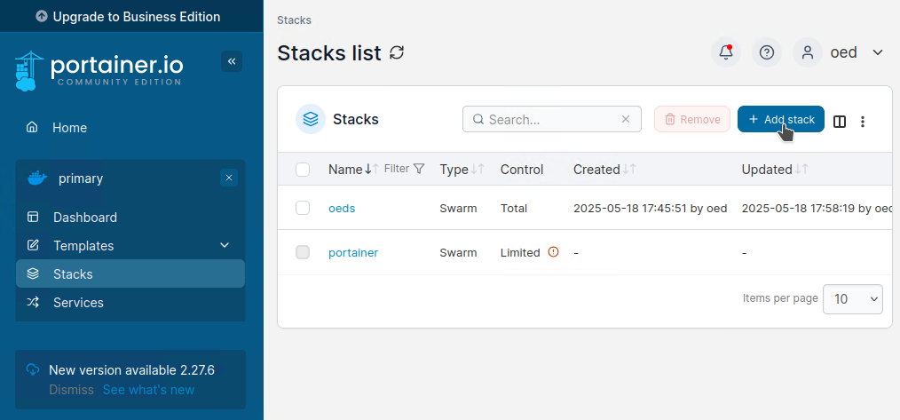
Then click add stack
Set a name for the stack then either paste content of “portainer-compose.yml” into Web editor

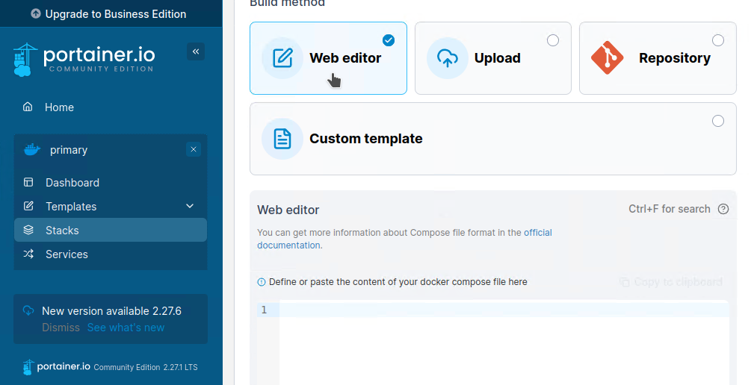
Or upload “portainer-compose.yml”
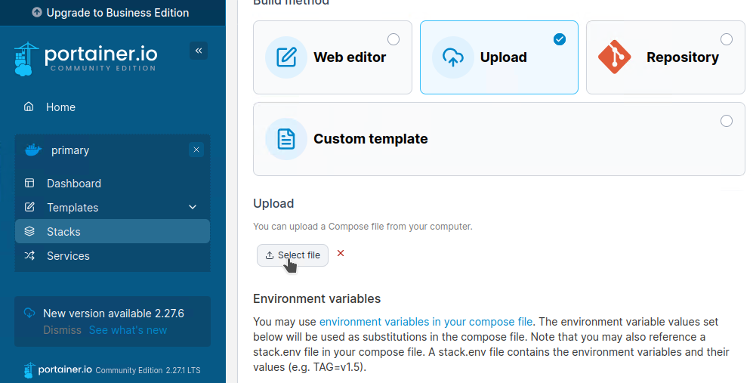

Then click “Deploy the stack” button below
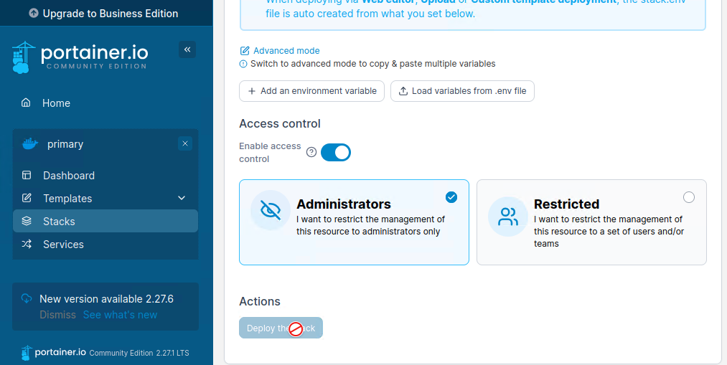

If created successfully, four services of stack created should be all running
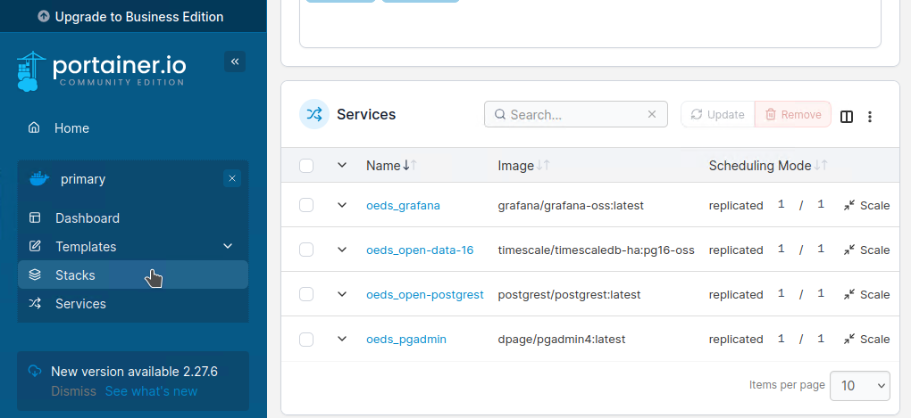
And you can check pdAdmin4 by visiting localhost:8080 in browser
