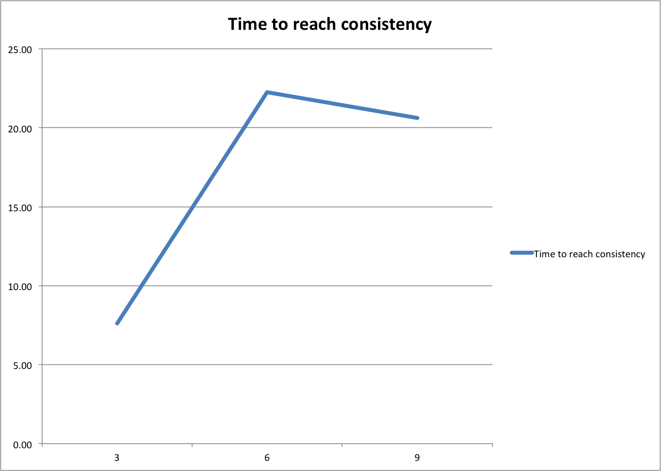

The number of vessels running is on the X-axis.

The time in seconds for the each of the board to have received all messages is on the Y-axis.

The bash script sent three messages to each vessel.

Unfortunately because of problems with Seattle where we lost connections to vessels the three data points were measured using different vessels which explains why sending the data using 6 vessels were slower than using 9.