Class04.R

johanntailor

2024-01-19

#This is a text file  
x <- 1:50  
plot(x, sin(x))

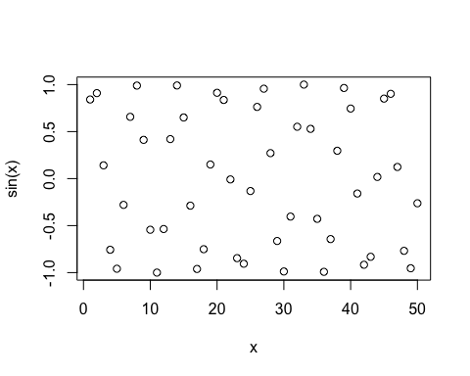

plot(x, sin(x), type = "l")

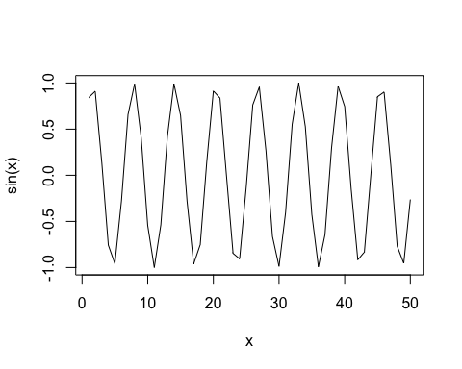

plot(x, sin(x), type = "l", col="red")

