Apache ODE and WS-BPEL 2.0

Helloworld a hands on description.

Introduction
A process in ODE is described in an XML based language, actually everything is described using XML.

A ODE project consists of at least 3 files in a folder :
- hello.bpel file that contains a process declaration and bussiness logics. (hello part of name is an example .bpel is the file extension)
- hello.wsdl file that declares XML-schema Types, webservice endpoints and partnerLinks. The wsdl file is very similar in syntax and content to a soap webservice WSDL file (Web Service Description Language) simplified the WSDL file contains information about what messages address, and protocol the process uses for communication the process is exposed as SOAP Webservice .
- deploy.xml declares process to deploy and their partnerLinks.

The components of each file is identified by their namespace so when referring to them it has to be done in the correct name space context with proper import of namespace and use of namespace prefix. If one want to refer to the HelloMessage in xml 1: namespace we have to use the namespace ”http://hello/test.wsdl”.

<?xml version="1.0" encoding="utf-8" ?>
<wsdl:definitions
xmlns:tns="http://hello/test.wsdl"
targetNamespace="http://hello/test.wsdl">

<wsdl:message name="HelloMessage">
<wsdl:part name="message" type="xsd:string"/>
</wsdl:message>

</wsdl:definitions>
xml 1: namespace

Overview of the projectfiles content

The WDSL file

In short declaration of types, address, ports and protocols no action here. xml 2: sample WSDL file shows a minimal (not all lines are visible ) wsdl file for a toy example service.

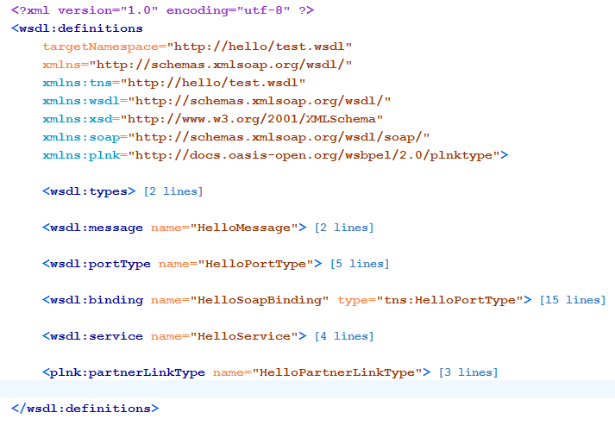
xml 2: sample WSDL file

<wsdl:types>
Contains type and element declarations (XML shema) later referenced from wdl:messages
section. This section may be empty if only simple XML schema types as string are used as datatypes for messages.

”<wsdl:types> </wsdl:types>”

<wsdl:message>
Declares the messages used for communication, the messages are of simple types or complex type. Complex types are declared / imported under the types (<types>) section. A WSDL document may contain multiple message declarations.

Simple type message

<wsdl:message name="HelloMessage">
<wsdl:part name="message" type="xsd:string"/>
</wsdl:message>

Complex type message notice! that the part refers to an element. Complex type messages has only one part element as child.
<wsdl:message name="PersonData">
<wsdl:part name="PersonData" element="tns:PersonData"/>
</wsdl:message>

<wsdl:portType>

Portype declares operation input and output messages used by this portType. Operation in this context can be seen as a method that takes a parameter and has a returntype. The PortType is abstract and not bound to any protocol or adress the messages references a <wsdl:message/>

<wsdl:portType name="HelloPortType">
<wsdl:operation name="sayHello">
<wsdl:input message="tns:HelloMessage" name="TestIn"/>
<wsdl:output message="tns:HelloMessage" name="TestOut"/>
</wsdl:operation>
</wsdl:portType>

<wsdl:binding>
Binds a porttype to a specific protocol, style attribute is worth to notice common style values is rpc and document, rpc allows only simple types as messages while document allows complex type elements.
<wsdl:binding name="HelloSoapBinding" type="tns:HelloPortType">
<!-- content -->
</wsdl:binding>

<wsdl:service>
Defines the service port(s), binding used and the service location.

<wsdl:service name="HelloService">
<wsdl:port name="HelloPort" binding="tns:HelloSoapBinding">
<soap:address location="http://localhost:8080/ode/processes/helloWorld"/>
</wsdl:port>
</wsdl:service>

<plnk:partnerLinkType>
Declares PortType and partnerRole, partnerLinkType is not seen in an ordinary WSDL file but are used in bpel it’s used to define the relationship between processses.

hello.bpel file
The hello.bpel contains the process defintion
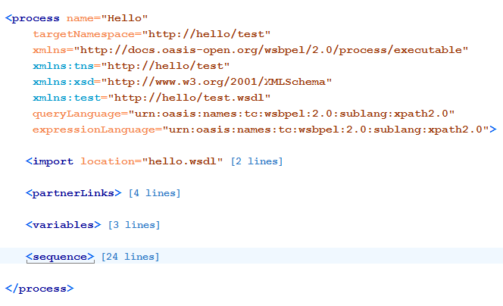

<import>
Used to import a wsdl file so that it’s possible to access types messages, portTypes PartnerLinkTypes and service definitions.

<partnerLinks>
Defines the partnerLinks <partnerLink> the partnerlink name, <PartnerLinkType> and the roles.

<variables>
Defines the variables used and their types.

<sequence>
Defines a synchronous sequence of activities, the activities are executed in a sequential order.

Deploy.xml
Contains deployment information for processes for example which partnerLink to provide, which service and port to use for the partnerlink. The service and the process are referenced by their namespace.
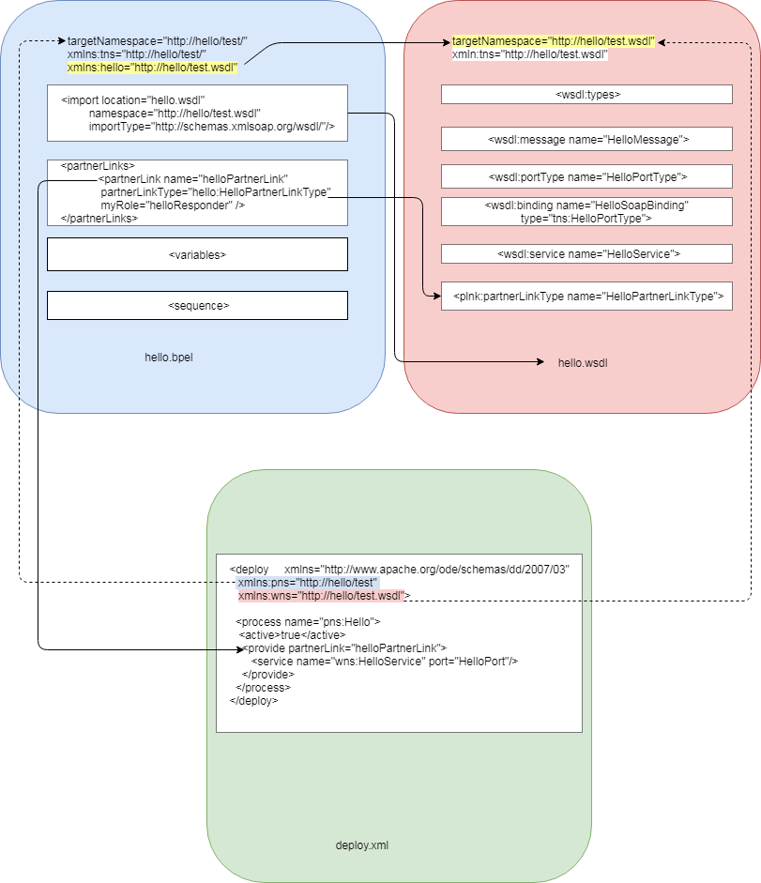
Illustration1: File relationship overview
Illustration1: File relationship overview shows the relationship between the files in the hello project to access types partnerlinks and messages from the process it has to be imported and, a namespace prefix hello is added to access types from this namespace start with the namespace prefix hello.
In the deploy file hello.bpel and hello.wsdl is referenced only by their namespace and the use of namespace prefix no import is required.

The source code for the Hello process is displayed in appendix A

Appendix A:
<process name="Hello"
targetNamespace="http://hello/test"
xmlns="http://docs.oasis-open.org/wsbpel/2.0/process/executable"
xmlns:tns="http://hello/test"
xmlns:xsd="http://www.w3.org/2001/XMLSchema"
xmlns:hello="http://hello/test.wsdl"
queryLanguage="urn:oasis:names:tc:wsbpel:2.0:sublang:xpath2.0"
expressionLanguage="urn:oasis:names:tc:wsbpel:2.0:sublang:xpath2.0">
<!-- Import hello.wsdl notice namespace "http://hello/test.wsdl"
and that there is a namespace prefic hello declared -->
<import location="hello.wsdl"
namespace="http://hello/test.wsdl"
importType="http://schemas.xmlsoap.org/wsdl/"/>
<partnerLinks>
<!-- Declares a partnerLink and it's type-->
<partnerLink name="helloPartnerLink"
partnerLinkType="hello:HelloPartnerLinkType"
myRole="helloResponder" />
</partnerLinks>
<!-- variables declares here -->
<variables>
<!--
Declares helloVar of messageType,
the message is declared in hello.wsdl
-->
<variable name="helloVar" messageType="hello:HelloMessage"/>
</variables>
<sequence>
<!-- Recieve request message from client store result in helloVar -->
<receive
name="start"
partnerLink="helloPartnerLink"
portType="hello:HelloPortType"
operation="sayHello"
variable="helloVar"
createInstance="yes"/>
<!-- Send echo reply to client using
recieved message stored in helloVar -->
<reply name="end"
partnerLink="helloPartnerLink"
portType="hello:HelloPortType"
operation="sayHello"
variable="helloVar"/>
</sequence>
</process>
xml 3: file hello.bpel

<?xml version="1.0" encoding="utf-8" ?>
<wsdl:definitions
targetNamespace="http://hello/test.wsdl"
xmlns:tns="http://hello/test.wsdl"
xmlns="http://schemas.xmlsoap.org/wsdl/"
xmlns:wsdl="http://schemas.xmlsoap.org/wsdl/"
xmlns:xsd="http://www.w3.org/2001/XMLSchema"
xmlns:soap="http://schemas.xmlsoap.org/wsdl/soap/"
xmlns:plnk="http://docs.oasis-open.org/wsbpel/2.0/plnktype">
<!--
Type and element declarations (XML shema) later referenced from
wdl:messages section if we use only simple types as xsd:string
This section may be empty
-->
<wsdl:types>
<!-- declare xml-Schema types here -->
</wsdl:types>
<!--
Declaration of messages used for communication simple type or
elements with compex content
( complex types from schema under the type section )
-->
<wsdl:message name="HelloMessage">
<wsdl:part name="message" type="xsd:string"/>
</wsdl:message>
<!-- Portype declares WSDL input and output messages used for this port-->
<wsdl:portType name="HelloPortType">
<wsdl:operation name="sayHello">
<wsdl:input message="tns:HelloMessage" name="TestIn"/>
<wsdl:output message="tns:HelloMessage" name="TestOut"/>
</wsdl:operation>
</wsdl:portType>
<!-- Binding binds a porttype to a concrete protocol etc -->
<wsdl:binding name="HelloSoapBinding" type="tns:HelloPortType">
<soap:binding style="rpc" transport="http://schemas.xmlsoap.org/soap/http"/>
<wsdl:operation name="sayHello">
<soap:operation soapAction="" style="rpc"/>
<wsdl:input>
<soap:body
namespace="http://hello/test.wsdl"
use="literal"/>
</wsdl:input>
<wsdl:output>
<soap:body
namespace="http://hello/test.wsdl"
use="literal"/>
</wsdl:output>
</wsdl:operation>
</wsdl:binding>
<!-- Service declaration specifies service adress, binding and portname-->
<wsdl:service name="HelloService">
<wsdl:port name="HelloPort" binding="tns:HelloSoapBinding">
<soap:address location="http://localhost:8080/ode/processes/helloWorld"/>
</wsdl:port>
</wsdl:service>
<!--
Declaration of partnerlink type specifies the port used and partner roles
partner roles defines relationship between not only different processes but also between a process and external services.
-->
<plnk:partnerLinkType name="HelloPartnerLinkType">
<plnk:role name="helloResponder" portType="tns:HelloPortType"/>
<plnk:role name="helloRequester" portType="tns:HelloPortType"/>
</plnk:partnerLinkType>
</wsdl:definitions>
xml 4: file: hello.wsdl
<!-- The process, wsdl file and types are identified by their namespaces-->
<deploy xmlns="http://www.apache.org/ode/schemas/dd/2007/03"
xmlns:pns="http://hello/test"
xmlns:wns="http://hello/test.wsdl">
<process name="pns:Hello">
<active>true</active>
<provide partnerLink="helloPartnerLink">
<service name="wns:HelloService" port="HelloPort"/>
</provide>
</process>
</deploy>
xml 5: file: deploy.xml

