Johan Ospina Michael Ethier EC413 Datapath Milestone 3

When creating the datapath, we realized that the PC only had to be incremented by 1 and we no longer needed to shift left by 2. This adjustment was made to the design of our CPU. The datapath was tested by manually assigning the control signals for each state. The first instruction in the IMEM was LI so in the testbench the control signals were defined for states 0, 1, 2, 3 then 4 because these are the states that the datapath goes through for the LI instruction. This was done for a couple more instructions. We then checked with the IMEM module to make sure the signals that were output were correct. The testbench uses hardcoded values from our controller and it fetches the instruction from the IMEM.

LI - Instruction

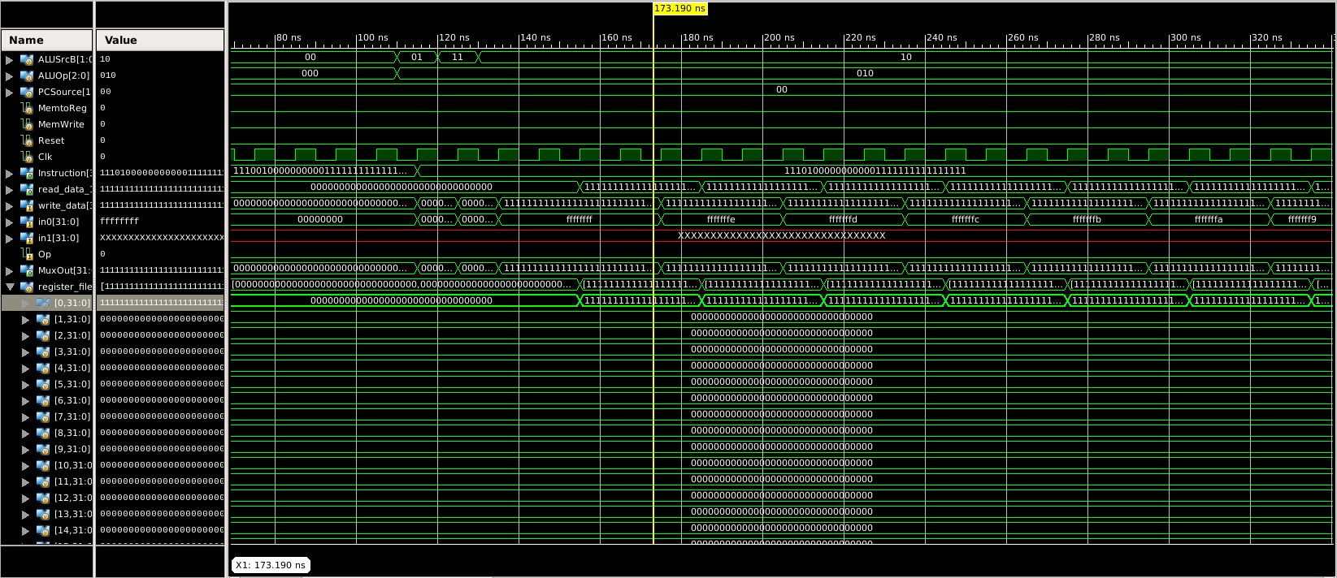

In the picture above the immediate value h’ffffffff is being loaded into register 0 and this is the first instruction of the IMEM module that was provided.