MotoMonitor
Smart Vehicle Service and Maintenance Management System
Mini Project Planning Document
Group No. 3
Aaron V Varghese (MGP22NMC001)
Albin Jomon (MGP22NMC014)
Alen Aby (MGP22NMC015)

1. Requirement Collection
Requirements below are derived from the project abstract, covering the three stakeholder groups: vehicle owners, authorized service centers, and manufacturers.

1.1 Functional Requirements
ID | Actor | Requirement
FR1 | Vehicle Owner | Register an account and log in securely (role-based: owner / service center / manufacturer).
FR2 | Vehicle Owner | Add and manage one or more vehicles with details (registration no., make/model, purchase date, odometer).
FR3 | Vehicle Owner | Store and update document details: insurance, road tax, and pollution certificate with expiry dates.
FR4 | System | Automatically calculate and generate reminders based on service intervals, mileage, and document expiry dates.
FR5 | System | Send notifications via Email (SMTP) and SMS for upcoming or overdue maintenance/documents.
FR6 | Vehicle Owner | View complete digital service history for each registered vehicle.
FR7 | Service Center | Search a vehicle by registration number and view its service history.
FR8 | Service Center | Add/update service records after each visit (service type, parts replaced, date, mileage, next due date).
FR9 | Manufacturer | Send recall notifications, maintenance advisories, and promotional offers to registered owners.
FR10 | Manufacturer | Filter/target vehicle owners by model or vehicle segment for communication.
FR11 | Admin/System | Maintain an audit log of all notifications sent and their delivery status.

1.2 Non-Functional Requirements
ID | Category | Requirement
NFR1 | Usability | Simple, responsive web UI accessible on desktop and mobile browsers.
NFR2 | Reliability | Reminders must trigger accurately with no missed notifications near due dates.
NFR3 | Security | Passwords hashed; role-based access control between owners, service centers, and manufacturers.
NFR4 | Performance | Dashboard and reminder queries should return within 2-3 seconds under normal load.
NFR5 | Maintainability | Modular codebase (Python backend) to allow independent development of modules by team members.
NFR6 | Scalability | Database schema should support growth in vehicles, service centers, and manufacturers.

1.3 Requirement Sources
Collected from the project abstract and refined through team discussion covering: vehicle owner pain points (missed renewals, poor visibility of service history), service center needs (record-keeping and customer communication), and manufacturer needs (recall and promotional outreach).

2. Initial User Stories

ID | Role | I want to... | So that...
US1 | Vehicle Owner | register my vehicle with its details | I can start tracking its service and document schedule.
US2 | Vehicle Owner | receive a reminder before my insurance/road tax/pollution certificate expires | I avoid legal penalties and last-minute renewals.
US3 | Vehicle Owner | receive a reminder for oil change, filter replacement, and other routine maintenance | I can keep my vehicle reliable and avoid breakdowns.
US4 | Vehicle Owner | view the complete service history of my vehicle in one place | I don't have to rely on paper receipts or memory.
US5 | Vehicle Owner | get notifications by both email and SMS | I don't miss alerts if I'm not checking one channel.
US6 | Service Center | search for a vehicle using its registration number | I can quickly pull up its history before servicing it.
US7 | Service Center | add a new service record after completing work | the owner's digital service history stays up to date.
US8 | Manufacturer | send a recall notice to all owners of a specific model | affected customers are informed quickly and safety issues are addressed.
US9 | Manufacturer | send promotional offers to registered customers | I can improve engagement and repeat business.
US10 | System/Admin | log every notification that is sent | we can confirm delivery and troubleshoot issues.

3. Modules and Team Ownership
Modules are split across the three team members so each owns a complete vertical slice (frontend + backend logic) while collaborating on shared database design.
Module | Description | Owner
Authentication & User Management | Registration, login, role-based access (owner / service center / manufacturer), profile management. | Aaron V Varghese
Vehicle & Reminder Engine | Vehicle registration, document/service interval tracking, reminder generation logic, notification dispatch (Email/SMS). | Aaron V Varghese
Service Center Module | Vehicle search, service record entry/update, service history views. | Albin Jomon
Service History & Reporting | Consolidated service history views for owners, history export/summary. | Albin Jomon
Manufacturer Module | Recall/advisory/offer creation, targeting by model, notification logging. | Alen Aby
Database Design & Integration | MySQL schema design, integration across modules, deployment (Git/GitHub, VS Code environment setup). | Alen Aby

4. Initial Database Schema (MySQL)

Table | Key Fields
users | user_id (PK), name, email, phone, password_hash, role (owner/service_center/manufacturer), created_at
vehicles | vehicle_id (PK), owner_id (FK -> users), reg_number, make, model, purchase_date, odometer_reading
vehicle_documents | doc_id (PK), vehicle_id (FK -> vehicles), doc_type (insurance/road_tax/pollution), expiry_date
service_records | record_id (PK), vehicle_id (FK -> vehicles), service_center_id (FK -> users), service_type, service_date, mileage_at_service, parts_replaced, next_due_date, remarks
service_centers | center_id (PK), user_id (FK -> users), center_name, address, contact_number
manufacturers | manufacturer_id (PK), user_id (FK -> users), company_name
notifications | notification_id (PK), sender_id (FK -> users, nullable for system), recipient_id (FK -> users), type (reminder/recall/advisory/offer), message, channel (email/sms), sent_at, delivery_status
reminder_rules | rule_id (PK), rule_type (mileage/date-based), item_name (e.g. oil change), interval_value, interval_unit (km/days)

4.1 Relationships
- One user (owner) can have many vehicles (1-to-many).
- One vehicle can have many documents and many service records (1-to-many each).
- One service center (a user with role=service_center) can create many service records.
- One manufacturer can send many notifications; notifications can target many recipients (owners).
- Reminder rules are referenced by the reminder engine to generate entries in notifications.

5. UI Sketch

5.1 Login / Registration
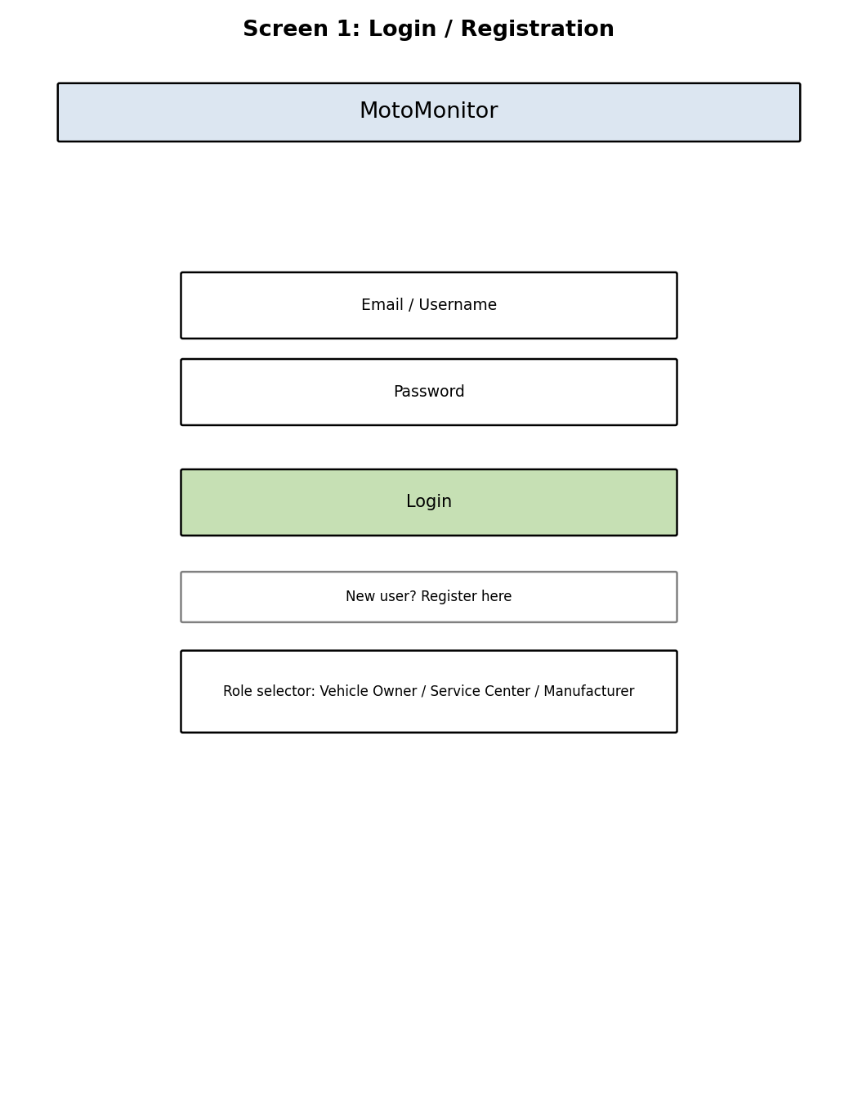

5.2 Vehicle Owner Dashboard
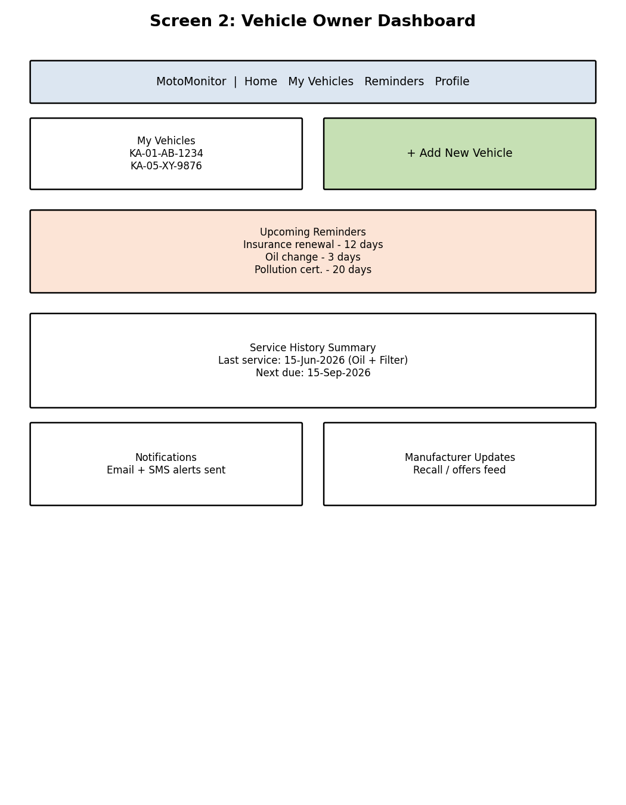

5.3 Add / Register Vehicle
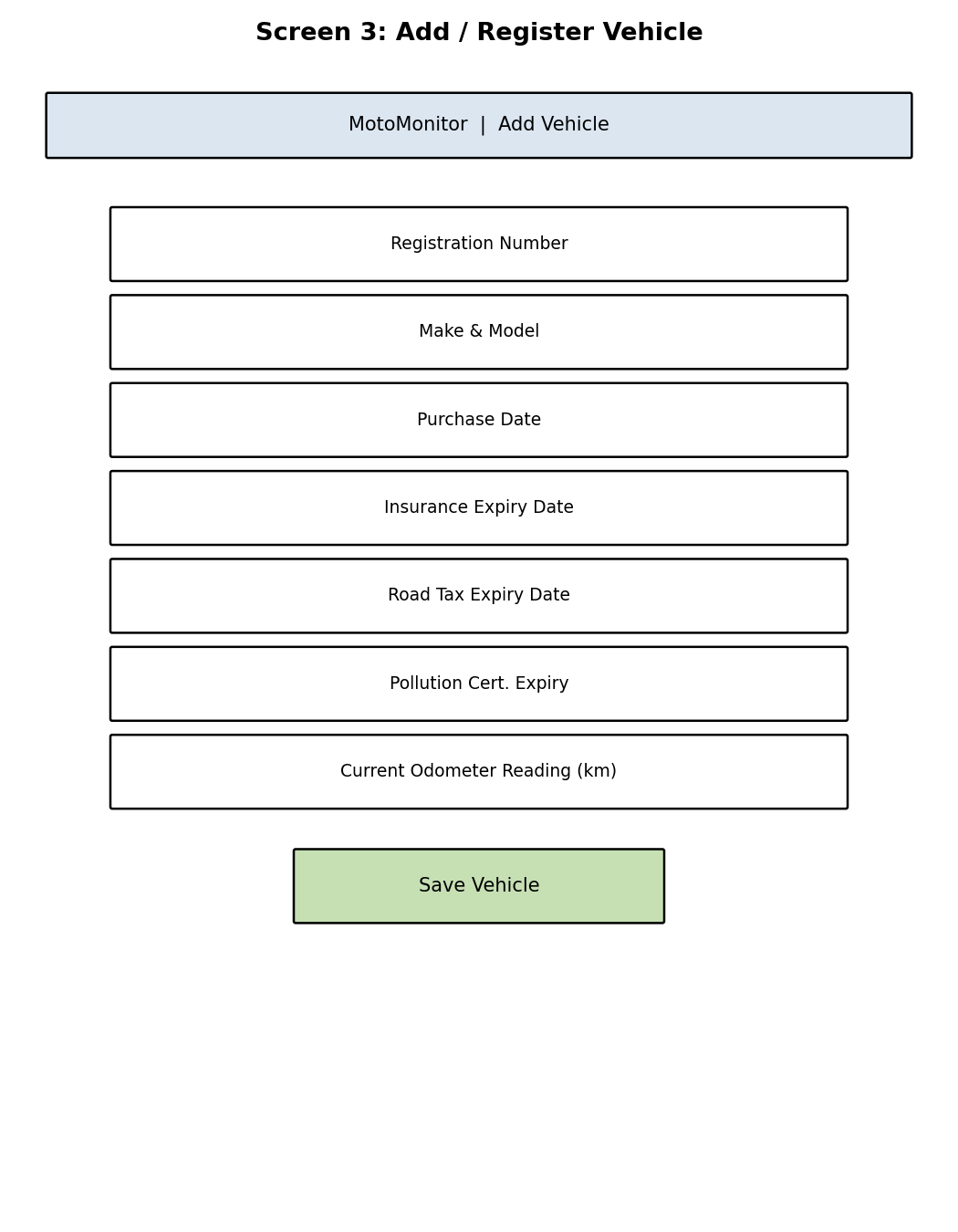

5.4 Service Center Panel
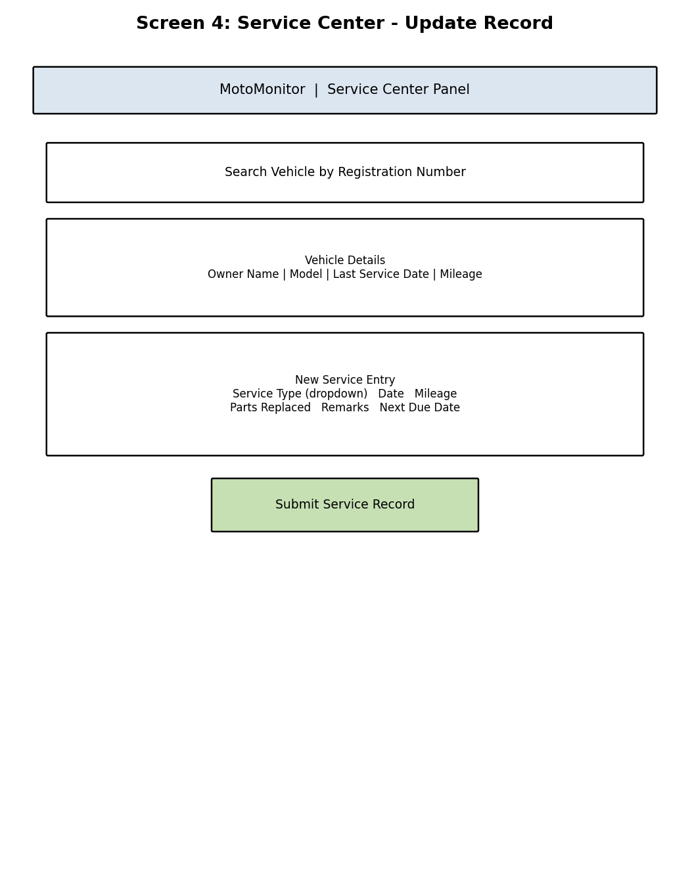

5.5 Manufacturer Panel
