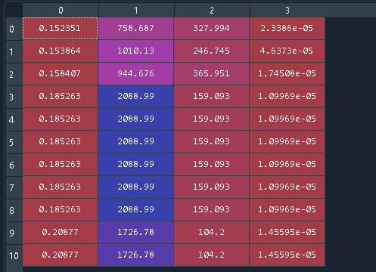

0.20898 2788.85 17.509 1.11758e-05

0.218655 2224.32 10.8322 1.56779e-05

0.218655 2224.32 10.8322 1.56779e-05

0.218655 2224.32 10.8322 1.56779e-05

0.218655 2224.32 10.8322 1.56779e-05

0.218655 2224.32 10.8322 1.56779e-05

0.218655 2224.32 10.8322 1.56779e-05

0.218655 2224.32 10.8322 1.56779e-05

0.218655 2224.32 10.8322 1.56779e-05

0.218655 2224.32 10.8322 1.56779e-05

0.218655 2224.32 10.8322 1.56779e-05

0.226062 1637.67 13.2407 1.54956e-05

0.226062 1637.67 13.2407 1.54956e-05

0.243096 1415.06 63.408 9.13688e-06

0.243096 1415.06 63.408 9.13688e-06

0.243096 1415.06 63.408 9.13688e-06

0.243096 1415.06 63.408 9.13688e-06

0.243096 1415.06 63.408 9.13688e-06

0.243096 1415.06 63.408 9.13688e-06

0.243096 1415.06 63.408 9.13688e-06

0.243096 1415.06 63.408 9.13688e-06

0.250787 2208.61 21.8382 1.21545e-05

0.250787 2208.61 21.8382 1.21545e-05