The Collaborative Framework Canvas™ |  | Game: | Designer: |  | Tags / Keywords / Search Terms:
YOUR Problem – Motivation – Goals - Purpose  What is motivating you to create this game?  What are your business goals?  What do you want to accomplish when this game is done? |  | Your PLAYER’s Problem – Motivation – Goals - Purpose  What is motivating your players?  What makes it meaningful? Engaging?  What do they get from playing your game? |  | Game Board / Space of Play  Does your game board rely primarily on space?  Is your game based on a metaphor?  What portions are used to keep or maintain status?  Do you need a special “space” for play?  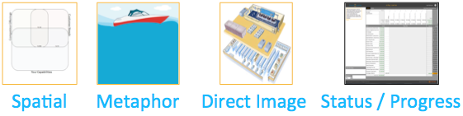
Resources  What resources does your game provide?  Is the game content a resource? | Rules  How do players interact with the game?  With each other?  What are the rules associated with resource allocation? Acquisition? | Desired Thought Process  What thought processes do you want to induce?  Divergent: Generating ideas, exploring solutions.    Sensemaking: Organizing, Creating Meaning  Convergent: Ranking, Prioritizing, Selecting |  | Physical Design  As you consider your implementation options, consider the needs of the Facilitators, the Players, and, if in-person and appropriate, the needs of the Observers.  Consider larger context: For example, physical game boards and games might need wall space and specific materials. |  | Digital Design  Digital game boards will need appropriate devices, internet connectivity, and so forth.  In general, it is easier for players to make changes to game artifacts within a physical game and it is easier to scale the interactions and create greater consistency with results in a digital game.

Internal or External Focus
Are your players internal or external?
Internal: Sales, Marketing, Internal Stakeholders
External: Customers, Market, Partners, Suppliers
Time Frame of Action

Is this game intended to create or
enable near-term actions & results or long-term results?

Actions  What actions can players take?  How to players make “moves”?  How do the players manipulate or manage resources?  What actions can players do to the other players? | Feedback  How do you provide feedback to your players? Consider timers, status, location and placement of items. | Game Content  What content does your game require?  
 |  | Player Preparation  How do your players prepare?    What demands are you making on them?  How much effort does it take to prepare for game? |  | Play Strategies – Win Strategies  What does it mean to play your game “well” or “with skill”?  What does it mean to “win” your game?  What are some of the key strategies players can use to “win”?
Duration
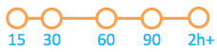
How much time does it take to play your game? Is “fast”? Is it slower?
Time can create urgency and engagement or frustration.

 

Points / Levels  Does your game have a scoring system?  Does it keep track of player levels? |  | Facilitation Skill  How much facilitation skill is required?    Can your players self-facilitate the game? |  | Post-Processing – How to Get Insights  Now that you’ve got you’re results, how do you get insights?  Consider the direct results of playing the game (e.g., items purchased in Buy a Feature).  Consider the indirect results of playing the game (e.g., the negotiations around purchases).

The Collaborative Framework Canvas™ |  | Game: | Designer: |  | Tags / Keywords / Search Terms:
YOUR Problem – Motivation – Goals – Purpose  - Proof that flat info structures complex problem solving  - Encourage behavioral change: openness |  | Your PLAYER’s Problem – Motivation – Goals – Purpose  - Inefficient communicating topology (unawareness)  - Inefficient communication structure (unawareness) |  | Game Board  - Spatial  - Metaphor  - Direct Image  - Status  Communication culture follows structure
Resources  - opaque cups, big enough bottom  - Tie for the Manager  - Post-it’s  - NO Sharpies  - Black or dark grey pencils  - 4 sorts of marbles:  - Easy color mixed marbles  - Easy color equal marbles  - Noisy color mixed marbles  - Noisy color equal marbles  - Booklet for writing down with co-learning logo (big enough so that it invites to write down a lot)  - # Marbles/color  - Other: N-1  - Common: N  - #colors:  (N.x)+1 (that’s the common, N.x is the others  #Pr = #Pv.(Color other + 1 Common)  - Reception bell | Rules  - Raise hands: Got paper + team hero picks  - First wheel then circle (feel the effect)  - As fast as possible  - Pencils/post-its for bad readability  - Same group: do both topologies & feel the difference  N groups (NSO 1)  - Start easy  - Wheel  - Circle  - Noisy  - Wheel  - Circle  - Competition wheel vs circle (only when more then 1 team)  - Easy  - Noisy  - Big group  Experiments:  - Only 2 same marbles: difficulty gets higher  - Max number of marbles  - Max amount of time  - Max persons  - Competition | Desired Thought Process  - 1st: Sense making  - 2nd: impact on change process   |  | Physical Design  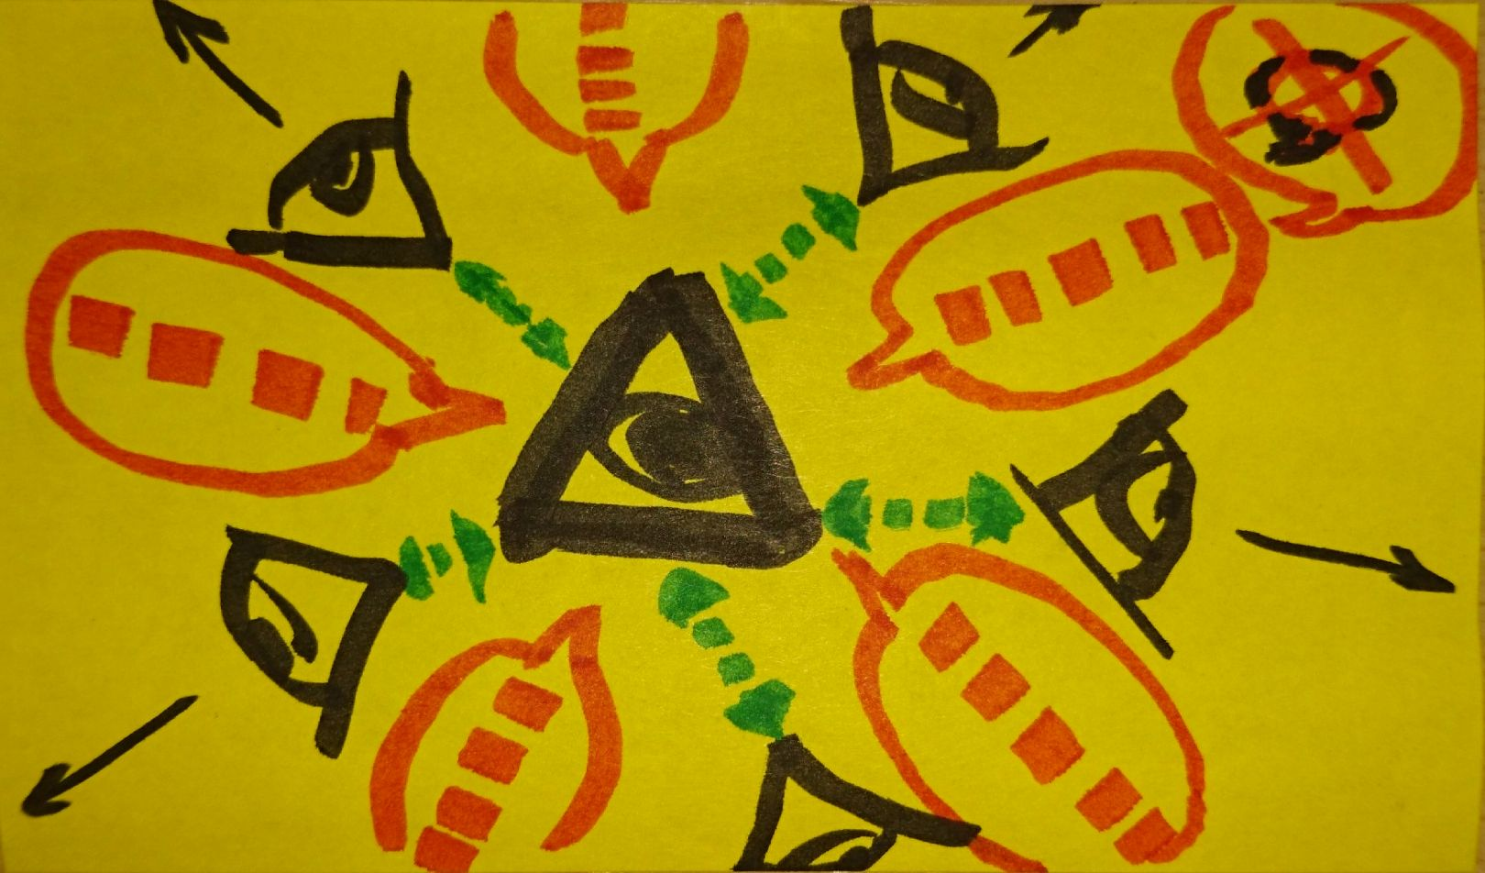  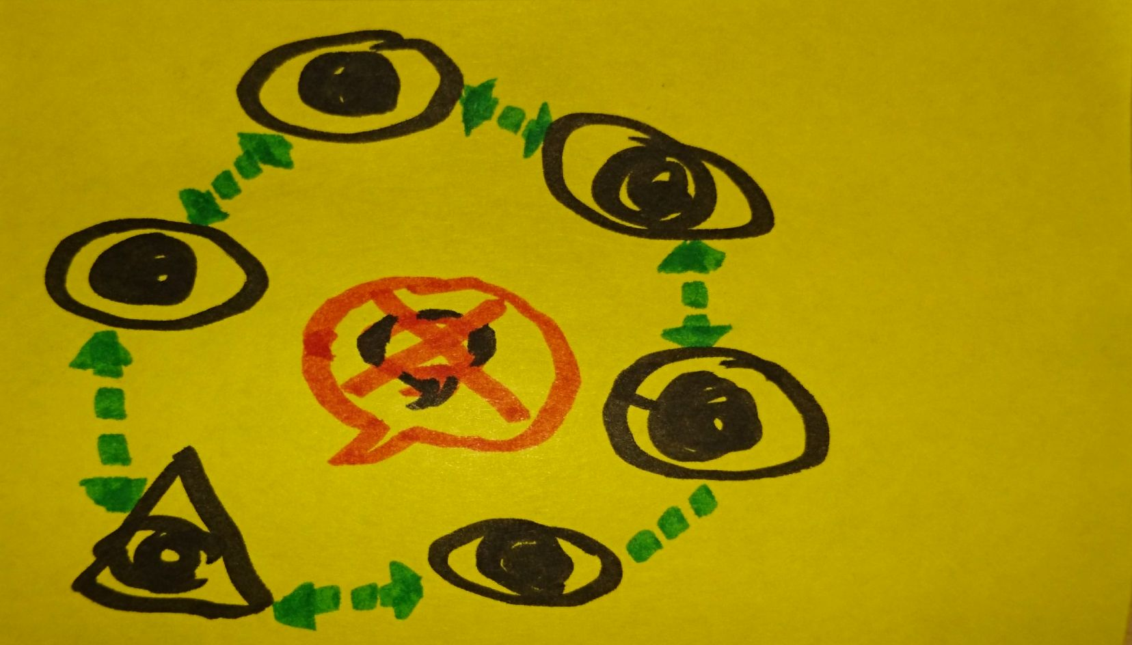 |  | Digital Design  Not yet  Ideas:  - Competition between companies  - Hierarchical  - Flat Structure  - What could be the natural boundaries that force the info flow (to wheel/circle)  - What could be the problem to resolve  - What would be the boundaries
Internal or External Focus

Internal: employees and management

Time Frame of Action

Near term; change in communication play

Actions  - Players use cards to communicate (written)  - They have to find the common marble  - See ‘rules’ section | Feedback  - Feedback through flipchart: measurement  - Happiness index  - Time 2 Win “Speed”  - Paper Consumption (communication density)  - Spider web 4 quadrants each quadrant Consumption, speed, happiness  - Minimal 6 pers (5+1)/team | Game Content  
 |  | Player Preparation  None   |  | Play Strategies – Win Strategies  In both topologies: Find the fastest strategy  Point of attention: Reserve time!!!!
Duration

To experiment
First run was at “Hogeschool Gent” Results?

 

Points / Levels  Group happiness index/AVG happiness  Paper consumption (Amount of communication  Speed of resolving  #errors made: How? What is an error?  Efficiency in approach (group vote) |  | Facilitation Skill  Easy/Self facilitation   |  | Post-Processing – How to Get Insights  - Evaluate the communication structure (how?)  - Evaluate after wheel/circle exercise to compare  - Reserve time for post processing !!!!!  - Silent post-up: what feels best for easy/noisy + why?

The Collaborative Framework Canvas™ |  | Game:  Missing Pieces | Designer:  Luke Hohmann |  | Tags / Keywords / Search Terms:  Divergent, Find what’s missing in a product or service, roadmapping
YOUR Problem – Motivation – Goals - Purpose  As a product designer, I want to identify unmet needs – those things that my customers want to do but can’t because a part of the product is missing.  This isn’t a Prune the Product Tree, because that’s about growth and evolution. This isn’t a Speed Boat, because that’s about what’s wrong. It is about what’s “missing”. |  | Your PLAYER’s Problem – Motivation – Goals - Purpose  This game is intended for my customers who want to get stuff done with my product and can’t. They benefit when they tell me what is missing and we get the team to build it. |  | Game Board  This is a Metaphorical game board. The theme I’ve chosen is the frustration that you feel when you are building a puzzle and you get to the end and you find one or two pieces that are missing.  Imagine you’re on vacation with your family at a lake and it is a rainy day. There is no TV and you want to do something together. You find a 500 piece puzzle and start to build it with your children. Alas! At the end you have a missing piece!
Resources  Players need puzzle pieces – both blank ones and pre-completed pieces. The pre-completed pieces represent portions of the product that exist.  Players have a field of play that represents the puzzle. It can be extended – meaning – the players can change the shape or boundaries of the puzzle in the game. | Rules  Players can add puzzle pieces.  Players can move them.  Players can remove pieces placed by other players if they believe the piece is not really missing. | Desired Thought Process    The game promotes divergent thought. Just make sure when players are adding pieces they can justify them – e.g., we want pieces that are needed. |  | Physical Design  For Physical play we need to get physical puzzle pieces. Pretty easy to find on amazon. |  | Digital Design  For Digital play we need items shaped like puzzle pieces and perhaps a picture of a game board that can hold these pieces.
Internal or External Focus


Intended for customers, but can certain be played with internal employees..
Time Frame of Action

Near term – this game should influence the near term roadmap and possibly the backlog if there are items on the backlog that are deemed missing.
Actions  Adding, moving, deleting pieces. | Feedback  The game board captures and provides feedback. | Game Content    Moderate to substantial – the puzzle has to have some starting conditions, which are the features and functions of the existing product.
 |  | Player Preparation    While not strictly required, the game will produce better results if you ask players to prepare before the game. |  | Play Strategies – Win Strategies
Duration

About 1.5 to 2 hours.

Points / Levels  This game does not have any scoring points or levels. |  | Facilitation Skill    Easy to moderate. Key points include asking customers what problem they would solve or what new jobs the customer could accomplish with the addition of these missing pieces. |  | Post-Processing – How To Get Insights

DO NOT PRINT THE FOLLOWING PAGES – THEY ARE USED FOR THE PURPOSE OF THE COURSE NOTES VIA THINGS LIKE SCREEN SNAPSHOTS

The Collaborative Game Canvas™ |  | Game: | Designer: |  | Tags / Keywords / Search Terms:
YOUR Problem – Motivation – Goals - Purpose |  | Your PLAYER’s Problem – Motivation – Goals - Purpose |  | Game Board
Resources | Rules | Desired Thought Process |  | Physical Design |  | Digital Design
 |  | Internal or External Focus
 |  | Time Frame of Action
Actions | Feedback | Game Content
 |  | Player Preparation |  | Play Strategies – Win Strategies
 |  | Duration
Points / Levels |  | Facilitation Skill |  | Post-Processing – How To Get Insights

