**Support material / *Material de apoyo***

**Learning activity 4 / *Actividad de aprendizaje 4***

**Presentation / *Presentación***

**A. Present continuous / *Presente continuo*:**

To describe something that is happening now or at the present period of time we use present continuous: / *Para describir algo que está pasando ahora o en el periodo actual de tiempo usamos presente continuo:*

|  |
| --- |
| I’**m** read**ing** a new book.  She’**s** not study**ing** French.  A: **Are** they do**ing** their homework?  B: No, they aren’t. |

**B*.* Weather and climate - Parts of the body, clothes and accessories:/ *Estado de tiempo y clima - Partes del cuerpo, atuendos y accesorios:***

Remember that we can use the vocabulary in the glossary to describe what someone is wearing at the moment according to the weather and climate: / *Recuerde que podemos utilizar el vocabulario del glosario para describir lo que alguien está usando en ese momento de acuerdo con el estado de tiempo y clima:*

|  |  |
| --- | --- |
| **Fuente:** SENA | She’**s** wear**ing** a scarf because it is **cold**. |

# Practice / *Práctica*

1. Tick (√) if the sentence is correct or cross (X) if it is wrong. Correct the wrong ones: / *Seleccione (√) si la oración está bien o (X) si está mal. Corrija las oraciones incorrectas.*

|  |  |
| --- | --- |
| 1. It raining and I don’t have my umbrella.   *It* ***is*** *raining and I don’t have my umbrella.* | X |
| 1. They aren’t wear their new uniforms.   _________________________________. |  |
| 1. Sarah is taking her English exam?   _________________________________. |  |
| 4. Michael and John isn’t playing soccer.  _________________________________. |  |
| 5. My mom is cooking dinner.  _________________________________. |  |
| 6. Why is you wearing sunglasses? It is cloudy.  _________________________________. |  |
| 7. We are watching an old movie.  _________________________________. |  |

1. Choose the correct tenses for the questions. The first question is done for you. / *Escoja el tiempo gramatical correcto para las preguntas. El primer ejercicio ya está hecho.*
2. Do you always wear / Are you always wearing sunglasses when it is hot?
3. What kind of clothes do you usually / are you usually wearing in winter?
4. Do you sometimes wear / Are you sometimes wearing casual clothes at work?
5. Do you often wear / Are you often wearing boots?
6. Do you occasionally wear / Are you occasionally wearing dresses?
7. Do you frequently wear / Are you frequently wearing long-sleeved shirts?
8. Do you always wear / Are you always wearing hats?
9. First, label the body parts. Then, answer the questions: / *Primero, etiquete las partes del cuerpo. Luego, responda las preguntas:*

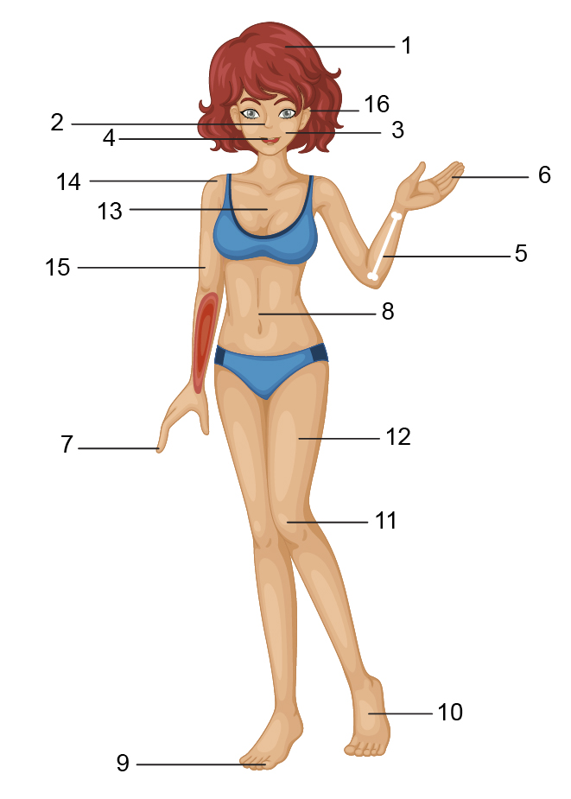

**Fuente:** SENA

|  |  |
| --- | --- |
| 1. ____Hair____ 2. ___________ 3. ___________ 4. ___________ 5. ___________ 6. ___________ 7. ___________ 8. ___________ | 1. ____*_______* 2. ___________ 3. ___________ 4. ___________ 5. ___________ 6. ___________ 7. ___________ 8. ___________ |

1. What is he doing? ________________________________________.
2. Is he smiling? ________________________________________.
3. What is he wearing? ________________________________________.

**Production / *Producción***

1. Describe the people in the pictures using the vocabulary about clothes and accessories: / *Describa las personas de las imágenes usando el vocabulario de atuendos y accesorios:*

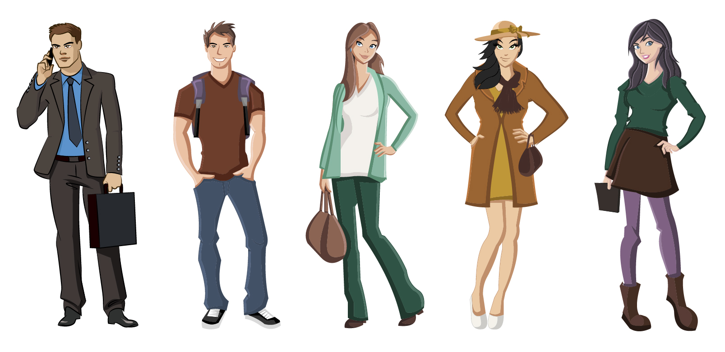

**Fuente:** SENA

|  |
| --- |
| **Example: 0.**  He is Joseph. He is 30 years old. He is a manager. He is going to a business meeting. He is wearing a suit and a tie. He is carrying a briefcase. |

|  |  |  |
| --- | --- | --- |
| 1. Thomas |  | 1. Allegra |
|  |  |  |
| 1. Andrea |  | 1. Mary |

1. Look at the following picture. Write a sentence for each person describing what she or he is doing: / *Mire la siguiente imagen. Escriba una oración para cada persona describiendo lo que él o ella está haciendo:*

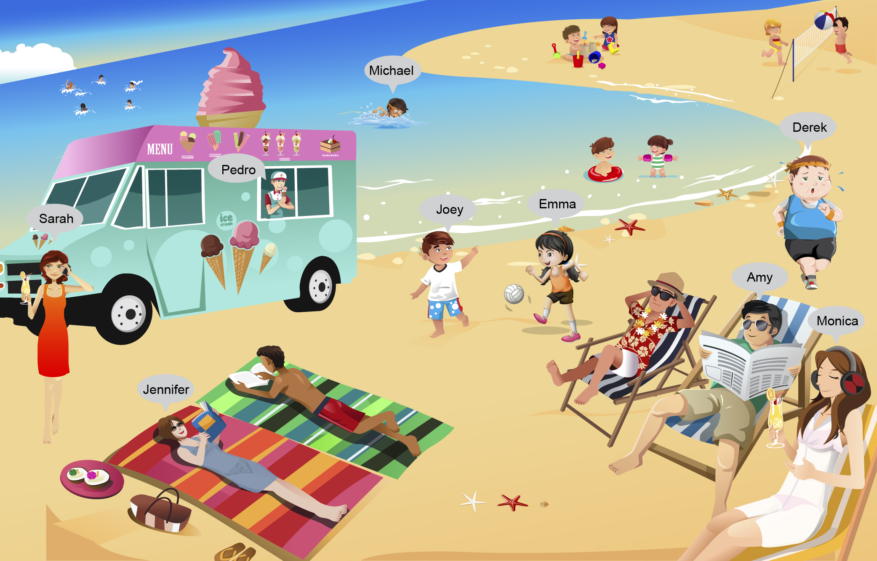

**Fuente:** SENA

**Example**

1. **Pedro is selling ice-cream at the beach.**
2. Sarah ________________________________________.
3. Michael _______________________________________.
4. Joey _________________________________________.
5. Amy _________________________________________.
6. Monica _______________________________________.
7. Derek ________________________________________.
8. Jennifer ______________________________________.
9. Emma _______________________________________.

|  |
| --- |
| **Note:** To check the answers go to Suggest answer sheet. / ***Nota:*** *para consultar las respuestas diríjase al enlace* Suggest answer sheet. |

**Document control / *Control del documento***

|  |  |  |  |  |
| --- | --- | --- | --- | --- |
|  | **Name** | **Position** | **Dependence** | **Date** |
| **Author** | Ricardo Aristizabal Salinas | Asesor pedagógico  English Dot Works | Dirección de formación profesional  Dirección General | August  2014 |
| **Adaptation** | Paola Andrea Bobadilla Gutiérrez | Copy editor – Línea de producción | Centro Agroindustrial  Regional Quindío | August  2014 |