**Support material / *Material de apoyo***

**Learning activity 3 / *Actividad de aprendizaje 3***

You will practice the vocabulary and expressions to give and ask for directions to get to a place. / *Usted practicará el vocabulario y expresiones comunes para dar o solicitar indicaciones para llegar a un lugar.*

**Presentation / *Presentación***

This is a summary of the vocabulary and expressions you can use to give or ask for directions to get to a place. / *Este es un resumen sobre el vocabulario y las expresiones que usted puede usar para dar o solicitar indicaciones para llegar a un lugar.*

|  |  |  |
| --- | --- | --- |
| **To ask for directions / *Para solicitar indicaciones*** | | |
| **Excuse me, / *Disculpe,*** | Where is the supermarket?  *¿Dónde queda el supermercado?* | **Fuente:** SENA |
| Is there a post office near here?  *¿Hay un supermercado cerca de acá?* |
| How do I get to the bank?  *¿*C*ómo llego al banco?* |

**To give directions / *Para dar indicaciones***

|  |  |
| --- | --- |
| It is on the corner of ____ and ____. | *Está en la esquina de _____ y _____.* |
| It is across the street. | *Está cruzando la calle.* |
| It is down the street. | *Queda bajando la calle.* |
| It is between _____ and _____. | *Queda entre _____ y _____.* |
| It is next to_____. | *Queda al lado de_____.* |
| It is near _____. | *Queda cerca de_____.* |
| It is behind _____. | *Queda detrás de _____.* |
| It is in front of _____. | *Queda en frente de _____.* |
| Turn right. | *Voltee a la derecha.* |
| Turn left. | *Voltee a la izquierda.* |
| Take the second right. | *Voltee a la derecha por la segunda calle.* |
| Take the second left. | *Voltee a la izquierda por la segunda calle.* |
| Go straight. | *Siga derecho* |

# Practice / *Práctica*

1. Look at the map and decide if the following sentences are true or false. Choose T for true and F for false. / *Observe el mapa y decida si las siguientes oraciones son verdaderas o falsas. Marque* ***T*** *para verdadero y* ***F*** *para falso.*

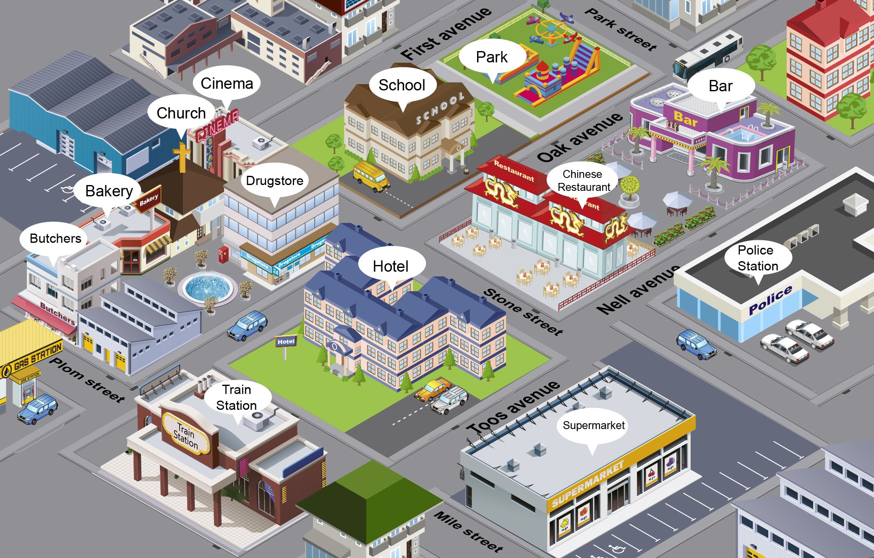

**Fuente:** SENA

|  |  |  |  |
| --- | --- | --- | --- |
| **Sentences** | | **T** | **F** |
| 1 | The cinema is behind the drugstore. | **✓** |  |
| 2 | The Chinese restaurant is on Toos avenue. |  |  |
| 3 | The park is next to the cinema. |  |  |
| 4 | The Church is between the cinema and the drugstore. |  |  |
| 5 | The Chinese restaurant is opposite the police station. |  |  |
| 6 | The school is on the corner of First Avenue and Park Street. |  |  |
| 7 | The Supermarket is in front of the hotel. |  |  |

1. Look at the map again and give directions to each point. Use the vocabulary and expressions studied in the “presentation” section. One example is done for you. / *Observe el mapa nuevamente y describa el recorrido en cada punto. Use el vocabulario y las expresiones estudiadas en la sesión de “Presentación”. Un ejemplo ya está hecho.*

|  |  |
| --- | --- |
| Journey | Description |
| 1. From the park to the police station. | Take Oak Avenue and turn left on Stone Street. Go straight for one block and then turn left again on Nell Avenue. The police station is down the street in front of the bar. |
| 2. From the church to the supermarket. |  |
| 3. From the train station to the cinema. |  |
| 4. From the park to the train station. |  |

**Production / *Producción***

1. Draw a map of your neighborhood and describe the journey from your house to three points of interest. Use the vocabulary and expressions studied in the “Presentation” section. / *Dibuje su barrio y describa el recorrido de su casa hasta 3 puntos de interés. Use el vocabulario y las expresiones estudiadas en la sesión de “Presentación”.*

|  |
| --- |
| **Neighborhood plan** |
|  |

**Description:**

|  |  |
| --- | --- |
| **Journey** | **Description** |
| 1. |  |
| 2. |  |
| 3. |  |

|  |
| --- |
| **Note:** To check the answers go to Suggest answer sheet. / ***Nota:*** *para consultar las respuestas diríjase al enlace* Suggest answer sheet. |

**Document control / *Control del documento***

|  |  |  |  |  |
| --- | --- | --- | --- | --- |
|  | **Name** | **Position** | **Dependence** | **Date** |
| **Author** | Juan Solano Franco | Asesor pedagógico  English Dot Works | Dirección de Formación Profesional  Dirección General | August  2014 |
| **Adaptation** | Paola Andrea Bobadilla Gutiérrez | Copy editor – Línea de producción | Centro Agroindustrial  Regional Quindío | August  2014 |