Learning activity 1 / Actividad de aprendizaje 1

Evidence: Identities / Evidencia: Identidades

Complete the texts with the corresponding information. / Complete el texto con la información correspondiente.

Hello, my name is Josh. I am from Peru. My nationality is Peruvian. I am 20 years old. I have a notebook, a pencil and a notepad.




This is my friend Sasha. She is from Colombia, her nationality is Colombian. She is 25 years old. There are many buildings in her city!

Hello, nice to meet you!

They are my friends Nicole and John. Nicole is from The United States, her nationality is American and John is from Australia. His nationality is Australian. We are in Rome now.



Fuente de imágenes: SENA

Teacher: Hello, what is your name?
Student 1: My name is Kevin.
Teacher: How old are you Kevin?
Student 1: I am 9 years old.
Teacher: Lorena, where are you from?
Student 2: I am from Brazil, so my nationality is Brazilian.
Teacher: Where is your mother from?
Student 2: My mom is from Peru. Her nationality is Peruvian.


Student 1
Student 2

- In the classroom there is a board 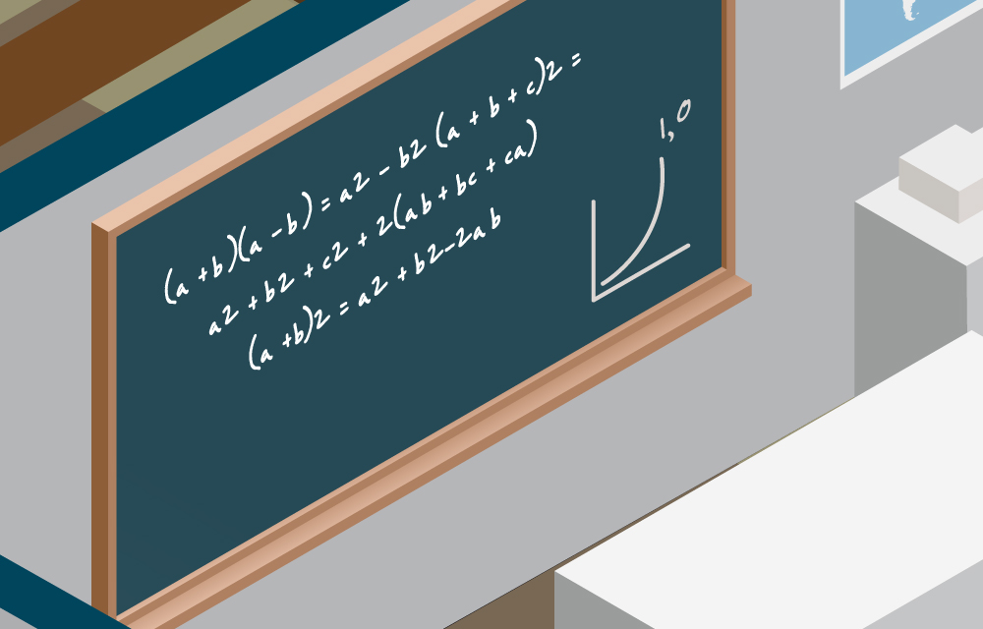, there

are four students, there is a desk 

and there is a big window 
Fuente de imágenes: SENA

When you finish your work, send the file to your instructor through the platform as follows:

- Click the title of this evidence.
- Click Examinar mi equipo and look for the file in your computer. Make sure the file is attached.
- Leave a comment for the instructor (optional).
- Click Enviar.

Una vez finalice la evidencia envíe al instructor el archivo a través de la plataforma, así:

- Dé clic en el título de esta evidencia.
- Dé clic en el enlace Examinar mi equipo y busque el archivo en su
computador. Asegúrese de adjuntar el archivo.
- Escriba algún comentario si lo considera pertinente.
- Dé clic en Enviar.

Note: This evidence is an individual activity. Remember to check the learning guide in order to know if you have done all the assigned activities, know how to develop them and deliver them correctly.

Nota: Esta evidencia es de carácter individual. Recuerde revisar la guía de aprendizaje con el fin de verificar que ha realizado todas las actividades propuestas, saber cómo desarrollarlas y entregarlas correctamente.

Criterios de evaluación
- Intercambia información personal con la estructura y el vocabulario requerido.

- Intercambia información respecto a los países y las nacionalidades en un contexto definido y con la estructura gramatical requerida.

- Describe la existencia de personas, animales o cosas en forma singular y plural con la estructura y vocabulario requeridos.

