# Student Details

Name: Johanz Te

Deakin Student ID: 223528029

Tutor: Mr Xiangwen Yang

Class: SIT320 – Advanced Algorithms

Intended Grade: Credit

**Instructions: Please fill in the module name, along with submission and discussion deadlines from Ontrack website.**

I will adhere to following timetable for submitting tasks, and will come to class for task discussion with my tutor.

# SIT320 - Time Table

|  |  |  |  |  |  |
| --- | --- | --- | --- | --- | --- |
|  | **Module** |  | **Tasks** | **Submission Deadline** | **Discussion Deadline** |
| 0 | **Introduction** | Must | Module 1 Task | 14 July | 21 July |
| 1 | Trees | P |  | 21 July | 28 July |
| 2 | Distributed Algorithms | P |  | 28 July | 4 Aug |
| 3 | Algorithm Analysis | C |  | 4 Aug | 11 Aug |
| 4 | Graphs | P |  | 11 Aug | 25 Aug |
| 5 | Dynamic Programming | P |  | 18 Aug | 25 Aug |
| 6 | Greedy Algorithms | P |  | 25 Aug | 1 Sep |
| 7 | Linear Programming | P |  | 1 Sep | 8 Sep |
| 9 | Flow-based Algorithms | C |  | 8 Sep | 15 Sep |
|  |  |  |  |  |  |
|  |  |  |  |  |  |
|  | Portfolio due |  |  | 13 Oct |  |

Discussed with your Tutor (Circle one): No

Signatures: Johanz

SIT320 PLANNING FORM 1

Tic-Tac-Toe Psuedocode

Design a solution to win the game

In this Psuedocode we assume that there are three positions left and the computer has to make the best decision.

Like this for example (gotten from lecture slides)

#Minimax function pseudocode inspiration gotten from <https://github.com/Cledersonbc/tic-tac-toe-minimax>

Class main

Board = 3x3 board (made up of some function)

X = computer

O = user

Spaceleft=9

Function minimax (state, depth, player)

if (depth == 0 or gameover) then

score = evaluate(state, player)

return [null, score]

if (player == computer) then

#Initialize best move and score for computer

best = [null, -infinity]

for each valid move m for player in state s execute move m on s #iterate over each valid move

[move, score] = minimax(state, depth - 1, -player) #Looks at what the opponent might do next

undo move m on s #Undos the move

#Updates the best move depending on which score is higher

if score > best.score then

best = [move, score]

else

best = [null, +infinity]

for each valid move m for player in state do

execute move m on state

[move, score] = minimax(state, depth - 1, player)

undo move m on state

if (score < best.score) then

best = [move, score]

return best

Function main

For Spaceleft i>0 and not gameover

{

Print board

[move, score] = minimax(board, depth, computer)

Execute move on the board

Decrease Spaceleft by 1

If there is a winner

Computer wins

Gameover

User moves

Decrease Spaceleft by 1

If there is a winner

Gameover

User wins

Else if spaceleft = 0

Draw

}

Draw

End

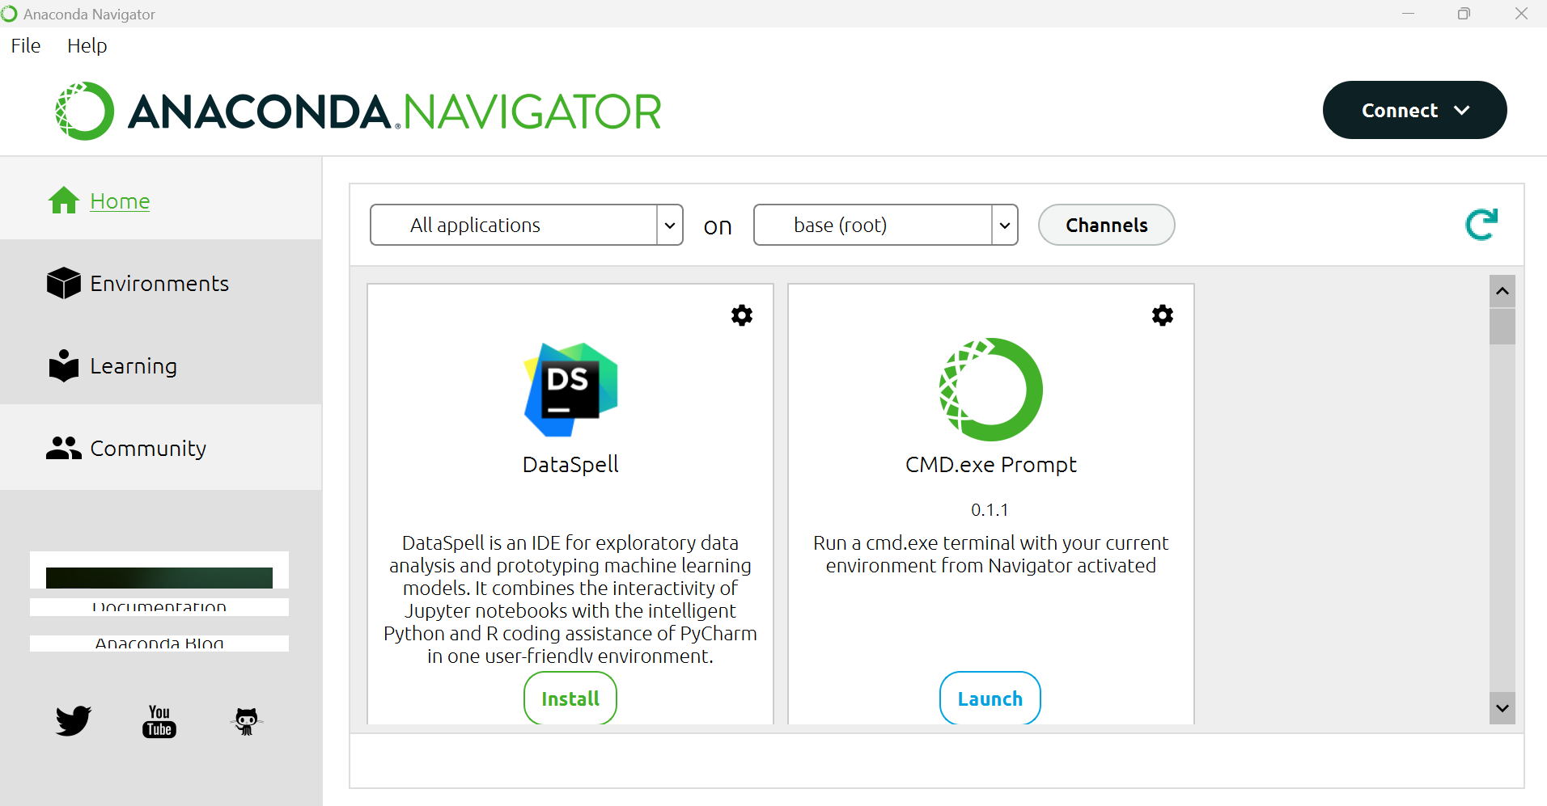

The Minimax Algorithm has the time complexity of O(b^d), where b is branching factor of possible moves and d is depth for future moves. Usually the branching factor starts of at 9 (as there are nine possible moves at the start of the game), however the branching factor will decrease to 1 as the game progresses. The depth is 9 as there are only 9 possible positions in the board. The algorithm has an exponential time complexity of b^d because for every b moves, there a b more possible moves. Tic-tac-toe is a class P problem as the game board only has a fixed size of 9, meaning there is a finite number of moves.