CSCI 458: Autonomous Mobile Robotics

Assignment Name: Line Follower

Assignment Number: 6

Group Members: John Buckley, Charles Clayton

**Project Description:**

In this assignment we used a color sensor to follow a black line on a white surface as quickly, smoothly, and accurately as possible.

**What Worked:**

We used what we learned from past assignments to help us with the physical design of the robot. This allowed us to quickly focus on the software that drives our robot. We set a base amount of power to send to each motor of the robot, adjusting those values by a static amount depending on what we read from our sensor.

**What Didn’t Work:**

Our first idea was to take all power from one wheel when we were detecting either black or white. We also tried the getColorAmbient method but this was not actually detecting the line but rather the ambient color in the surrounding environment. To combat this we changed to using getColorReflected to be detecting the line.

**What we learned from this assignment:**

We learned that our line foll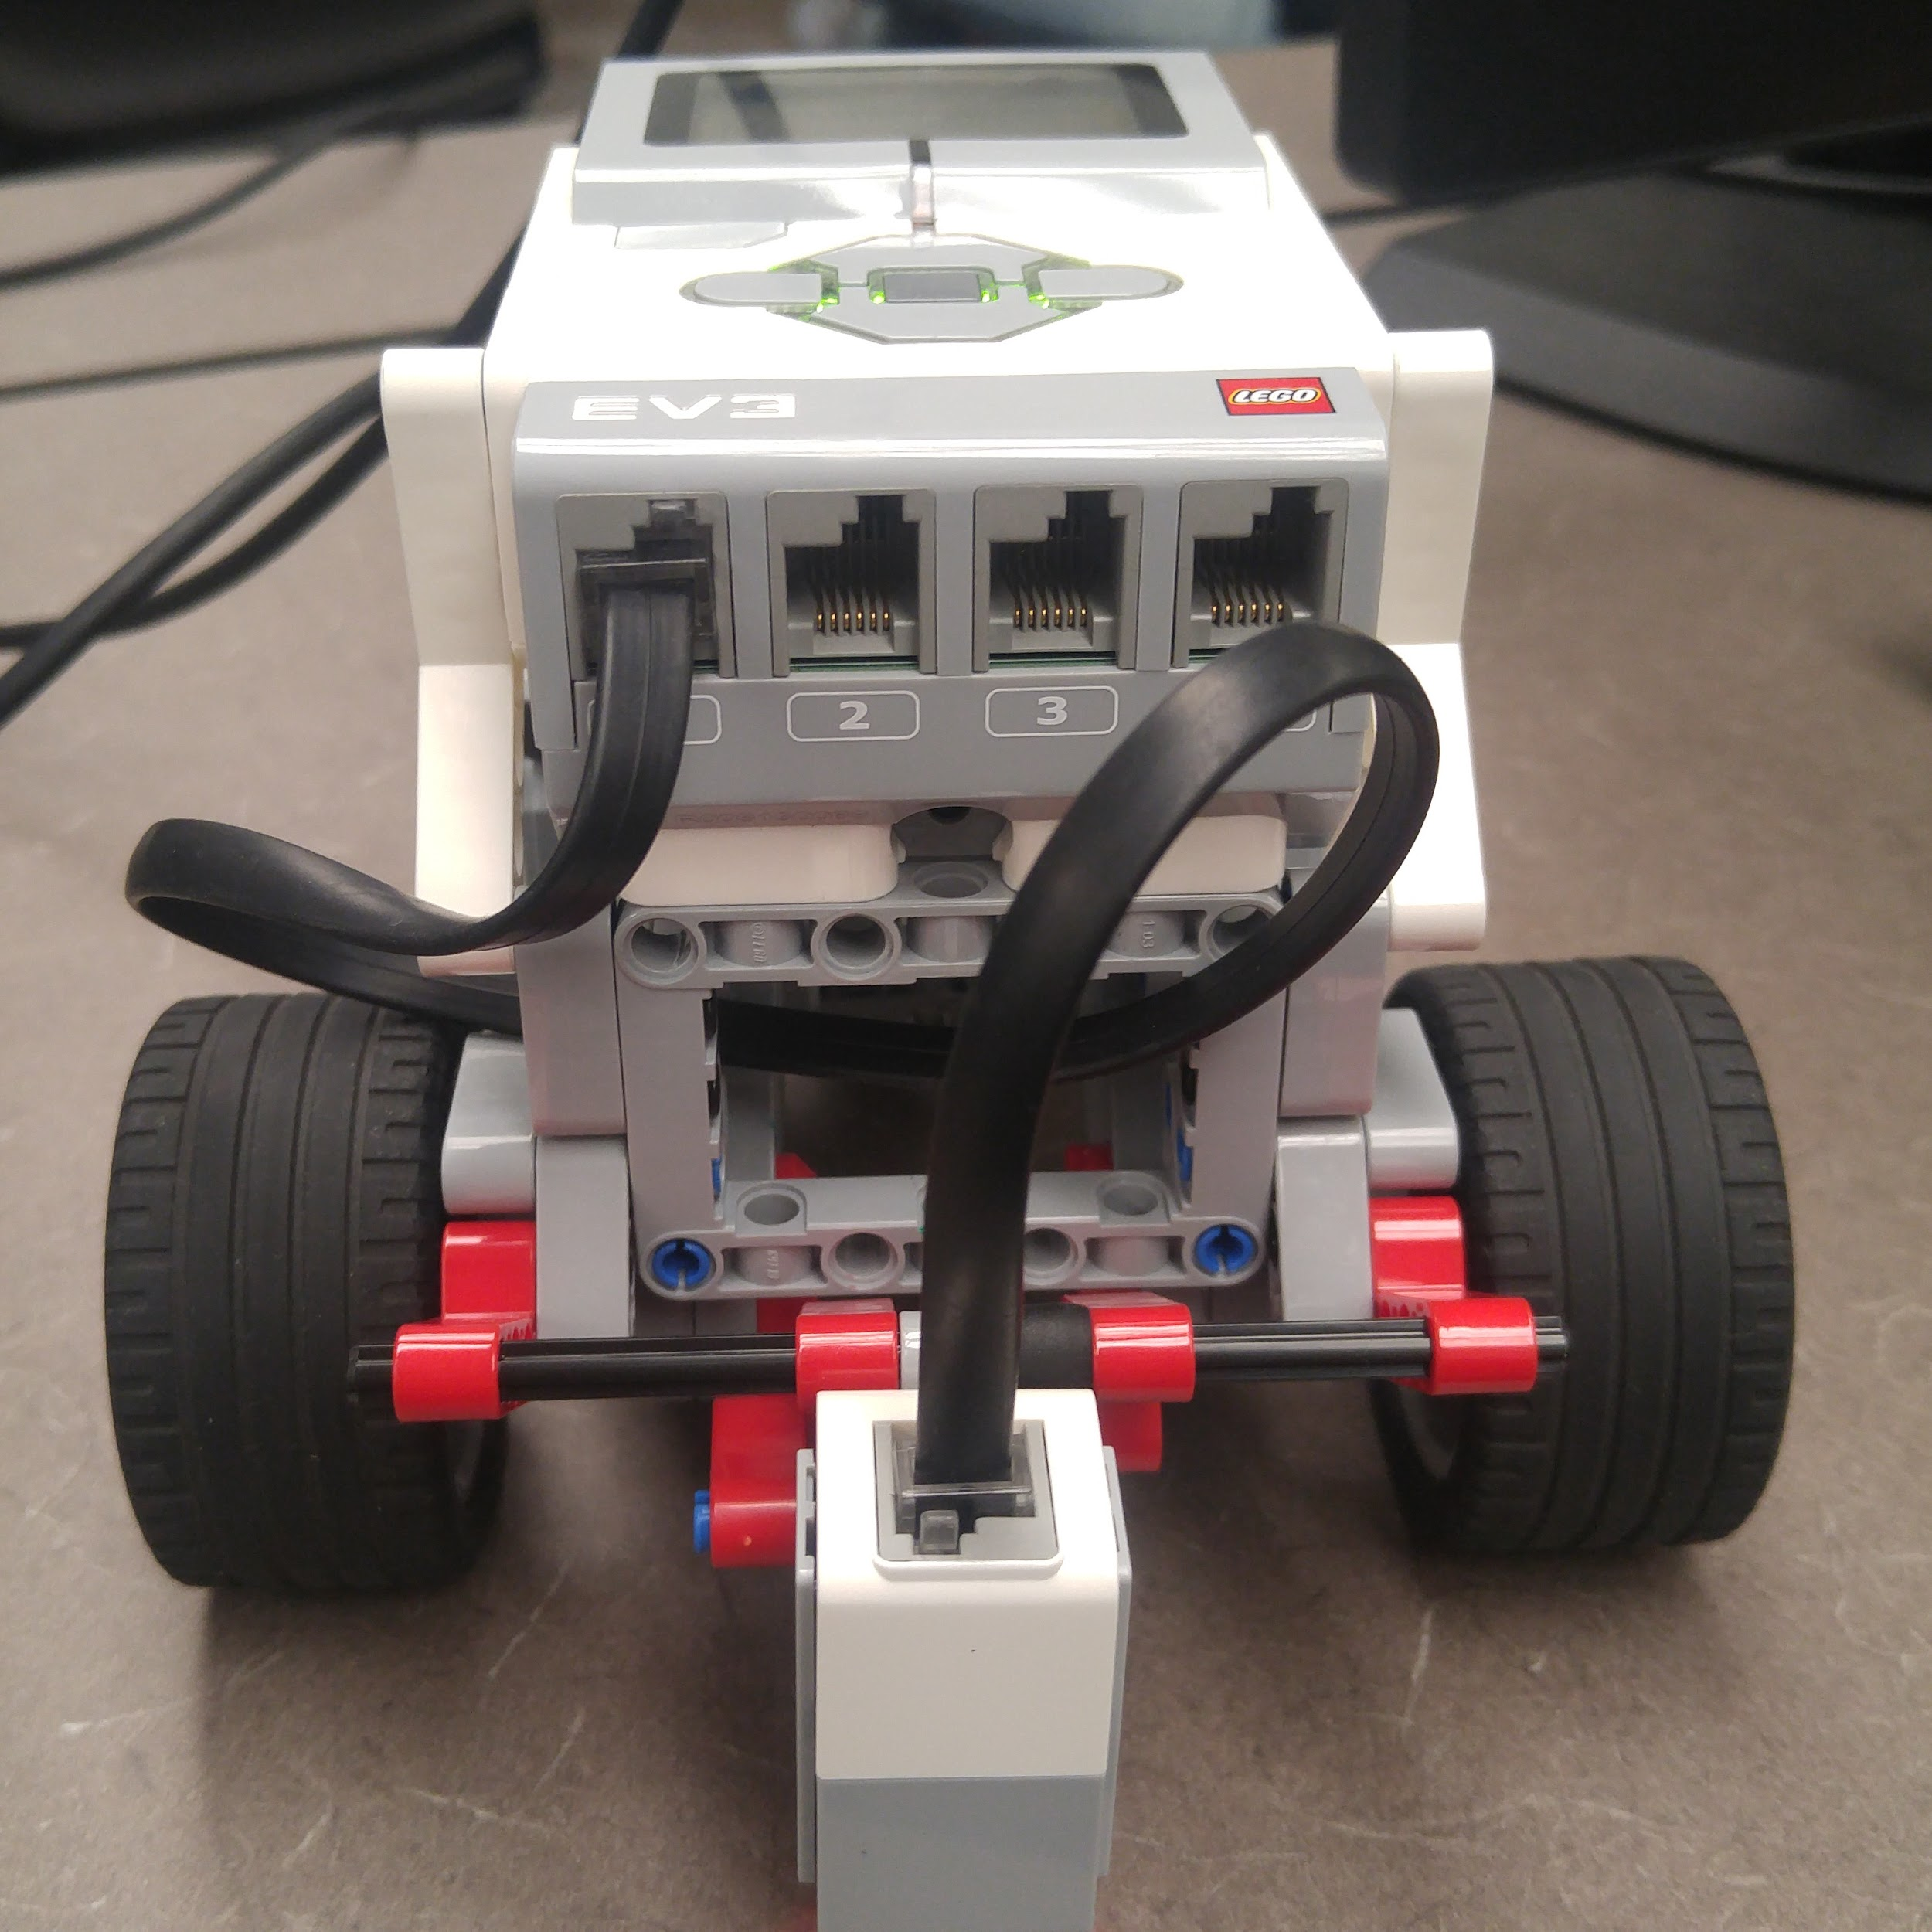owing robot does not actually follow a line. Instead it follows the space between the black line and the white space. We were able to leverage this in our conditions that checked the color our sensor was reading to allow the robot to follow the line more smoothly.

**Figure 1**: Our first and final design. We used previous experience with the light/color sensor to aid us in the placement of the sensor.

**Source:**

|  |
| --- |
| tMotor leftMotor = motorD; tMotor rightMotor = motorA;  task main(){  int power;  power = 30;   while (true){  if(getColorReflected(S1)<=8){  setMotorSpeed(leftMotor, power);  setMotorSpeed(rightMotor, -7);  }  if(getColorReflected(S1)>13 && getColorReflected(S1)<19){  setMotorSpeed(leftMotor,(power-12));  setMotorSpeed(rightMotor,6);  }  if(getColorReflected(S1)>18 && getColorReflected(S1)<24){  setMotorSpeed(leftMotor,(power-18));  setMotorSpeed(rightMotor,12);  }  if(getColorReflected(S1)>23 && getColorReflected(S1)<28){  setMotorSpeed(leftMotor,0);  setMotorSpeed(rightMotor,18);  }  if(getColorReflected(S1)>=28){  setMotorSpeed(leftMotor,-7);  setMotorSpeed(rightMotor,power);  }  } } |