



Transformation of Amateur Jupiter Images

For Collaboration With The Juno Mission

Jet Propulsion Laboratory 2013

Tom Craig – UC Santa Barbara

Mentor: Glenn Orton

Abstract
In 2016 and 2017, the Juno mission will provide new information about the distribution of water and ammonia gas in Jupiter’s atmosphere via the MicroWave Radiometer (MWR) experiment. To associate this information better with what can be gathered at higher altitudes, it will be beneficial to compare it with other experiments, such as Juno’s near-infrared JIRAM experiment. Because Juno’s CCD camera will not necessarily image the same locations covered by the MWR and JIRAM, the Juno project will be soliciting images from professional and talented amateur astronomers. This project designed the system through which these amateur images will be obtained and then converted to a format comparable to images from professional telescopes. These comparisons yielded data that will help associate Jupiter’s cloud types with colors and reflectivities in the 5-micron range.

I. Introduction
The goal of the Juno project is to learn more about Jupiter and its atmosphere. It is known that the atmosphere is 75% hydrogen and 24% helium by mass. The remaining 1% is of great interest to the scientific community. In the past, the Pioneer, Voyager, and Galileo missions have explored Jupiter, and traces of water vapor, ammonia, and other molecules have been found in its atmosphere. Figure 1 schematically shows Jupiter’s expected vertical atmospheric breakdown.

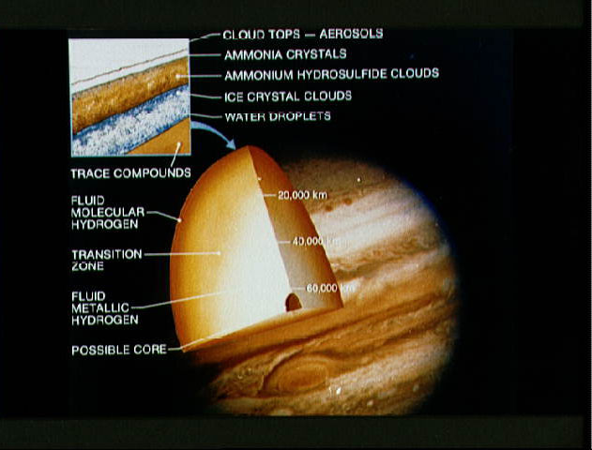
Fig. 1: Labeled drawing of Jupiter showing its core and composition.
Provided by NASA (http://science.ksc.nasa.gov/mirrors/images/images/pao/STS34/10063706.htm)
Image located: http://science.ksc.nasa.gov/mirrors/images/images/pao/STS34/10063706.jpg

By learning more about the composition of Jupiter’s atmosphere, more knowledge can be gained about its origin, and to a greater extent, the origin and evolution of solar systems in general.

Juno’s science payload includes two important instruments for probing Jupiter’s neutral atmosphere: the Jupiter InfraRed Auroral Mapper (JIRAM), and a Microwave Radiometer (MWR), used for probing the upper and lower regions of the atmosphere respectively. The JIRAM is an image spectrometer that will probe down to pressures between 5 and 7 bars and infrared wavelengths in the 25µm range. The MWR on Juno was built at the Jet Propulsion Laboratory, and will probe the atmosphere at radio wavelengths between 1.3 and 50 cm to measure thermal emission.

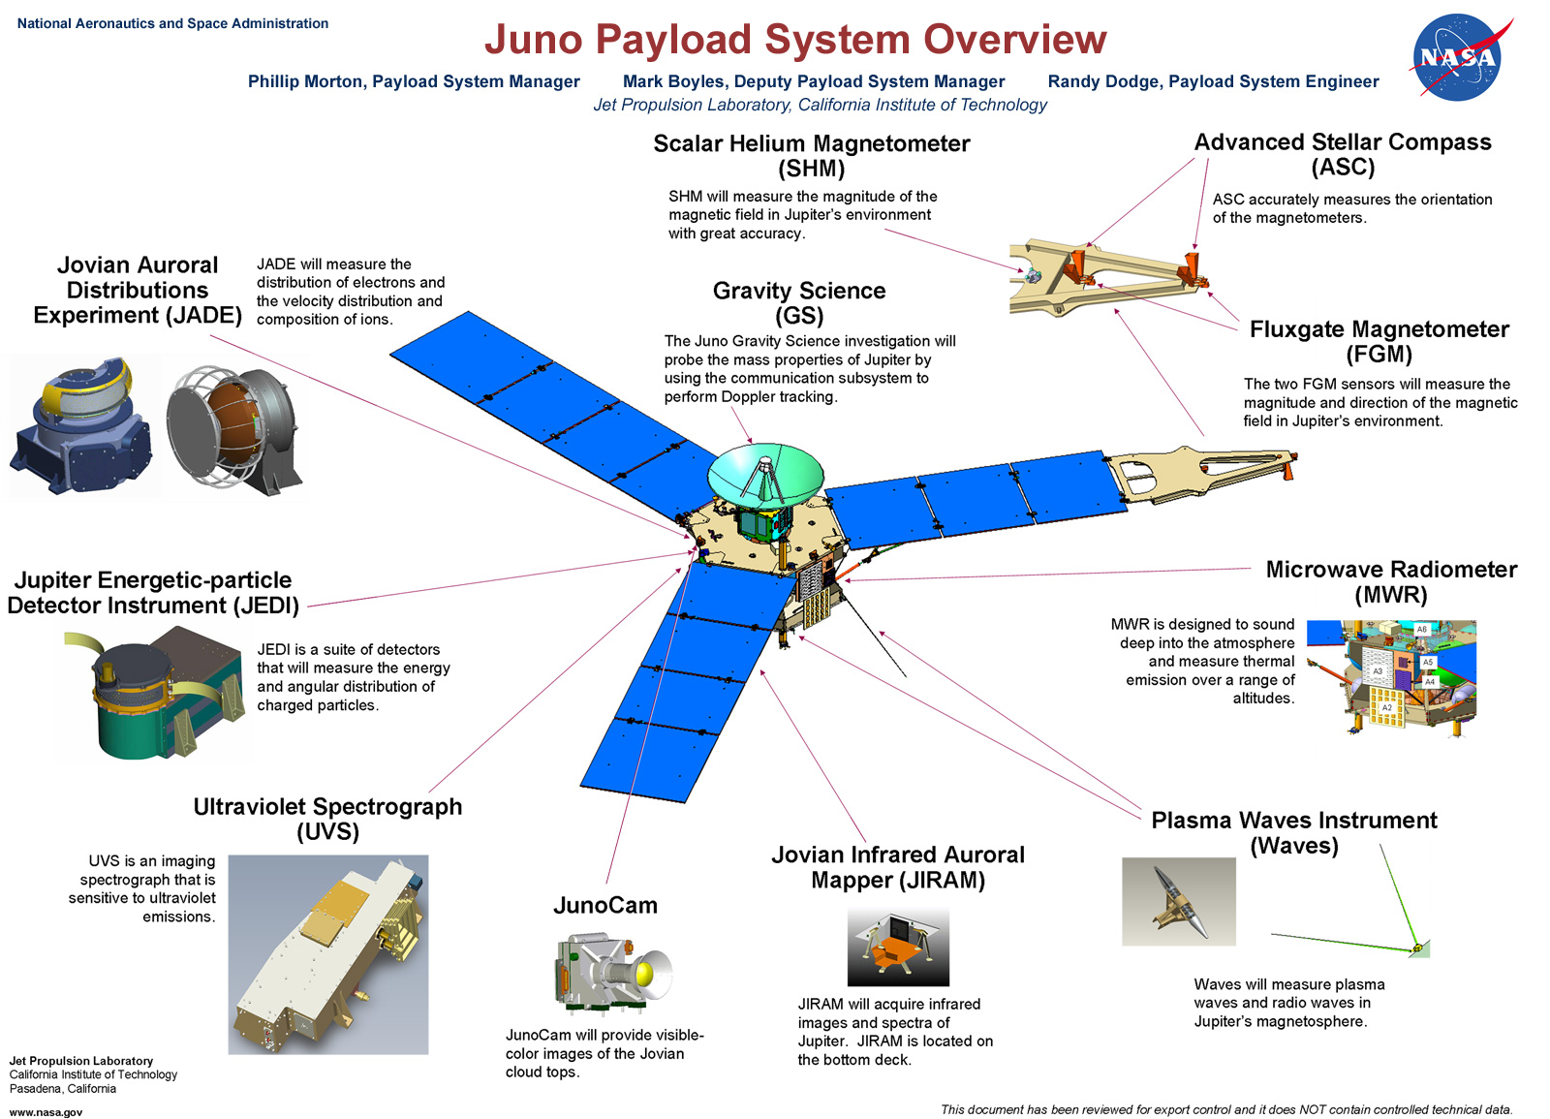

Fig. 2: Overview of instruments onboard Juno
Provided by Juno (juno.wisc.edu)

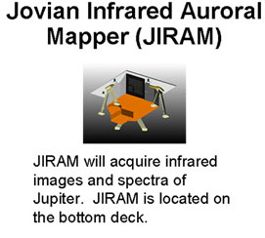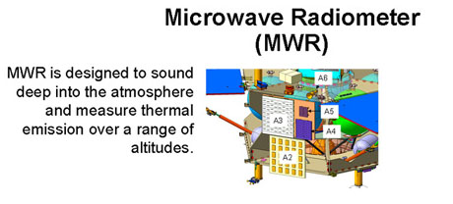

Fig. 2a (left): JIRAM close up
Fig. 2b (right): MWR close up

Juno also has a CCD imager – the JunoCam (Fig. 2) that will take visible images of Jupiter’s clouds. JunoCam may not always be pointed in the same direction as the MWR and JIRAM, and for this reason, the Juno mission will be asking professional astronomers and talented amateur astronomers to share their images of Jupiter taken from the ground.

II. Amateur Images – Categorization and Collection

This project focused on the creation and preliminary testing of a pipeline to receive images of Jupiter from amateur astronomers. The pipeline is displayed in Fig. 3; images are obtained from amateurs and archived in the JPL system, then converted to a form that can be operated upon by existing JPL software.

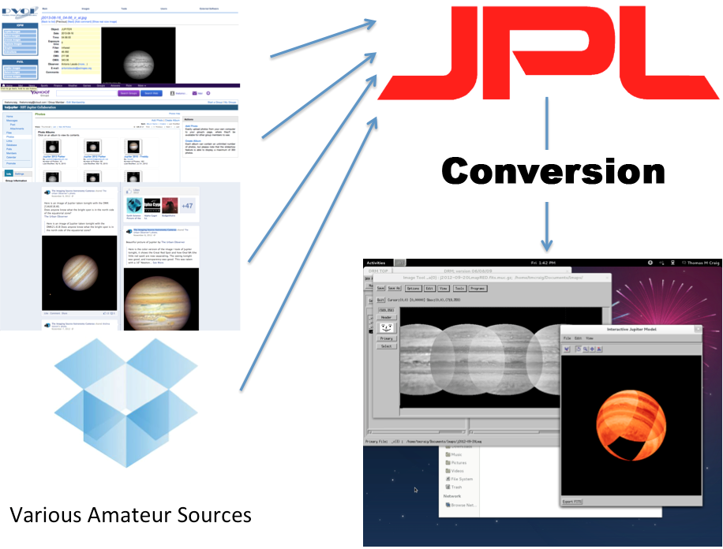

Fig. 3: Image displaying the pipeline created.

A (left): Gathering the images.

B (top right): Archiving and storing on the JPL system.

C (right): Converting to format usable by JPL programs.

D (bottom right): Transformation and other technical tasks.

Before work could be done on the conversion, images were collected from various amateur sources, primarily from the Planetary Virtual Observatory and Laboratory (PVOL) seen in the top left of Fig. 3. Other resources included the Facebook group “The Imaging Source Astronomy Cameras” and the Yahoo group “HST Jupiter”. By conversing with the amateurs directly, as well as studying their work, it was determined that PNG, JPEG, and TIFF files were the most prevalent formats to be considered. Fortunately, PVOL required a specific naming scheme for their images that could be taken advantage of to gain most of the necessary technical information. But despite this, it was clear that more information would be necessary than was already present on the images. This extra information included a description of the instrument that recorded the image and the status of Jupiter itself at the time of imaging.

It was soon discovered that the program needed to be able to intake a wide variety of formats. Every example picture taken rom PVOL was unique because each amateur astronomer used different combinations of instruments and had his or her own format preference. This can be seen in the variety of types of images seen in Figs. 4a – 4c. Fig. 4a has information above and below the planet, which could not be extracted programmatically, and thus was ignored; the information was added through preprocessing instead, covered in Section IV. Fig. 4c shows four different versions of the same picture, which could not be separated programmatically. These kinds of images had to be either broken up with an external editor prior to conversion, or duplicated such that they could be processed several times, adding only information that pertained to one image for each duplicate time.

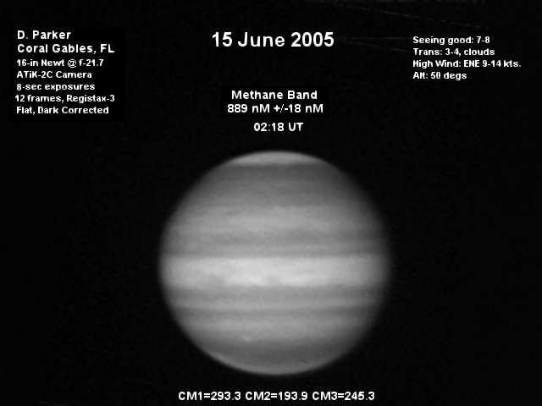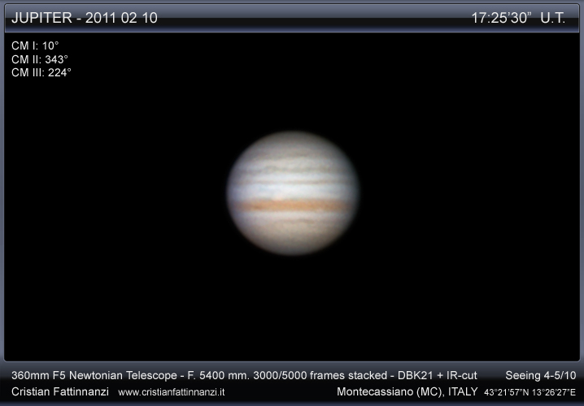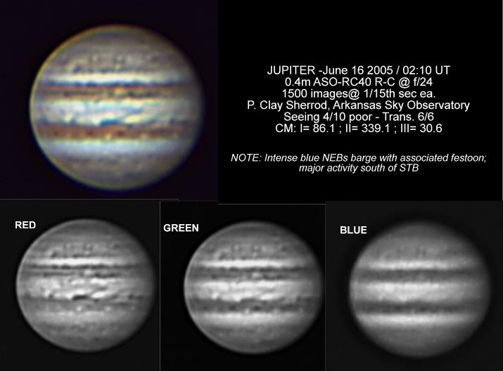
Fig. 4a (left): Methane filter, June 2005, Florida USA. Provided by D. Parker via PVOL.
Fig. 4b (center): RGB filter, Feb. 2011, Montecassiano, Italy. Provided by Cristian Fattinnanzi via PVOL
Fig. 4c (right): Infrared blocking filter with red, green, and blue exposures separated. June 2005, Arkansas, USA. Provided by P. Clay Sherrod via PVOL.

III. Conversion
Once categorization was done and inventory had been taken of the archived amateur images, the conversion program was created. The program, “Convert To Fits”, is written in the Interactive Data Language (IDL): a programming language used largely in areas of astronomy. Convert To Fits reads in PNG, JPEG, and TIFF files and converts them to the Flexible Image Transport System (FITS) format. FITS is a digital picture format that includes a plain text section, called a header. FITS is the primary format used by professional astronomers, and it allows for easily ascribing scientific information to an image, such as date and time of capture, distance of the object from earth, and photometric information. All of this is added to the header.

The goal of this conversion is the ability to perform the same processing tasks on the amateur recordings that are done with images from professional sources such as the Hubble Space Telescope (HST). The tasks include adding information to the FITS headers, like rotational velocity and position in celestial coordinates (right ascension and declination), and various transformation tasks covered in section IV.

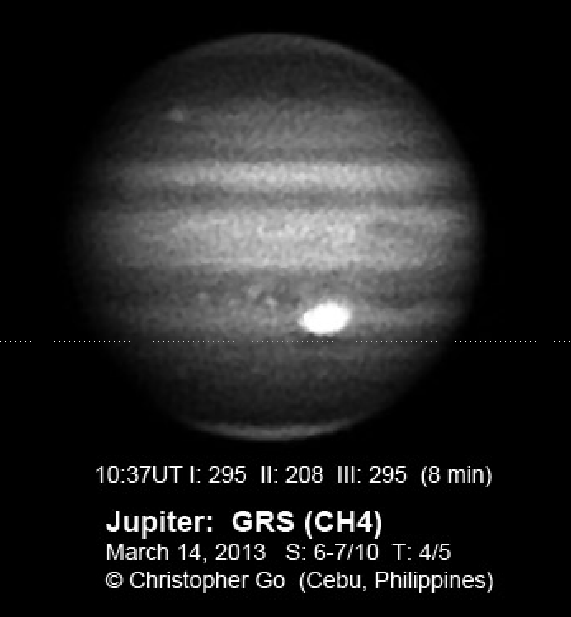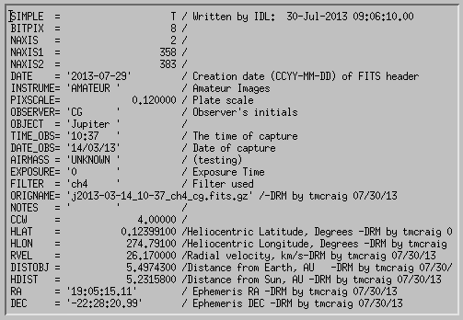
Fig. 5: A methane filter amateur image with its matching FITS header
Image taken Mar, 2013, Cebu, Philippines. Provided by Christopher Go via PVOL.
Note the “FILTER” and “DATE_OBS” that match information from the original image.

There were several fields that needed to be present in the FITS headers before transformation tasks could be carried out. The “Convert To Fits” program takes advantage of the naming scheme that PVOL requires for its images, and this scheme is sufficient for future contributions outside of PVOL, save for one field – plate scale. Plate scale is a number that corresponds to the angular size of a pixel at the focal plane of the telescope used to record the image. For the purposes of this project, is was simply a number that needed to be supplied for the images to be processed properly. Because this was not required by PVOL, and thus not present in the file names, it was requested from the amateurs directly in a plain text file accompanying their images. This system was not tested thoroughly, but is simple enough to adapt and verify. Should future work prove that more information would be beneficial, it can be required in the text file as well.

IV. Processing and Transformation
The Data Reduction Manager (DRM) generated the remaining required fields in the FITS headers. DRM is a set of code written in IDL that performs standard processing and transformation tasks on FITS images using IDL widgets for easy user interfacing. The amateur images underwent preprocessing, remapping, and projection.

IVa: Preprocessing and Geometric Information
Before any transformation tasks could be performed on the images, they had to be preprocessed in DRM. Preprocessing adds information to the FITS headers that is used in subsequent DRM tasks. After some preliminary information taken from the filename and text file was added to the FITS header, the remaining information was added with preprocessing.

After this, geometric information was added to the FITS headers through “limb fitting”, which involved fitting a wireframe model of Jupiter over the actual image. By aligning this model with the edge and bands of the planet, geometric information was generated and saved to the FITS header. This step aided in future tasks.

After the tasks were completed, the images held enough information for transformation.

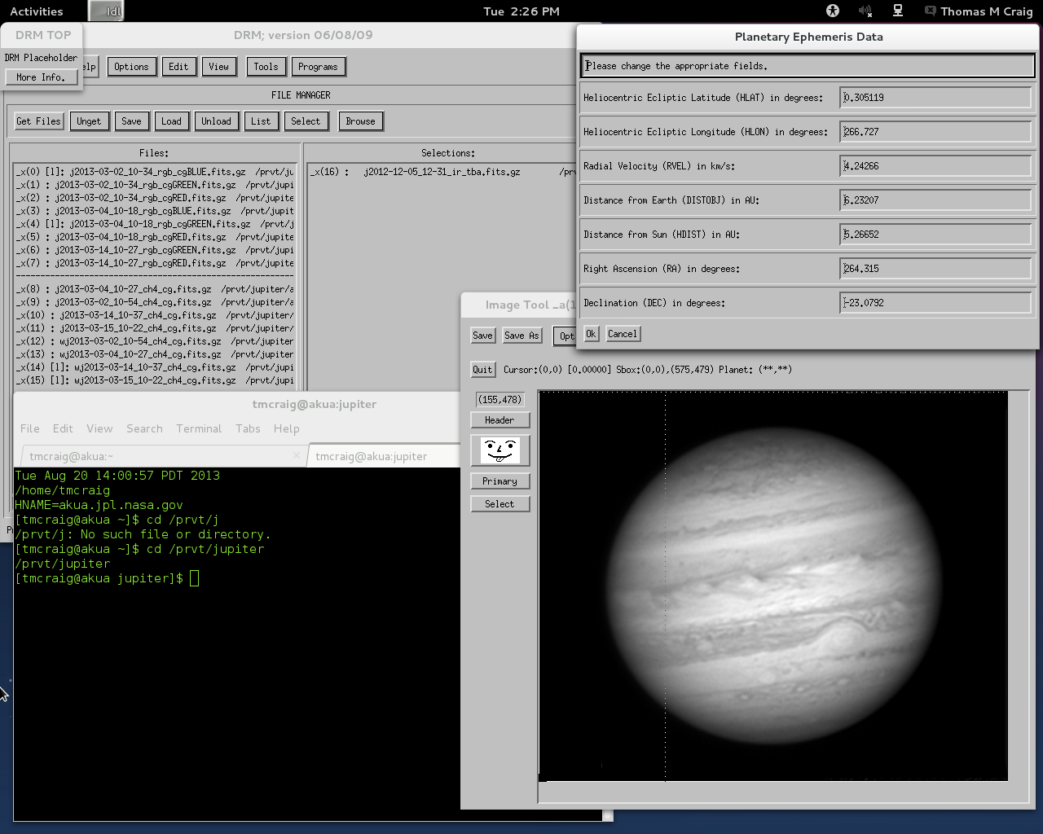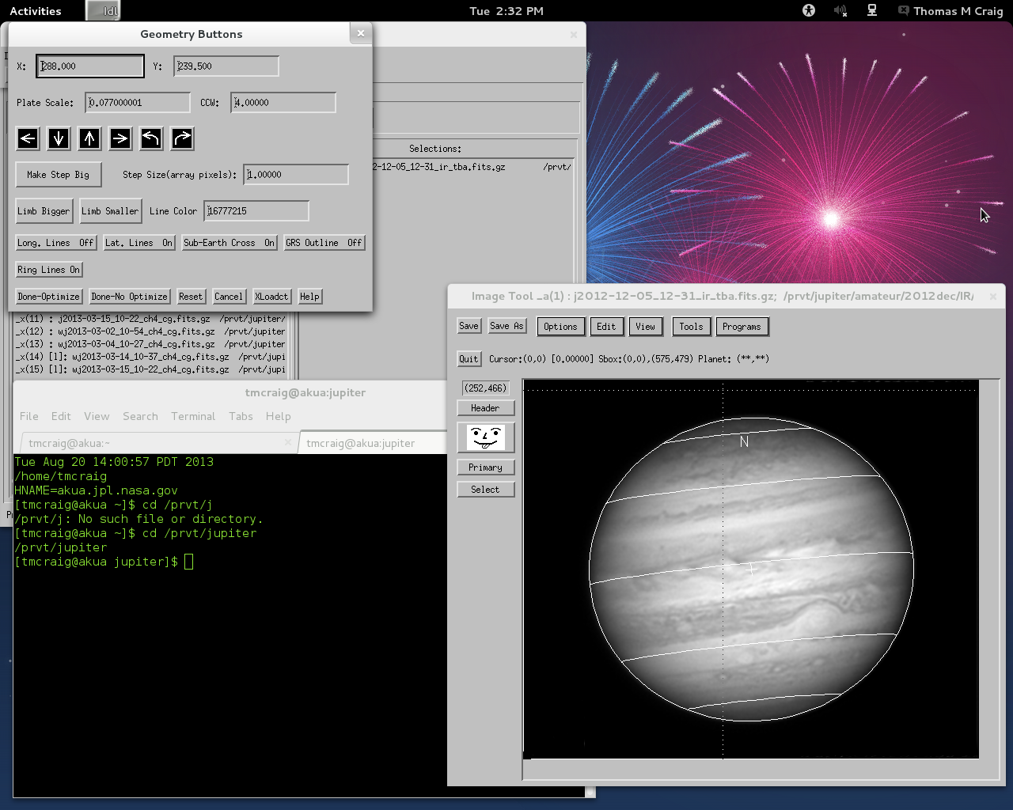
Fig. 6a (left): DRM Preprocessing – latitude, longitude, rotational velocity, and others added to the image.
Fig 6b (right): Fitting the limb. In this image, the bands are not quite properly aligned; the limb was rotated counterclockwise before saving.

IVb: Transformation
The images were transformed into three different formats: cylindrical maps, longitudinal maps, and 3D projections, all done inside DRM. A cylindrical map is simply a projection of an image to system with a regular grid in longitude and latitude. DRM remapped the images onto this grid. Because only one hemisphere of Jupiter can be mapped at a time, only combining multiple cylindrical maps covering different longitudes could fill an entire map.

This filled in map is referred to as a “longitudinal map” as it is a single map of the entire longitude of the planet. This allows for easily viewing the atmospheric conditions of the entire planet within a given timespan.

Because the longitudinal map shows most visible parts of a planet, it is possible to create a three-dimensional projection from one of these maps. While these were not essential to the pipelines laid out in section II, they allow for another method of comparison of these images.

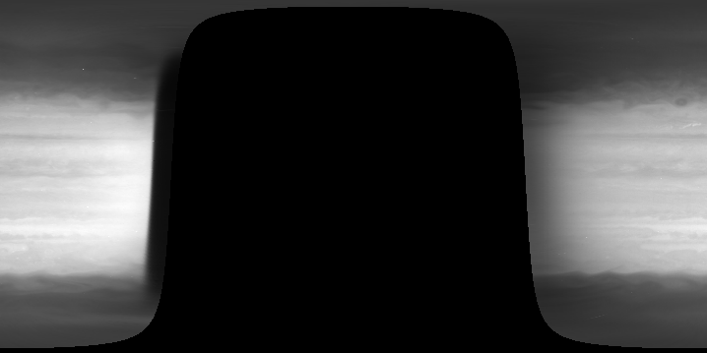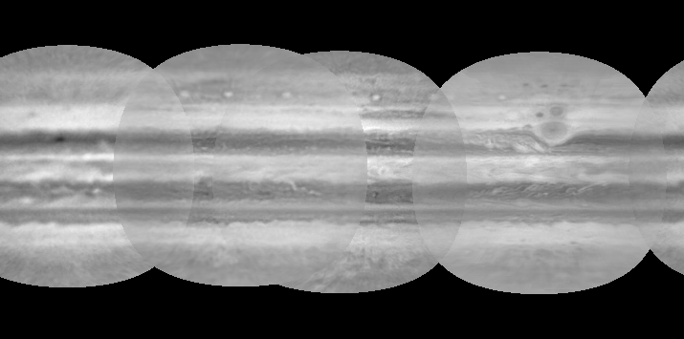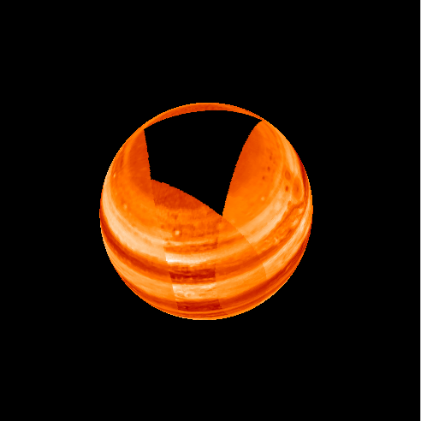
Fig. 7a (left): Cylindrical map made from a HST image, taken September 20, 2012.
Fig. 7b (center): Longitudinal map made from combination of cylindrical maps.
Fig 7c (right): 3D projection of longitudinal map.
Longitudinal map images recorded between September 19 and 21, 2012, using
images taken by Christopher Go, Manos Kardasis, Gary Walker, and Javier Beltran Jovani, and obtained via PVOL.

V: Conclusion
The goal of this project was to create a reliable system for the conversion and transformation of amateur images, and the outlined pipeline accomplished this task. The system is well documented and flexible, such that it may accommodate any additional sources of amateur images before Juno reaches Jupiter. As amateurs continue to contribute and images are collected prior to 2016, there will be a substantial archive of images in various forms.

There were several issues encountered, none of which was too difficult for the project to overcome. The conversion program had to be tested with several different image formats, due to the different preferences of the various amateur astronomers. The fields required in the FITS files’ header sections were only found through examining images taken from other instruments and finding how they applied to the amateur images. This was a large task, but will not need to be repeated.

The combination of cylindrical maps to make longitudinal maps did not always produce satisfactory results. The edges of the cylindrical maps were often too light or too dark, as can be seen in Fig. 7a, which led to imperfect matching of multiple maps, seen in 7b. While this issue was observed in the HST and amateur images, it was more severe with amateur images due to the differences between images from different astronomers. This issue should first be examined with the HST images, as it can be solved when the correct algorithm is created. The correct matching of the amateur images may prove more difficult. The remaining project time will be devoted to this task.

Of course, there is future work that will be necessary. Images from more amateur astronomers are always useful. At the time of the mission, the more imaging is done globally, the greater coverage of Jupiter is gained. The conversion program now existing in DRM could be optimized further, e.g., the file selection process could be written to require fewer manual steps and the planetary center location might be automated.

Comparisons between amateur images and professional images, envisioned at the beginning of this project, were not completed. Much of the project time was spent on the creation and optimization of the conversion program, and the images from the HST were not initially in a form of FITS that the IDL code in DRM could read immediately. Further work on this and related projects can address this comparison.

VI: Acknowledgements
I would like to thank JPL for giving me the chance to do this research, and the SURF program through Caltech for providing me with this fellowship opportunity. I would also like to thank my mentor: Glenn Orton for teaching and helping me learn so much about the planetary-science field. Thank you to the Juno team for sponsoring me, and allowing me to contribute to their mission. Lastly, thank you to my co-interns for helping me when I asked, and sharing with me all that they learned as well.

References
[1] West et al. 2004. Jovian Clouds and Haze, In Jupiter: The Planet, Satellites and Magnetosphere (Bagenal, Dowling, McKinnon, Eds.), pp 79-104.
[2] Irwin and Dyudina. 2002. The retrieval of cloud structure maps in the equatorial region of Jupiter using a principal component analysis of Galileo /NIMS data. Icarus 156, 52-63.
[3] Simon-Miller et al. 2001. Color and the vertical structure in Jupiter’s belts, zones and weather systems. Icarus 154, 459-474.
[4] NASA’s New Frontiers Mission to Jupiter, Juno. http://juno.wisc.edu/juno-mission.html
[5] Planetary Virtual Observatory and Laboratory. http://www.pvol.ehu.es/pvol/
[6] Yahoo! Groups – HST Jupiter. http://tech.groups.yahoo.com/group/hstjupiter/
[7] Facebook – The Imaging Source Astronomy Cameras

