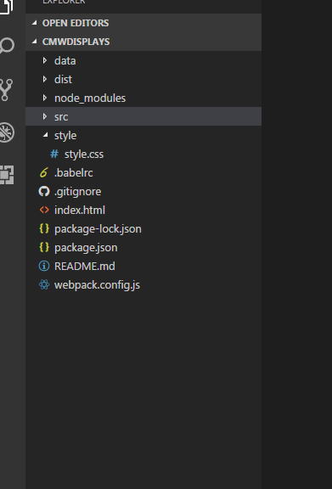

**webpack.config.js** : file contains the webpack related configuration

for reference : https://webpack.github.io/docs/what-is-webpack.html

**index.js** : routing is defined in this file and this is the entry point of app

**src**: this folder contains the main source code of react.

**dist** : this folder contains the third party css

**style** : this folder will contain the global css

**data** : mock up data will be available in this folder . in case if rest api is not available. Developer can mock the json data using json server.

**Technologies and Tools** :

**Technologies :** Node js for dependencies, React, Webpack, Webpack-Dev-Server, Bootstrap,Validator and json server(to mock up the json data)

**Dev Tool** : Visual Studio and Node(add it in path variable)