KONGU ENGINEERING COLLEGE
DEPARTMENT OF CT-UG
JAVA PROGRAMMING - 24BCT31
Leetcode Problems Assignment
- 1.Two Sum
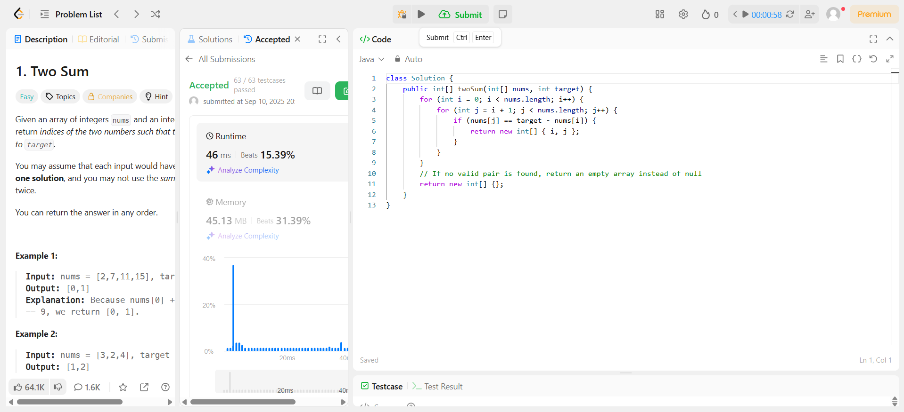
- 9.Palindrome Number
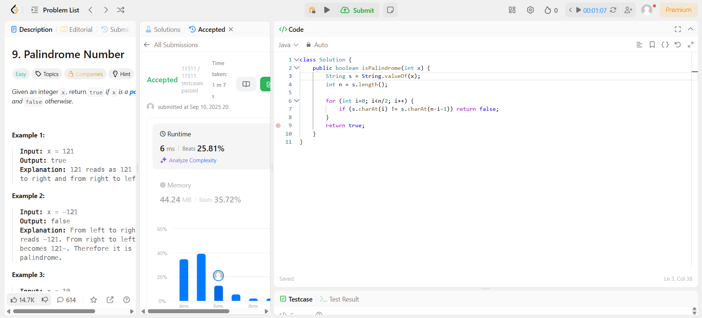
- 7. Reverse Integer
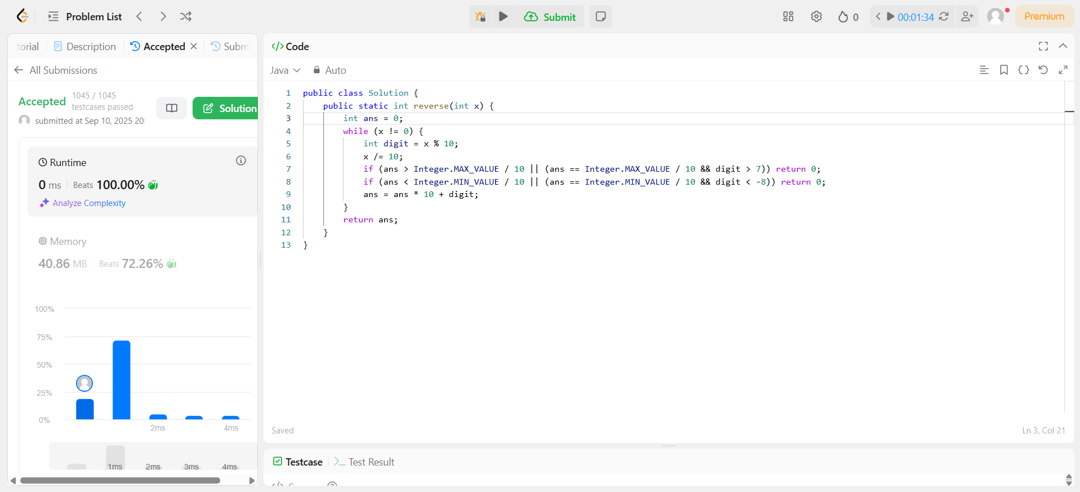
- 14. Longest Common Prefix
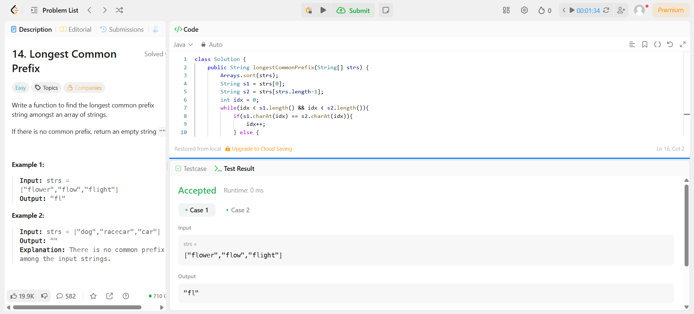
- 20. Valid Parentheses
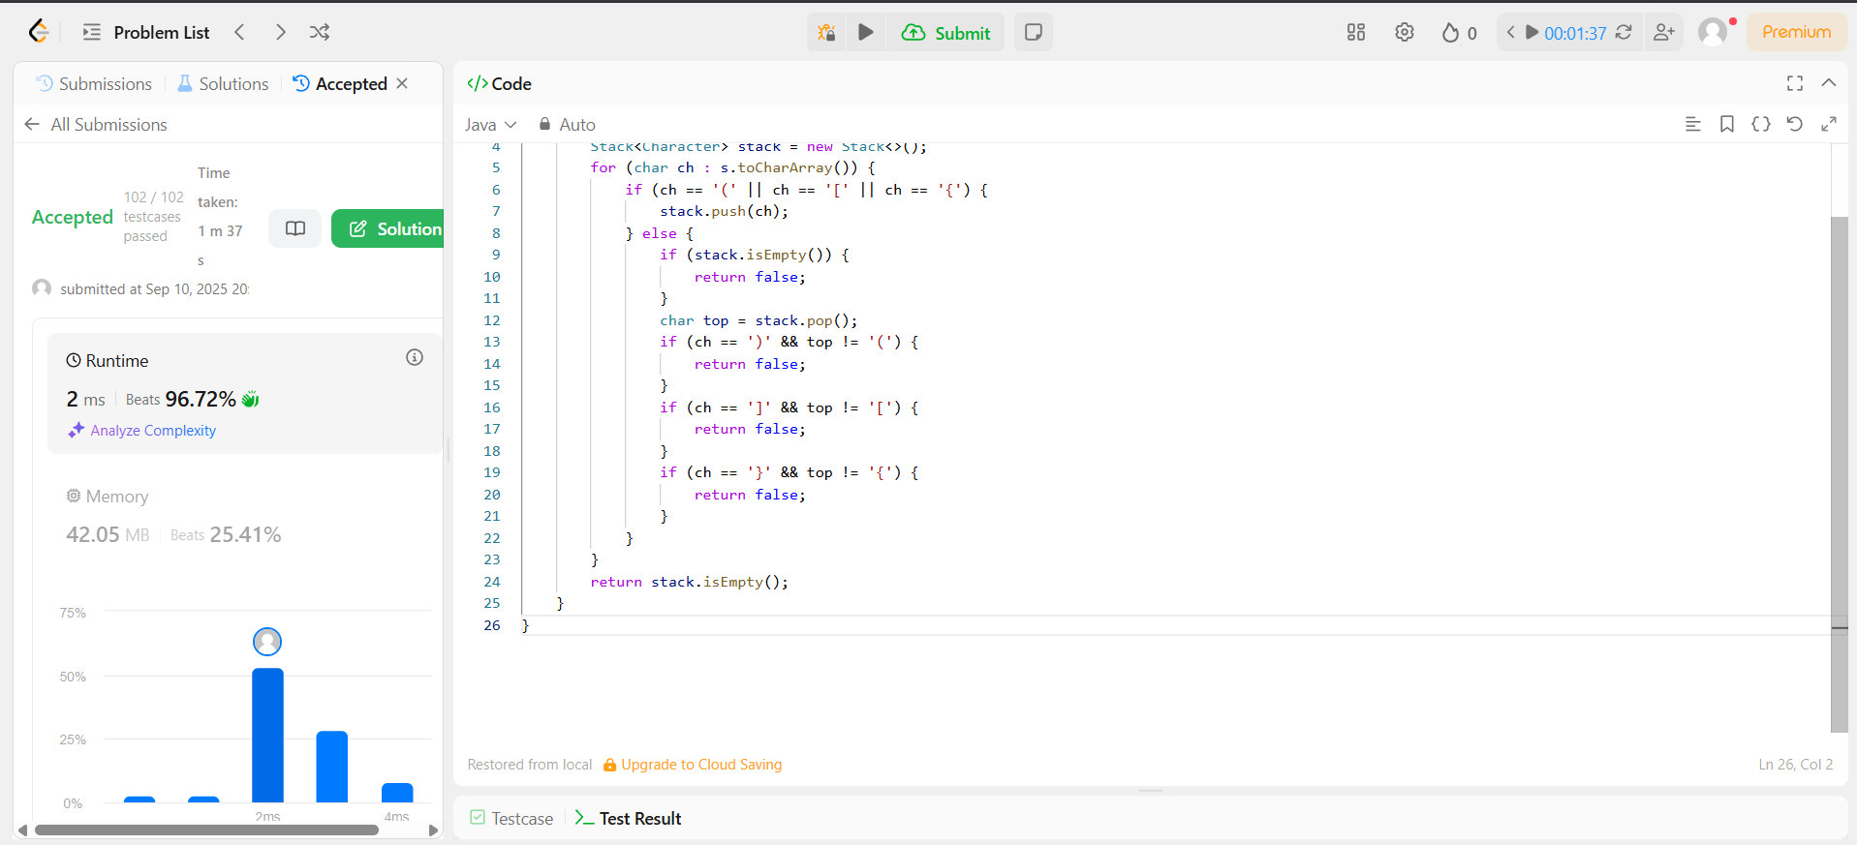
- 26. Remove Duplicates from Sorted Array
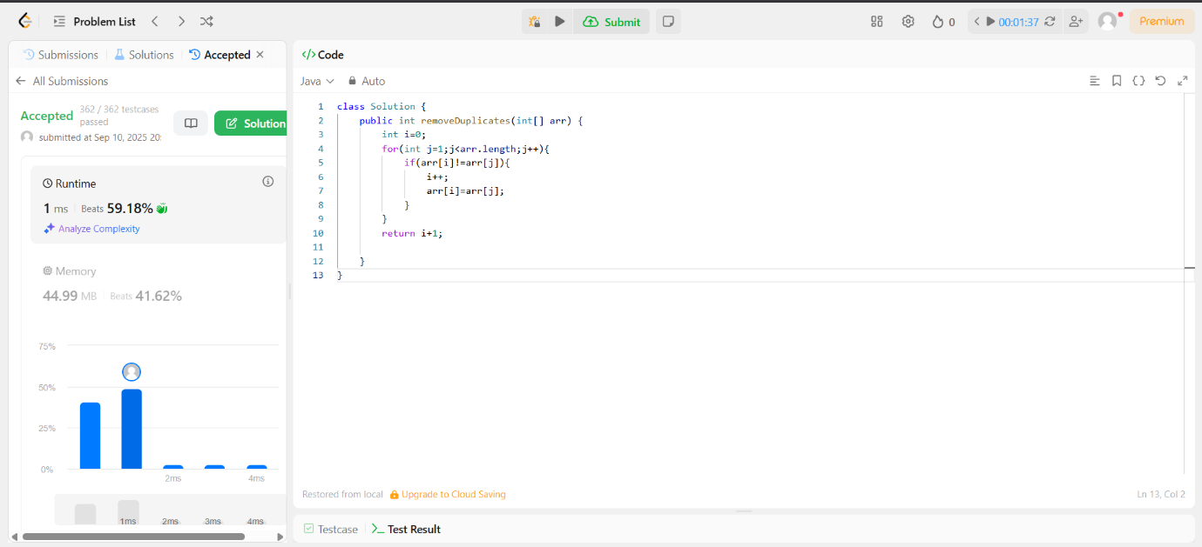
- 27. Remove Element
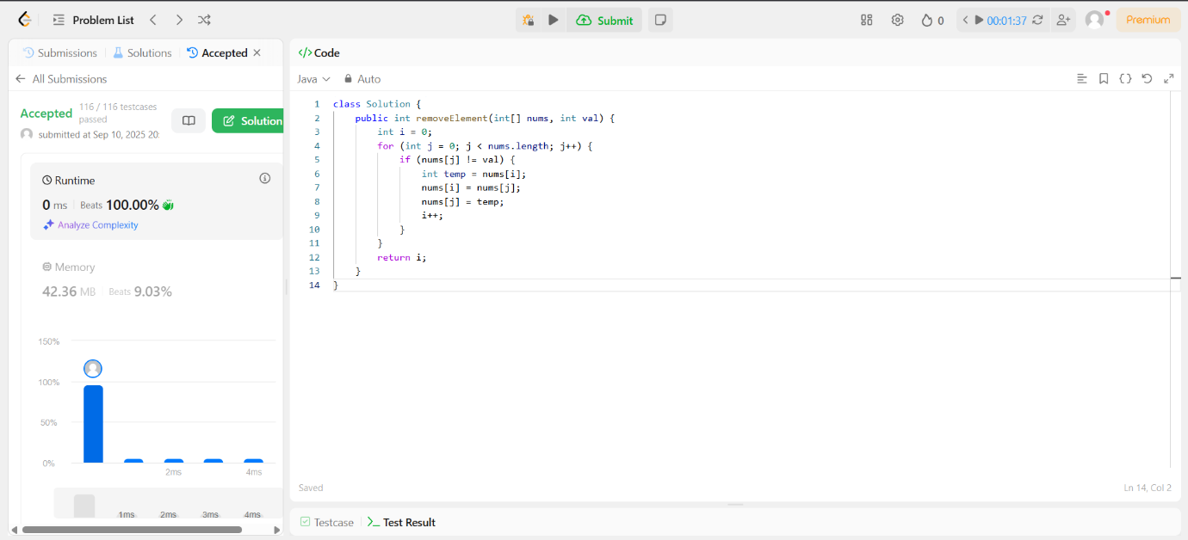
- 28. Find the Index of the First Occurrence in a String
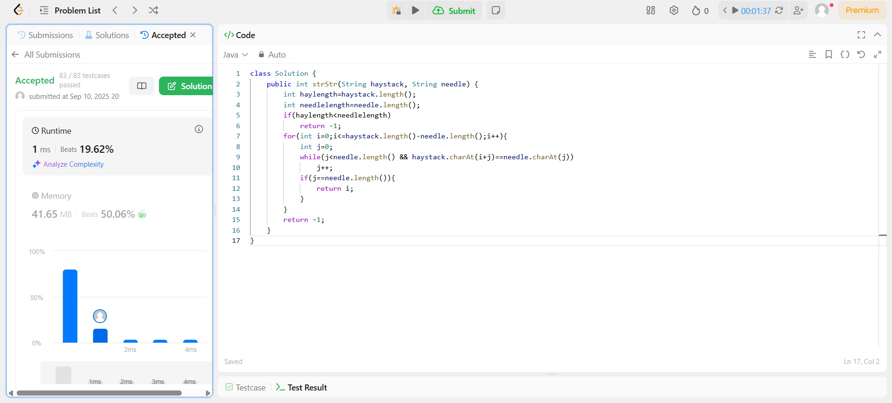
- 58. Length of Last Word
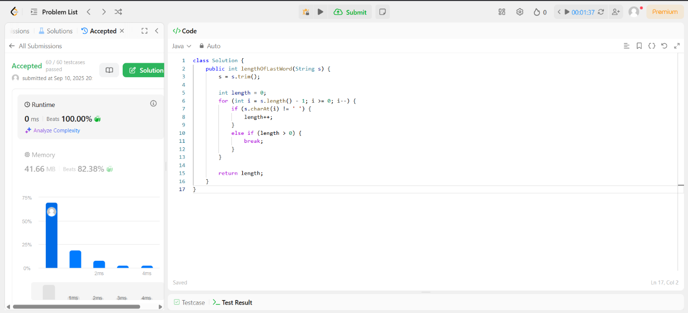
- 66. Plus One
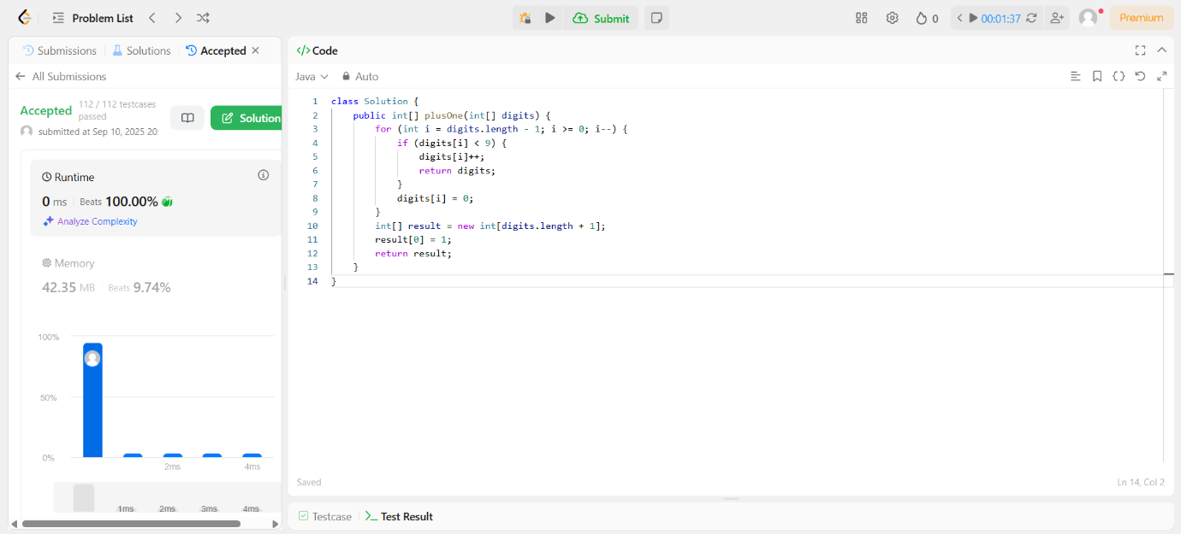

KONGU ENGINEERING COLLEGE
DEPARTMENT OF CT-UG
JAVA PROGRAMMING LABORATORY - 24BCL31
Leetcode Problems Assignment

- 67. https://leetcode.com/problems/add-binary/
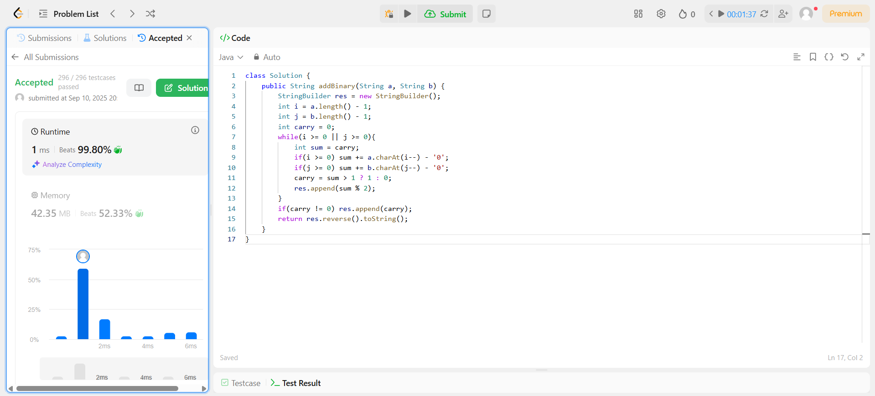
- 70. Climbing Stairs
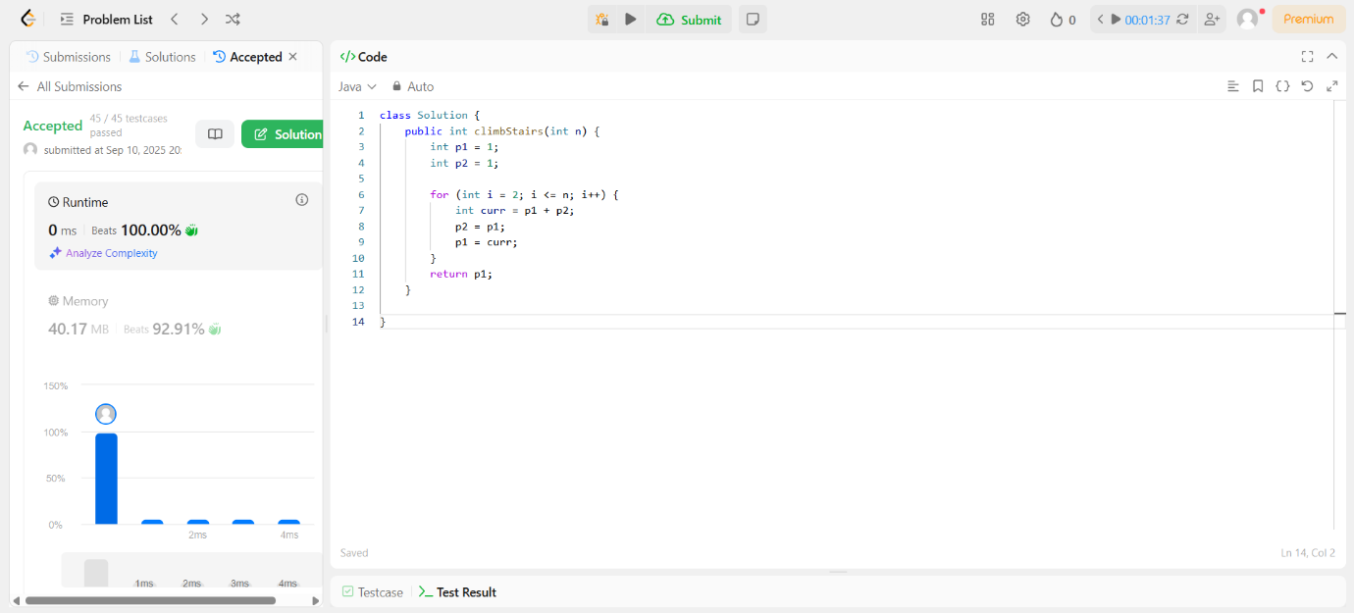
- 136. Single Number
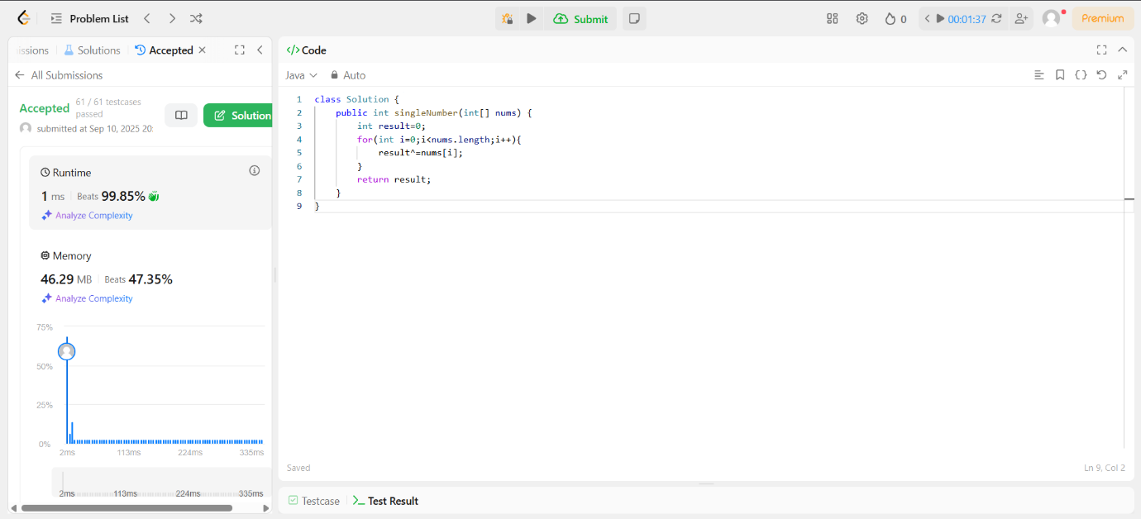
- 43. https://leetcode.com/problems/multiply-strings/
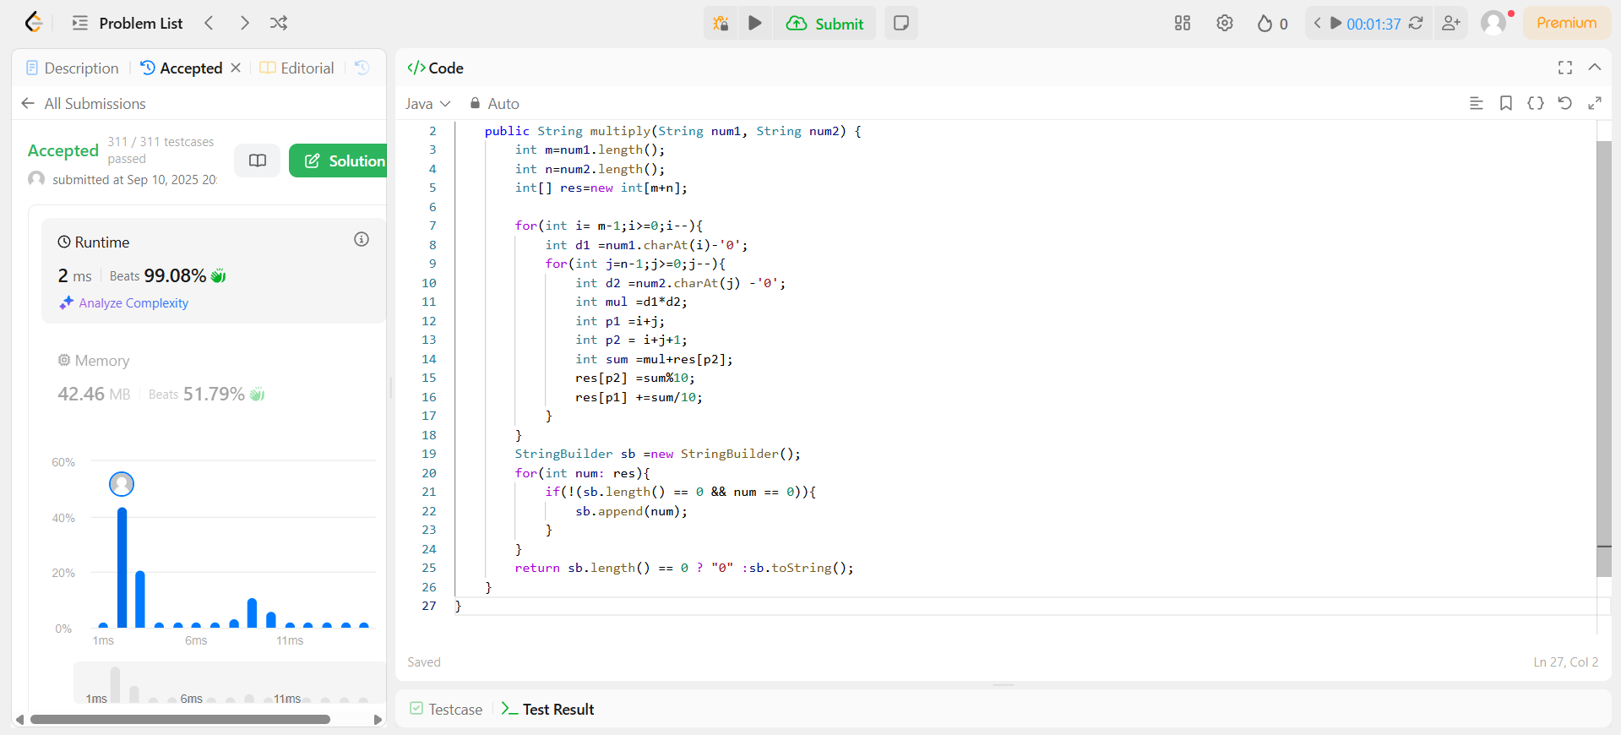
- 231. https://leetcode.com/problems/power-of-two/
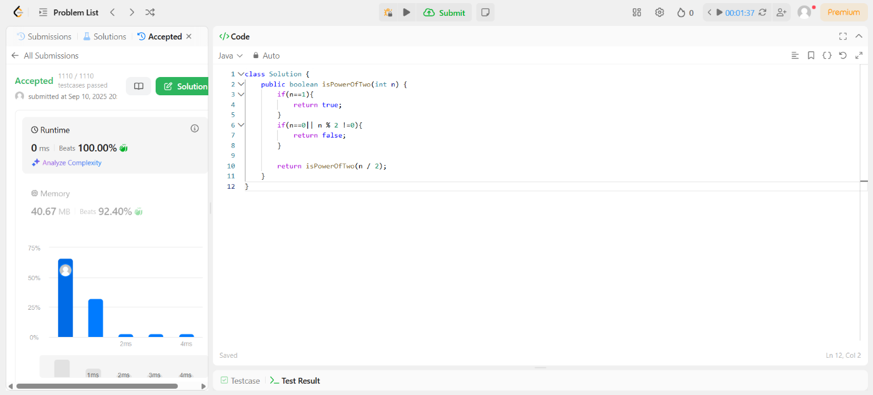
- 258. https://leetcode.com/problems/add-digits/
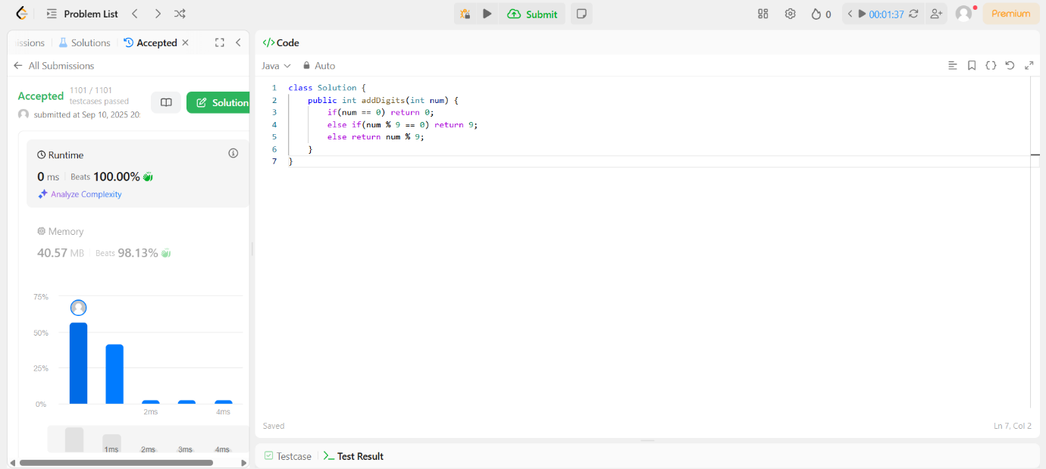
- 283. https://leetcode.com/problems/move-zeroes/
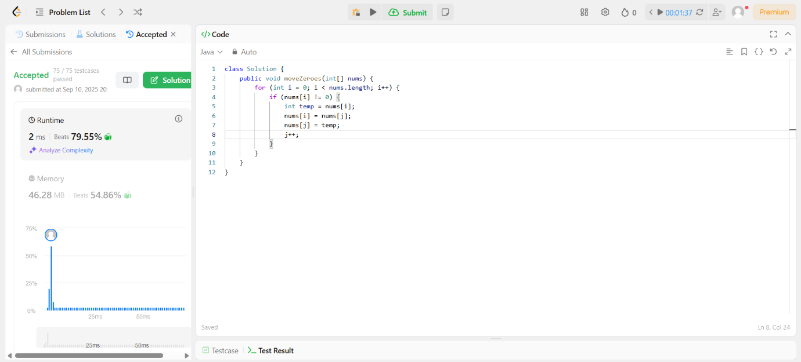
- 476. https://leetcode.com/problems/number-complement/
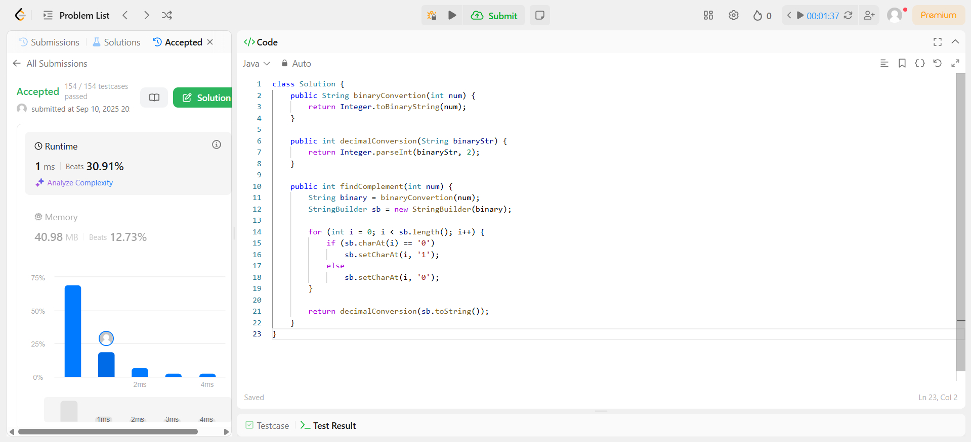
- 492. https://leetcode.com/problems/construct-the-rectangle/
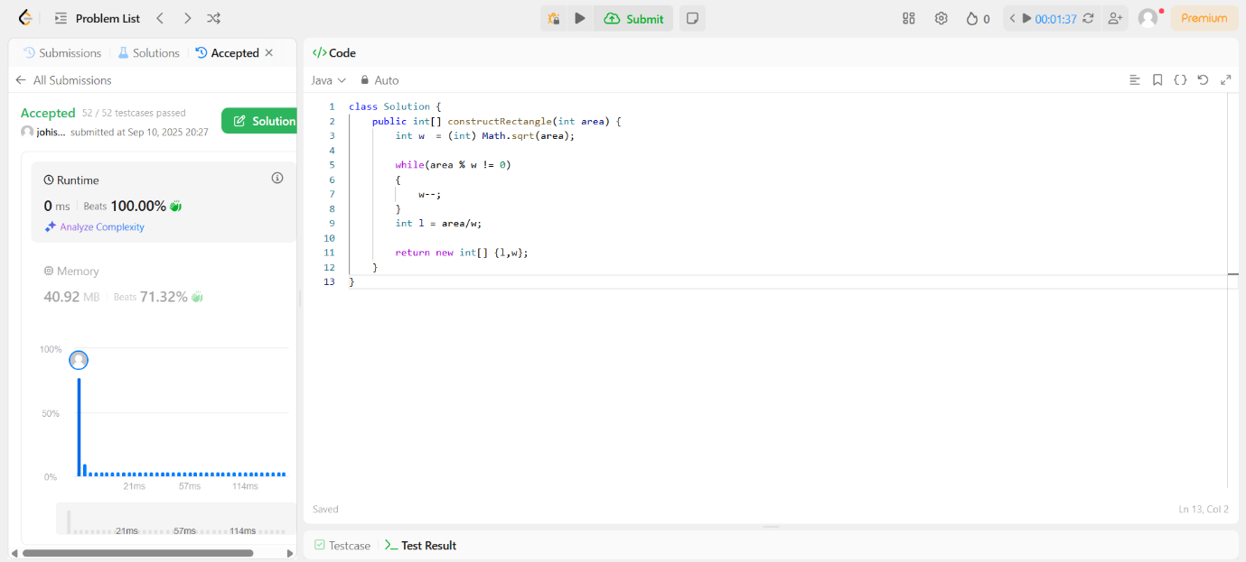
- 507. https://leetcode.com/problems/perfect-number/
