EXPERIMENT-02

OUTPUT

24BAD050

JOHIYA SRI S
1) SCENARIO 1:
Predict ocean water temperature using environmental and depth-related features.
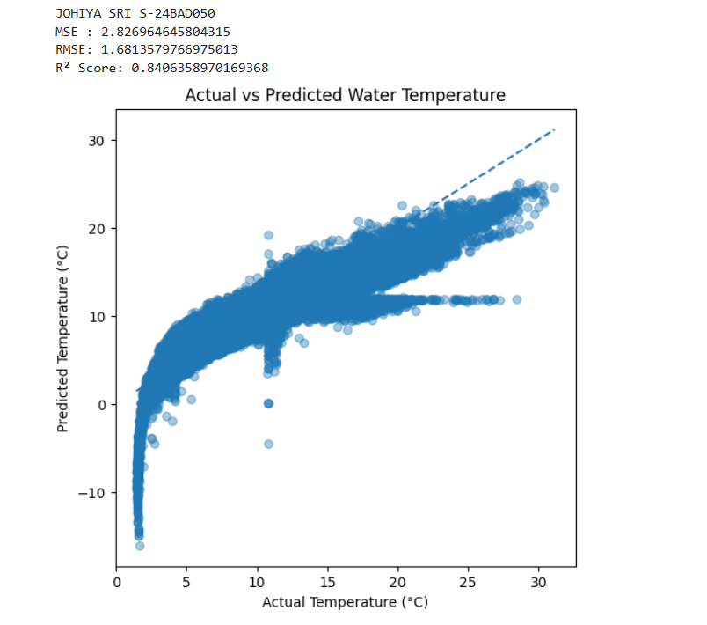

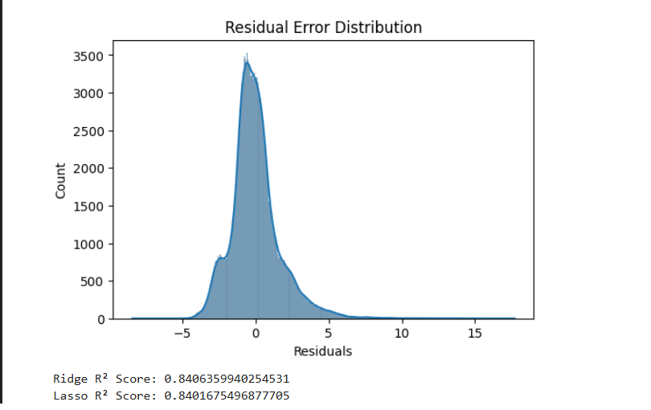

2) SCENARIO 2:
Classify whether LIC stock price will increase (1) or decrease (0) based on historical data.
