Planning, that is the production of a set of rational actions to achieve a goal, has formed, and continues to form, a key part of the AI landscape. Many different approaches to planning have been produced over the years. The landscape of AI planning is complex with new approaches building on and combining previous approaches. Figure 1 (Hendler, Tate and Drummond, 1990) illustrates this complexity.

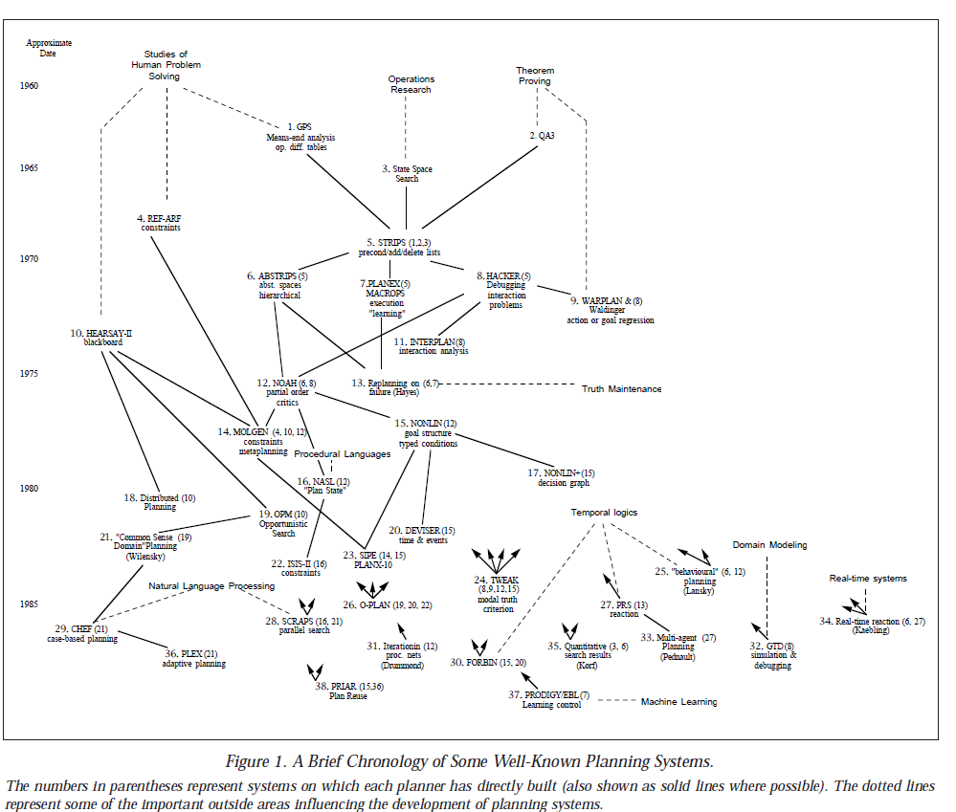

It can be seen from figure 1 that STRIPS occupies a central position in this landscape and that much of what follows in the field of AI Planning has built on STRIPS.

Stanford Research Institute Problem Solver or STRIPS was one of the early attempts at AI planning. It was developed for the SHAKEY robot program and has been been more influential for its problem definition semantics than for its algorithms (Russell and Norvig, p393) which were based on GPS like means-end strategy (Fikes and Nilsson,1971). STRIPS introduced a language for planning problem definition which is still the basis of most of the languages in use by automated planning tools to this day. The STRIPS language enabled planning problems to be formally articulated as a goal state, an initial state and a list of possible actions along with their preconditions and post-conditions which are either created or destroyed by the action and are sometimes referred to as the Add List and Delete List (Wikipedia, STRIPS). Examples of later work that builds on the STRIPS language include Action Description Language (Pednault, 1986) and Problem Domain Description Language (Ghallab, 1998) which provides a computer readable syntax for the representation of planning problems.

Warren’s 1974 WARPLAN program was a compact implementation of STRIPS, built with fewer than 100 lines of Prolog code (Ennals, 2014). It also provided a solution to the problem of interleaving actions which had bedevilled linear planning systems such as HACKER which had sought to decompose the problem into sub-goals, generate sub-plans for each sub-goal and then place the sub-plans in some linear order. This new approach, later typified by the NOAH and NONLIN systems, was known as partial-order planning and was based on identifying conflicts and the protection of achieved conditions from interferences (Russell and Norvig, p394).

After dominating the AI planning world, partial-order planning fell out of favour as interest switched to faster alternatives using state-space planning such as Bonet and Geffner’s Heuristic Search Planner (HSP) and the reverse search version of this known as HSPr. These state-space planning systems and their successors such as FASTFORWARD ad FASTDOWNWARD have achieved notable success.

Blum and Frust’s 1995 GRAPHPLAN was an alternative to both partial-order planning and state-space search and was an orders of magnitude faster than the partial-order planners (Russell and Norvig, p395). However even all of these years later GRAPHPLAN was still based on STRIPS problem definition. GRAPHPLAN accepts a problem definition articulated as STRIPS (Blum and First, 1997) and achieves its remarkable speed through reducing the search space by iteratively extending a data structure known as the planning graph, proving that there are no solutions of length l-1 before looking for plans of length l by backward chaining (Wikipedia, GRAPHPLAN).

**References**

### Russell, S. J. and Norvig, P., Artificial Intelligence, A Modern Approach, 3rd Edition, Pearson Education Limited (2016)

### Hendler, J., Tate, A. and Drummond, M., AI Planning Systems and Techniques, AI Magazine Volume 11Number 2 (1990)

* + 1. STRIPS. (2017, April 21). In *Wikipedia, The Free Encyclopedia*. Retrieved

17:30, July 23, 2017, from <https://en.wikipedia.org/w/index.php?title=STRIPS&oldid=776534185>

Graphplan. (2016, January 31). In *Wikipedia, The Free Encyclopedia*. Retrieved

17:37, July 23, 2017, from

<https://en.wikipedia.org/w/index.php?title=Graphplan&oldid=702636751>

Blum, A. and Furst, M. , Fast Planning Through Planning Graph Analysis, Artificial intelligence. 90:281-300. (1997)

Ennals, J.R., Artificial Intelligences: State of the Art Report, Elsevier, 2014, pp.74

* + 1. Fikes, R.E. and Nilsson,N.J., STRIPS: A New Approach to the Application of Theorem Proving to Problem Solving, Stanford Research Institute (1971)