DevOps Final Project Documentation
Docker + GitHub Actions + Docker Hub + Amazon ECS on EC2

Course: DevOps Final Project
Application: final-python (Flask REST API)
GitHub: https://github.com/john-2331/final-python
Docker Hub: https://hub.docker.com/r/john2331/final-python
AWS Region: us-east-1
AWS Account: 139830186794

Partner 1 – Full name: ___________________________ ID: ______________
Partner 2 – Full name: ___________________________ ID: ______________

Note: This document includes written explanations and screenshots for each course part.

1. Project Overview
This project delivers a complete DevOps pipeline for the final-python Flask application. The application is dockerized, published to Docker Hub using GitHub Actions, and deployed to Amazon ECS using the EC2 launch type with one EC2 container instance. An Application Load Balancer exposes the application publicly.

1.1 Selected course options
- Part A: Dockerfile for https://github.com/lidorg-dev/final-python (Compose also provided for local use)
- Part B: GitHub Actions workflow — checkout → build → push to Docker Hub (same code as Part A)
- Part C: Amazon ECS with one EC2 instance — deploy the Docker Hub image to ECS on EC2

1.2 Architecture
Developer pushes to main → GitHub Actions builds the image → image is pushed to Docker Hub → ECS service on EC2 is updated → users access the app through the Application Load Balancer. Logs are written to Amazon CloudWatch.
- Registry: Docker Hub only (Amazon ECR is not used)
- Compute: Amazon ECS, launch type EC2, one registered EC2 instance
- Ingress: Application Load Balancer on port 80 → container port 5000
- Live URL: http://final-python-alb-1567240385.us-east-1.elb.amazonaws.com/api/doc
- Health URL: http://final-python-alb-1567240385.us-east-1.elb.amazonaws.com/health

2. Part A (25 points) — Dockerization
Requirement: Write a Dockerfile for the final-python repository, ensure the container runs, and provide screenshots of the GitHub repository, Dockerfile/Compose, and the application in the browser.

2.1 What we implemented
- Multi-stage Dockerfile based on python:3.7-slim
- Non-root container user and HEALTHCHECK on /health
- docker-compose.yml for local build and run on port 5000
- Application source under app/ (Flask + Flask-RESTPlus)

2.2 How to run locally
docker build -t final-python:local .
docker run --rm -p 5000:5000 --name final-python final-python:local
Or: docker compose up --build -d
Open http://localhost:5000/api/doc

2.3 Written explanation
For Part A we selected the final-python option. We wrote a production-oriented Dockerfile that packages the Flask API into a lightweight image. Docker Compose is used to build and launch the container locally. The Swagger UI at /api/doc confirms the application is running correctly in the browser.

2.4 Screenshots — Part A

GitHub repository
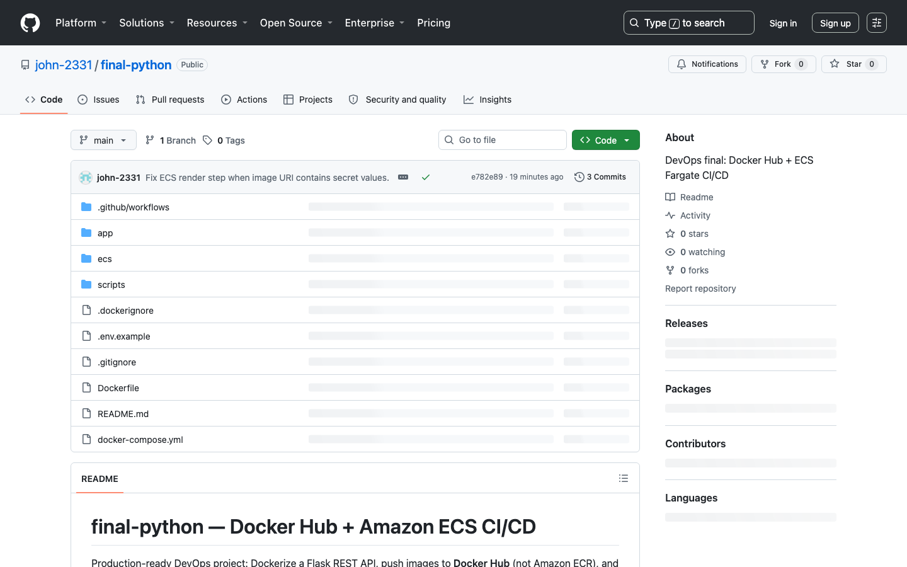
Figure A1. GitHub repository (01-github-repo.png)

Dockerfile
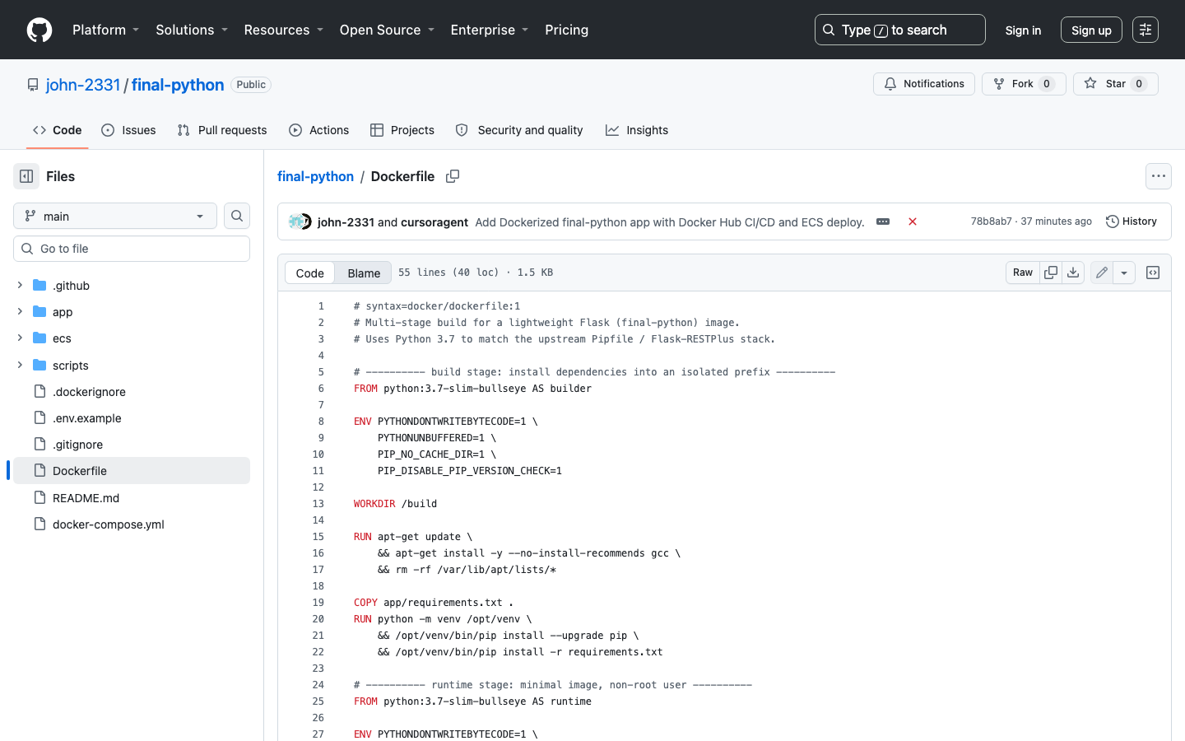
Figure A2. Dockerfile (02-dockerfile.png)

Application in browser (local)
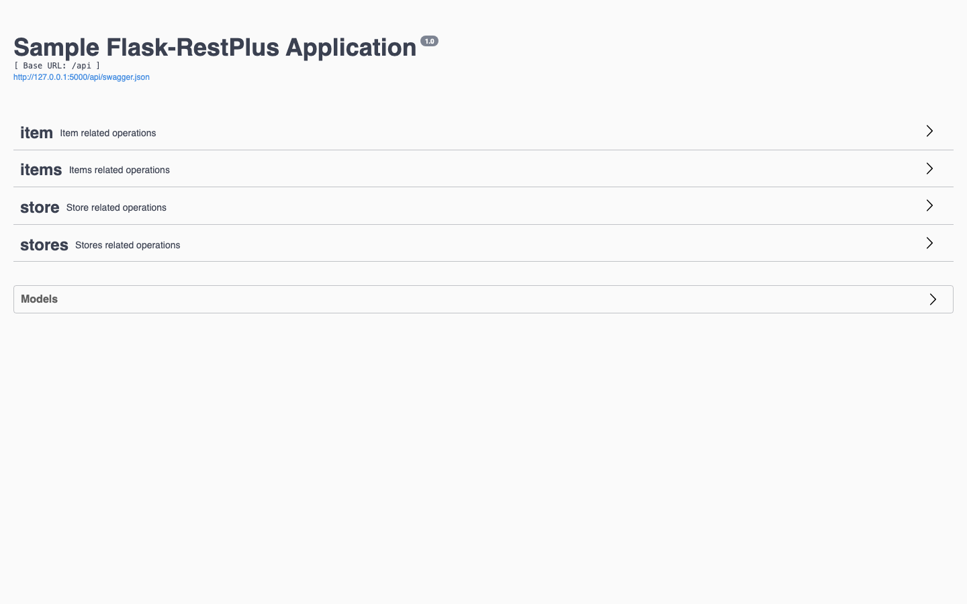
Figure A3. Local application (03-local-app.png)

3. Part B (50 points) — GitHub Actions to Docker Hub
Requirement: Using the same code from Part A, create a GitHub workflow that checks out the code, builds the Docker image, and pushes it to Docker Hub.

3.1 What we implemented
- Workflow file: .github/workflows/deploy.yml
- Trigger: push to main
- Steps: checkout → Docker Hub login → build → push tags latest and <git-sha>
- Same final-python codebase as Part A

3.2 Written explanation
Part B uses the same application dockerized in Part A. On every push to main, GitHub Actions checks out the repository, builds the Docker image, and pushes it to Docker Hub repository john2331/final-python. Secrets are stored in GitHub Secrets and are not hardcoded.

3.3 Screenshots — Part B

Workflow YAML
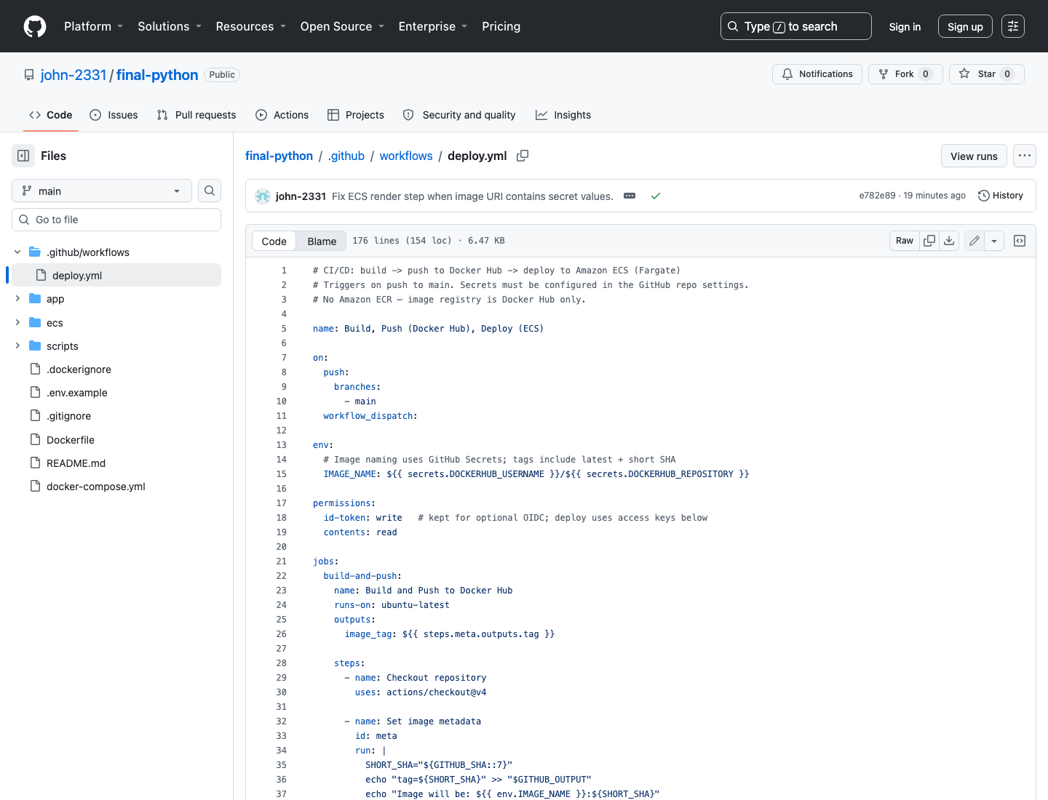
Figure B1. Workflow YAML (04-workflow-yaml.png)

Workflow success
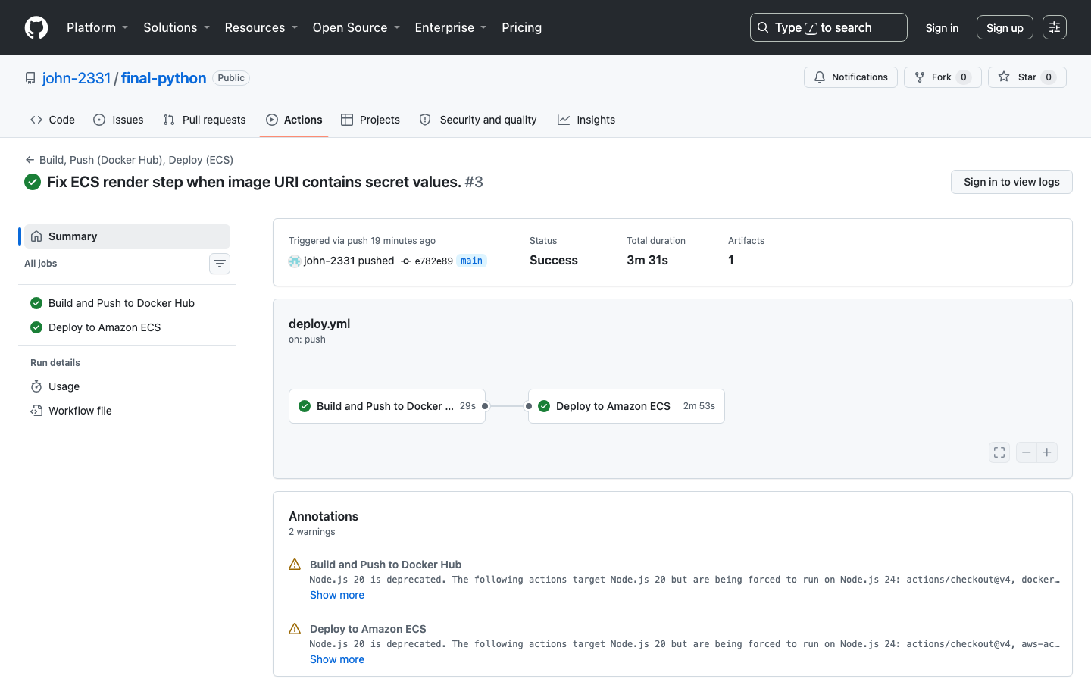
Figure B2. Successful workflow run (05-workflow-success.png)

Docker Hub repository
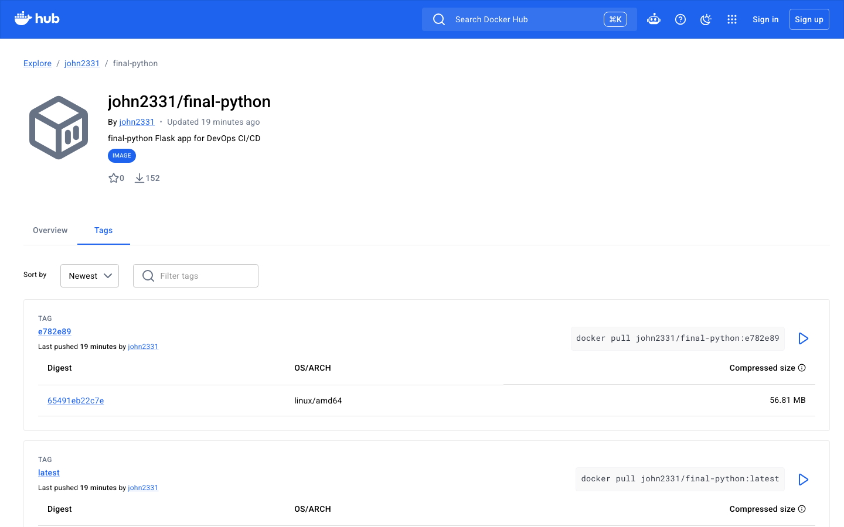
Figure B3. Docker Hub repository (06-dockerhub.png)

4. Part C (25 points) — Amazon ECS on EC2
Requirement: Deploy ECS and one EC2 instance on AWS. Deploy the image from Docker Hub on ECS. Provide screenshots of the ECS cluster, task definition, ECS service, and the application in the browser.

4.1 What we implemented
- ECS cluster: final-python-cluster
- One ECS-optimized EC2 instance: final-python-ecs-ec2
- Task definition with requiresCompatibilities = EC2
- ECS service final-python-service with launch type EC2
- Image from Docker Hub: john2331/final-python
- Application Load Balancer for public access

4.2 Written explanation
For Part C we selected ECS (not CodeDeploy). The Docker Hub image from Part B runs on Amazon ECS with the EC2 launch type. One EC2 instance is registered to the cluster. The live application is reachable through the Application Load Balancer.

4.3 Screenshots — Part C

ECS Cluster
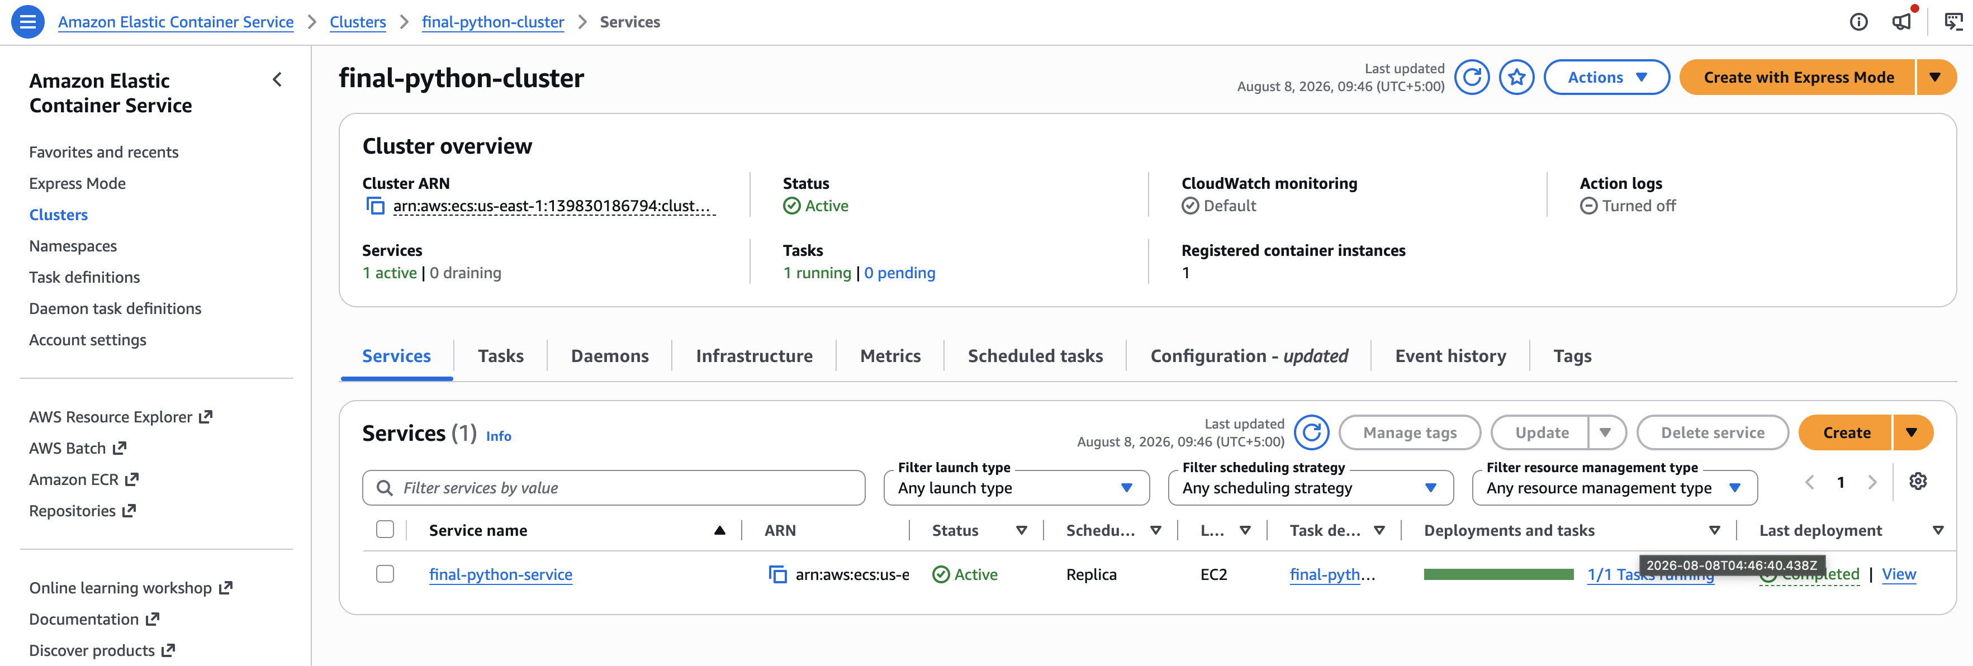
Figure C1. ECS Cluster (07-ecs-cluster.png)

Task Definition
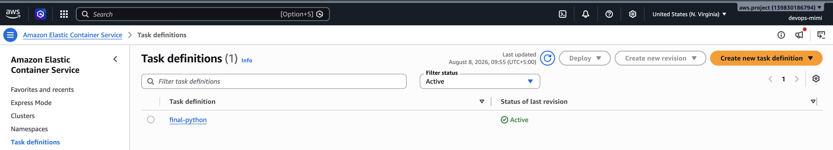
Figure C2. Task Definition (08-task-definition.png)

ECS Service
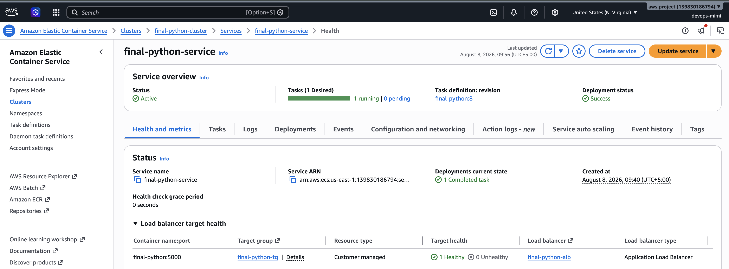
Figure C3. ECS Service (09-ecs-service.png)

Live application
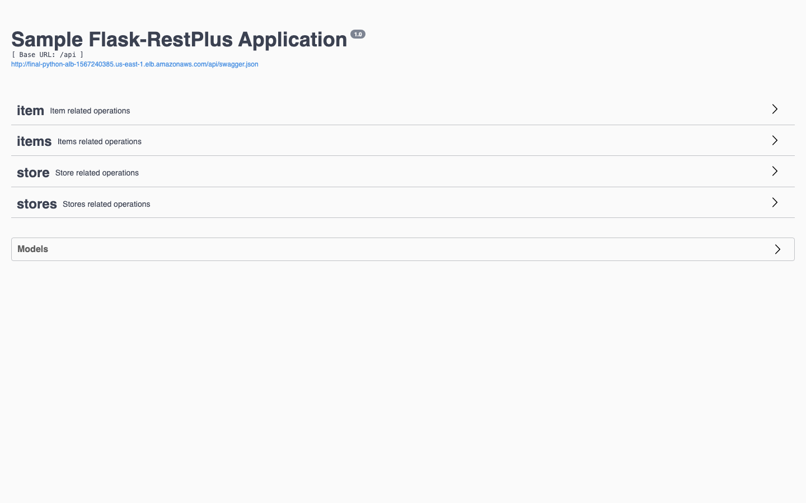
Figure C4. Live application (10-live-app.png)

5. Operations reference

5.1 GitHub Secrets
- DOCKERHUB_USERNAME
- DOCKERHUB_TOKEN
- DOCKERHUB_REPOSITORY
- AWS_REGION
- AWS_ACCESS_KEY_ID
- AWS_SECRET_ACCESS_KEY
- ECS_CLUSTER
- ECS_SERVICE
- ECS_TASK_DEFINITION
- CONTAINER_NAME

5.2 Screenshot index
- 01-github-repo.png — GitHub repository
- 02-dockerfile.png — Dockerfile
- 03-local-app.png — Local app in browser
- 04-workflow-yaml.png — Workflow YAML
- 05-workflow-success.png — Successful Actions run
- 06-dockerhub.png — Docker Hub repository
- 07-ecs-cluster.png — ECS Cluster
- 08-task-definition.png — Task Definition (EC2)
- 09-ecs-service.png — ECS Service (EC2)
- 10-live-app.png — Live app via ALB

6. Conclusion
All selected course parts are implemented: Dockerization of final-python, CI/CD to Docker Hub, and deployment to Amazon ECS with one EC2 instance. Screenshots and explanations are included above.

