Module 6 Activity 1: Working with Maps, Layers and Layouts

Purpose:
Use the mapping module to create layer files and add them to a project, list map layout elements and export a map to PDF.

Instructions:
Any Python environment will work for this exercise.

Download the data Module 6 Activity 1 and save the data to your working directory.

- Open a standalone Python environment (IDLE)
- Import the arcpy module
- Import the arcpy mapping module
- Set the overwrite outputs
- Reference the aprx

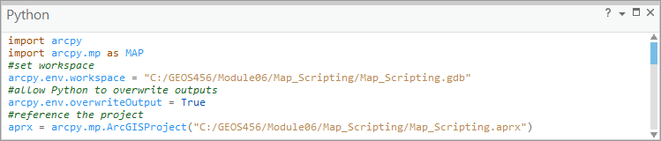

- List the maps within the .aprx
- Print properties of the maps

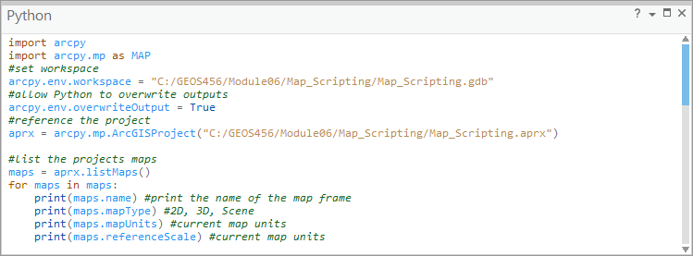

- Create a list of the feature classes in the geodatabase and save them as layer files

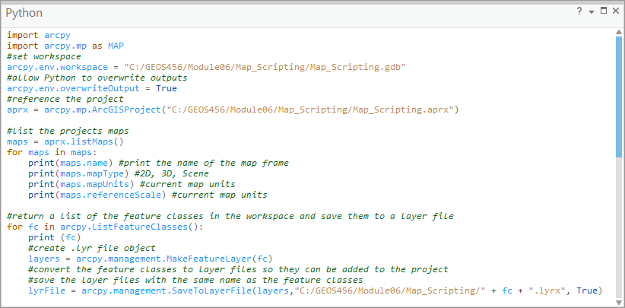

- Add the layers to the map

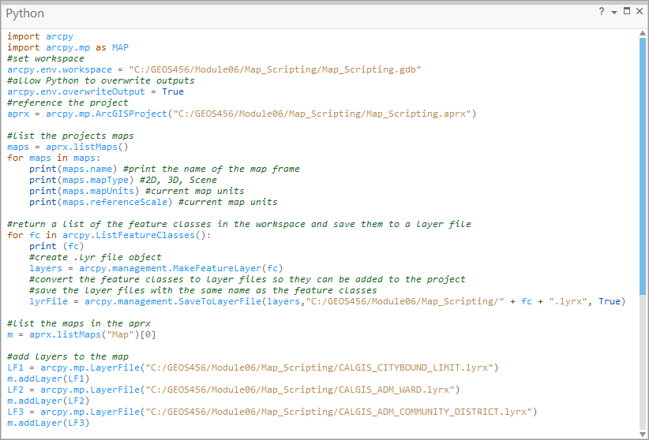

The next steps will work with the map layout and elements within the layout.

- List the layouts within the aprx

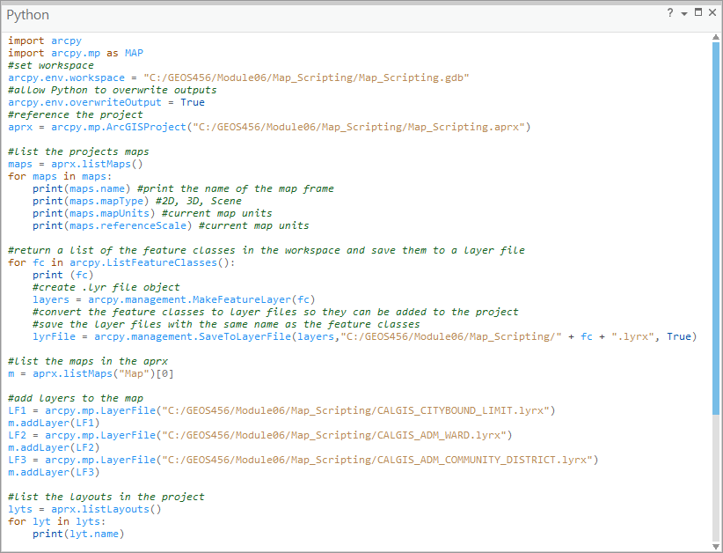

- List all the elements in the map layout and change the map title to “Calgary”

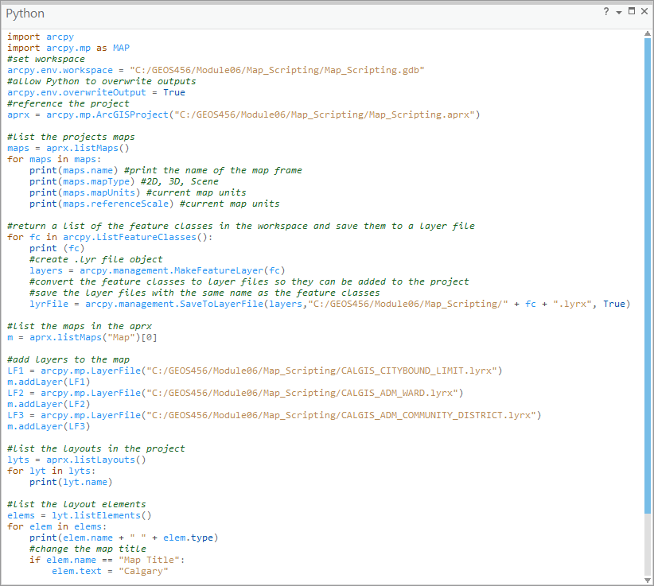

- Save a copy of the project and delete any locks on the document
- Export the map to a PDF

