# Finite State Machine

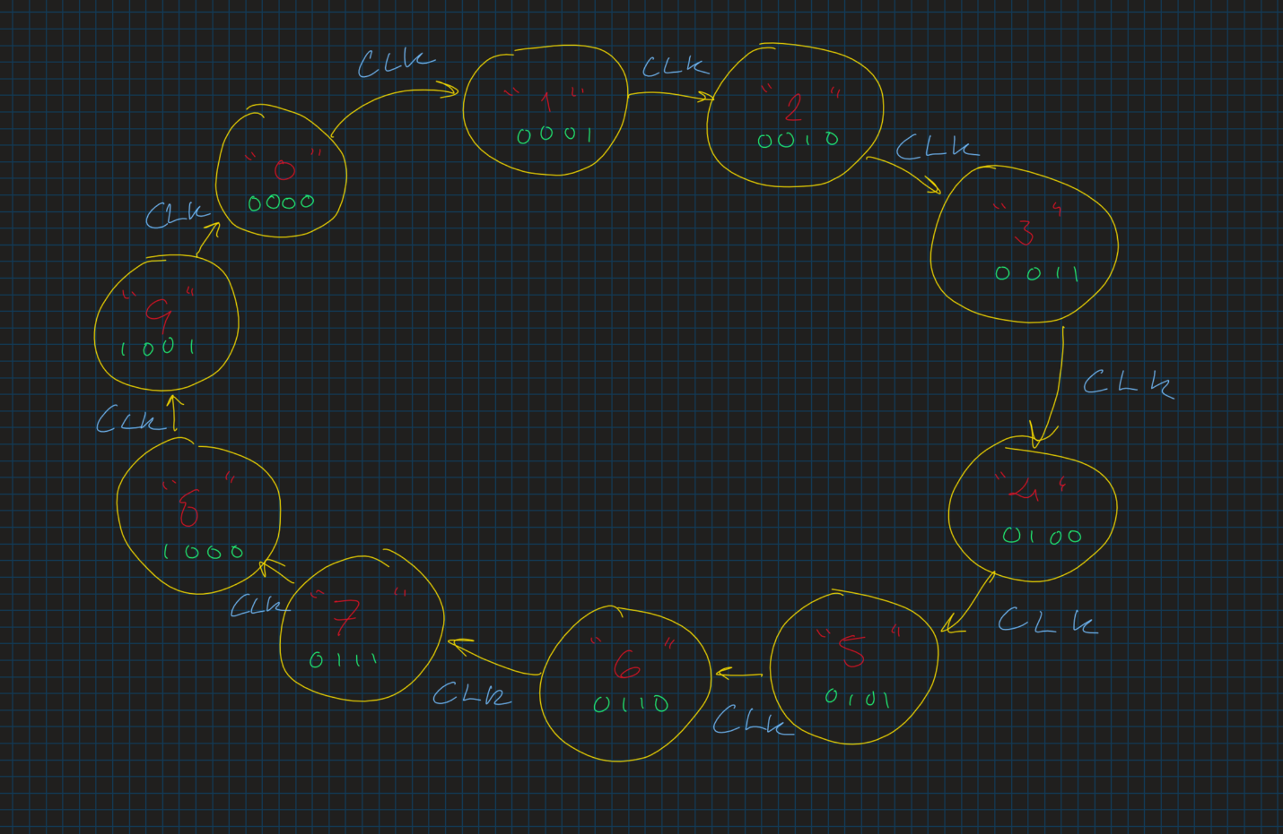

No other possible state transitions besides going to the following number.

# BCD to 7-segment decoder

## Truth tables

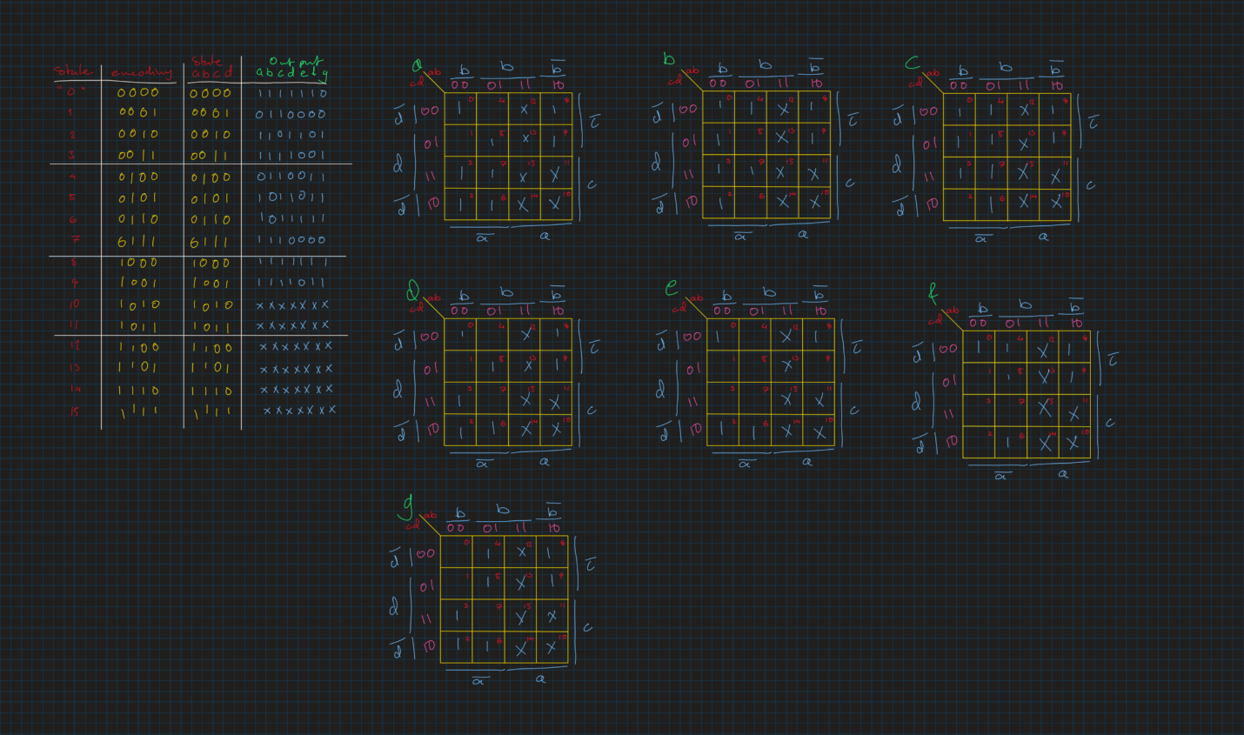

## K-maps and simplification

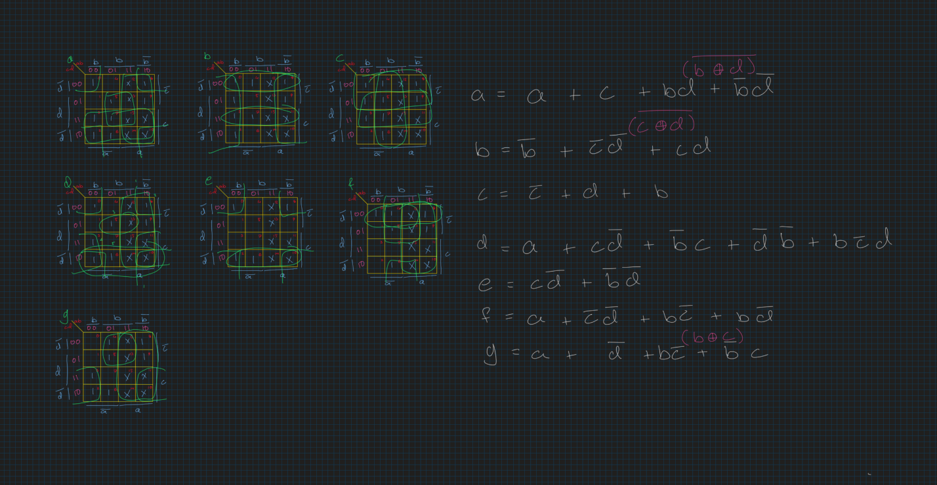

# Counter Circuit

## Truth tables

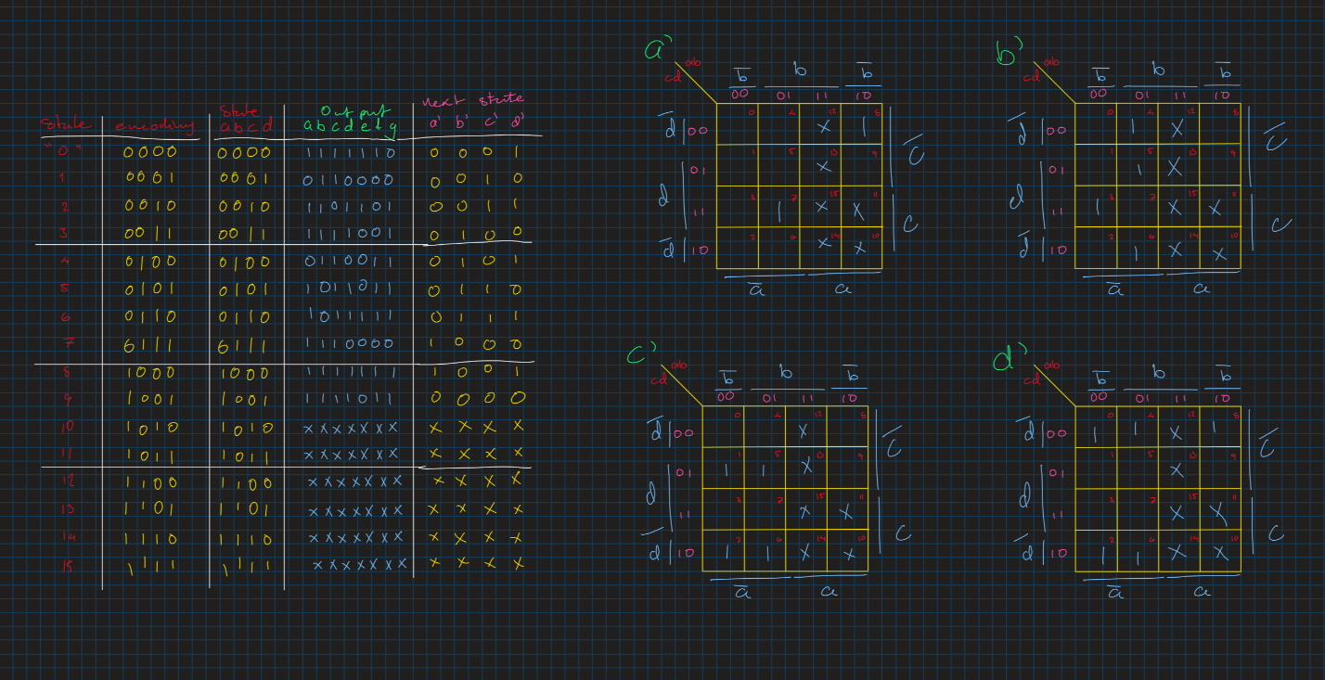

## K-maps and Simplification

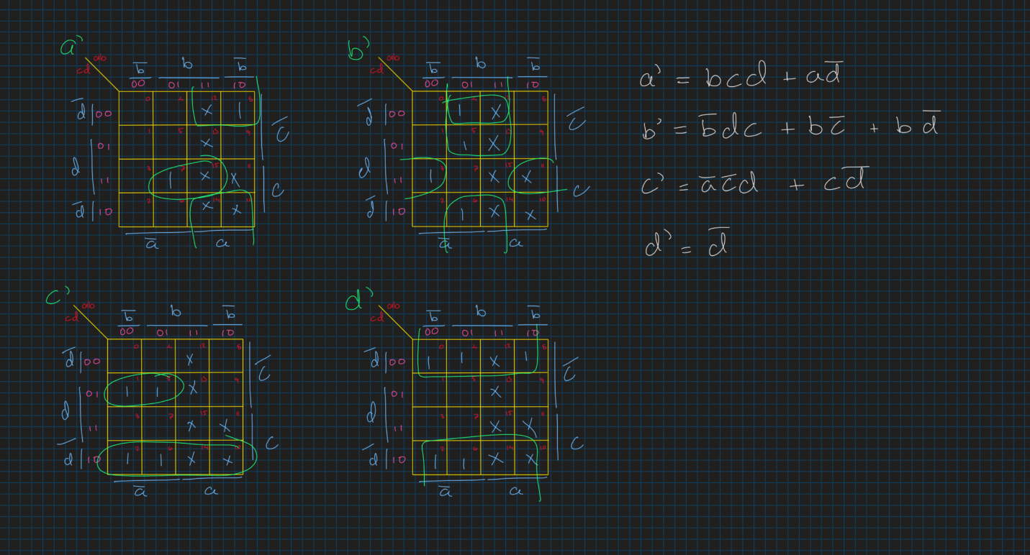

## Explanation

The X’s represent unreachable states and are allowed to be don’t-care values in the k-map and truth table. This helped simplification by allowing for more spaces to be included when looking for minterms. The FSM was simple, as each state followed the next with no possible branching. The truth tables of the counter were then derived using the FSM, and the truth tables for the decoder was taken from assignment sheet.