**METS - Ambiwarriors**

**(Medical Emergency transportation service)**

**Problem definition:**

Whenever there is an emergency situation’s such as road traffic injuries, Sudden illness, etc., it is necessary to call an emergency service such as Ambulance or Medic team to provide a first aid and to transport the patient safely to the hospital.

But due to some factors the patient is unable to reach the hospital at time, in emergency situation the time factor plays an important role in saving the patient’s life, the quicker the patient reach the hospital the life can be saved.

These factors can be varied, in this project we focus on the problem’s that are caused due to

* Lack of access to Emergency Transportation service
* Treatment delay in mass accidents due to patient dumping

*Lack of access to Emergency transportation service.*

At recent times we all are provided with a toll-free number to contact ambulance service whenever needed, which has a positive effect in some ways, but considering the distance of the ambulance to the distance of the patient, it can be hard sometimes for the ambulance drivers to reach the spot on-time, which can lead to the death of patient due to the delayed ambulance service.

According to the article published by **Times of India** it is said that there were **146,133 people were killed in the road accidents** in India in the year of 2016, and unfortunately about **30% of deaths are caused due the delayed ambulances**.[[TOI]](https://ieeexplore.ieee.org/document/8076818)

*Treatment delay in mass accidents due to patient dumping.*

And the second focus of this project is to avoid deaths in mass-disaster, pandemic or mass-accident. Whenever there is an accident which involves large number of people, we can expect a treatment delay in hospital due to the sudden raise in patients, which can also lead to death of the patient.

The best example for this scenario is the COVID-19 a national level pandemic which has caused a heavy trauma in many people lives. According to estimates and a article published by the Anadolu Agency (News agency) 15,571 COVID-19 patients dies due to a lack of ICU beds during this pandemic.[[AA]](https://www.aa.com.tr/en/asia-pacific/india-hospitals-reject-covid-19-patient-due-to-lack-of-beds/1836603).

**Validation of the problem through data collection and analysis:**

As for the project, this project mainly aims the regular civilians, Ambulance service providers, Hospitals, etc. The data-collection process is been done through both online & offline method. This project has an official website which has been used as a platform for various service providers to connect with us. As this is a startup project, we have planned to include the data’s only inside Chennai.

This scenario has been chosen very carefully by analyzing the importance of emergency services during the COVID pandemic, and the factor responsible for these kinds of losses are analyzed with the supporting articles, and the solution has been worked-out carefully and problems are been extracted, as mentioned above many patients died due to lack of beds in a hospital, and a huge amount of people died due to delayed treatment and delayed service.

**Idea / concept/solution to address the problem:**

The solution for the above-mentioned problem is being solved by creating a web application which can detect the user’s location and search for the hospitals and ambulance service nearby, and the nearby ambulance and hospitals details are being displayed in the user’s screen.

As we all are well aware of the toll-free numbers which has been provided to contact the ambulance or hospitals during emergency cases, this can be advantage for some users, but not for everyone, the distance between the hospital and the ambulance to the distance between the patient can differ from person to person.

The major outcomes of this project are to reduce the overflow of the patient to reduce the treatment delay and reduce the death’s due to delayed ambulance services. In order to solve these problems, there are a total of two factor which need to be optimized, these factors are time and distance. Instead of finding the services that is far away from the user location, creating an activity which can detect the user’s location and display the associated medic-services and hospitals can reduce the distance. And due to less distance, the transportation will be quicker and more efficient.

**Project Description and high-level design:**

The output of this project will be a web application, which can detect the user location and produce the necessary details, and these details are optimized by adjusting some of the factors according to the user’s interest.

As simple structure of this project is been shown in the *fig1*, where this whole application contains 3 stages of data processing to produce the required optimized result.

*Fig.1- process steps*

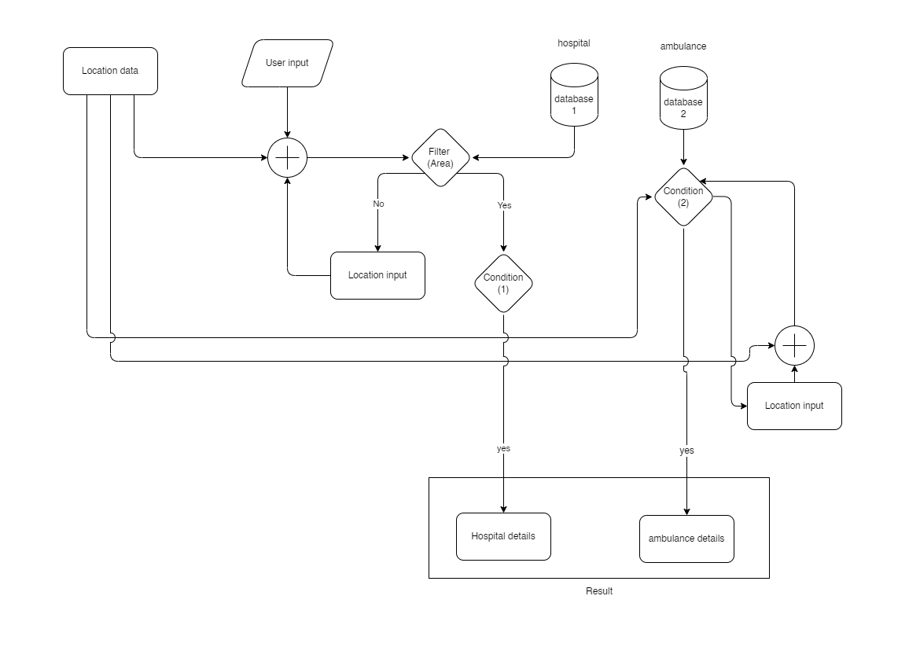

*Fig 2. Complete process flow chart*

This project collects necessary details from the user such as patient name, age, gender, etc., and then collects the location data with the help of GPS. Then these data are being added and assigned to respected variables for checking the conditions, the Filter 1 which takes the data from the hospital database and check for the hospital which are present in the location given.

And then the sorted hospitals are checked for ambulance service, if the hospital contains the service, then the necessary details are displayed, but if not, then the program checks for the ambulance database for find the nearest ambulance service provider.

Then the sorted Hospitals and Ambulance services is displayed in the user’s screen.

**Project Benefits.**

This project mainly aims to reduce the treatment or medic-service delay however possible. One of such initiatives is to develop an application which can handle and process the data’s which is given as input and produce a satisfactory output.

Producing the sorted list of hospitals and ambulance services can help to reduce the reaching time and travelling time. Which is the main objective of this project.

Developing this service in the form of an application with a feasible design can help the civilians to access this service easily; and introducing these kinds of services can increase the chance of saving lives.