ZINC 3.6 Tutorial Manual
John Blackburn and Neil McCartney
February 2016

Introduction 2
Example 1: Dielectric Problem 3
Introduction 3
Geometry and meshing 6
Input file *.zin 14
Running the simulation 15
Viewing the output. 18
A quick look at the result 18
Post processing 19
Traceability 25
More advanced graph plotting 25
If you don’t like gnuplot 31
Also in the directory 31
Example 2: piezoelectric example 33
Introduction 33
Alternative: using tensor notation to discover the Zinc coefficients 35
Simulation 37
Results 41
Comparison graphs 46
Also in the directory 47
Example 3: Fuel cell 48
Introduction 48
Zinc implementation 53
DLL method 54
Expressions method 58
Running the simulation 59
Using the Newton-Raphson method 66
Also in the directory 71
Example 4: Material Diffusion 73
Introduction 73
Dirichlet Boundaries 73
Diffusion with open (Neumann) boundary 80
Example 5: Plane strain problem 83
Introduction 83
Results 86
Comparison to analytical theory 90
Appendix A: Description of differential equations 93

Introduction
This tutorial manual shows a series of real life problems being solved with Zinc. It is probably the best place to learn how to use Zinc, though it may be helpful to refer back to the User Manual from time to time. Each tutorial corresponds to one of the examples in the “examples” folder that came with your Zinc distribution (by default in c:\program files\zinc\examples). These example folders contain the input and output files for the simulation as generated by us. When you run the simulations, you should check you get the same answers we did. It’s a good idea to copy the input files to a fresh folder so as not to overwrite the output files we’ve supplied. That way, you can check you get the same answers we do.

Even if you are not very interested in dielectric problems, you should start with Example 1 as it gives a very detailed description of the various components of Zinc and says exactly which button to press at each stage in the calculation. We recommend you then progress through the remaining tutorials in order as each one introduces some new features of Zinc. By the time you’ve finished this manual you should be familiar with all of Zinc’s features. The learning curve for Zinc is quite steep but the program is not enormous and the 5 tutorials shown here pretty much cover everything.

If anything is unclear please feel free to contact me directly at john.blackburn@npl.co.uk. Good luck!

Example 1: Dielectric Problem

Directory: examples/dielectric

Introduction

ZINC is a finite element program that is designed to solve problems having the form

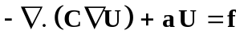,

which is written explicitly in component form as follows

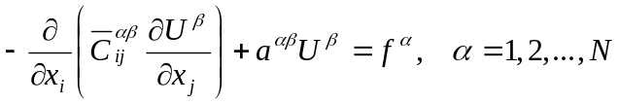

where summation over 1, 2, …. N (where N is the number of variables) is implied by repeated Greek superscripts, and where summation over 1, 2, 3 is implied by Arabic suffices. Appendix A gives a more detailed description of the notation and definitions. The reader can also refer to the Zinc User Manual, Chapter 4, for a more detailed description.

In this tutorial, the problem is to determine the electrical potential distribution, and other derived properties such as the electric field and displacement field. The system consists of a spherical sample of one type of material that is embedded in a cuboid of another material. The system is excited by a potential difference between opposing faces of the cuboid. This problem is in fact mathematically equivalent to both thermal and electrical conduction problems, and to diffusion and magnetic permeability problems.

The field equations that must be solved is one of Maxwell’s equations, in the absence of distributed charge, namely,

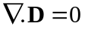,

where D is the electric displacement whose value is given by the constitutive relation

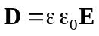,

where E is the electric field, 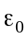 is the permittivity of free space and is the relative permittivity (a dimensionless material property). The electric field is related to the electric potential V according to the relation

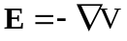.

The relations - imply that the electric potential must satisfy the equation

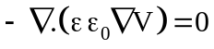.

In component form this equation is written

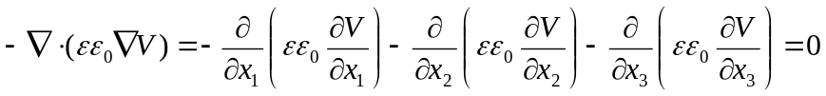

The relation results from if the following identifications are made (See Zinc User Manual, Chapter 4)

,

where 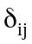 is the Kronecker delta symbol having the value 1 if i = j, 0 otherwise. It follows from that the C matrix used by ZINC has the values given by

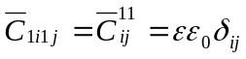

It should be noted that in ZINC all coefficients appearing in the general differential equations are zero unless non-zero values are set in the ZINC input files *.zin where * denotes an input filename introduced by the user.

The differential equation has a unique solution only if suitable boundary conditions are applied.

The boundary condition assumed by Zinc is

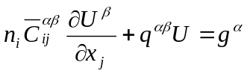
where n is the unit normal on the surface. It is easy to check that with

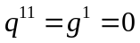
this becomes

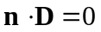
or
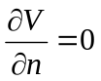

which is the usual open boundary condition used in electrical problems. It implies the electric field, E, will be parallel to the outer edges of the simulation. In the example to be solved this boundary condition applies everywhere on the external surface of the system except on two opposing planes of the cuboid where differing uniform electric potentials are to be imposed. These Dirichlet boundary conditions are imposed simply be fixed the values of the nodes at the appropriate potential (which will be simply 1 V and 0V). In ZINC, any unset components of the C, a, f, q, g matrices defaults to zero so the condition occurs automatically.

At the surface of the spherical region the normal component of the electric displacement must be continuous across the boundary, and the electric potential must also be continuous across this boundary. Provided we leave q and g at their default zero values, this condition will also occur automatically. The boundary conditions that apply are illustrated in Fig.1.

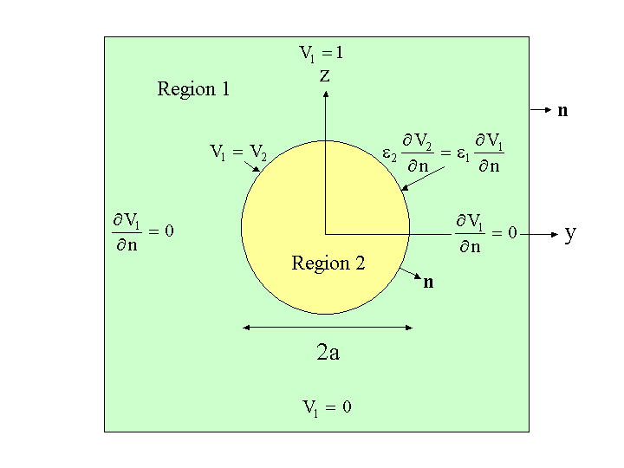
Fig.1: Schematic diagram of geometry and the boundary conditions.

The default condition on the external boundary of Region 1 is, therefore,

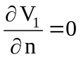, implying that 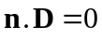,

where n is the unit outward normal to the free surface.

On the plane z = 1
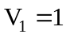,
On the plane z = −1
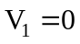.

On the interface between Regions 1 and 2 the following conditions must be satisfied

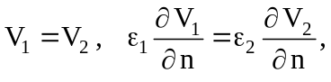 implying that 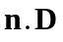 is continuous across the interface,

where n is now the unit outward normal to the interface, 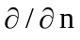 denotes the normal derivative and where 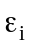 is the relative permittivity of Region i. The conditions ensure that the normal component of the electric displacement vector and the tangential component of the electric potential are continuous across the surface. These “continuity conditions” are true, by default, for all such internal interfaces and normally the user only needs to think about applying boundary conditions at the outer surfaces.

The other boundary condition is the Dirichlet boundary in which the unknown variables, U, are set at fixed values. In this tutorial, we will use the Dirichlet boundary at the top and bottom faces of Fig 1 and the Neumann condition (n.D=0) at all other faces.

Geometry and meshing

Having installed ZINC onto your computer, it is useful to generate a new folder having name ‘ZINC_Runs’ (or similar) into which all simulations will be generated and saved. To deal with the first example of this tutorial a new folder within ‘ZINC_Runs’ is created having the filename ‘Dielectric’. This file will now be denoted in the following text by ‘*’.

Input file *.min

To represent the geometry shown in Fig.1 by finite elements the following input file must be written and stored in ZINC_Runs/Dielectric. The first step defines the global mesh of cubic elements which represents the entire region of the problem. The remainder of the file defines ‘parts’ of the system that are needed to define homogeneous regions having specific properties and boundary and interface conditions. In the following code comments are included to provide some explanation. More details of the *.min file are given in the Zinc User Manual. (These files are also provided in <Zinc install directory>/examples/dielectric)

global
format ascii

xmesh
-1 1 0.2 The x range -1 < x < 1 is divided into elements of length 0.2
end

ymesh
-1 1 0.2 The y range -1 < x < 1 is divided into elements of length 0.2
end

zmesh
-1 1 0.2 The z range -1 < x < 1 is divided into elements of length 0.2
end

end

part 1 Defines a cubic box having sides of length 2 as Region 1
region 1
type box
fab 2 2 2
end

part 2 Defines a sphere having radius 0.5 as Region 2, inserted into Region 1
region 2
type sphere
fab 0.5
surface region 1
end

part 3 Defines Region 3 to be the upper plane (z = 1)
region 3
type boundzup
end

part 4 Defines Region 4 to be the lower plane (z = −1)
region 4
type boundzdn
end

endfile

The next step is to generate a mesh using zmesh.exe which appears as two windows shown in Figs. 2 and 3. The ZMesh window (Fig.2) enables the user to generate the required mesh while the Output window (Fig.3) provides information on locations of files being used.

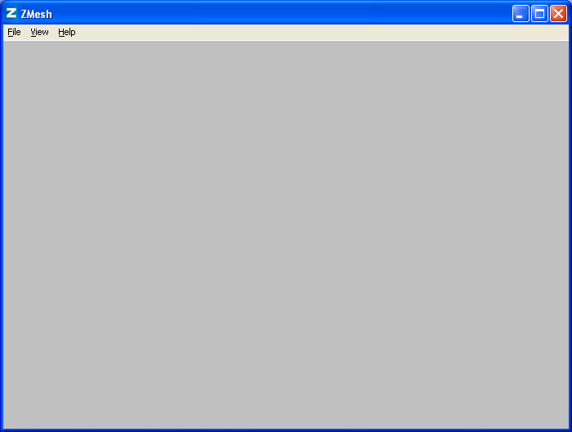
Fig.2: Window first opened by Zmesh.

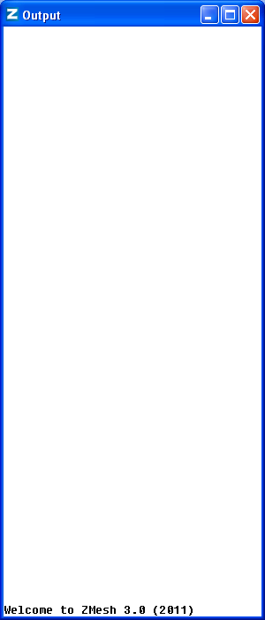
Fig.3: Output window first opened by Zmesh.

Select File > Open MIN and open the file *.min whose contents are then displayed (see Fig.4).

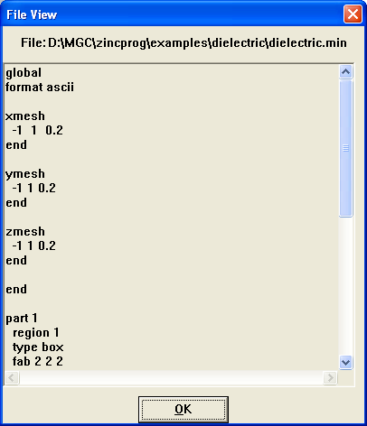
Fig.4: Window opened by Select File > Open MIN showing file *.min.

Select File/Process to generate the mesh. Provided no error occurred, the resulting mesh is shown on screen and the mesh file is automatically stored as *.mtf in the folder ‘*’. The main window now shows the geometry and mesh that has been generated (Fig 5). To view the geometry from different angles, drag with the mouse.

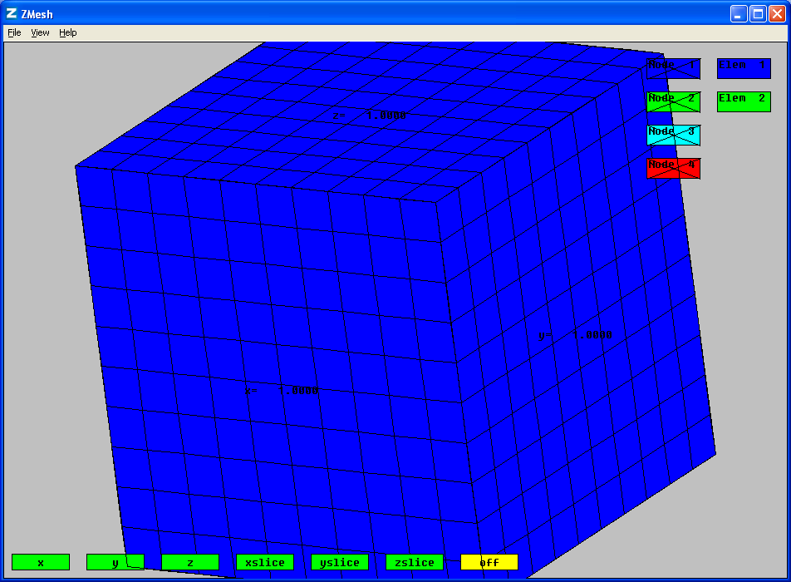
Fig.5: Window opened by Select File > Open MIN showing file *.min after rotation of model.

Dragging rotates the model so that its 3D nature can be observed. It can be returned to a standard state simply by pressing the buttons x, y or z which shows the view along the selected axis.

NOTE:
You can rotate by dragging with the mouse, or use arrow keys. Hold down SHIFT while dragging with the mouse to shift (rather than rotate) the figure. Press keys A/Z to zoom in/out and N/M to rotate in the plane.

To observe the sphere alone press the button ‘Elem 1’ (in the key at the right) which switches off the elements in Region 1 and reveals the embedded sphere in Region 2 (see Fig.6). When the elements of a region are switched off a cross appears in the key symbol. Click on the key symbol again to toggle the elements back on.

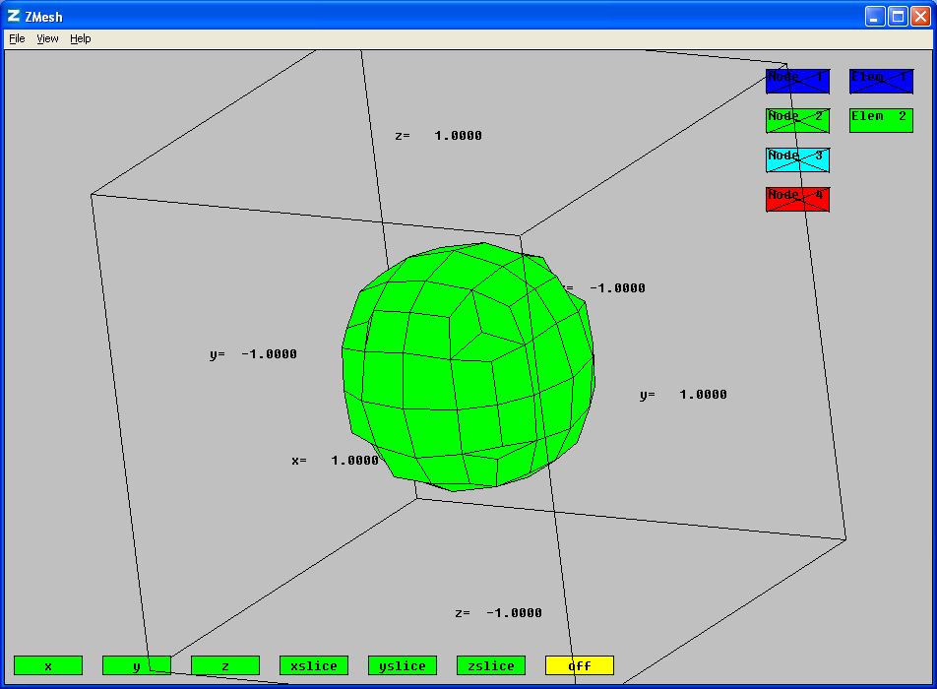
Fig.6: Spherical region is exposed by switching off the elements of Region 1.

The elements of Region 2 can be switched off by pressing the button ‘Elem 2’ and so on. Nodes can also be toggled on or off by clicking on the key symbols marked ‘node 1’ etc. The geometry of the nodes is best seen by dragging. Repeated pressing of all buttons simply toggles between two possible states; visible or invisible. In Fig.7 is shown the result of retaining the elements of Region 2 but showing the nodes.

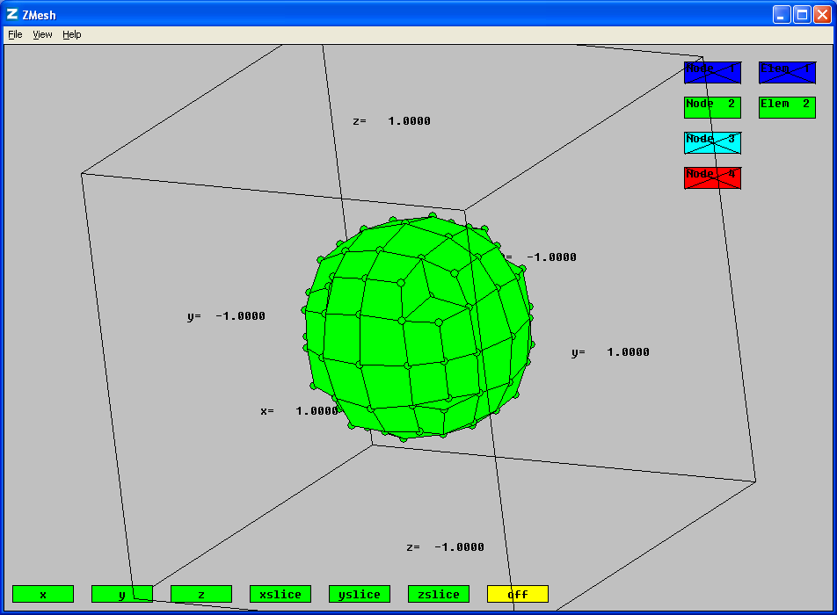
Fig.7: Elements and nodes of spherical region shown by a suitable choice of active buttons.

The colours of the nodes and elements can be changed by right-clicking on node or element buttons on top right hand side of the window. The colour is selected by specifying the mix of primary colours using the Set Colour dialogue box (see Fig.8). The result of changing node colours is shown in Fig. 9 while the result of changing element colours is shown in Fig.10.

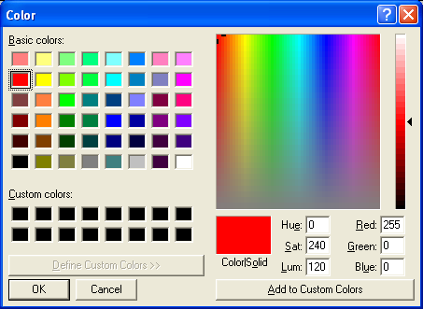
Fig.8: Dialogue box for selecting the colours of elements and nodes.

Pressing the ‘xslice’, ‘yslice’ or ‘zslice’ buttons shows only a slice of the model in the x, y, or z directions. The location of the slice can be changed using the Up/Down arrows on the keyboard. While doing this, you can continue to rotate the system by dragging or use keys A/Z or N/M normally. An example is shown in Fig.11 where the slice intersects both Regions 1 and 2. The elements for Region 2 can be switched off in a slice as shown in Fig.12.

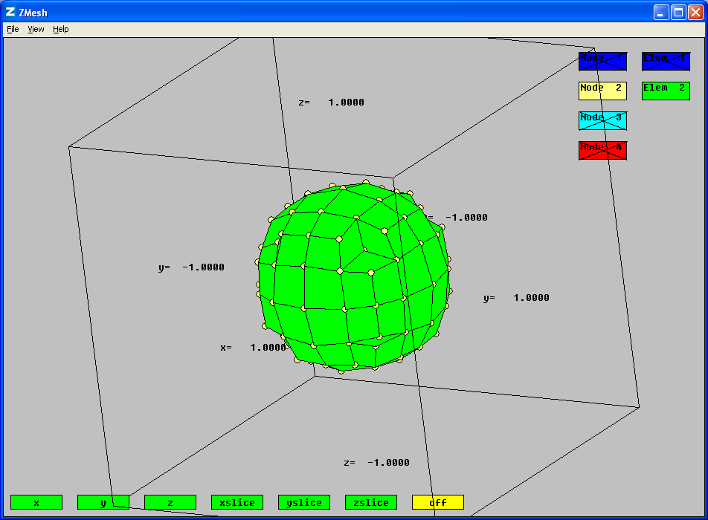
Fig.9: The result of changing the colours of the nodes of the spherical region.

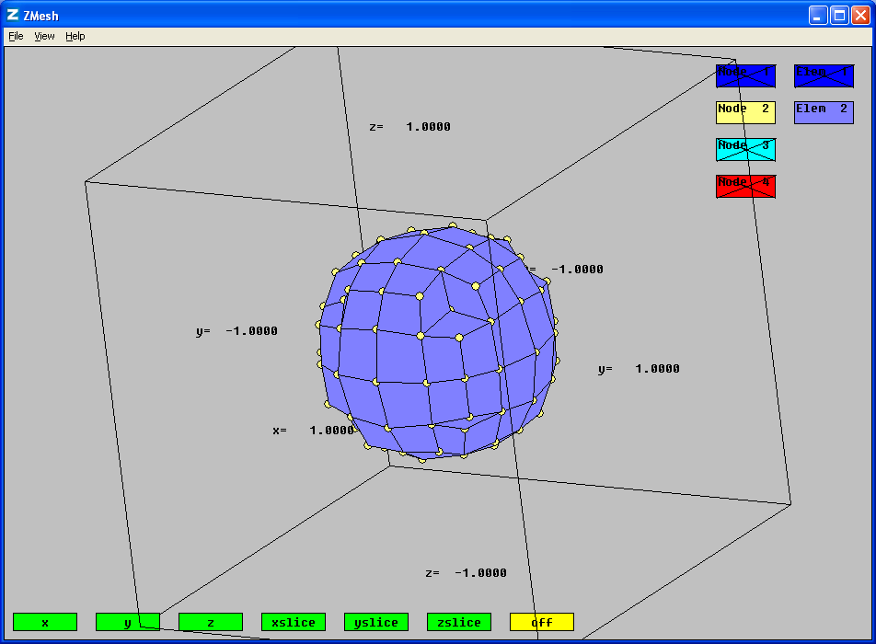
Fig.10: The result of changing the colours of the elements of the spherical region.
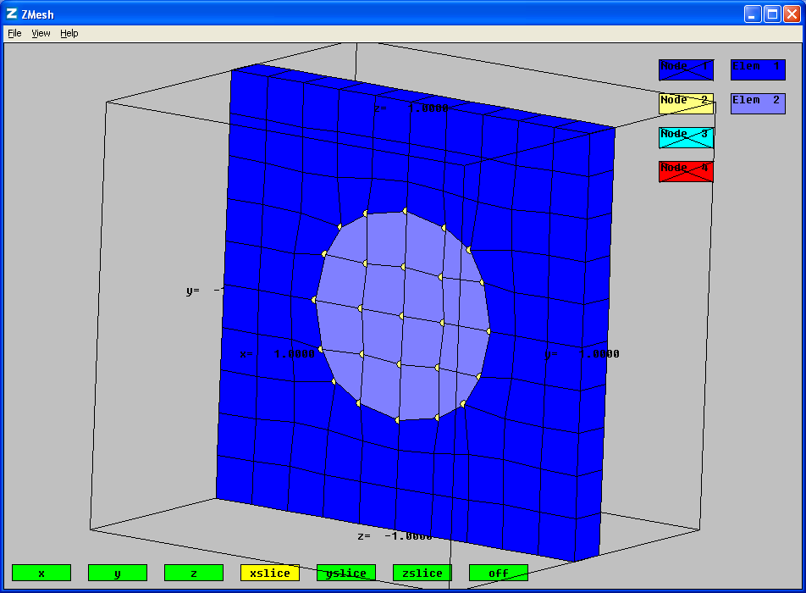
Fig.11: Example of a slice through Regions 1 and 2.

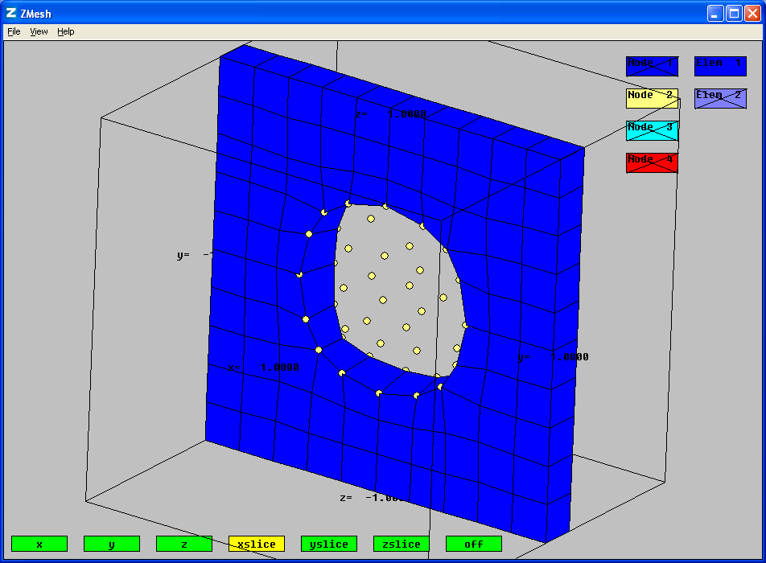
Fig.12: Example of a slice through Region 1 where elements for Region 2 are switched off.

In this case, the mtf file that is generated by Zmesh.exe is:

IMax: 10
JMax: 10
KMax: 10

I J K x y z RegNo RegUp
========================================================================
0 0 0 -1.0000E+00 -1.0000E+00 -1.0000E+00 4 1
1 0 0 -7.9998E-01 -1.0000E+00 -1.0000E+00 4 1
2 0 0 -5.9995E-01 -1.0000E+00 -1.0000E+00 4 1
3 0 0 -3.9991E-01 -1.0000E+00 -1.0000E+00 4 1
4 0 0 -1.9992E-01 -1.0000E+00 -1.0000E+00 4 1
5 0 0 2.2495E-05 -1.0000E+00 -1.0000E+00 4 1
6 0 0 1.9996E-01 -1.0000E+00 -1.0000E+00 4 1
7 0 0 3.9992E-01 -1.0000E+00 -1.0000E+00 4 1
8 0 0 5.9993E-01 -1.0000E+00 -1.0000E+00 4 1
9 0 0 7.9996E-01 -1.0000E+00 -1.0000E+00 4 1
10 0 0 1.0000E+00 -1.0000E+00 -1.0000E+00 4 0
0 1 0 -1.0000E+00 -7.9998E-01 -1.0000E+00 4 1

Etc. …………

The MTF file is not mysterious, it is just a text file showing the locations of nodes, their Region, and their connectivity to neighbouring regions. This file is read in by the program Zincwin (see later). Normally, the user does not have to look at this file.

Input file *.zin

ZINC requires information that controls the performance of the software, materials data for each region, and data relating to boundary conditions that are not set by default. For the dielectric problem this information is given in the following *.zin file:

solver=SOR ! Specifies Successive Over-Relaxation solver
nvar=1 ! No. of unknown variables (in this case just one: electrostatic potential)
itmax=10000 ! No. of iterations
omega=1.5 ! Successive over-relaxation parameter (<2)
tol=1e-12 !
scale=1 ! scaling factor for lengths found in *.mtf
labels=V ! List of unknown variables (nvar in number)

region 1 elements C !For elements of Region 1 the are 3 non-zero
!coefficients of ZINC matrix C
1 1 1 1 = eps1
1 2 1 2 = eps1
1 3 1 3 = eps1
end

region 2 elements C !For elements of Region 2 the are 3 non-zero
!coefficients of ZINC matrix C
1 1 1 1 = eps2
1 2 1 2 = eps2
1 3 1 3 = eps2
end

region 3 nodes 1 values !For nodes of Region 3 there is 1 value 1.0 for unknown variable
V = 1.0
end

region 4 nodes 1 values !For nodes of Region 4 there is 1 value 0.0 for unknown variable
V = 0.0
end

init !Initial value 0.0 for unknown variable
V = 0.0

In this problem, as specified in Eq (8), the C matrix coefficients are just the permittivities. In this simple case, all regions are isotropic so permittivities 11=22=33. Note that coefficient 1111 is permittivity 11; 1212 is permittivity 22 etc. The first and third index numbers refer to the variable while the second and forth relate to spatial dimension (See User Manual, Chapter 4). In this case, there is only one variable so all indexes are 1x1y. It would, of course, be easy to simulate an anisotropic dielectric rather than an isotropic one as in this example.

The constants “eps1” and “eps2” are in the constants file, dielectric.con. They specify the permittivity of both regions. You can easily change these permittivities without altering the dielectric.zin file. In this case the dielectric.con file looks like this:

eps0=8.854e-12
eps1=eps0
eps2=eps0*2

As of Zinc 3.6, the region specification blocks for the C-matrix can be written in a different format which is more reminiscent of a permittivity matrix:

region 1 elements C
1 1 = [eps1, 0, 0, &
0, eps1, 0, &
0, 0, eps1]
end

where the “1 1” refers to the block index within the overall block matrix C. In this case, there is only one block because we are solving for only one variable, V. In multiphysics problems there will be multiple blocks. You can also see the use of the continuation character “&”. In fact the above text is identical to

region 1 elements C
1 1 = [eps1, 0, 0, 0, eps1, 0, 0, 0, eps1]
end

but more readable.

Running the simulation

Having prepared the Zinc input file, it is time to run the actual simulation using Zinc shown in Fig 13. Zinc also pops up an additional console window. As Zinc runs, information about convergence is written into the console window.

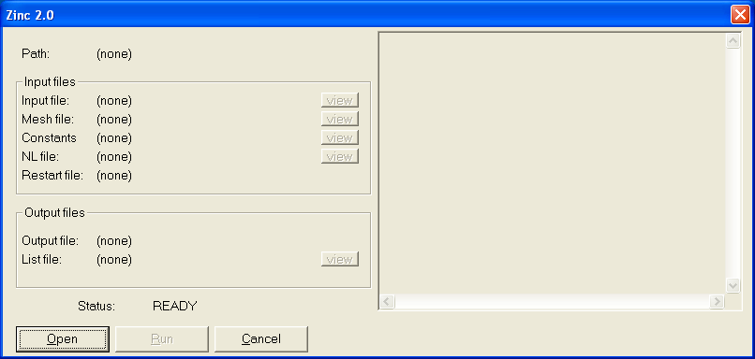
Fig 13: Zinc (core) window

Now, use the Open button to select the file dielectric.zin, Fig 14

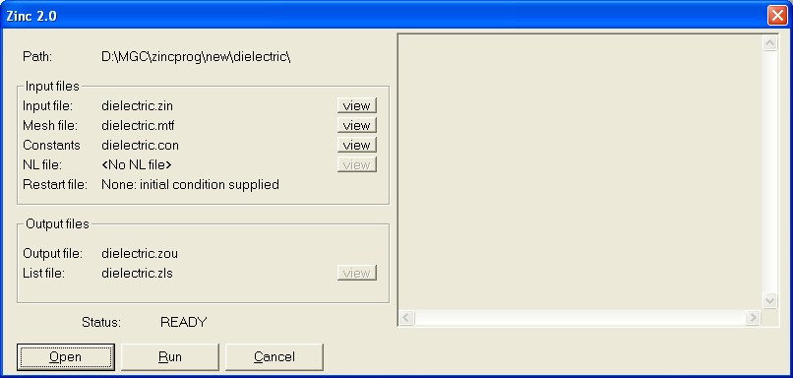
Fig 14: Zinc window with “dielectric.zin” selected.

The program checks all input files are present and shows the filename of each. To run Zinc, at least an input file (*.zin) and a mesh file (*.mtf) are needed. The constants and non-linearity (NL) files are optional. A restart file is needed only in the case restart=filename (which means, “take the initial state from another Zinc run”). Since we did not specify restart it defaults to NONE, so this is file is not needed.

You can view any file by clicking on the “view” button next to it. In Fig 15, we are viewing the *.zin file. Note that the program does not allow you to edit files, you should use a text editor to do that. You can just use Notepad, but a programming text editor is probably better. We personally use Emacs, but there are many free editors to chose from.
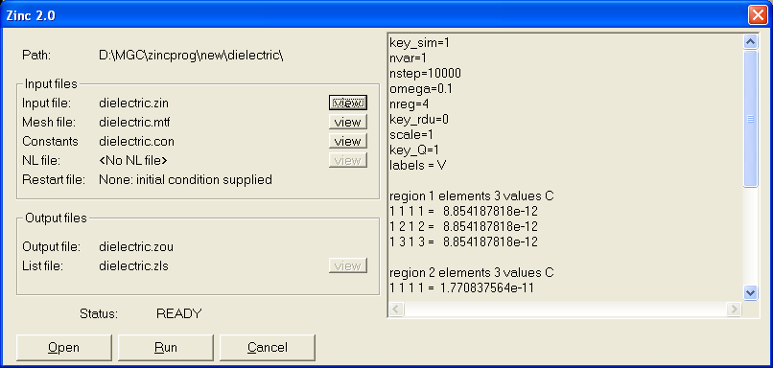
Fig 15: Viewing one of the input files

If all seems to be in order it is now time to run Zinc. Press the “run” button. In the console window you will see output shown in Fig 16.

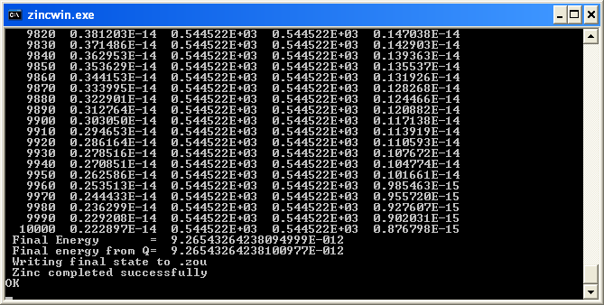
Fig 16: Output console window showing simulation convergence.

The number of time steps is shown in the first column. Here we are running up to 10,000 time steps. The second and fifth columns show “residuals”: numbers which should get low when an approximate solution has been found to the problem. The 3rd and 4th columns show a number which approximates the “left hand side” and “right hand side” of the set of equations to be solved. These numbers should be equal to each other. Clearly in this simulation, a solution has been found to good accuracy. The final energy of the system is output using two different calculations. These numbers should be very similar to each other. If they are not an error has occurred. (they should always be nearly identical)

Viewing the output.
Once the simulation has completed, the Status shown returns to “READY” and the Zinc list file *.zls becomes viewable (Fig 17). This file contains information about Zinc’s input reflecting the specifications in the *.zin file and also memory usage and convergence information. Note that all the components of the Zinc matrices c, a, f, g, q are listed in this file, including the zero ones so the user can check what was actually set up (recall that we only set the c values in the *.zin file so all other matrices should be full of zeros in this simple system)

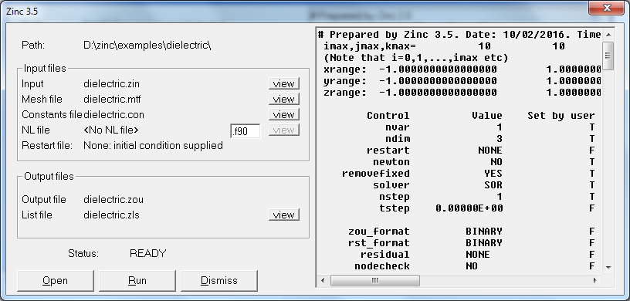
Fig 17: Viewing the ZLS output file in a completed run

As Zinc shows us, the output file containing the simulation result in *.zou. This file is not viewable, because it is not intended to be human readable. By default, the *.zou file is in binary format. However, you can set it to ASCII format using the command zou_format=ASCII in the *.zin file. Then you can examine the file using a text editor. Normally, you will examine this file using Zmesh or Zpp.

Note that the output files are automatically saved to disk with the names *.zou, and *.zls. There is no need to save the files manually.

Zinc is now complete and you dismiss the window by pressing Dismiss.

A quick look at the result

We can get a simple view of the data using Zmesh. In Zmesh, open the zinc output file, dielectric.zou using the File > Open ZOU option as shown in Fig 17. We can see from the figure that the boundary conditions V=1 and V=0 Volts have been satisfied. In systems with more than one variable, you can switch between the different variables using buttons at the top-left of the screen. The usual features to hide regions and take slices are still available. Fig 18 shows a slice through the data. Note that the inner region (region 2) has been set to show the region number (i.e. pink=2) while the outer region is colour-coded to show the Voltage data (refer to the colour legend on the left). When viewing a ZOU file, the colour key elements on the right of the screen now have three states on / DATA / off.

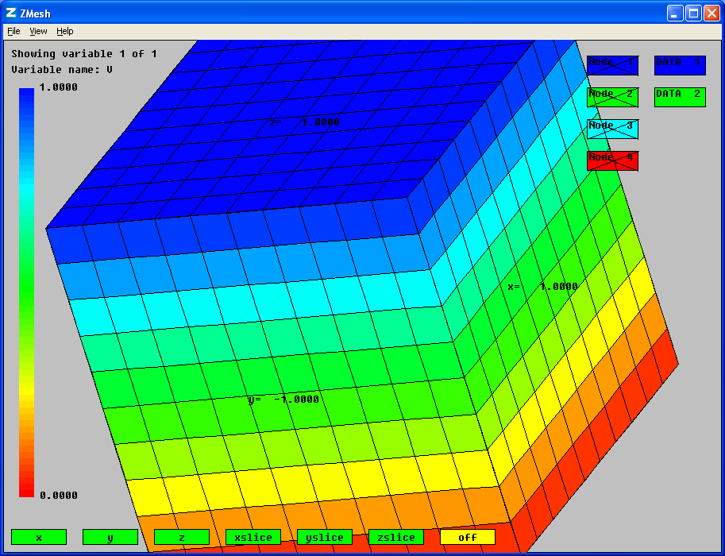
Fig 17: Viewing the simulation output (ZOU) file

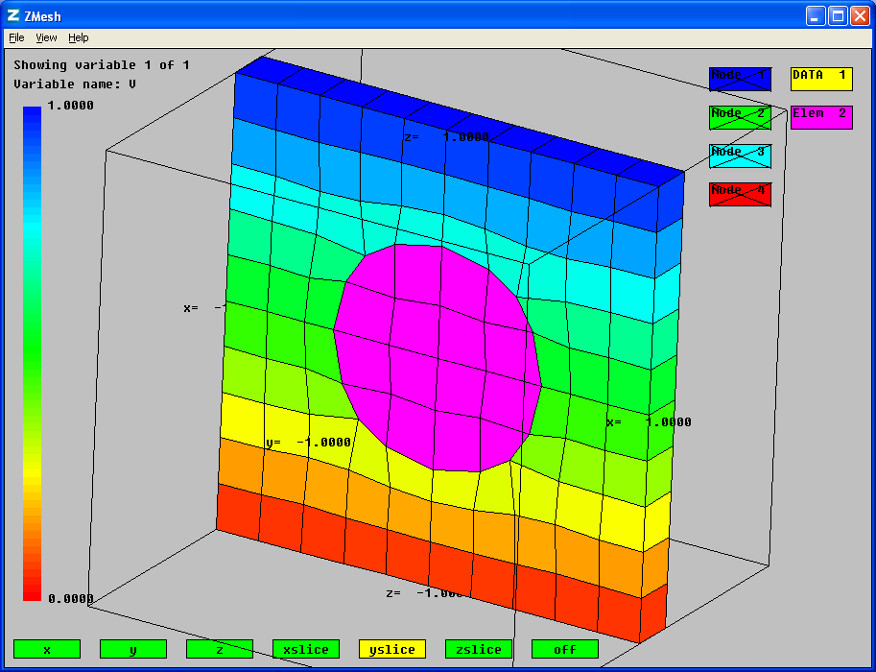
Fig 18: Slice view through the data showing simulation result in region 1.

Post processing

We now wish to examine the output of the simulation using ZPP (the Zinc post processor). This program allows us to take various “scans” through the data and prepare graphs either of the simulated quantities (electric potential in this case) or quantities derived from these. In particular, we will show how to calculate the E-field and D-field.

Open a new text file called *.zpp (Zinc post processor) and type in the following.

graph=emf ! output emf files
ftol=1e-3 ! tolerance for fitting

! N x1 y1 z1 x2 y2 z2

linescan 100 0.101 -0.3 -1.0 0.101 -0.3 +1.0 = V
linescan 100 0.101 -0.3 -1.0 0.101 -0.3 +1.0 = V^2
linescan 100 0.101 -0.3 -1.0 0.101 -0.3 +1.0 = -Vz
linescan 100 0.0 0.0 -1.0 0.0 0.0 +1.0 = -Vz
linescan 100 0.0 0.0 -1.0 0.0 0.0 +1.0 = &
-{1=eps1,2=eps2}*Vz

! yplane y x1 x2 z1 z2 Nx Nz

planescan 2 0.0 -1.0 1.0 -1.0 1.0 40 40 = V
planescan 2 0.0 -1.0 1.0 -1.0 1.0 40 40 = &
-{1=eps1,2=eps2}*Vz

Here we are requesting 7 scans, 5 linescans and 2 planescans. Linescans are cuts through the data along a line. The first one is a line scan with 100 points between coordinates (0.101,-0.3,-1.0) and (0.101,-0.3,+1.0), i.e. it is a scan along the z-direction. The function to be plotted is shown after the equals sign. In the first line scan, it is V, the electrostatic potential. Zppwin knows about “V” because it also reads the *.zin input file in which, we recall, we put the command

Labels = V

The labels command is optional: if you did not use it you’d have to refer to the default name u1 instead of V. In multi-variable simulations, the default names are u1, u2 etc. Clearly it is more readable to specify a mnemonic name using the “labels” command.

The file illustrates the use of comments (with !) and the continuation character (&) for splitting lines which are uncomfortably long. Whether split or not, each scan command should not be more than 1000 characters long.

Having prepared the *.zpp file, launch ZPP and select the file using the “Open” button as shown in Fig 19

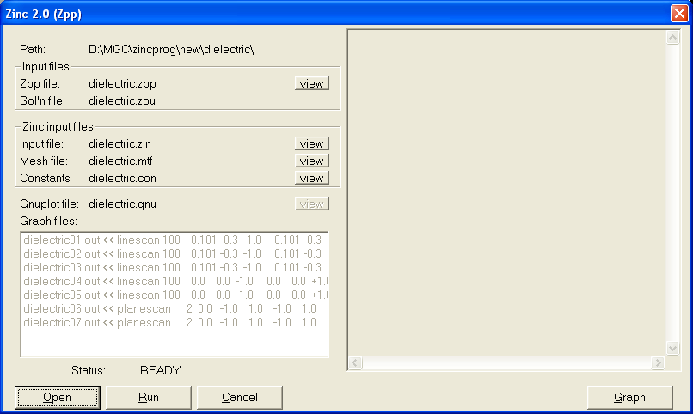
Fig 19: Creating scans through the data using ZPP

The main input files used by Zpp are *.zpp and *.zou (the simulation solution). Zpp will complain if any of these are absent. Zpp also reads *.zin, *.mtf and *.con as used by Zinc (core solver) so these must also be present. As before we can examine files, using the view button as shown in Fig 20

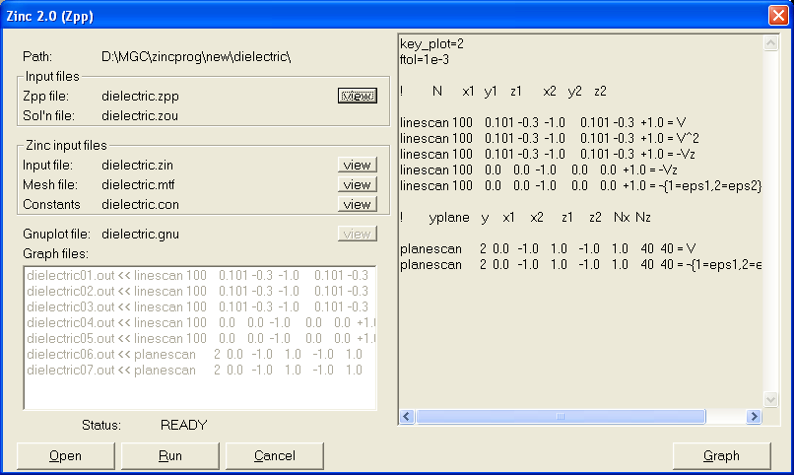
Fig 20: Viewing the dielectric.zpp input file which specifies line and plane scans.

If all is well, run the post processor using “Run”. Once the post processing is complete, the “graph files” list becomes active. This list shows us which datafiles correspond to which of the selected scans. For example dielectric01.out will contain the first linescan requested. Clicking on this line, as illustrated in Fig 21, allows us to view the file.

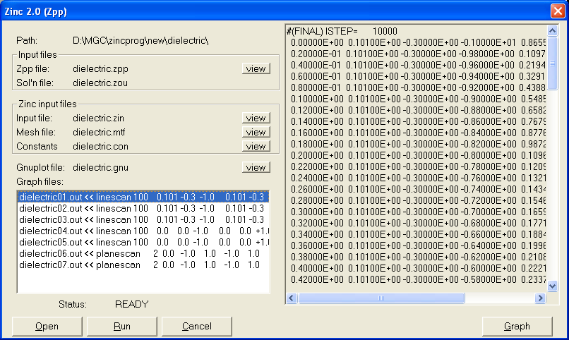
Fig 21: Once a run is complete the “Graph files” list is active and we see the resulting graphs

But it’s much more fun to view this as a graph! To do this, click “Graph” at the bottom right of the window. Another window pops up, Fig 22, showing the graph. In this case, it is a graph of voltage versus distance along the z-axis. The voltage goes from 0 to 1 V as we expect and there is a “kink” in the middle where the high permittivity sphere is located.

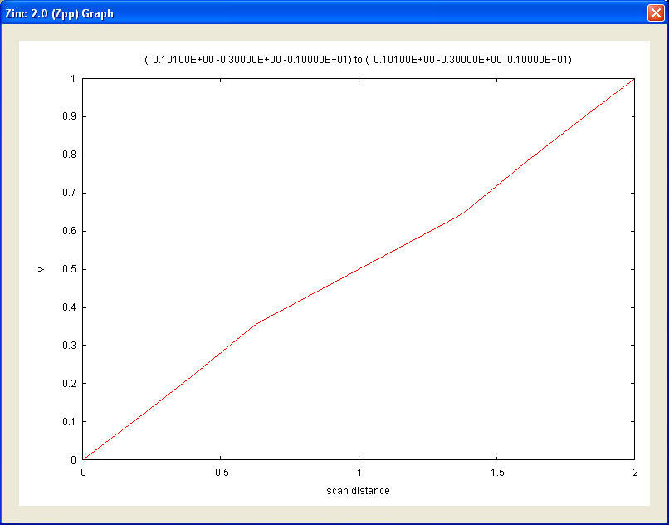
Fig 22: Variation of voltage through the sample

You can look at the other graphs using the Next or Prev buttons on the graph window, or by returning to the listbox in the zppwin window. Note that there is no need to save any of these files: they are automatically saved when we run zppwin. In fact two types of files are saved in this case, the dielecticxx.out files which contain a table of numbers corresponding to the scan and the dielectricxx.emf which contain the actual graphs. Graph files are only generated if graph is EPS or EMF which create encapsulated postscript and enhanced metafiles respectively. Graph previews within zppwin are only available for emf files, graph=EMF. To view EPS files, you’ll need to install Ghostview, a free program. It depends which word processor, you intend to import graphs to. EPS graphs are suitable for LaTeX, while EMF are suitable for Microsoft products, like Word and Powerpoint. Both these graph formats are vector based.

Fig 22 is the second of the two plane scans showing D_{z}, the z component of the D-field.
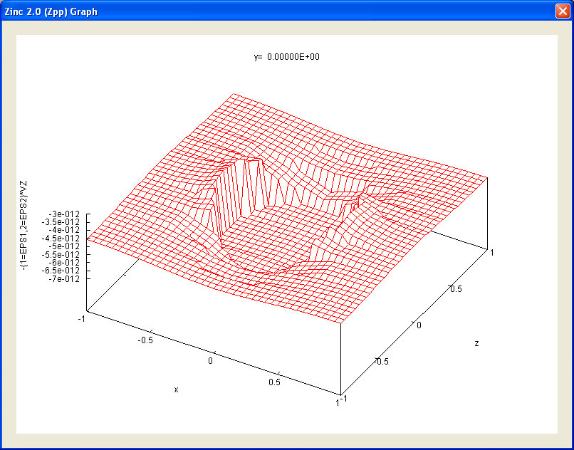
Fig 23: Plot of Dz (C/m²) through the central plane of the system

Let us look at the command which generated this plot:

planescan 2 0.0 -1.0 1.0 -1.0 1.0 40 40 = &
-{1=eps1,2=eps2}*Vz

The {1=eps1,2=eps2} conditional expressions means
“if we are in region 1, use value eps1; if we are in region 2, use value eps2”.

Here eps1 and eps2 are parameters appearing in the *.con file:

eps0=8.854e-12
eps1=eps0
eps2=eps0*2

As we scan in the plane indicated we will move between region 1 and region 2 (inner sphere) areas. The appropriate value of permittivity needs to be taken in each case. The expression is then -eps*Vz. Vz means dV/dz. This is the standard notation used by Zinc: since we have given potential the name V, the derivatives can be accessed using “Vx, Vy, Vz”. Thus, the whole expression is eps*Ez=Dz, and we are plotting the z-component of the electrostatic displacement field, D.

The parameters after the planescan command indicate what sort of scan is needed. “2” means perpendicular to the y-direction. –1.0 1.0 means scan x between [-1.0,1.0]. The next “-1.0 1.0” means z=[-1.0,1.0]. “40 40” is the number of points requested along each direction.

The meaning of the other scans should now be apparent. Note that quite arbitrary functions involving the variables solved for and the constants in *.con can be used. The second line scan plots V^2 which is the potential squared. In expressions like these, all the usual operators are allowed and the functions sin, cos, tan, exp, log etc can be used also. (see the Zinc User Manual, Chapter 5 for more information)

Traceability
Before continuing this tutorial, a quick word about traceability. In running the dielectric simulation we have generated 33 files:
Dielectric.zin
Dielectric.min
Dielectric.mtf
Dielectric.con
Dielectric.mls
Dielectric.zls
Dielectric.zou
Dielectric.zpp
Dielectric.gnu
Dielectricxx.out xx=01 to 10
Dielectricxx.emf xx=01 to 10

This might seem like rather a lot of files but this structure provides traceability. Imagine 6 months down the line you look at file dielectric01.emf and wonder “how on earth did I generate this graph?”. By looking at dielectric.zpp, we can see that it is a line scan between such-and-such points of the electric potential, V. But how did we get this simulation in the first place? By looking at dielectric.zin (physics) and dielectric.min (geometry) we can see exactly how the simulation was run. We can then reproduce the same simulation or a variation of it easily. Furthermore, the actual numbers that were used to plot the linescan in dielectric01.emf are present in dielectric01.out so you can regenerate the graph using any prefered graph plotter. Thus, the Zinc, text-based, file-based paradigm give clear traceability and is superior to the “nested dialog box” approach used by most FE packages. With these other packages, it is common to end up with graph image files and have no idea how you generated them!

Furthermore, almost all Zinc input and output files are in text format so there is no mystery about what anything means. Zinc does not use any proprietry file formats. The main solution output ZOU file is in binary by default but this is purely for the sake of accuracy: binary format allows numbers to be stored with full machine precision and reloaded easily when using the “restart” command. However, you can tell Zinc to output ZOU files in text format using the command zou_format=ASCII in the ZIN file.

More advanced graph plotting
We’ve seen that Zpp can generate basic graphs which give a good immediate insight into what is happening in the simulation. For publication, however, these graphs are probably not sufficient. For a start it will be necessary to re-label the y-axis of most graphs. Labels like
-{1=eps1,2=eps2}*Vz don’t mean much to most people! Zinc, of course, just labels the axes with the formula you give it: it doesn’t know the physics, nor the right units to use. Beyond this, it might be necessary to compare two curves on the same graph with a legend to distinguish them. Or, we might want to compare FE simulation results with theory or experimental data obtained from elsewhere.

Zinc creates its graphs by running gnuplot, an open source graph plotting package bundled with the Zinc distribution. The script file used to generate the graphs is shown called *.gnu and can be viewed by pressing the view button, shown in Fig 24.

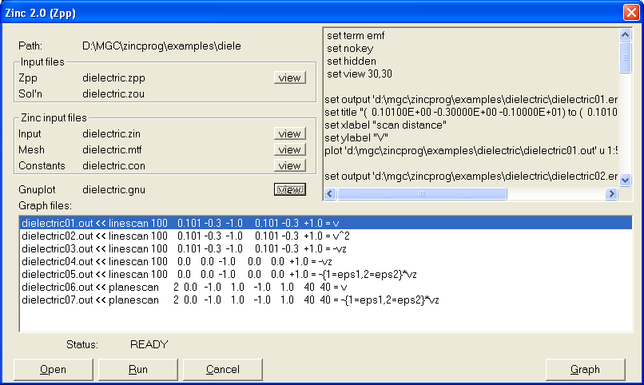
Fig 24: The gnuplot script file used to generate the graphs

The gnuplot file consists of a series of commands most of which revolve around the “plot” command. There are also lots of “set” commands. In this case we are setting the “term(inal)” to be emf so that gnuplot will output enhanced metafiles.

Let’s consider the first plot command in this file

set output 'd:\mgc\zincprog\examples\dielectric\dielectric01.emf'
set title "( 0.10100E+00 -0.30000E+00 -0.10000E+01) to ( 0.10100E+00 -0.30000E+00 0.10000E+01)"
set xlabel "scan distance"
set ylabel "V"
plot 'd:\mgc\zincprog\examples\dielectric\dielectric01.out' u 1:5 w l

This instructs gnuplot to plot the file dielectric01.out to make graph file dielectric01.emf. “u 1:5” means use columns 1 and 5 (resp.) for the x and y axes. “w l” means “with lines” ie datapoints are connected using lines. For more information about the gnuplot commands, see the gnuplot manual and tutorials. However, a lot can be gleaned from the default gnuplot script file generated by Zpp.

So how do we improve the graph quality? All gnuplot does it plot the *.out files. Since these files are still present on disk, we can replot these files in different ways as needed. The best way is to create a new gnuplot script file and run it through gnuplot. [In principle, one could just alter dielectric.gnu (in this example), but this file will be overwritten next time zppwin is run so its probably better to use a new file.] We will now prepare a file to

1) plot the first linescan with better labelled axes
2) plot the two Ez linescans in the same graph with a legend
3) plot the Dz planescan as a colour grid rather than a surface plot.

Create a text file called “comp.gnu” and enter the following

set term emf mono dashed

set output 'vscan.emf'
set xlabel 'Scan distance (m)'
set ylabel 'V (Volts)'
unset key

plot 'dielectric01.out' u 1:5 w l

set output 'Ezscan.emf'
set ylabel 'Ez (V/m)'
set key

plot 'dielectric03.out' u 1:5 t 'x=0.1 m' w l,\
'dielectric04.out' u 1:5 t 'x=0.0 m' w l

set output 'Dzmap.emf'
set title 'Dz (C/m^2)'
set xlabel 'x (m)'
set ylabel 'z (m)'
set size square
set pm3d map
splot 'dielectric07.out' u 1:3:4

By now, you should have a rough idea of what this is doing, but consult the gnuplot manual for further details. We are simply plotting the files dielectric01.out, dielectric03.out, dielectric04.out and dielectric07.out with slightly more advanced formatting.

There are several ways to run gnuplot. If you are unfamiliar with the command prompt, the simplest is to start gnuplot from its desktop/start menu shortcut producing the window in Fig 25.
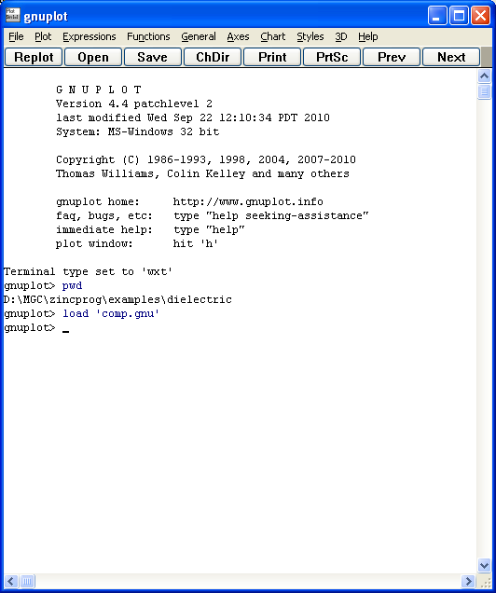
Fig 25: The gnuplot window

First make sure you are in the right directory using the pwd command (as shown in Fig 25) and change directory using the cd command if necessary. Then use the “load” command to run the script file you’ve prepared (comp.gnu in this case). If all goes well the graphs are created in the same directory.

Tip: Note that we did not type in the full file path for the *.out files in comp.gnu. This is because gnuplot works in the current directory by default.

Another Tip: You can also operate gnuplot interactively by typing commands one at a time instead of “load”ing them in. If you do not specify “set term”, by default the graph will be plotted in a separate window which is useful for interactive plotting and exploring. You can also cut and paste directly from this window if you like. If you make a change to some setting (eg the graph title) use “replot” to replot the same graph again.

If you are familiar with using the command prompt, you can simply run gnuplot at the command line with the script file as an argument, fig 26
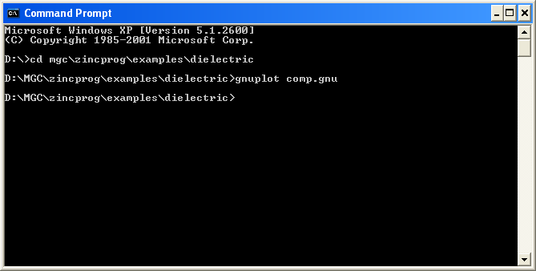
Fig 26: Running gnuplot under batch control

If all goes well the graph files are silently created (in the same directory). The three graphs generated are shown in Figs 27-29.
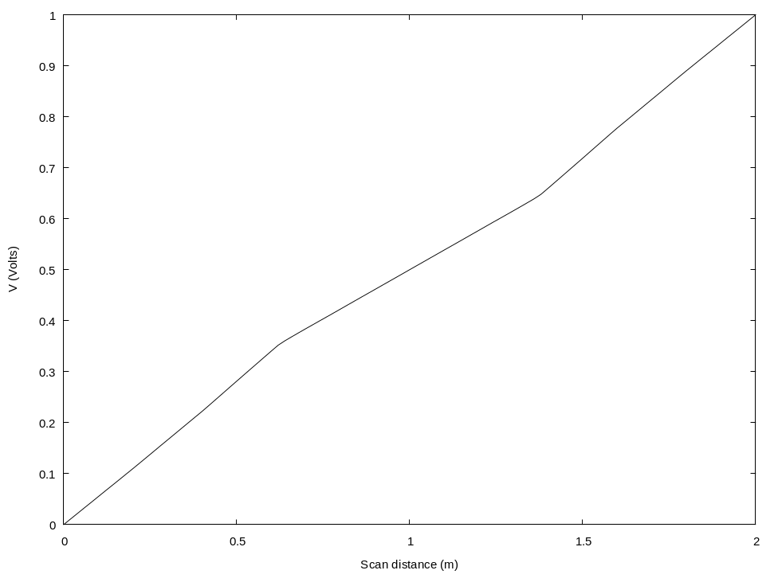
Fig 27: Graph plotting with better axis labelling
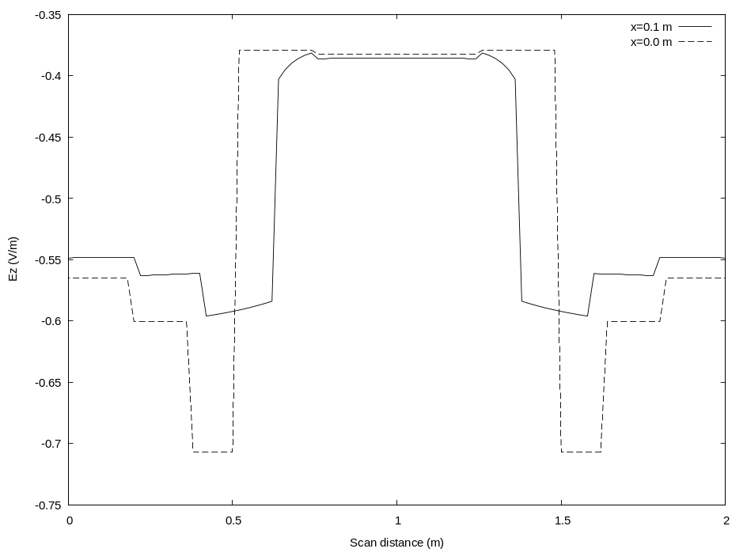
Fig 28: Graph with two curves and a legend.
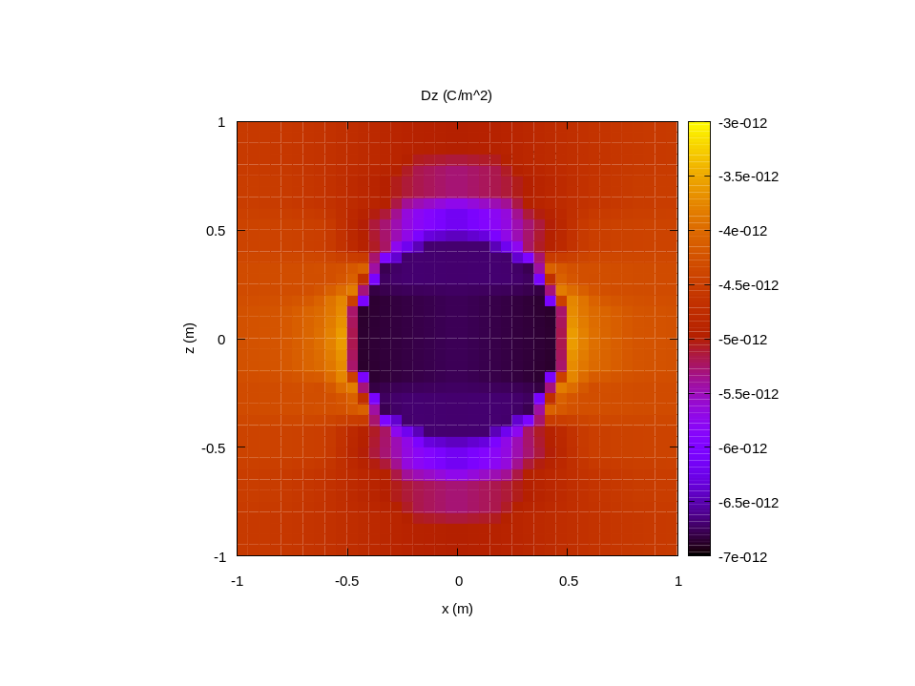
Fig 29: Colour coded graph of Dz

Figs 27 and 28 were prepared in black and white (with dashed lines) which is more usual for journal papers.

This is just a taste of the graphs one can prepare using gnuplot. The full range of graphs commonly found in papers (inset graphs, multiple axes, histograms, vector fields, error bars etc) can all be generated using gnuplot.

For completeness, Fig 30 shows the same 3 graphs rendered as EPS (encapsulated postscript) and being viewed using ghostview (freeware). EPS is the normal graph format when using LaTeX: it arguably gives the best quality graphs.

If you don’t like gnuplot
You don’t have to use it! Since the data being plotted is created and stored as *.out files, you can plot it using any spreadsheet program or graph plotter. Or you could use scripting languages like Matlab to read the *.out files and prepare graphs. It’s also possible to get Matlab to write Zinc’s input files, call Zinc and read in and plot the resulting graphs thus automating the use of Zinc.

Also in the directory
Dielslap.zin: Exactly the same simulation but with solver=GMRES_LU. That is, the equations are solved using the diagonally scaled Generalised Minimum Residual solver with LU factorisation as pre-conditioner. See the Zinc User Manual (Chapter 5) for more information about different solvers. The simulation result is almost identical. SLAP refers to the open source Sparse Linear Algebra Package which Zinc uses to provide this solver.
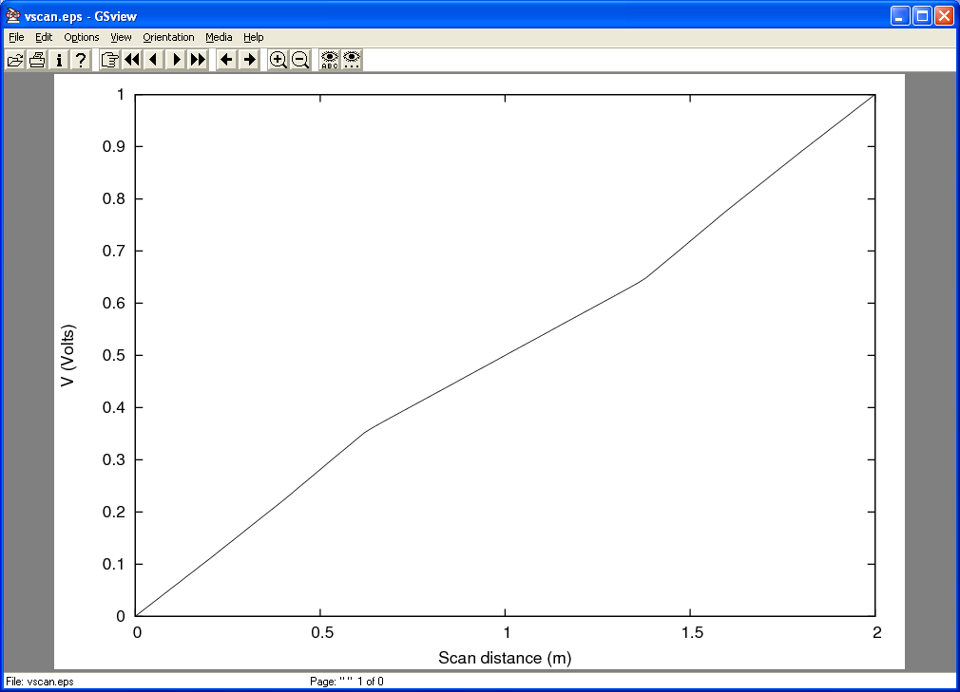
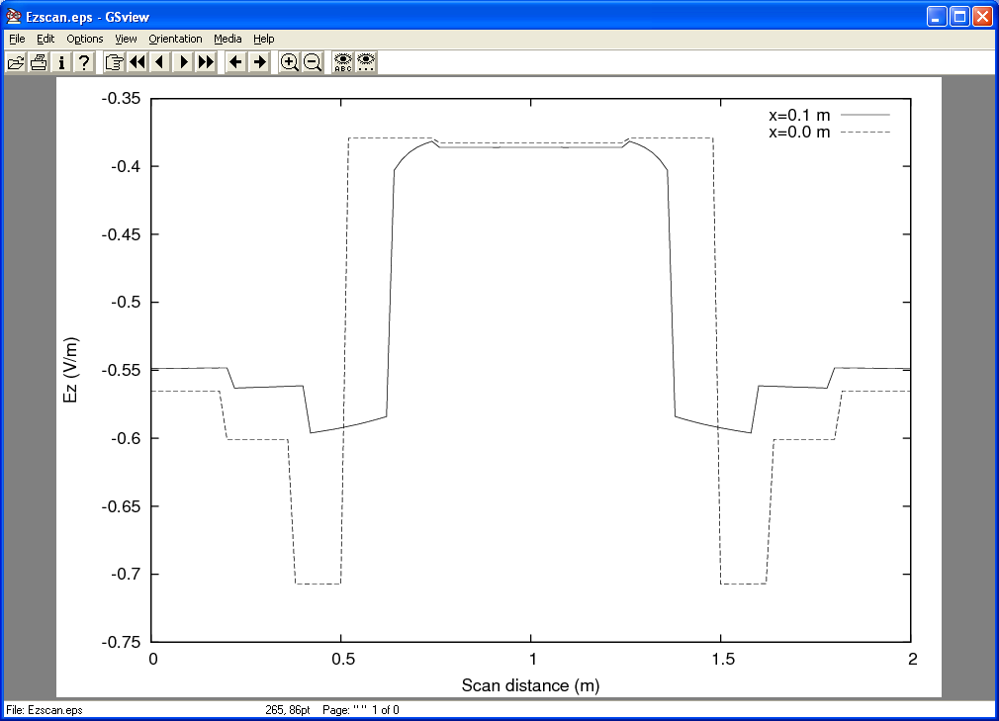
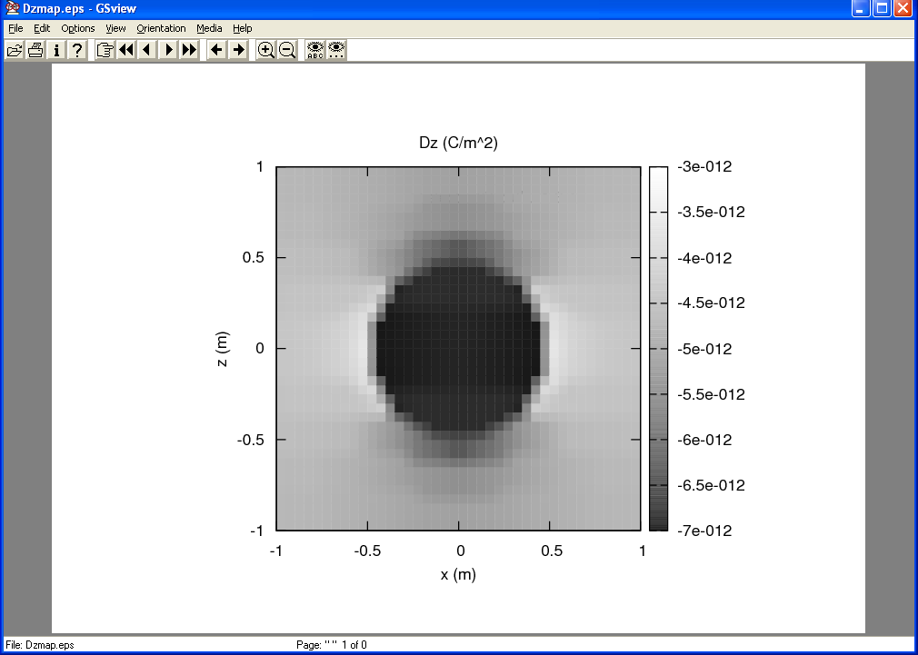
Fig 30: Encapsulated postscript graphs generated by Zinc using graph=EPS

Example 2: piezoelectric example

Directory: examples/piezo

Introduction

We now consider a piezoelectric problem. Here there are 4 variables to solve for, the x, y, z components of elastic displacement (ux, uy, uz) and the electrostatic potential (V). This is our first multiphysics problem. However, note that the problem is still linear.

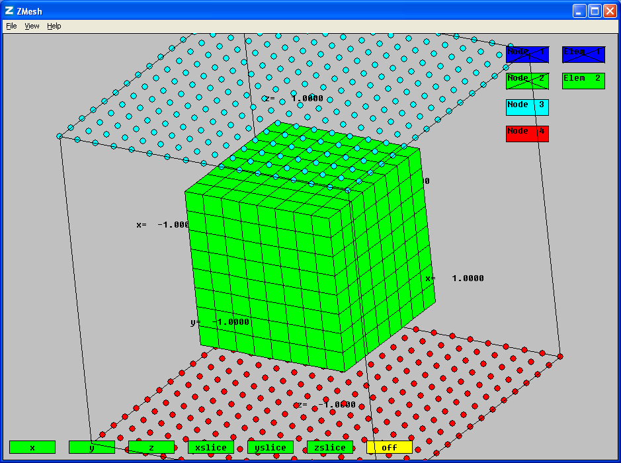
Fig 1: Piezoelectric simulation consisting of two piezoelectrics (cube in a cube). Region 3 nodes (cyan) are clamped and fixed at 1V. Region 4 nodes (red) are clamped and fixed at 0 V.

We consider a very simple geometry as shown in Fig 1. The outer area is a piezoelectric known as PZT-5H while the inner area is a fictitious material with 10 times greater stiffness and the same piezoelectric constant and permittivity. The top and bottom row of nodes shown in Fig 1 are fixed in terms of all the variables: the displacements are fixed at zero (u_{x} = u_{y} = u_{z} = 0) while the potential is set at 1 V (top) and 0 V (bottom). In Zinc, it is, of course, possible to fix only a selection of the variables on each node. Here we will fix all variables. We will set the Zinc matrices g = q = 0 (the default) which results in a zero-stress, zero-charge boundary condition at the x and y minimum and maximum edges. The simulation is rather similar to that of Example 1 but with extra elastic interactions.

In Chapter 4 of the User Manual, the full C matrix for a multiferroic material is derived. We won’t need all of that matrix since we are only solving for a piezoelectric. In fact, the C-matrix is given by the top left portion of that multiferroic matrix:

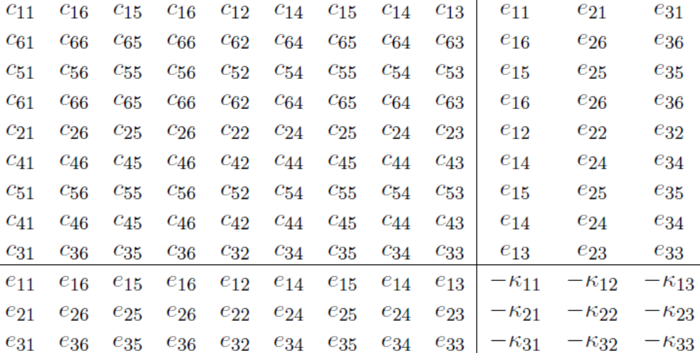

where c₁₁ etc are the elastic stiffnesses (N/m²), e₁₁ etc are the piezoelectric constants (C/m²), κ₁₁ etc are the permittivities (F/m). The upper left block of this matrix gives the elastic behaviour, the lower right block gives the dielectric behaviour and is essentially the same as the matrix we derived in Example 1 (Dielectric model), except we now allow for anisotropy. The off diagonal blocks specify the elastic-electric coupling. See User Manual, chapter 4 for the full derivation of this matrix.

We will use “C” for the Zinc matrix and “c” for elastic stiffnesses. Although the two are related, it’s important not to get confused!

In our problem, all the other matrices can be set to zero as we have no body/surface forces or charges. If these were required the f matrix would be used for body forces and charges while the g matrix would be used for surface forces and charges. In the case of steady state, elastic vibration, the a matrix can be used to encode the material densities and vibration frequency, in fact the a vector would be given as

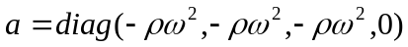

This will not be needed here, however, since we are modelling a static situation.

In the Zinc input file, piezo.zin, it is necessary to enter the C matrix in its component form. The equivalence is shown in Appendix A, equation A3. Thus, for example

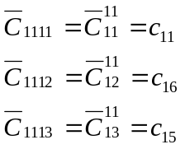
Etc…This is entered using in the ZIN file using

region 1 elements C
1 1 1 1 = 0.12600E+12 ! c11
1 1 1 2 = 0.00000E+00 ! c16
1 1 1 3 = 0.00000E+00 ! c15
:
end
etc

Note that, for example, that c₁₆ is just a conventional way to specify the stiffness tensor component c₁₁₁₂ (both in N/m²). Thus the Zinc C-matrix components corresponding to elasticity are simply the stiffness tensor components. The relation between tensor and matrix components for elastic stiffness is (in the standard convention):

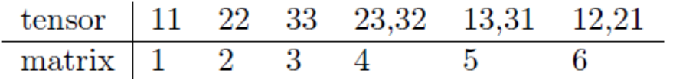

The Zinc input file piezo.zin is pretty long for this problem and is not all shown here (see examples/piezo/piezo.zin). In fact, we generated it automatically using a computer program. Thus, as can be seen above, we have set all the stiffness components even those which are zero. Also, we have input the constants directly rather than using constants in the piezo.con file. However, the piezo.con file is used for post processing.

Alternative: using tensor notation to discover the Zinc coefficients

In the above description, we have followed the matrix approach shown in Chapter 4 of the User Manual to derive the Zinc coefficients. However, there is another way to represent Zinc’s equation system: using tensor component notation. We can discover the Zinc components by direct comparison to this notation, which is more convenient in certain cases. Let us see how to do this for the piezoelectric system. We already know what answer to expect from the above analysis. In “tensor” notation, the fundamental Zinc equations have the form:

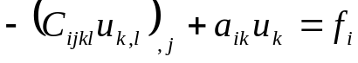 i=1,2,…N (1)

Where the “comma” notation f_{i,j} means ∂f_{i}/∂x_{j} and there is implied summation over repeated indices (By the way, this notation is commonly used in elasticity books and papers). Here, N is the number of equations which must be equal to the number of unknown fields. In the piezoelectric problem there are 4 unknowns (u_{x},u_{y},u_{z},V) which we will refer to, in (1), as (u₁,u₂,u₃,u₄). The constitutive laws for a piezoelectric can be written, in tensor notation as
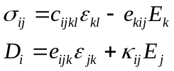 (2)
Where σ, ε, E and D are the stress, strain, electric and displacement field and c, e, κ are the stiffness tensor (rank 4), piezoelectric tensor (rank 3) and permittivity tensor (rank 2).
The equations of motion are given as

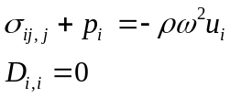 (3)

again with implied summation. Here p is the body force (N/m³), ρ is the density and ω is the angular frequency. The first equation comes from Newton’s laws of motion; the second is Gauss’s law for electrostatic systems (Maxwell’s first equation: 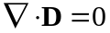). Putting (2) and (3) together and using the relation between strain and displacement 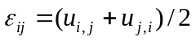and between voltage and electric field 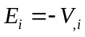gives:

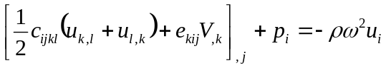 i=1,2,3
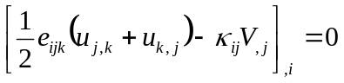
This may be simplified immediately by noting that 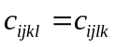and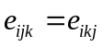. In that case
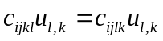
Since l and k are just dummy variables in a summation, we can set l→k and k→l so that
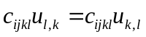
And the two terms after “c_{ijkl}” are the same. It is the same story for the two terms after “e_{ijk}” so we get:

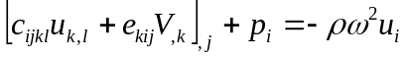 (4)
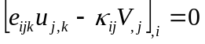 (5)

Rearranging (1) gives

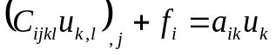 (6)

Comparing (4) and (6) it is evident that a₁₁=a₂₂=a₃₃=-ρω² and f_{i}=p_{i}. It is also clear that

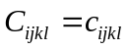 i,j,k,l = 1,2,3 (7)

For example, the Zinc component C₁₂₃₂=c₁₂₃₂=c₆₄ where we have used the tensor-matrix mapping discussed in the Introduction. (“c₆₄” is how the stiffness would be actually listed in data sheets). Let us now consider the summation

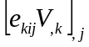

which appears in equation (4). The Zinc C-matrix must also contain this term. The voltage will be set as V=u₄ for k=4 in this term. Thus

In the second step, we have simply substituted k→l. It is clear from this that
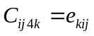 (8)

So, for example, C₂₃₄₁=e₁₂₃=e₁₄ where the last step comes from the tensor-matrix mapping in the Introduction. This is entirely in keeping with the C-matrix specified in the Introduction. If you check piezo.zin you will see that C₂₃₄₁ is indeed set to e₁₄ and so on.

Now let’s consider the term

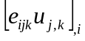

in equation (5). Note that the implied summation is over i, j, k with each variable going 1,2,3. In the Zinc formulation, (5) is the fourth differential equation that Zinc will solve so that

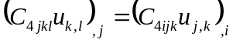

where we have used k→j, l→k and j→i. This has the same form as so that
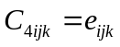 (9)

(eg C₄₁₂₃=e₁₂₃=e₁₄). Finally we can use the same analysis to show that

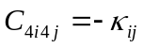 (10)

Equations (7)-(10) fully define the Zinc C-matrix and a bonus is we have it in component form and do not need to extract the components from a matrix as we would need to with the large matrix shown in the Introduction. The “tensor” and “matrix” methods are both valid and equivalent ways of finding the Zinc matrices. Which one to use depends on the way the equations are originally formulated. In problems involving elastic effects, equations will often be written in terms of individual spatial derivatives (as seen here) in which case the “tensor” approach is easiest and most natural. Equations involving vector calculus (grad, div and curl) may be easier to convert using the “matrix” approach. Electromagnetic, diffusion and quantum mechanical problems are often written with vector calculus.

Simulation
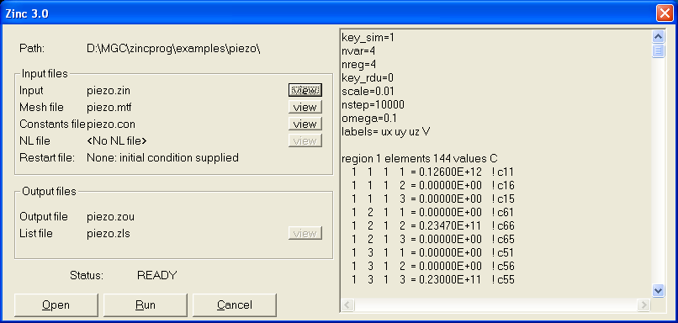
Fig 2: Zinc window ready for simulation.

Having set up the geometry and output the MTF file, we are now ready to run the simulation as shown in Fig 2.

Having run the simulation, we can take a look at the output using Zmesh, Fig 3.

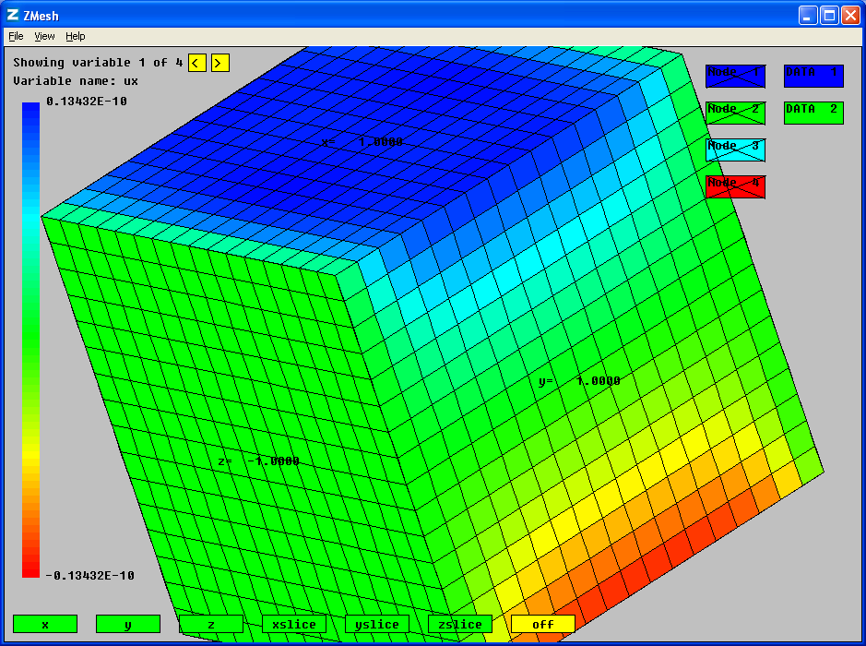
Fig 3: Showing the output using Zmesh. The Yellow < and > buttons can be used to cycle between the four variables solved for (u_{x}, u_{y}, u_{z}, V).

We now run Zpp to output scans through the data, Fig 4

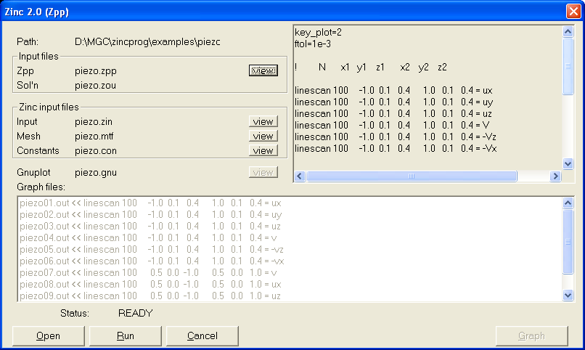
Fig 4: Post Processing with ZPP.

Let’s look at the piezo.zpp input file here:

graph=emf
ftol=1e-3

! N x1 y1 z1 x2 y2 z2

linescan 100 -1.0 0.1 0.4 1.0 0.1 0.4 = ux
linescan 100 -1.0 0.1 0.4 1.0 0.1 0.4 = uy
linescan 100 -1.0 0.1 0.4 1.0 0.1 0.4 = uz
linescan 100 -1.0 0.1 0.4 1.0 0.1 0.4 = V
linescan 100 -1.0 0.1 0.4 1.0 0.1 0.4 = -Vz
linescan 100 -1.0 0.1 0.4 1.0 0.1 0.4 = -Vx

linescan 100 0.5 0.0 -1.0 0.5 0.0 1.0 = V
linescan 100 0.5 0.0 -1.0 0.5 0.0 1.0 = ux
linescan 100 0.5 0.0 -1.0 0.5 0.0 1.0 = uz

linescan 100 -1.0 0.1 0.4 1.0 0.1 0.4 = &
{1=c11,2=c11inc}*uxx + {1=c12,2=c12inc}*uyy + {1=c13,2=c13inc}*uzz + &
{1=e31,2=e31inc}*Vz

linescan 100 -1.0 0.1 0.4 1.0 0.1 0.4 = &
{1=c12,2=c12inc}*uxx + {1=c22,2=c22inc}*uyy + {1=c23,2=c23inc}*uzz + &
{1=e32,2=e32inc}*Vz

The first batch of scans are along x and plot the raw output and also the electric fields. Recall that Vz means dV/dz, so –Vz is the electric field, z-component, Ez.

The next batch of line scans are along z, between the two electrode plates.

The final two scans are stress plots, specifically σ₁=σ_{xx} and σ₂=σ_{yy}. Let us consider the constitutive law of piezoelectrics.

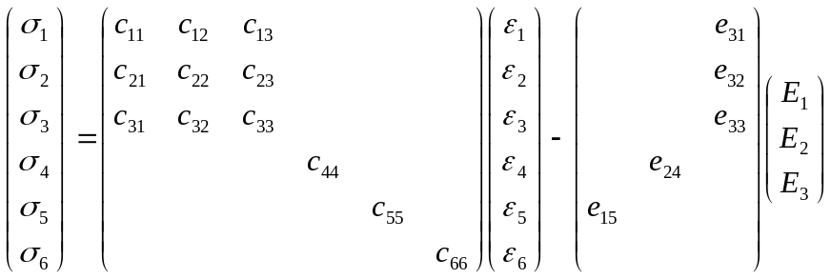

(blank entries are zero). Multiplying out gives

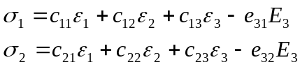

which are precisely the formulas used in the last two linescans. The expression

{1=c12,2=c12inc}

means “take c12 when we are in region 1 and c12inc (inclusion) when we are in region 2”. Note that u_{xx} is simply du_{x}/dx which is the necessary ε₁ strain etc. The last two linescans make use of constants in piezo.con:

eps0=8.854e-12

c11=12.6e10
c33=11.7e10
c44=2.3e10
c12=7.95e10
c13=8.41e10
c66=2.347e10

e31=-6.5
e33=23.3
e15=17

k11=1700*eps0
k33=1470*eps0

c22=c11
c23=c13
c55=c44

e32=e31
e24=e15

k22=k11

! ----------------------------------------------------------------------

c11inc=12.6e11
c33inc=11.7e11
c44inc=2.3e11
c12inc=7.95e11
c13inc=8.41e11
c66inc=2.347e11

e31inc=-6.5
e33inc=23.3
e15inc=17

k11inc=1700*eps0
k33inc=1470*eps0

c22inc=c11inc
c23inc=c13inc
c55inc=c44inc

e32inc=e31inc
e24inc=e15inc

k22inc=k11inc

Note that parameters can be defined in terms of previously-specified parameters. Here, we use this to enforce the symmetry equivalence of certain coefficients (assuming the piezoelectric has 6mm symmetry and is poled along the z-direction).

Results
The following are the enhanced metafiles (EMF) supplied with the Zinc distribution for this example (piezo01.emf, piezo02.emf etc). You should check you get the same results!

u_{x} variation x-scan
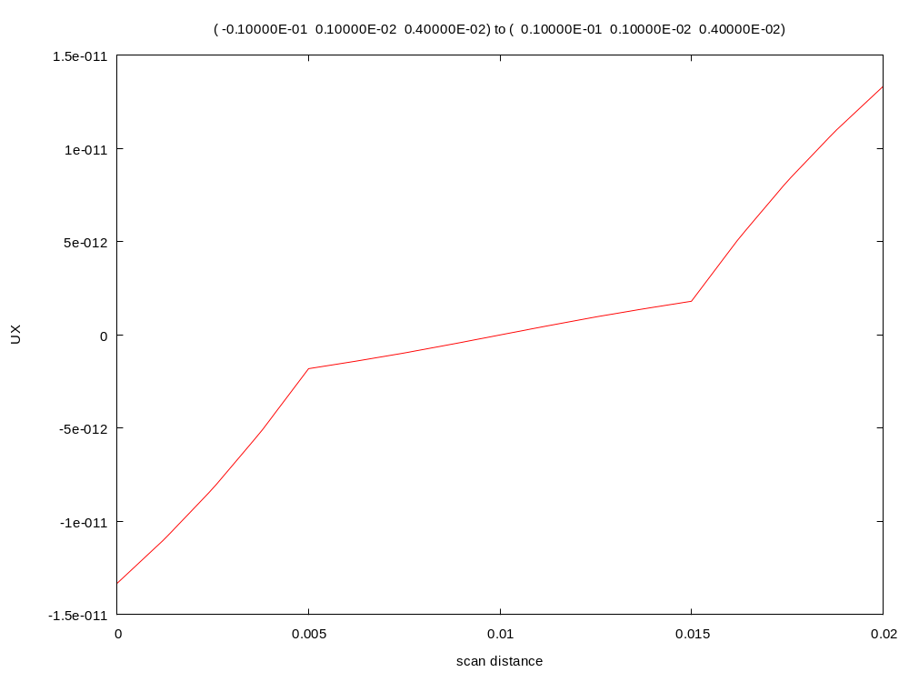
u_{y} variation x-scan
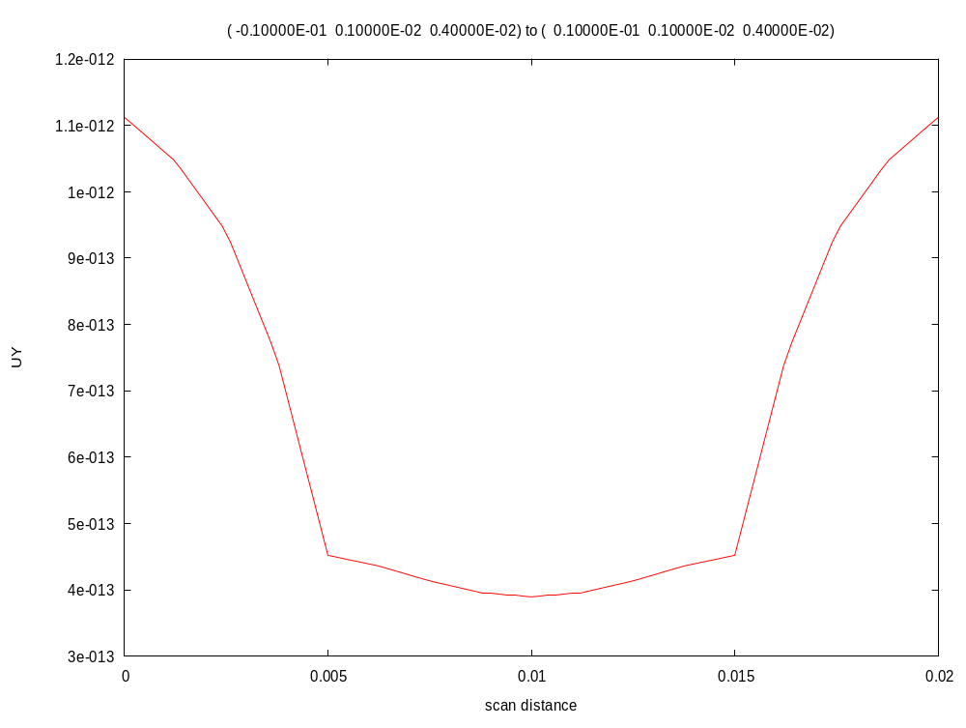
u_{z} variation x-scan
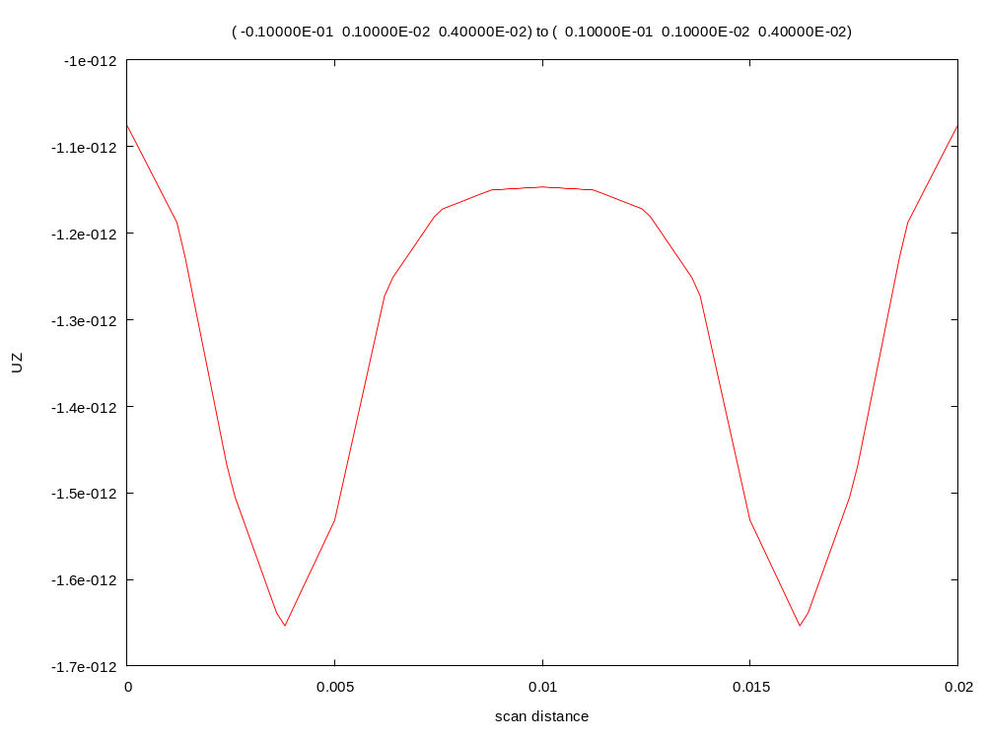
Voltage variation x-scan
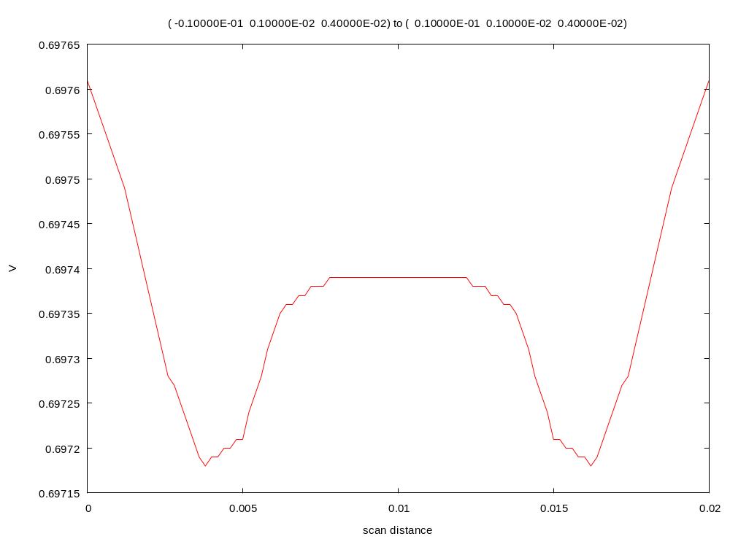
E_{z} variation x-scan
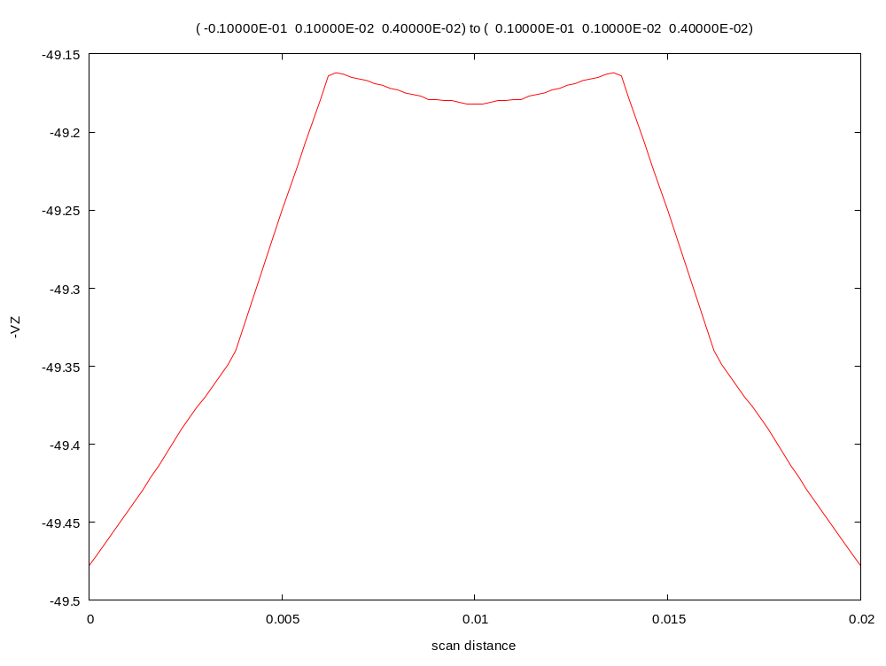
u_{x} variation z-scan
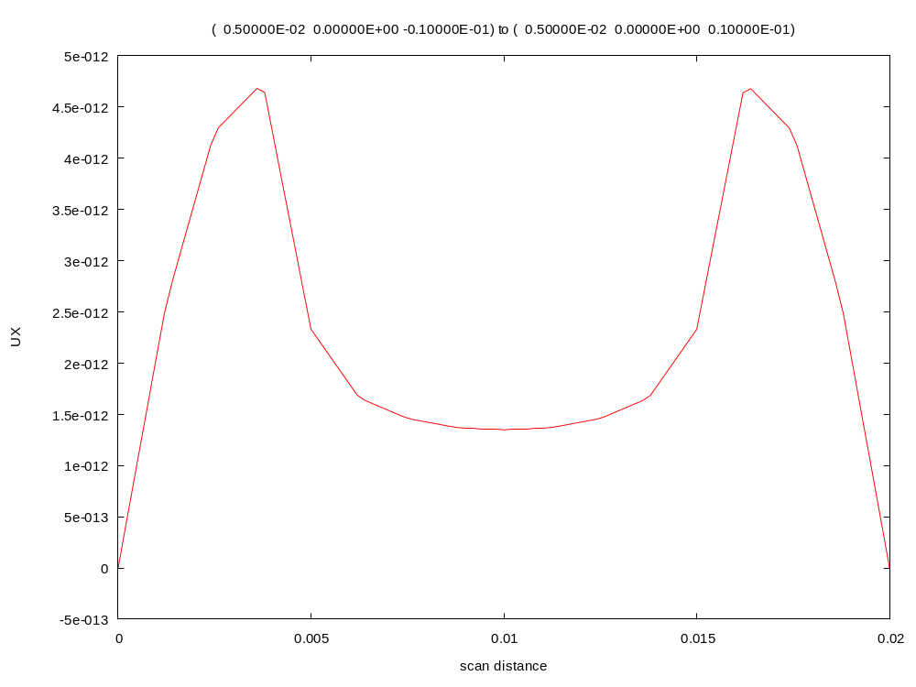
u_{z} variation z-scan
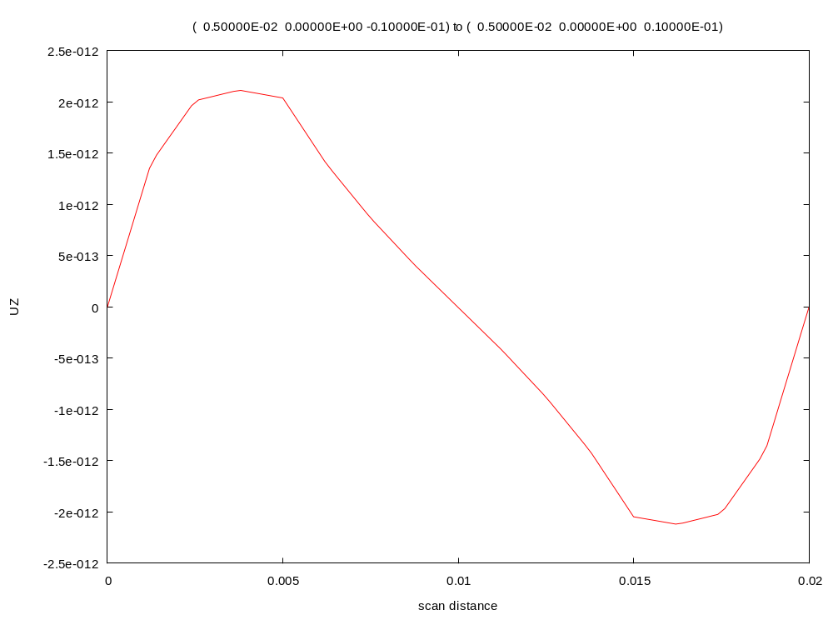
σ_{xx} x-scan

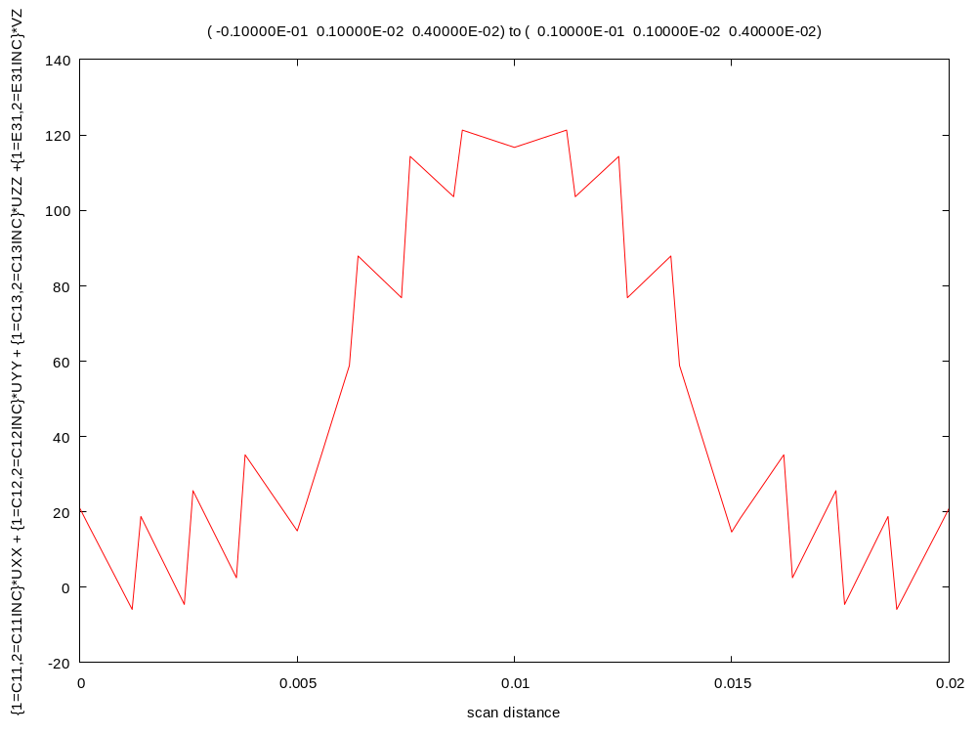
σ_{yy} x-scan

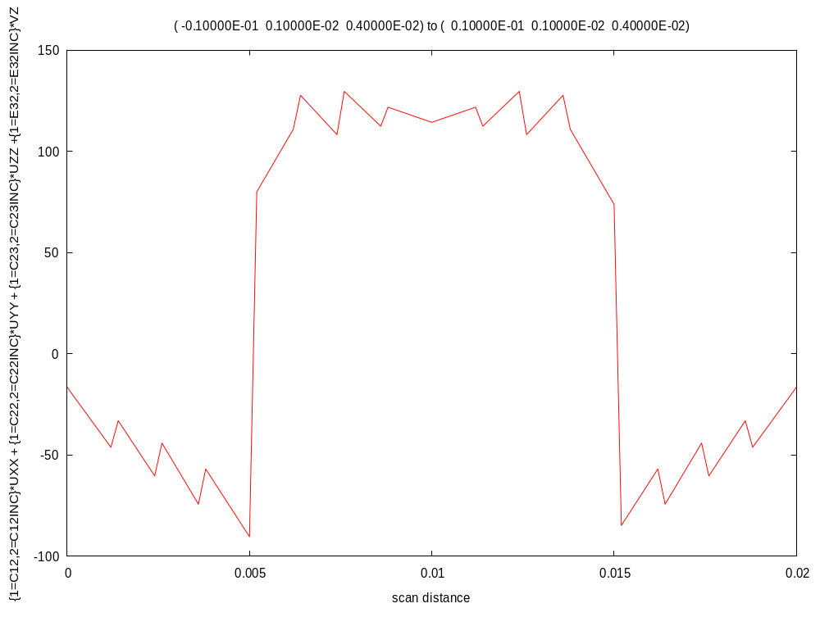

Comparison graphs

To check solution accuracy, it is often a good idea to compare simulation results between different FE solvers. We have therefore compared u_{x}(z) and u_{z}(z) with Comsol (another finite element solver). The Comsol results are in files ux.txt and uz.txt in the Zinc distribution (you will find this files in <zinc install dir>/examples/piezo). The following gnuplot script file was written to perform the comparison.

set term emf

set output 'uzcomp.emf'
set xlabel 'z (cm)'
set ylabel 'uz (pm)'
plot 'piezo09.out' u ($1*100):($5*1e12) t 'Zinc','uz.txt' i 0 u 1:($2*1e12) t 'Comsol' w l

set output 'uxcomp.emf'
set xlabel 'z (cm)'
set ylabel 'ux (pm)'
plot 'piezo08.out' u ($1*100):($5*1e12) t 'Zinc','ux.txt' i 0 u 1:($2*1e12) t 'Comsol' w l

This results in the following graphs which show good agreement.

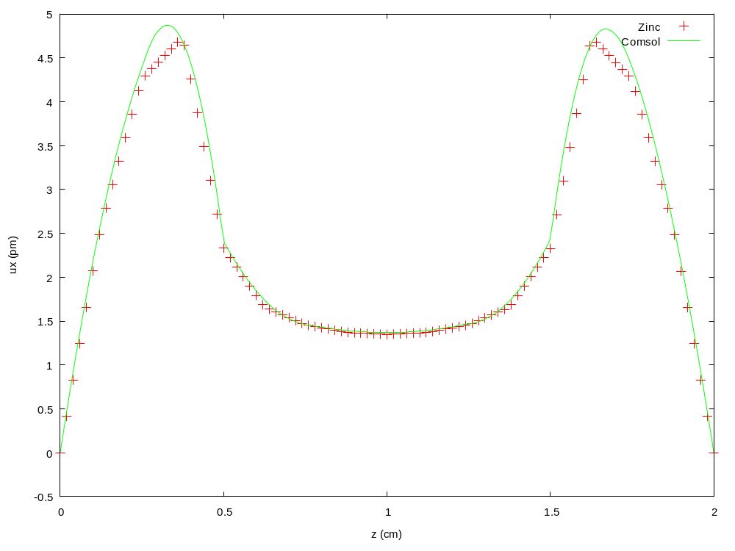
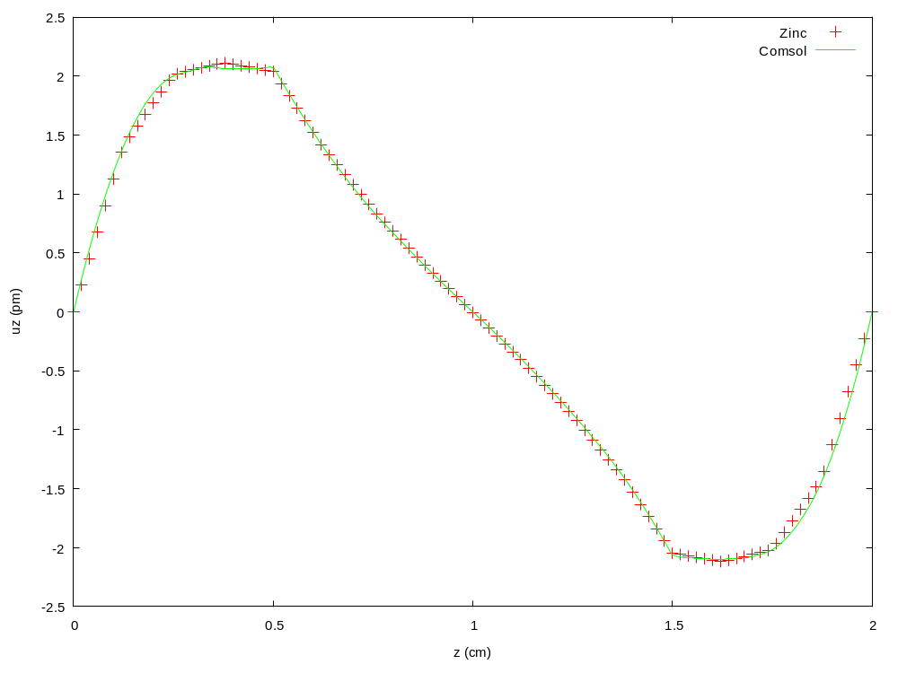

Also in the directory
Piezoslap.zin: Same simulation but using the incomplete LU factorisation GMRES method. (solver=GMRES_LU).

Example 3: Fuel cell

Directory: examples/fuelcell

Cathode.zin: self contained simulation without programming
Cathodetoken.zin: simulation with DLL written in Fortran
Cathodetokenc.zin: simulation with DLL written in C.

Introduction

We now consider a multiphysics, non-linear example, the fuel cell. Fuel cells are ideal cases for general purpose multiphysics solvers like Zinc since the precise set of equations and boundary conditions is under constant debate. It is often necessary to solve a set of equations only recently derived which cannot be done with traditional FE packages that have built in modules corresponding to common problems. Zinc allows you to write down a new set of equations and immediately solve them without having to wait for developers to explicitly add the new equation sets in. This is precisely the approach we took in a recent fuel cell project at NPL. We derived the equations ourselves from first principles and them implemented them in Zinc. The full derivation of the fuel cell equations is given in NPL report MAT (RES) 108. Here we will briefly summarise the derivation and show the working equation set that needs to be implemented.

The fundamental equation for diffusion of n species is

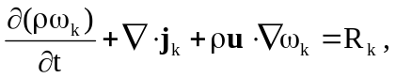 k = 1…n−1 (1)

where ρ denotes the density (kg/m³), 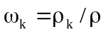 is the mass fraction of species k, u is the mass-based mean velocity vector (m/s) and 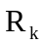 is the reaction rate (kg/(m³·s)). Also, 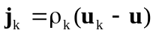 describes the diffusion-driven transport where u_{k} is the mean velocity of the k^{th} species

The flux j_{k} is given by

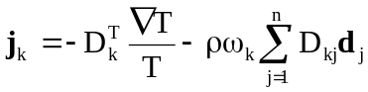, k = 1…n , (2)

where the “driving force” vector d is given by

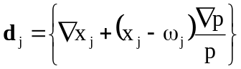, j = 1…n , (3)

where 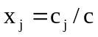 is the molar fraction of species j and p is the pressure (Pa), and where c_{j} is the concentration (moles/m³) of the j^{th} species and c is the mean molar concentration defined by

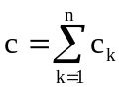

Thus, the driving force for diffusion comes from two parts, the variation in species concentration x_{j} and the variation of pressure, p.

The molar and mass fractions satisfy the relations

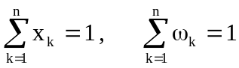,

and can be expressed in terms of each other using

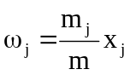

with

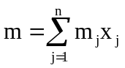

The total density ρ, in (1), can be written as
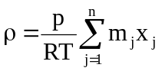

We now make several assumptions to simplify the problem. Firstly, we assume steady state so that d/dt=0. Next, we assume no temperature variation for that 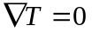. Finally, we assume reaction rates, R_{k} of zero. With these assumptions, substituting (3) into (2) and then (2) into (1) gives:

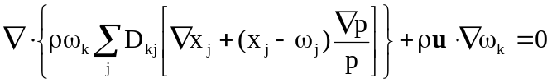 k=1,…n-1 (4)

In our problem we will consider a cathode simulation as shown in Fig 1. We will take n=3 species namely O₂, H₂O and N₂. Since we are dealing with mass fractions (which sum to unity we need only consider the first two species. Thus there are three variables to be solved: (x_{O2}, x_{H2O}, p)
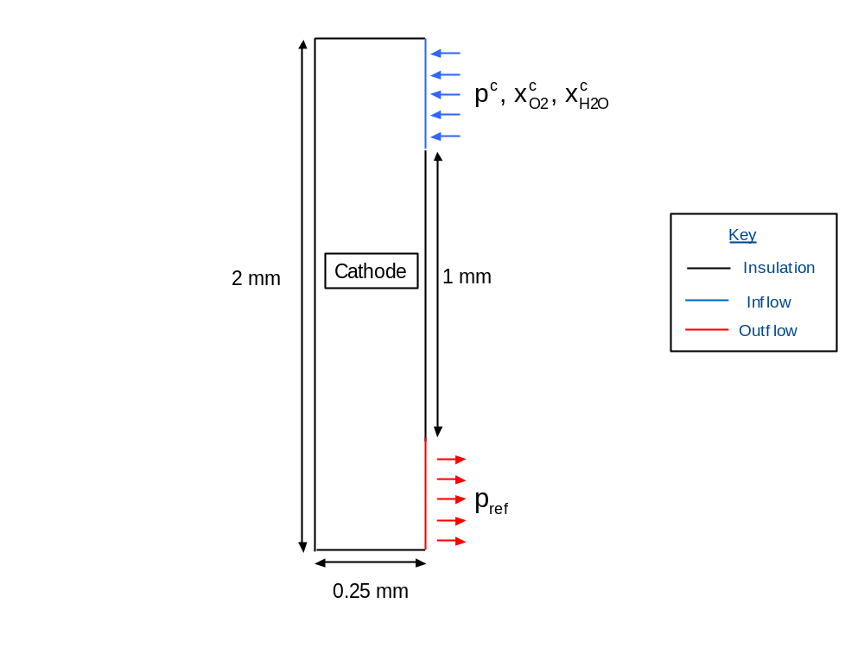
Figure 1: Geometry and boundary conditions for the cathode model

The D coefficients in (4) are not constants but themselves depend on the mass fractions as

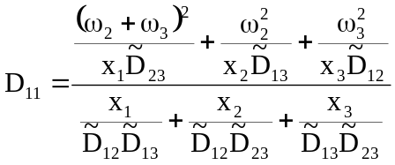,
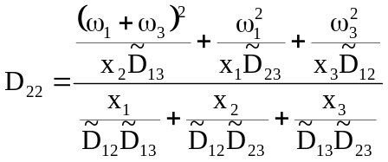,
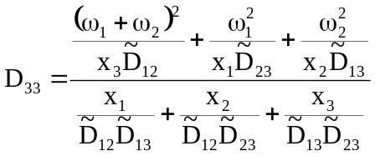,
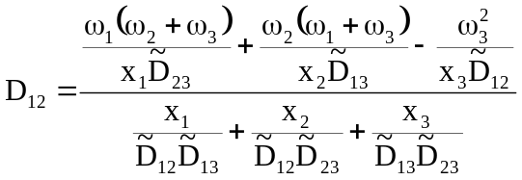,
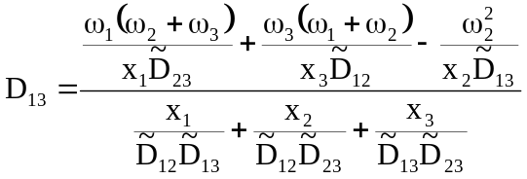,
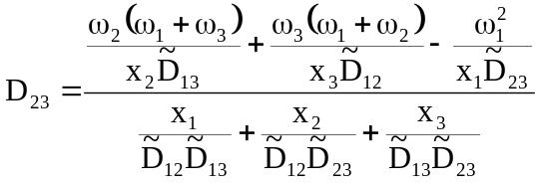.
The D coefficient matrix is symmetrical. Tables 1-4 summarise the full set of material properties used in the simulation. These are present in the constants file (cathode.con, cathodetoken.con).

Table 1: Constants for the electrode flow models.

Name | Value | Description | Units
R | 8.314 | Gas constant | J/K·mol
T | 353 | Temperature | K
KH2 | 3.9×10⁴ | Henry’s constant for H2 dissolved in H2O | Pa·m3/mol
KO2 | 3.2×10⁴ | Henry’s constant for O2 dissolved in H2O | Pa·m3/mol
mO2 | 32.0×10⁻³ | Molar mass of O2 | kg/mol
mH2 | 2.0×10⁻³ | Molar mass of H2 | kg/mol
mH2O | 18.0×10⁻³ | Molar mass of H2O | kg/mol
mN2 | 28.0×10⁻³ | Molar mass of N2 | kg/mol
 | 1.0×10⁻¹³ | Permeability | M²
 | 2.1×10⁻⁵ | Fluid/gas viscosity | Pa·s
P_{ref} | 1.013×10⁵ | Reference pressure | Pa
 | 0.4 | Macroscopic porosity

Table 2: Effective diffusion coefficients.

Name | Value | Description | Units
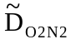 | 0.0000074 | Binary diffusion coefficient for 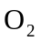 and 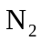 | m²/s
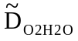 | 0.0000087 | Binary diffusion coefficient for and 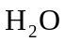 | m²/s
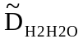 | 0.0000285 | Binary diffusion coefficient for and | m²/s
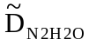 | 0.0000080 | Binary diffusion coefficient for and | m²/s

Table 3: Inlet parameters.

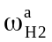 | 0.1 | Mass fraction of H₂ at anode inlet | -
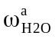 | 0.9 | Mass fraction of H₂O at anode inlet | -
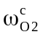 | 0.168 | Mass fraction of O₂ at cathode inlet | -
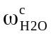 | 0.2 | Mass fraction of H₂O at cathode inlet | -
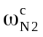 | 0.632 | Mass fraction of N₂ at cathode inlet | -
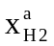 | 0.5 | Molar fraction of H₂ at anode inlet | -
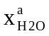 | 0.5 | Molar fraction of H₂O at anode inlet | -
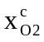 | 0.1348486 | Molar fraction of O₂ at cathode inlet | -
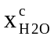 | 0.2853939 | Molar fraction of H₂O at cathode inlet | -
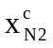 | 0.5797574 | Molar fraction of N₂ at cathode inlet | -
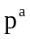 | 111430 | Pressure at the anode inlet | Pa
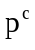 | 111430 | Pressure at the cathode inlet | Pa

Table 4: Initial conditions/parameters.

 | 0.5 | Mass fraction of H₂ in the anode | -
 | 0.5 | Mass fraction of H₂O in the anode | -
 | 1/3 | Mass fraction of O₂ in the cathode | -
 | 1/3 | Mass fraction of H₂O in the cathode | -
 | 1/3 | Mass fraction of N₂ in the cathode | -
 | 0.9 | Molar fraction of H₂ in the anode | -
 | 0.1 | Molar fraction of H₂O in the anode | -
 | 0.2550607 | Molar fraction of O₂ in the cathode | -
 | 0.4534413 | Molar fraction of H₂O in the cathode | -
 | 0.2914980 | Molar fraction of N₂ in the cathode | -
 | 1.013×10⁵ | Pressure in the anode | Pa
 | 1.013×10⁵ | Pressure in the cathode | Pa

Zinc implementation

We now need to see how to implement equation (4) in Zinc. The Zinc PDE specification is

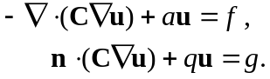 (5)

We will set a=q=g=0 and put non-zero values only in the C and f matrices. Let us split the C matrix into 3 parts

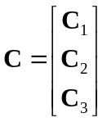

Then, comparison of (5) with (4) shows that

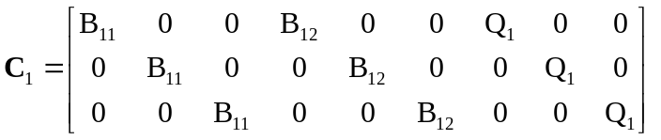, (6)
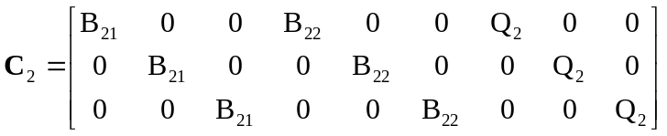 , (7)
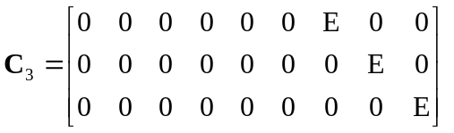. (8)
with
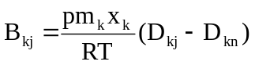, j, k = 1 … n−1, (9)
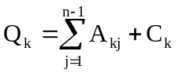, k = 1 … n−1, (10)
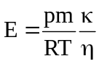, (11)
with 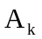 and 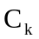 defined as
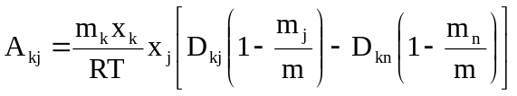 , (12)
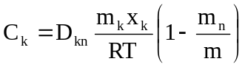 (13)

This completes the specification of the C matrix. The f-matrix is given by
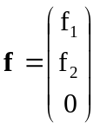,
with
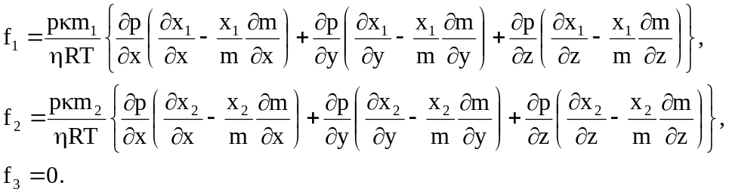 (14)

From (5), the Neumann boundary conditions that will exist on non fixed surfaces of the simulation are

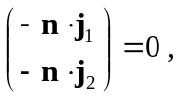

with the flux j given in (1). The is the so-called convective boundary condition we want to solve in this problem. The way we have set things up, the Zinc C matrix encodes the div j_{k} term in (1) while the Zinc f vector encodes the 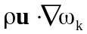. Since C appears in the boundary condition (5), n.j_{k}=0 is the natural boundary condition we get.

There are two ways to solve non-linear problems in Zinc

- Write a set of subroutines to encode the non-linearity, compile to a dynamic link library (DLL) and run with Zinc (recommended)
- Write expression in the Zinc input file encoding the non-linear behaviour

In this tutorial, we will show both methods and furthermore, we will prepare the DLL using both Fortran and C implementations. We will first consider the DLL method

DLL method

We will implement this method using the name cathodetoken. The input file, cathodetoken.zin, looks like this

solver=SOR
nvar=3
scale=1e-3

omega=0.1
nstep=30
itmax=1000
nstride=100

labels = x1 x2 p

region 1 elements C

! Row 1 of B
1 1 1 1 = $B11
1 2 1 2 = $B11
1 3 1 3 = $B11

1 1 2 1 = $B12
1 2 2 2 = $B12
1 3 2 3 = $B12

! Row 2 of B
2 1 1 1 = $B21
2 2 1 2 = $B21
2 3 1 3 = $B21

2 1 2 1 = $B22
2 2 2 2 = $B22
2 3 2 3 = $B22

! col 3, row 1 Q block
1 1 3 1 = $Q1
1 2 3 2 = $Q1
1 3 3 3 = $Q1

! col 3, row 2 Q block

2 1 3 1 = $Q2
2 2 3 2 = $Q2
2 3 3 3 = $Q2

! E section at bottom right
3 1 3 1 = $E
3 2 3 2 = $E
3 3 3 3 = $E
end

region 1 elements f
1 = $F1
2 = $F2
end

! ######################################################################

region 2 nodes
x1 = x1c
x2 = x2c
p = pc
end

region 3 nodes
p =pref
end

init
x1 = x1c
x2 = x2c
p = (pc+pref)/2
end

The main concept here is token replacement whereby elements in the C and f matrices are defined, not by expressions but by tokens beginning $. Any string can be used; when Zinc comes across the string it calls a user supplied function with the token name passed in as an argument. Thus, for the C functions, Zinc calls function cfun; for the f tokens, it calls ffun.

Here is the cfun function written in Fortran (cathodetoken.f90)

function Cfun(label,x,y,z,ur,dur,nvar,istep, <some args ommitted>)

use nlinc
implicit none
character label*(*)
integer nvar,istep
double precision Cfun,x,y,z,ur(nvar),dur(nvar,3)

double precision D11,D12,D13,D21,D22,D23,D31,D32,D33
double precision x1,x2,p,x3,w1,w2,w3,m,denom

call NLinit

x1=ur(1)
x2=ur(2)
p=ur(3)

x3=1-x1-x2

m=m1*x1+m2*x2+m3*x3

w1=m1*x1/m
w2=m2*x2/m
w3=m3*x3/m

denom=x1/(D12tilde*D13tilde)+x2/(D12tilde*D23tilde)+x3/(D13tilde*D23tilde)

D11=((w2+w3)**2/(x1*D23tilde)+w2**2/(x2*D13tilde)+w3**2/(x3*D12tilde))/denom
D22=((w1+w3)**2/(x2*D13tilde)+w1**2/(x1*D23tilde)+w3**2/(x3*D12tilde))/denom
D33=((w1+w2)**2/(x3*D12tilde)+w1**2/(x1*D23tilde)+w2**2/(x2*D13tilde))/denom

D12=(w1*(w2+w3)/(x1*D23tilde)+w2*(w1+w3)/(x2*D13tilde)-w3**2/(x3*D12tilde))/denom
D13=(w1*(w2+w3)/(x1*D23tilde)+w3*(w1+w2)/(x3*D12tilde)-w2**2/(x2*D13tilde))/denom
D23=(w2*(w1+w3)/(x2*D13tilde)+w3*(w1+w2)/(x3*D12tilde)-w1**2/(x1*D23tilde))/denom

D21=D12
D31=D13
D32=D23

if (label.eq.'$B11') then
Cfun=p*m1*x1*(D11-D13)/RT

else if (label.eq.'$B12') then
Cfun=p*m1*x1*(D12-D13)/RT

else if (label.eq.'$B21') then
Cfun=p*m2*x2*(D21-D23)/RT

else if (label.eq.'$B22') then
Cfun=p*m2*x2*(D22-D23)/RT

else if (label.eq.'$Q1') then
Cfun=m1*x1/RT*(x1*(D11*(1-m1/m)-D13*(1-m3/m)) &
+ x2*(D12*(1-m2/m)-D13*(1-m3/m)) &
+D13*(1-m3/m))

else if (label.eq.'$Q2') then
Cfun=m2*x2/RT*(x1*(D21*(1-m1/m)-D23*(1-m3/m)) &
+ x2*(D22*(1-m2/m)-D23*(1-m3/m)) &
+D23*(1-m3/m))

else if (label.eq.'$E') then
Cfun=p*m*kappa/(RT*eta)
else
print *,'Error in Cfun: token not recognised:',trim(label)
stop
endif

end function Cfun

The operation of this function should be clear by considering (6)-(13). For example, if the “B11” token is called for, the function implements equation (9). This function calls Nlinit (see cathodetoken.f90) which simply reads in the cathodetoeken.con file in order to obtain the material properties stored there. This illustrates how user-written functions can call other functions and perform input/output operations as required.

The cfun function in C is written as

double cfun(char *label, double *x, double *y, double *z,
double ur[3], double dur[3][3], int *nvar, int *istep,
<other args>, int length)
{

double D11,D12,D13,D21,D22,D23,D31,D32,D33;
double x1,x2,p,x3,w1,w2,w3,m,denom;

NLinit();

x1=ur[0];
x2=ur[1];
p=ur[2];

x3=1-x1-x2;

m=m1*x1+m2*x2+m3*x3;

w1=m1*x1/m;
w2=m2*x2/m;
w3=m3*x3/m;

denom=x1/(D12tilde*D13tilde)+x2/(D12tilde*D23tilde)+x3/(D13tilde*D23tilde);

D11=((w2+w3)*(w2+w3)/(x1*D23tilde)+w2*w2/(x2*D13tilde)+w3*w3/(x3*D12tilde))/denom;
D22=((w1+w3)*(w1+w3)/(x2*D13tilde)+w1*w1/(x1*D23tilde)+w3*w3/(x3*D12tilde))/denom;
D33=((w1+w2)*(w1+w2)/(x3*D12tilde)+w1*w1/(x1*D23tilde)+w2*w2/(x2*D13tilde))/denom;

D12=(w1*(w2+w3)/(x1*D23tilde)+w2*(w1+w3)/(x2*D13tilde)w3*w3/(x3*D12tilde))/denom;
D13=(w1*(w2+w3)/(x1*D23tilde)+w3*(w1+w2)/(x3*D12tilde)w2*w2/(x2*D13tilde))/denom;
D23=(w2*(w1+w3)/(x2*D13tilde)+w3*(w1+w2)/(x3*D12tilde)w1*w1/(x1*D23tilde))/denom;

D21=D12;
D31=D13;
D32=D23;

if (equal(label,length,"$B11"))
return p*m1*x1*(D11-D13)/RT;

else if (equal(label,length,"$B12"))
return p*m1*x1*(D12-D13)/RT;

else if (equal(label,length,"$B21"))
return p*m2*x2*(D21-D23)/RT;

else if (equal(label,length,"$B22"))
return p*m2*x2*(D22-D23)/RT;

else if (equal(label,length,"$Q1"))
return m1*x1/RT*(x1*(D11*(1-m1/m)-D13*(1-m3/m))
+x2*(D12*(1-m2/m)-D13*(1-m3/m))
+D13*(1-m3/m));

else if (equal(label,length,"$Q2"))
return m2*x2/RT*(x1*(D21*(1-m1/m)-D23*(1-m3/m))
+ x2*(D22*(1-m2/m)-D23*(1-m3/m))
+D23*(1-m3/m));

else if (equal(label,length,"$E"))
return p*m*kappa/(RT*eta);
else {
printf("Error in Cfun: token not recognised\n");
exit(1);
}

}

Note that the token is passed in as a fixed length variable (length “length”) rather than being null-terminated. For this reason we have written a function “equal” which the user should examine in the cathodetokenc.c file.

We used the free gcc compiler (including gfortran) to compile the Fortran and C DLLs.

gfortran -c –fnounderscoring cathodetoken.f90
gfortran -s -shared -mrtd -o cathodetoken.dll cathodetoken.o

and

gcc -c cathodetokenc.c
gcc -shared -mrtd -o cathodetokenc.dll cathodetokenc.o

The batch files compile.bat and ccompile.bat, included in the fuel cell directory, contain these commands. You should run these batch files yourself to practice compiling Zinc DLL files.

Expressions method

Instead of entering literal constants for the C, f coefficients, it is possible to enter these as expressions in the ZIN file. This approach is used in cathode.zin which does not require linking to a DLL file. Thus, the full expression for C matrix element C₁₁₁₁ is

region 1 elements C

! p*m1*x1*(D11-D13)/RT
1 1 1 1 = p*m1*x1/RT*((x2*m23+m3-m3*x1)^2/(x1*D23) + m2^2*x2/D13 + m3^2*(1-x1-x2)/D12 &
-(m1*(x2*m23+m3-m3*x1)/D23 + m3*(m1*x1+m2*x2)/D12 - m2^2*x2/D13))/ &
(m13*x1+m23*x2+m3)^2/(x1*fac1+x2*fac2+fac3)
:
This can be derived from (6) and (9) and using the D coefficient expressions just after Figure 1. Everything needs to be substituted in so that the C and f coefficients are written purely in terms of

1) The variables to be solved for x1, x2, p in this case (a labels command sets this up)
2) Constants in the cathode.con file. We have introduced a few new extra constants including fac1, fac2 and fac3 here (see cathode.con)

Writing out the expressions explicitly like this is OK, but it makes them more complicated to read. In the program based approach, the expressions were built up using intermediate variables which is not possible here. Also the DLL file method will work faster since the expressions are compiled into machine code. On the other hand, expressions like the one shown above need to be repeatedly interpreted by Zinc when it runs.

In general, the programming/DLL method should be used for all non-linear problems as it is much faster. What slows Zinc down is having expressions that need to be repeatedly recalculated. It’s perfectly OK for the C-matrix etc to depend on X,Y,Z coordinates as these expressions are only evaluated at the beginning of the run (and the simulation is still linear in this case). It’s also fine to use expressions that depend only on the .CON variables eg R*T in the current example. Zinc will just evaluate these to literal numbers at the start of the simulation. But if one-line expressions depend on the actual variables to solve for (x1,x2 and p in this example), which is what makes a simulation non-linear, it’s better to use the DLL method.

See the file cathode.zin for the full set of expressions.

Running the simulation

After a lengthy preamble, we are now ready to run the simulation. Fig 2 shows the simulation geometry which may be compared to Fig 1. The geometry is essentially 2-D so we have only two planes of elements in the third direction (z). Note that the distances in Fig 2 are in mm whereas the equations we have derived are in SI units (m). Therefore a scale factor of 0.001 is needed and this is in the command

scale=1e-3

in the cathode.zin files. Finally let’s look at the node fixing (Dirichlet boundary) part of the ZIN file and the initial condition

region 2 nodes
x1 = x1c
x2 = x2c
p = pc
end

region 3 nodes
p =pref
end

init
x1 = x1c
x2 = x2c
p = (pc+pref)/2
end ! end is optional here since there must be 3 entries in “init”
This says that region 2 nodes will be completely fixed (see Fig 2) but region 3 nodes will be fixed only in terms of the pressure. The two mass fractions are allowed to vary.

The initialisation block (init) fixes the mass fractions and pressures at x1c, x2c and (pc+pref)/2. These constants are all in cathode.con.

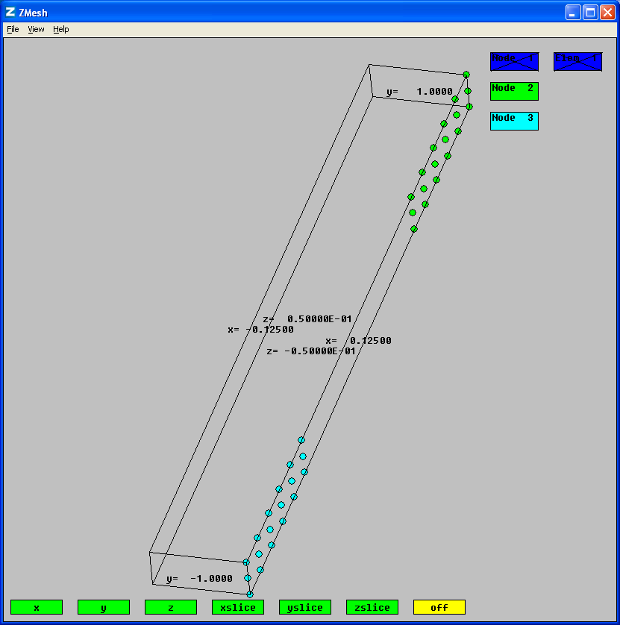
Fig 2: Fuel cell geometry. Mass fractions and pressures are fixed on region 2 nodes (green). Pressure only is fixed on region 3 nodes (cyan).

The Zinc window is shown in Fig 3. Note that Zinc has noticed the presence of the cathodetoken.f90 file and allows you to view it (you can change the source file extension). When you run Zinc, the program opens the cathodetoken.dll file and calls the functions contained within it. Note that Zinc itself will not read the source code file only the DLL file.
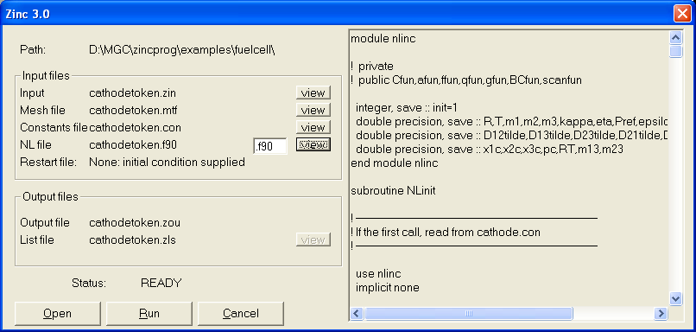
Fig 3: Zinc solver ready to run the fuel cell problem. Here the non-linear source code routines have the extension .f90 for a Fortran file. You can change this to match your language.

Having run the simulation, it is now time to post process with Zpp, Fig 4. Here we stick to simple output of the raw quantities: the mass fractions and the pressure. Fig 5 shows the simulation result viewed with Zmesh.

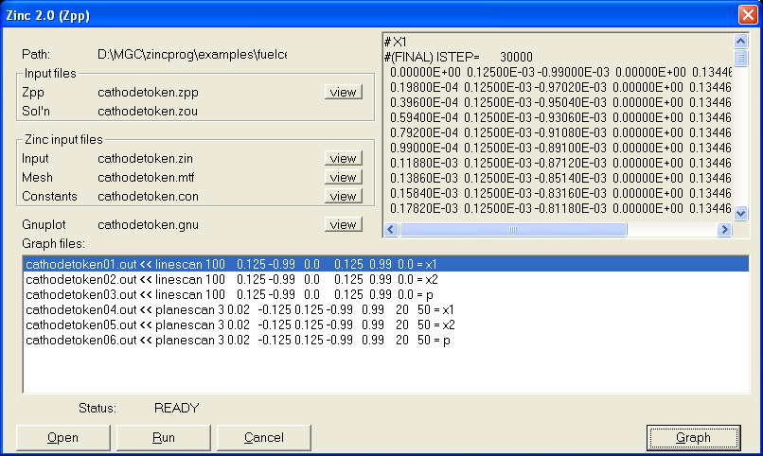
Fig 4: Post processing the fuel cell run

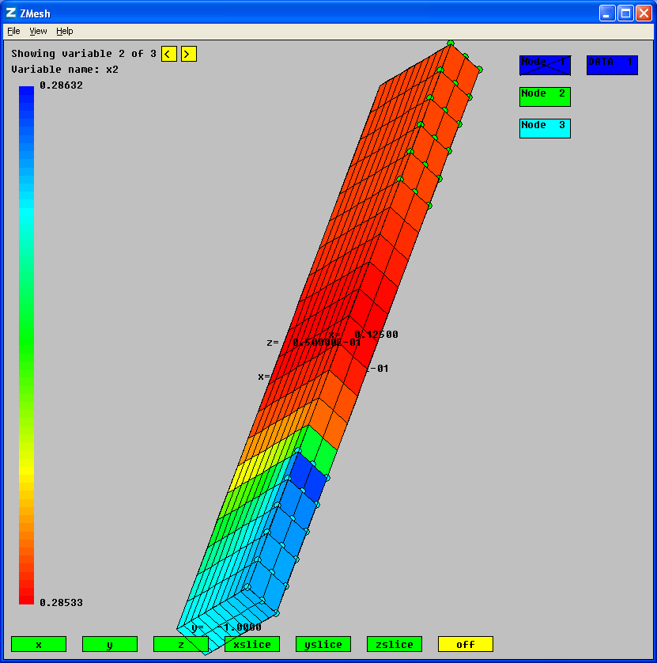
Fig 5: Fuel cell result viewed with Zmesh.
Results
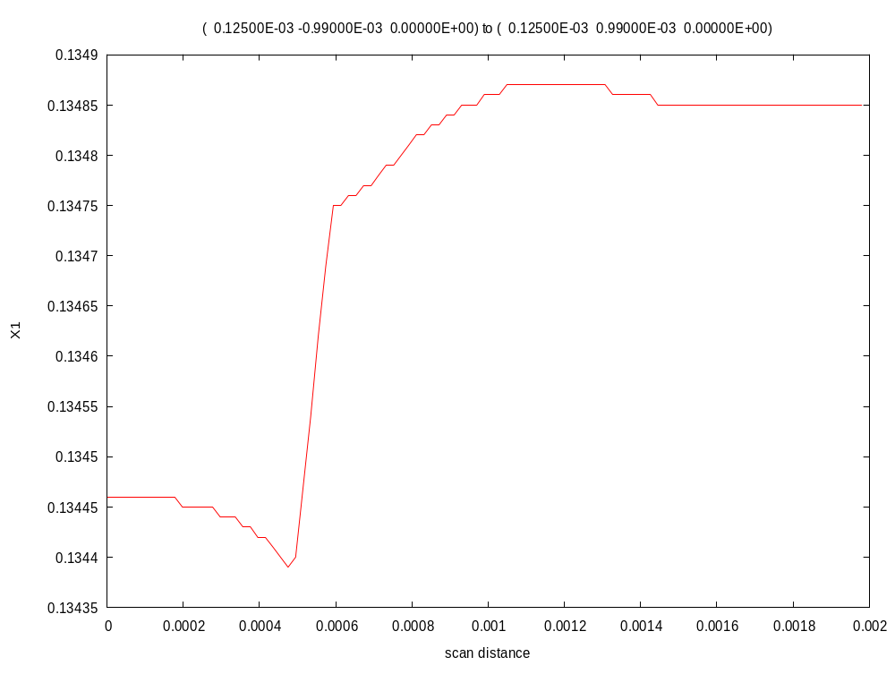
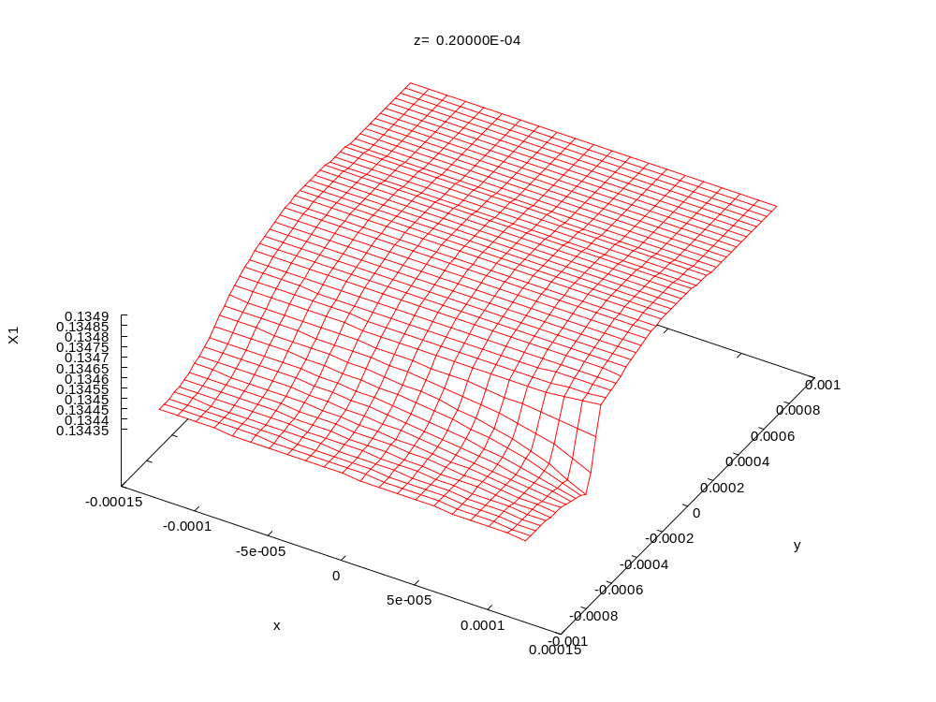
Fig 6: Variation of x_{O2}
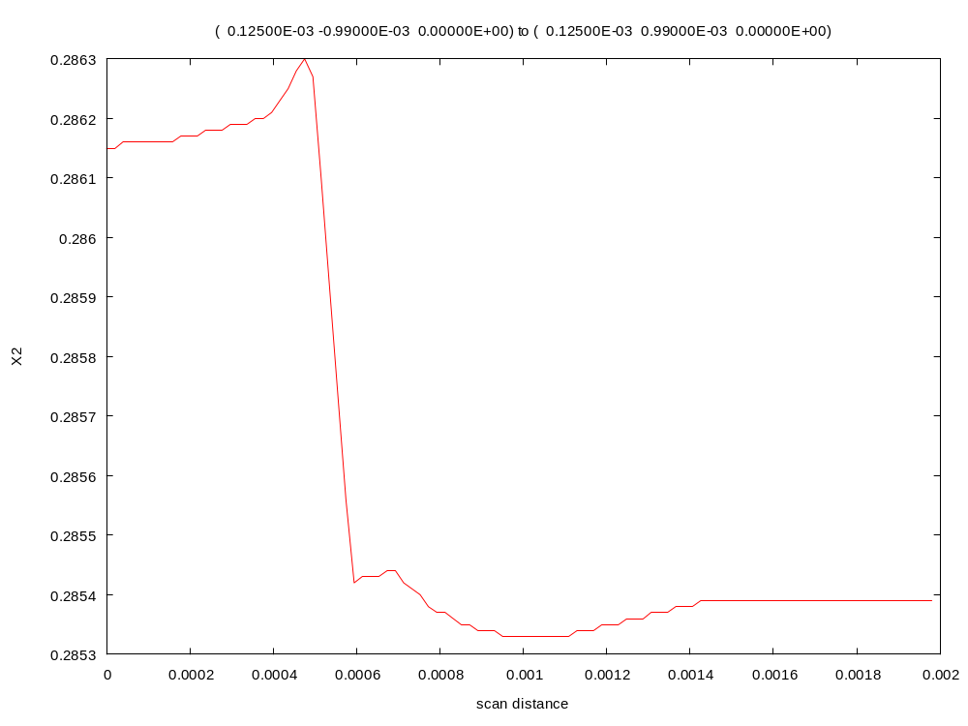
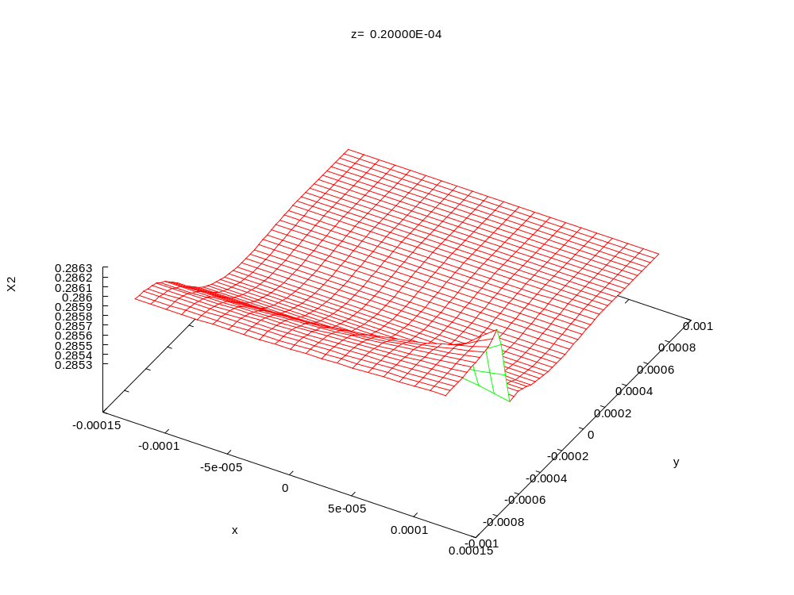
Fig 7: Variation of x_{H2O}
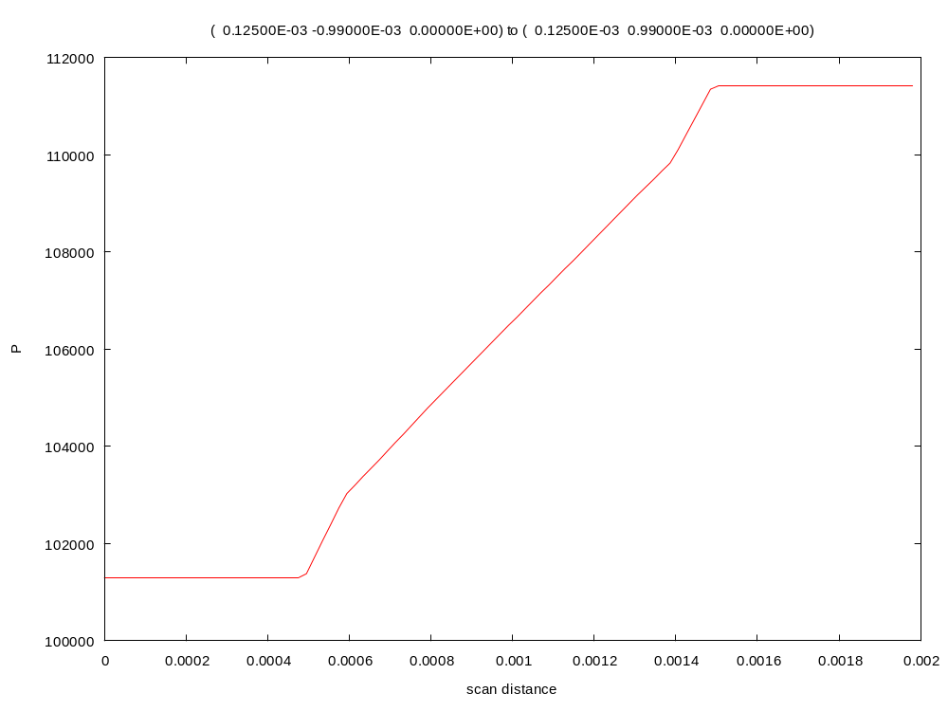
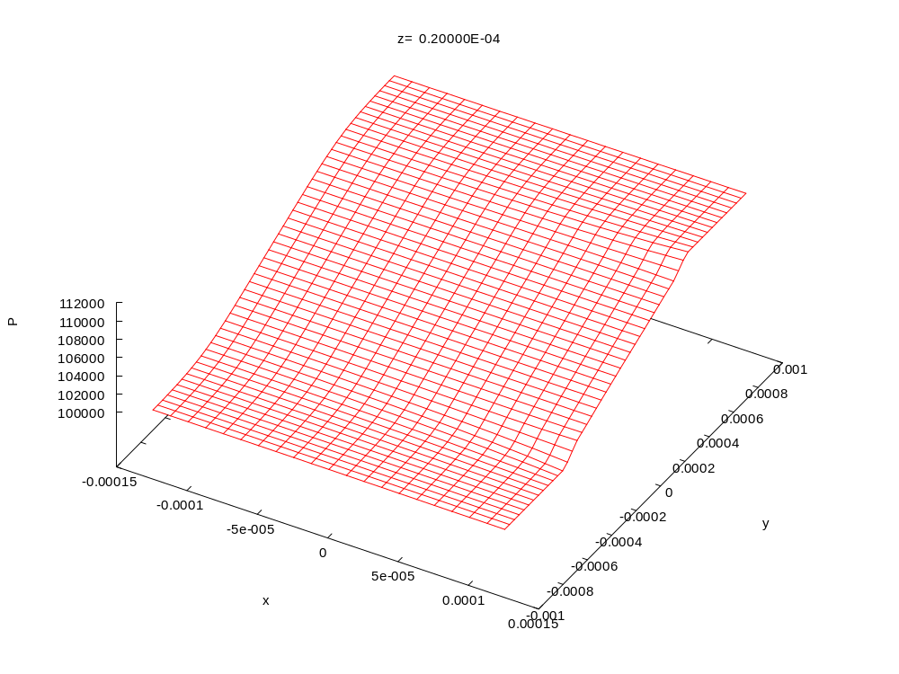
Fig 8: Variation of pressure
Figs 6-8 show the oxygen (x₁), water (x₂) and pressure (p) distribution in the sample.

Using the Newton-Raphson method
So far we have been using a “direct” method to calculate the solve the non-linear problem. This means we have to specify, C, f variables either as one-line expressions or via functions compiled into a DLL. We only need to supply the functions for C, f themselves. However, Zinc now supports another method called Newton-Raphson which requires that we also specify derivatives of the C, f components as additional functions within the DLL file. This method only works in the DLL approach, you cannot enter one-line expressions as in cathode.zin. In addition to the cfun and ffun functions in the DLL file, we must also specify corresponding derivative subroutines like so:

cfun → dcfun_du, dcfun_ddu
ffun → dffun_du, dffun_ddu

If you take a look at cathodetoken.f90 and cathodetokenc.c, you will see all of these functions are already present, but we have not used them so far.

Before we get into the exact specification of these new functions let’s compare the direct method and Newton-Raphson methods. Consider a very simple non-linear problem: we want to find x so that

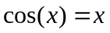

The direct method used so far is equivalent to setting up the iterative scheme

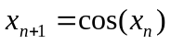

with x₀ as the initial guess at the solution. Eg if x₀=0.8, then

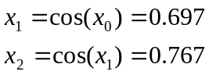

etc. You can solve this problem easily with a scientific calculator. Just enter 0.8 as the initial guess and repeatedly press the “cos” button. (I’m assuming a rather old fashioned scientific calculator which does not display symbolic expressions, hammering the cos button may not work for you! Also be sure you are in radians mode). After hitting “cos” a few times, you should notice the number on the screen does not change much and converges to about x=0.739 which satisfies our non-linear equation. The fact that the number is not changing convinces us we have found a solution since we clearly have an x such that its cosine is equal to itself as required.

The benefit of this technique is that it is very simple and we do not need take derivatives of 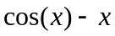but the problem is convergence is not guaranteed for any given choice of function. Furthermore the path the algorithm takes in getting to the solution can be very mysterious with wild swings as we go from one iteration to the next making it hard to tell if we solved the problem. Also for a given equation f(x)=0 it’s not always obvious how to divide it up so as to obtain an iteration scheme which has the form 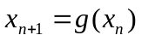. There are many ways to do this.

A well-known technique which resolves many of these problems is the Newton-Raphson method. In this case we set

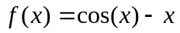

We want f(x) to be zero (f is the “residual” of the problem). The Newton-Raphson method gives an iteration scheme as follows

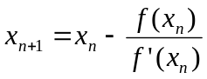

This result can be derived either from Taylor’s series or from a geometric argument. The method requires the derivative of the residual function f, which in our case is

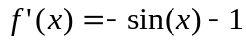

This is obviously easy to calculate for a single non-linear equation but much harder for the problem that Zinc solves which consists of thousands of simultaneous equations. (in that case f’(x) maps to a matrix called the Jacobian). Nevertheless, the basic result is the same: the Newton-Raphson method requires more effort on the part of the user (calculating derivatives), but generally gives better convergence. The convergence is both faster and more likely to occur. The Newton-Raphson method tends to make steady progress towards the solution. The direct method often fails to converge at all, and swings wildly between different guesses as we go from one iteration to the next.

Let’s consider again the region block

region 1 elements f
1 = $F1
2 = $F2
end

Here we state that f₁ is given by $F1. In cathodetoken.f90, we define function ffun defined like this:

function ffun(label,x,y,z,ur,dur,nvar,istep, &
ireg,iregup,rnode,vec,imax,jmax,kmax)

! definitions…

x1=ur(1)
x2=ur(2)
p=ur(3)

x3=1-x1-x2

m=m1*x1+m2*x2+m3*x3

x1x=dur(1,1)
x1y=dur(1,2)
x1z=dur(1,3)

x2x=dur(2,1)
x2y=dur(2,2)
x2z=dur(2,3)

px=dur(3,1)
py=dur(3,2)
pz=dur(3,3)

mx=m1*x1x + m2*x2x + m3*(-x1x-x2x)
my=m1*x1y + m2*x2y + m3*(-x1y-x2y)
mz=m1*x1z + m2*x2z + m3*(-x1z-x2z)

if (label.eq.'$F1') then
ffun=p*kappa*m1/(eta*RT)*(px*(x1x-x1*mx/m)+py*(x1y-x1*my/m)+pz*(x1z-x1*mz/m))
else if (label.eq.'$F2') then
ffun=p*kappa*m2/(eta*RT)*(px*(x2x-x2*mx/m)+py*(x2y-x2*my/m)+pz*(x2z-x2*mz/m))
else
print *,'ffun: unknown token encountered'
stop
endif

end function ffun

(cathodetokenc.c contains a similar function). This implies,

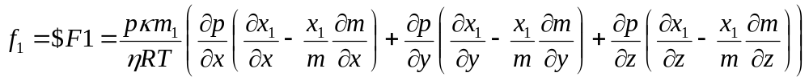

(as described above). We now need to also tell Zinc about the derivatives of this function wrt the 3 independent variables in the simulation: x₁, x₂ and p. We obtain

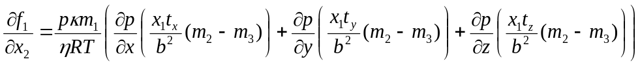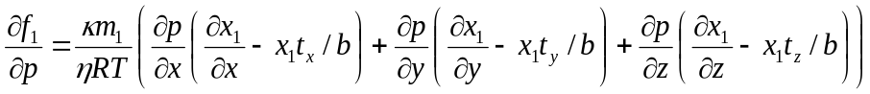

with
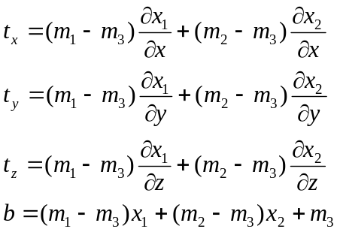 (15)

Note that in taking these partial derivatives we hold spatial derivative quantities constant, thus 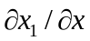is regarded as constant when forming 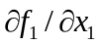etc. We specify these derivatives in the subroutine dffun_du:

subroutine dffun_du(token,x,y,z,ur,dur,nvar,istep, &
ireg,iregup,rnode,vec,imax,jmax,kmax,dfdu)

! definitions …

if (analytical) then
x1=ur(1)
x2=ur(2)
p=ur(3)

x1x=dur(1,1)
x1y=dur(1,2)
x1z=dur(1,3)

x2x=dur(2,1)
x2y=dur(2,2)
x2z=dur(2,3)

px=dur(3,1)
py=dur(3,2)
pz=dur(3,3)

topx=(m1-m3)*x1x+(m2-m3)*x2x
topy=(m1-m3)*x1y+(m2-m3)*x2y
topz=(m1-m3)*x1z+(m2-m3)*x2z

bot =(m1-m3)*x1 +(m2-m3)*x2 +m3

if (token=='$F1') then

dfdu(1)=p*kappa*m1/(eta*RT) &
*(px*(-topx/bot+x1*topx/bot**2*(m1-m3)) &
+ py*(-topy/bot+x1*topy/bot**2*(m1-m3)) &
+ pz*(-topz/bot+x1*topz/bot**2*(m1-m3)))

dfdu(2)=p*kappa*m1/(eta*RT) &
*(px*( x1*topx/bot**2*(m2-m3)) &
+ py*( x1*topy/bot**2*(m2-m3)) &
+ pz*( x1*topz/bot**2*(m2-m3)))

dfdu(3)=kappa*m1/(eta*RT) &
*(px*(x1x-x1*topx/bot) &
+ py*(x1y-x1*topy/bot) &
+ pz*(x1z-x1*topz/bot))

else if (token=='$F2') then

dfdu(1)=p*kappa*m2/(eta*RT) &
*(px*( x2*topx/bot**2*(m1-m3)) &
+ py*( x2*topy/bot**2*(m1-m3)) &
+ pz*( x2*topz/bot**2*(m1-m3)))

dfdu(2)=p*kappa*m2/(eta*RT) &
*(px*(-topx/bot+x2*topx/bot**2*(m2-m3)) &
+ py*(-topy/bot+x2*topy/bot**2*(m2-m3)) &
+ pz*(-topz/bot+x2*topz/bot**2*(m2-m3)))

dfdu(3)=kappa*m2/(eta*RT) &
*(px*(x2x-x2*topx/bot) &
+ py*(x2y-x2*topy/bot) &
+ pz*(x2z-x2*topz/bot))
else
print *,'dffun_du: Unknown token'
stop
endif
:
So that is specified in dfdu(1) etc. The array dfdu is an argument of function dffun_du and the job of subroutine dffun_du is to fill this with the derivatives. The function must return the correct values for this array for every token supplied for it ($F1 and $F2 in this example).

Calculating derivatives like analytically can be tedious. In function dffun_du, an alternative is presented: calculating the derivative numerically by calling ffun using the approximation

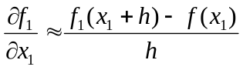

If you set the parameter “analytical” in dffun_du, to false, this method will be used (you must recompile the DLL of course). The only difficulty is estimating a value of “h” which is small compared to x₁. In this case variable “x1cent” contains a rough central value of x₁ that we expect. (x₁ is a molar fraction so must be in the range [0,1]) We then set “h” to be a small fraction of this expected number. The same process is used for the displacement in x₂ and p. Of course, this technique only gives an approximate value for the derivative. More sophisticated numerical techniques could be used included automatic differentiation.

So far we have provided Zinc with the derivative of f₁ wrt variables x₁, x₂, and p. Now we need to provide derivatives wrt spatial derivatives of these variables

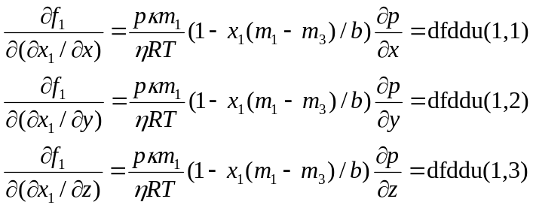

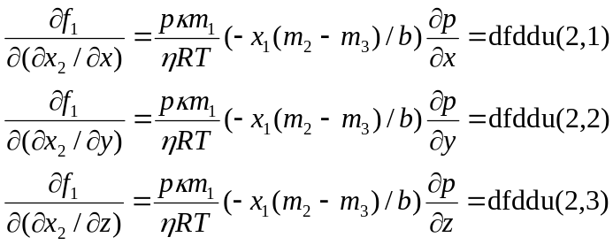

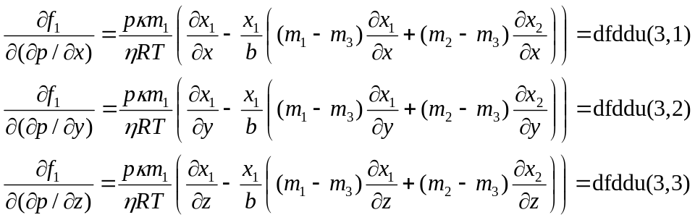

These functions are provided in the dfddu array of subroutine dffun_ddu. The array element used for each derivative is shown above. Again, both anayltical and numerical calculations are given in dffun_ddu; to toggle between them set “analytical” to true or false and recompile. The numerical result is calculated as (for example)

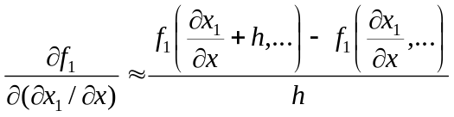

In this case, h needs to be chosen to be small compared to . To estimate the latter, we have set a variable x1range = 0.1 meaning that x₁ (the molar fraction of hydrogen remember) is expected to vary by about 0.1 across the sample. We also set dist = 1e-3 which is the distance across the sample in metres. Thus, the expected value of is about x1range/dist. The program uses an offset equal to this value times a safety factor of 0.0001. The required derivatives are then calculated by calling ffun multiple times, in fact 18 calls are needed to form the matrix dfddu.

All the remarks made here about f₁ apply equally to f₂ and f₂ derivative values are provided in functions dffun_du and dffun_ddu as already presented (we must detect the “$F2” token in this case). Similarly, derivative functions must be provided corresponding to the C-matrix and these are given in functions dcfun_du and dcfun_ddu with the same format as dffun_du, dffun_ddu already described. (only numerical approximations are provided for these)

The entire structure described works equally well in C language and corresponding functions are given in cathodetokenc.c. Note that the derivative functions are void functions (corresponding to Fortran subroutines) and matrices need to be transposed and made base 0 as usual.

To run the simulation using Newton-Raphson, we only need to alter some parameters in the ZIN file (since the new functions dffun_du etc are already in the DLL file). Compile the source files using compile.bat or ccompile.bat and make the following changes to either cathodetoken.zin or cathodetokenc.zin

newton=YES
nstep=5
solver=UMFPACK

The first command switches on the Newton-Raphson method (otherwise the direct method is used). Each Newton non-linear step is slower than the direct non-linear step, due to the formation of the Jacobian. But convergence is typically more rapid so nstep can be lowered to 5. We have noticed the SOR solver is not sufficient to solve the Jacobian-based equations in this case (it diverges!) so we recommend the UMFPACK direct solver be used as shown.

Now run Zinc and Zpp and you should get similar graphs for x₁, x₂ and p to those shown previously.

Also in the directory

The non-DLL version of this simulation, cathode.zin, runs slowly. To speed things up cathode.zin can be made to continue from a previous simulation result, cathode.rst, using these commands:

nstep=5
restart=cathode.rst
rst_format=ASCII
:
init
x1 = R1
x2 = R2
p = R3
end

The “restart” keyword tells Zinc to read in cathode.rst and the “init” section says to use the first variable in the restart file to initialize x1, the second to initialize x2 and the third to initialize p. This facility is quite powerful, allowing you to initialize some variables algebraically and read others from the restart file. You can restart from a file with a different number of variables than the current simulation and also restart based on expressions like 2*R3-1 etc (the two simulations must be geometrically congruent however). If you want to run the simulation from scratch, replace the above commands with

nstep=30
:
init
x1 = x1c
x2 = x2c
p = (pc+pref)/2
end

(these commands are in cathode.zin but commented out).

Example 4: Material Diffusion
Directory: examples/diffusion

Introduction
We now consider a simple 1-D problem in which a material diffuses into an area over time. This is our first example of a transient problem. Although Zinc is a 3-D solver, this example shows how we also solve lower order problems (basically by setting 1 element in the redundant directions). The geometry here is very simple: as such analytical solutions exist and we will compare Zinc’s output to the analytical solution. We will also compare to TherMol, another program written at NPL which is specific to diffusion systems.

Dirichlet Boundaries
z
c=1 mol/m³

x
h=25 mm

y
c=0 mol/m³

Figure 1: Diffusion system. The sample is infinite in the x and y directions.

The test system we want to consider is a simple plate as shown in Fig. 1. Here, we have a concentration c=1.0 mol.m⁻³ at the top of the system (z= +0.0125 m) and a fixed concentration c=0.0 mol.m⁻³ at the bottom (z= -0.0125 m). Figure 2 shows the system as meshed using Zmesh. The mesh input file is diffusion.min:

global
format ascii

xmesh
-0.0125 0.0125 0.025
end

ymesh
-0.0125 0.0125 0.025
end

zmesh
-0.0125 0.0125 1.25e-3
end

end

part 1
region 1
type box
fab 1 1 0.025
end

part 2
region 2
type boundzup
end

part 3
region 3
type boundzdn
end

endfile

Note that “xmesh -0.0125 0.0125 0.025” implies that only a single element spans the simulation area in the x-direction. It’s the same in the y-direction. Our problem will show no variation in the x- or y-directions so there is no need for further meshing in these directions (you might want to experiment with putting more meshing in the lateral directions to check this). The actual lateral size simulated is of no consequence here: the real system being stimulated is infinite in the x-y plane. In the z-direction there are 10 elements as can be seen in Figure 2. Nodes 2 and nodes 3 will be clamped at c=1 and c=0 respectively (see Fig. 2). The unclamped sides along the z-direction (Fig 2) will automatically take Neumann boundary conditions implying that material does not flow over the system sides.

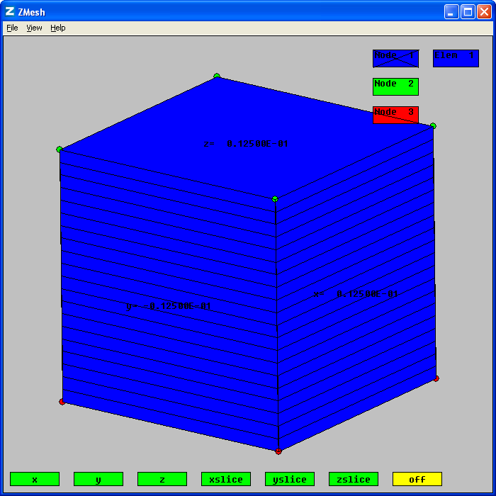
Figure 2: Simple diffusion system as setup in diffusion.min.

Diffusion is governed by the simple isotropic, homogenous, diffusion equation:
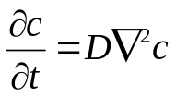
We will take D=2x10⁻¹⁰ m²/s. Comparing this formula to that given in the Zinc User Manual (chapter 4) shows that the Zinc C-matrix diagonals are simply equal to the diffusion constant D. there is only one variable, the concentration, c. Therefore, we need only set up

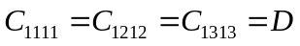

with other C components equal to zero. (see Tutorial Example 1 for more on the meaning of the Zinc C-coefficients). The other Zinc matrices: a, f, q, and g are all zero in this problem so we do not need to set them as all unspecified parameters are zero in Zinc.

The entire diffusion.zin file looks like this:
nvar=1
nstep=1000
solver=transient
nstride=100
tstep=1000.0 ! seconds

region 1 elements 3 values C
1 1 1 1 = 2e-10
1 2 1 2 = 2e-10
1 3 1 3 = 2e-10

region 2 nodes 1 values
1 = 1.0

region 3 nodes 1 values
1 = 0.0

The important point is the solver=TRANSIENT statement which indicates that Zinc will perform a transient analysis. We will run for 1000 time steps with time interval Δt = tstep = 1000.0 seconds each. Thus the simulation models diffusion over 1 million seconds (don’t worry: it will finish much quicker than that!). In the previous tutorials, nstride=100 simply means Zinc will output convergence information every 100 timesteps. That’s still the case here, but in transient problems, Zinc will also output a snapshot of the simulation state every 100 timesteps. All these snapshots are collated into the diffusion.zou file, so transient problems have multiple snapshots while static/steady state problems just have one: the final state. A snapshot is simply the value of c on every node at the given timestep: you can look at diffusion.zou (a text file) to see how the snapshots are collated.

We now run Zinc in the usual way using Zincwin as shown in Figure 3.

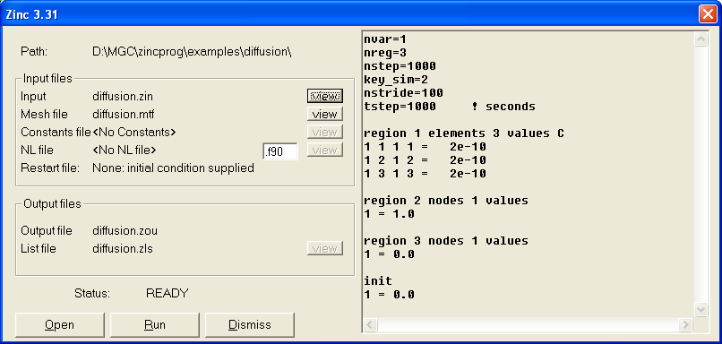
Figure 3: Zinc ready to solve the transient mateiral problem. Press “Run” to start the simulation.

For such a trivial problem, Zinc will finish almost instantly. For the post-processing, I’ve again kept things simple as shown in Figure 4. I’ve just set up one linescan which cuts through the simulation from z=-0.0125m to +0.0125m at x=y=0 and outputs the solved-for variable “u1” (I did not use a “labels” command in this run so the variable name just defaults to “u1”: if you want you can try adding “labels c” to the diffusion.zin file then you can put “linescan [parameters] = c” instead).

The resulting graph in shown in Figure 5. Note that this graph shows multiple curves, each one corresponding to a requested snapshot. In our case we set nstep=1000 and nstride=100, so snapshots are output at timesteps 100, 200, 300,…, 1000 corresponding to 100,000 s; 200,000 s;… 1,000,000 s in real time. In diffusion.zpp, we requested 1 linescan which Zinc puts into diffusion01.out (if multiple plane/line scans were requested each output file would contain scans for all snapshots that were simulated). Zinc puts all the snapshots in this file separated by double blank lines. As you can see from Figure 4, there are comments in this file marked by “#” showing which snapshot is which. Having prepared diffusion01.out, Zinc then calls gnuplot which prepares the graph file diffusion01.emf. Gnuplot simply puts all the curves on one graph, but you can use gnuplot outside of Zinc and isolate individual curves using gnuplot’s “index” command. For example, open gnuplot (it’s in the Zinc part of the Start Menu), make sure you are in the right directory as shown in Figure 6 and then enter the command:

plot 'diffusion01.out' index 0 using 1:5 with lines

The result is shown in Figure 7: only the first curve is plotted (index 0) corresponding to the diffusion at t=100,000 s. You can abbreviate the words (u)sing, (i)ndex and (l)ines here, so the command could be written:

plot 'diffusion01.out' i 0 u 1:5 w l

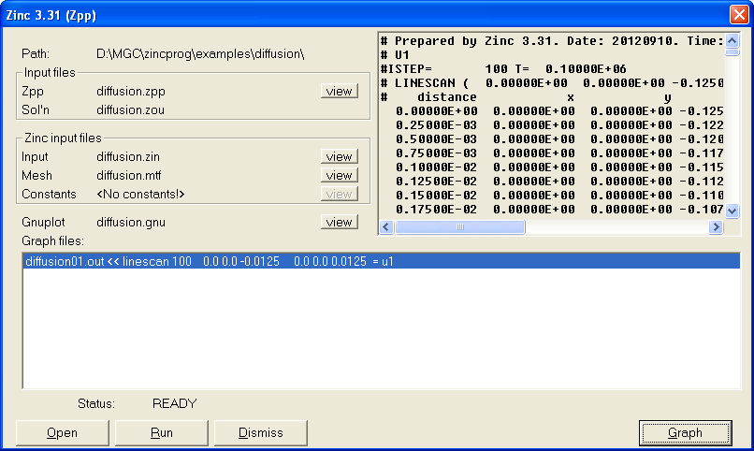
Figure 4: Zpp with a single linescan requested

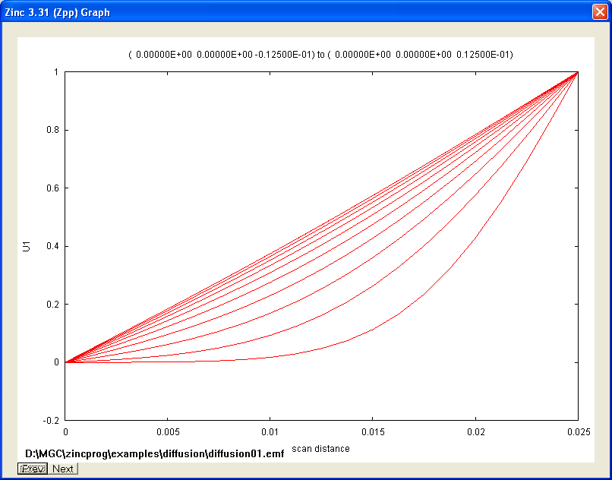
Figure 5: Material diffusion traces as function of time (as shown by zpp). The straight line trace is at the final output timestep (t=1,000,000 s).

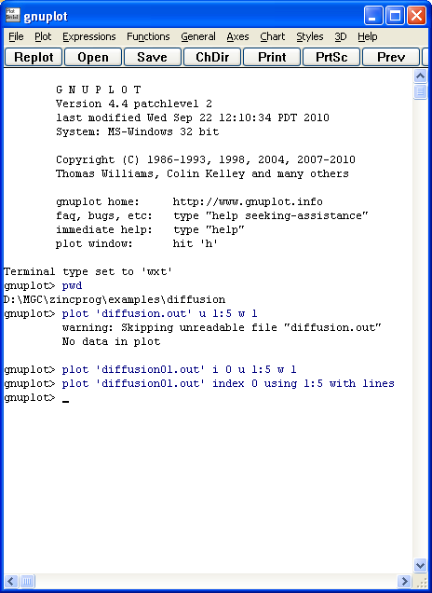
Figure 6: Using gnuplot to plot a single curve, here the first curve (index 0) at time t=100,000 s is plotted. The two plot commands shown are equivalent.

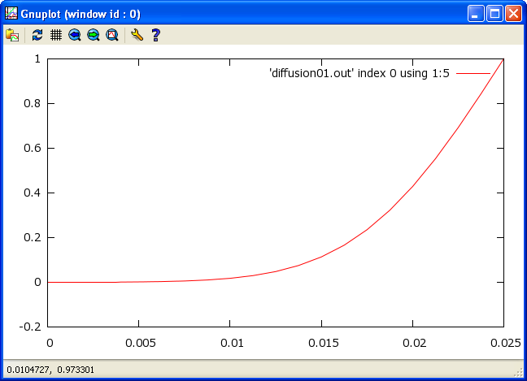
Figure 7: Gnuplot output showing concentration at t=100,000 s.

Figure 8 shows a comparison of two timesteps with the key (i.e. graph legend) showing which is which. Here, I used the command

plot 'diffusion01.out' i 0 u 1:5 t 't=100,000 s' w l,
'diffusion01.out' i 1 u 1:5 t 't=200,000 s' w l

I also prettified the graph by adding

set xlabel=’Time(s)’
set ylabel=’concentration (mol/m^3)’
set key left

The last command puts the key on the left of the graph. There are many other ways to improve the graph in gnuplot, I’ll leave you to explore the gnuplot examples and manual yourself (see also Tutorial Example 1 for some hints). Figure 9 shows a comparison between Zinc and TherMol, another NPL code. The agreement is clearly good at 100,000 s.

At the beginning of the tutorial, I mentioned that this simple geometry has an analytical solution. The analytical concentration is given by
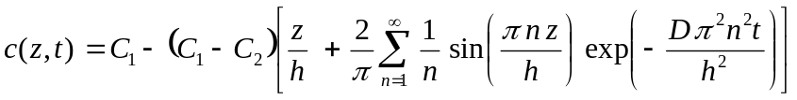
Where C₁ is the fixed concentration at z=0 and C₂ is the fixed concentration at z=h (the top of the simulation: h=0.025 m in our case). In this analytical model, the initial condition is c=C₂. Figure 10 shows comparison between this solution and Zinc for C₁=1 mol/m³, C₂=2 mol/m³. This is not the simulation result of Figure 5: here the boundaries are 1 and 2 mol/m³ and also the initial condition is c=2 mol/m³. We leave it as an exercise for the reader to repeat the result of Figure 10 using Zinc (hint: just alter diffusion.zin). Good agreement is shown between Zinc and the analytical solution.

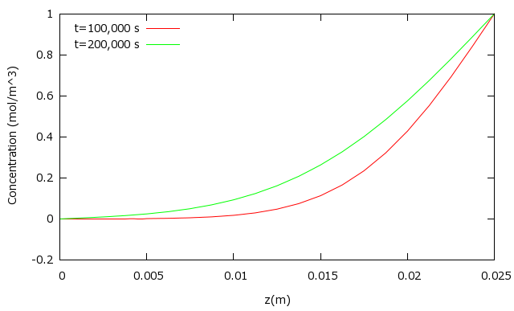
Figure 8: Comparison of concentration at two timesteps.

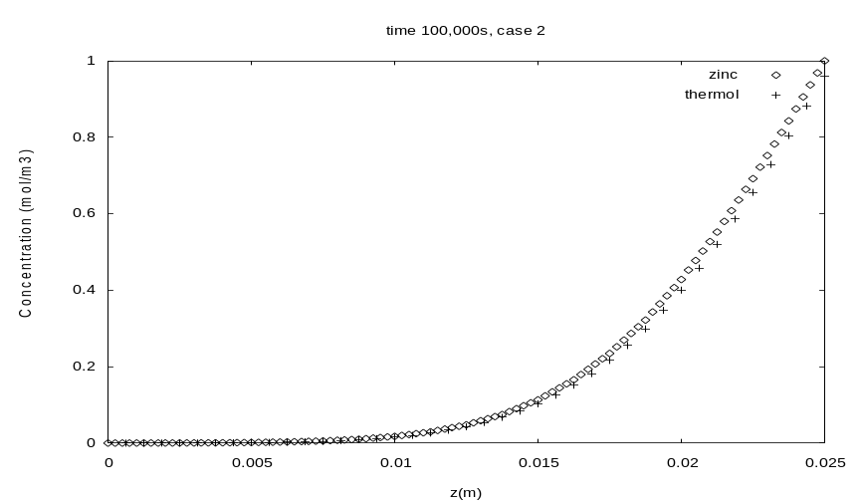
Figure 9: Comparison between Zinc and TherMol output at t=100,000 s.

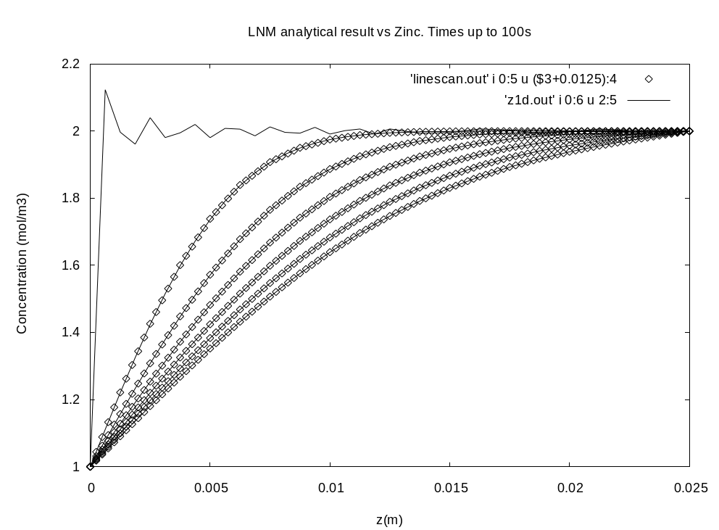
Figure 10: Zinc solution (symbols) and analytical solution (line). Times are up to 100s. The jagged appearance of the analytical solution at t=0 is because the Fourier series of equation (1) cannot easily represent a step function (c=1 mol/m³ at z=0 m; c=2 mol/m³elsewhere).

Diffusion with open (Neumann) boundary
We now consider simulation with one open boundary: at z=0. Figure 11 shows the system meshed using Zmesh (only nodes are shown). If you compare to Figure 2, you will see that there are no red (region 3) nodes, only blue (region 1) nodes and green (region 2) nodes. In diffusionopenbc.zin, we will fix the concentration in region 2 only. Thus, the bottom of the simulation will have an open or Neumann boundary condition, implying dc/dz=0 at z=0. The diffusionopenbc.zin file looks like this:

nvar=1
nreg=3
nstep=1000
nstride=100
tstep=1000.0 ! seconds
solver=transient

region 1 elements C
1 1 1 1 = 2e-10
1 2 1 2 = 2e-10
1 3 1 3 = 2e-10
end

region 2 nodes 1 values
1 = 1.0
end

init
1 = 0.0
end
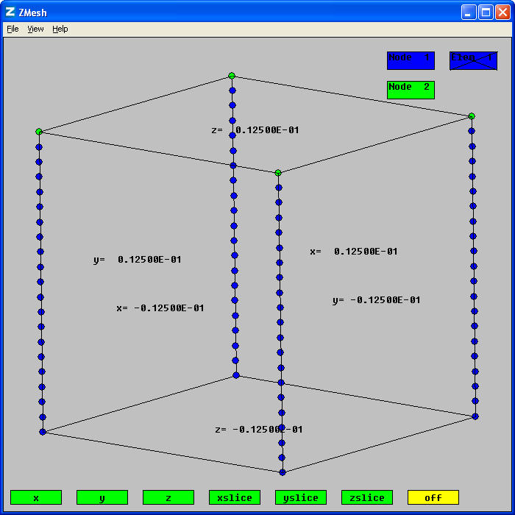
Figure 11: Diffusion problem with Neumann boundary at z=-0.0125 m. Note that nodes at the bottom are node 1 which will not be given a fixed value. So no Dirichlet boundary is set at the bottom of the simulation.

where there is no mention of region 3. Running on Zinc is the same as before and Figure 12 shows zpp ready to do the linescan. Again this is a simple z-scan through the centre showing the raw concentration. Figure 13 shows the result, again with multiple snapshots on the same graph. We can see the concentration derivative is indeed zero at z=0 m.
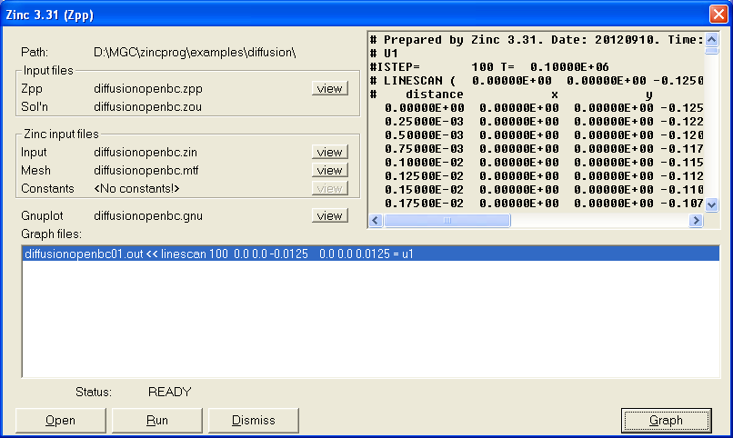
Figure 12: Ready to plot the open boundary diffusion problem

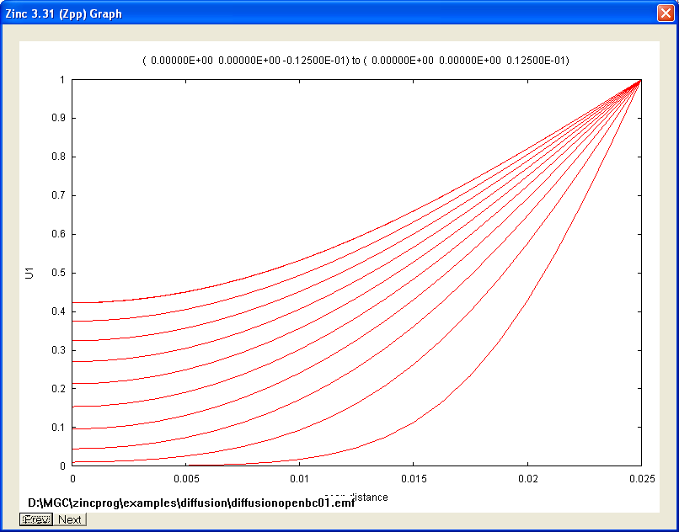
Figure 13: Concentration along z showing timsteps up to 1,000,000 s. Output by zpp.

To prove this answer is right, Fig. 14 shows a comparison between Zinc and TherMol for this, open boundary case. Agreement is very good at t=1,000,000 s.

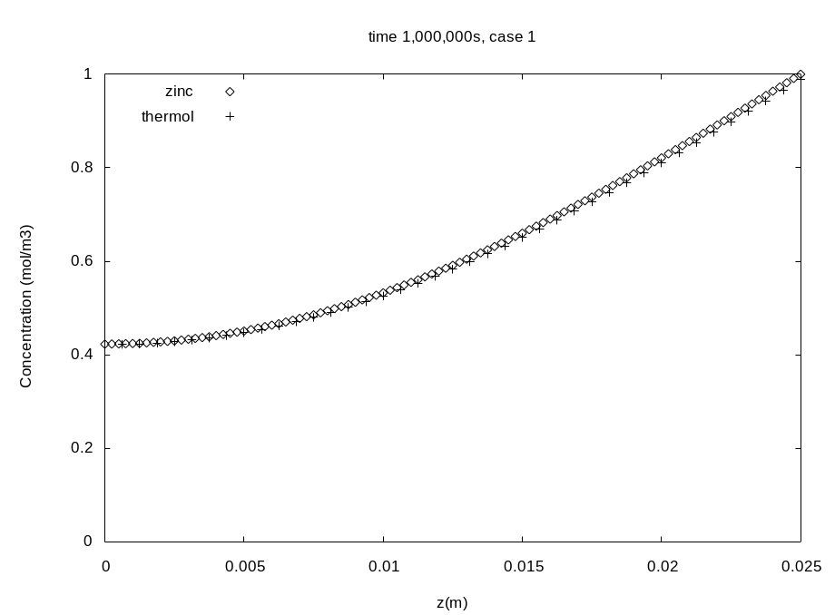
Figure 14: Comparison of Zinc and TherMol concentration plots with open boundary at z=0 m.

Example 5: Plane strain problem
Directory: examples/planestrain

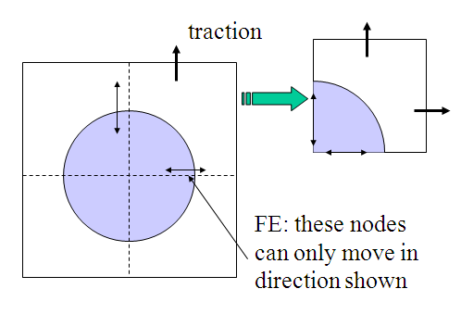
Region 2
Region 1
xmax
ymax
a
Figure 1: Simple cylinder in a cube geometry. The system is infinite in the out-of-page direction. Only one quarter of the system needs to be simulated using symmetry.

Introduction

We now consider a simple system consisting of an infinitely long cylinder with axis along the z-direction embedded in a cuboid (Fig. 1). The system is infinite in the z-direction so can be modelled as a 2-D system in the x-y plane. We will assume plane strain so that du_{z}/dx=0. In fact we will go further than this and simply take u_{z} itself to be zero throughout the problem. The system is stimulated by the application of hydrostatic tractions as shown in Figure 1. To simplify the problem further we will introduce symmetry boundaries (Figure 1) so that only ¼ of the system needs to be simulated. The stem name for this simulation is “planealcu”: as the name suggests, the inner cylinder is made of copper and the outer region is aluminium. The result of meshing with zmesh is shown in Figure 2.

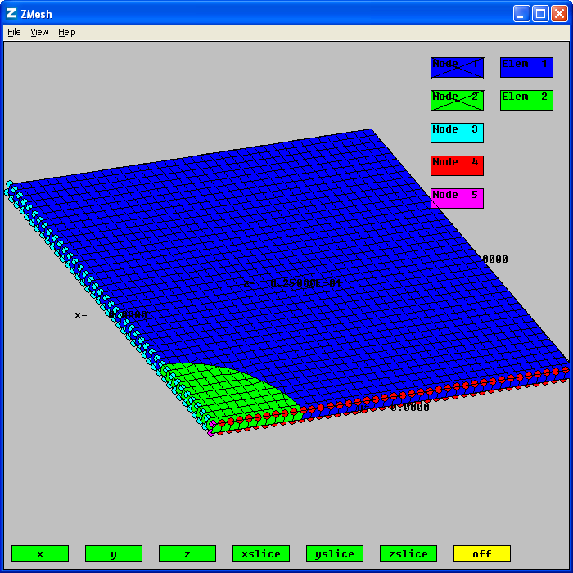
Figure 2: Plane strain system meshed using zmesh.

As in the transient example (Example 4) we have removed the redundant dimension (z) by simply putting a single element along this direction. Thus we simulate a plane perpendicular to the z-direction. In the planealcu.zin file, all nodes have been clamped in the z-direction (u_{z}=0). Furthermore, region 3, 4 and 5 nodes have been set so as to apply the symmetry conditions shown in Figure 1. For example, in planealcu.zin, we have the command:

region 3 nodes
ux=0.0
uz=0.0
end

indicating that region 3 nodes (see figure 2) are not allowed to move in the x-direction (nor in the z-direction as discussed). The outer tractions are applied using the commands (in planealcu.zin):

surface 1-xmax g
1=1.0
end

surface 1-ymax g
2=1.0
end

The statement “1-xmax” indicates the surface between region 1 and the region called “xmax” which conceptually sits outside the x-boundary of the system (see Figure 1). Thus 1-xmax refers to the upper-x boundary, while 1-ymax refers to the upper-y boundary. In this elastic simulation, the Zinc g-matrix corresponds to applied traction. The first surface command sets g1=gx=1 N/m² while the second command sets g2=gy=1 N/m². Thus tensile hydrostatic stress is applied to the system.

We could have also written these commands as
surface 1-xmax g
1=nx
end

surface 1-ymax g
2=ny
end

Here nx and ny are Zinc’s built in variables corresponding to the unit normal which are always available to use with surface commands (nz is also available). The direction of the unit normal (nx,ny,nz) depends on the order regions are specified in the surface command. In our case “surface 1-xmax” means the normal is from region 1 to region xmax, that is, the outward normal in Figure 1.

To see why the Zinc g-matrix corresponds to traction, let us recall the fundamental Zinc PDE and boundary specification (see User Manual):

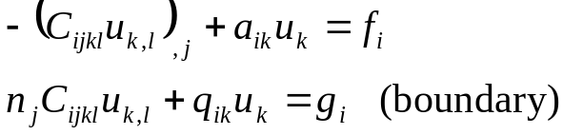 (1)

Where the notation u_{i,k} means du_{i}/dx_{k} (etc) and repeated indices imply summation. In the static elastic case with no body forces, the elastic PDEs are,
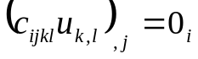
where u_{i} are the elastic displacements and c_{ijkl} are the stiffness tensor components. This formula can be derived from Newton’s laws of motion using the 4th rank “c” (stiffness) tensor to set the relationship between stress and strain. From the above it is clear that C_{ijkl}=c_{ijkl}. However, in data sheets we normally encounter the stiffness components in their matrix form. The standard convention is to map tensor index pairs (11, 22, 33, 23, 13, 12) to matrix components (1, 2, 3, 4, 5, 6). Thus the Zinc C element C₁₃₃₁=c₅₅ as you can see from the planealcu.zin file which contains specifications such as

region 1 elements C
:
1 3 3 1 = c55

Which sets C₁₃₃₁=c₅₅ where c₅₅ is a constant set in the planealcu.con file. From the “boundary” statement of equation (1) we can see that C_{ijkl} u_{k,l} is the stress and n_{j} C_{ijkl} u_{k,l} is the external force applied to the surface of the body which is called the traction (this is the definition of stress: stress multiplied by the unit normal gives applied force). Equation (1) then sets this to g so, by setting g, we set the traction applied to the external surface of the simulation.

We could have equally set the traction on surface 1-2 using a “surface” command. That would apply tractions on the curved internal curved surface between the two regions. Not setting such a surface command leaves these internal tractions at zero implying the usual continuity boundary between regions (i.e. normal stress continuous). Normally, we only apply surface forces at the edge of the simulation but, in general, we can set internal forces which would imply a discontinuity in the normal stress (in this example). See the User Manual for more discussion about setting internal boundary forces/fluxes/charges.

Results
We now run the simulation using Zinc (Figure 3) and process using zpp (Figure 4). To solve the equations, we are using the GMRES solver (solver=GMRES_LU). Figure 4 shows that we are requesting several planescans corresponding to all components of elastic displacement, stress and strain. Some of these results are shown in Figures 5-9.

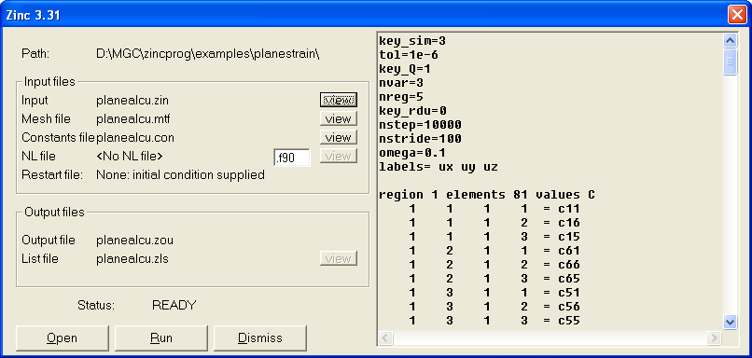
Figure 3: Simulation ready to run in Zinc

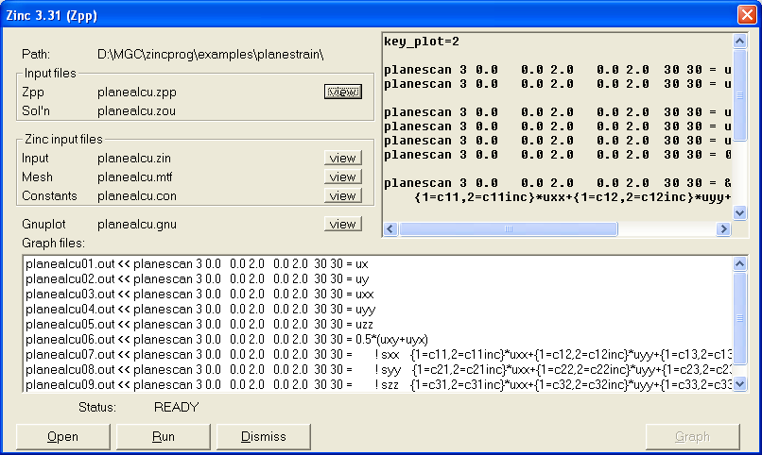
Figure 4: Post processing with zpp

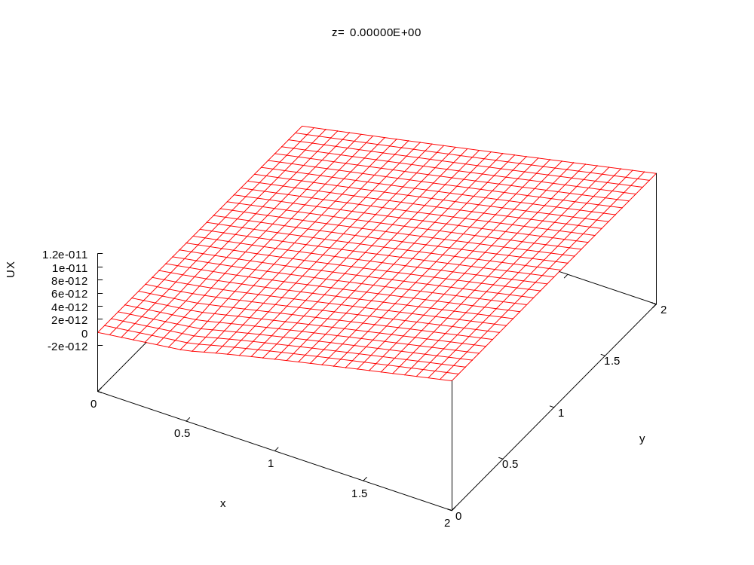
Figure 5: X-component of displacement
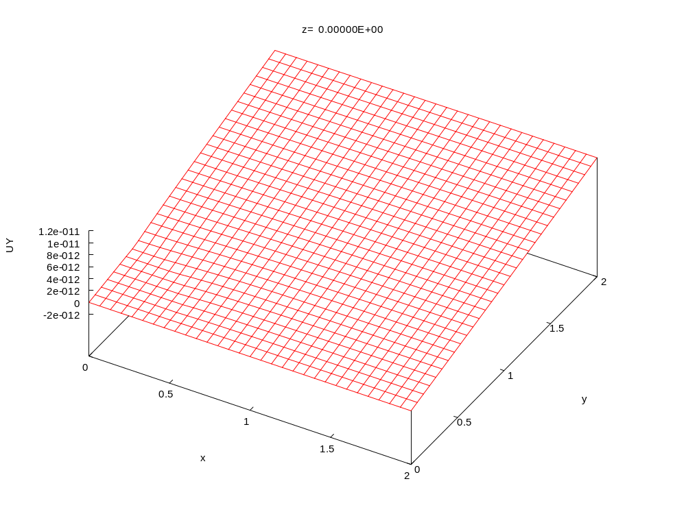
Figure 6: Y-component of displacement
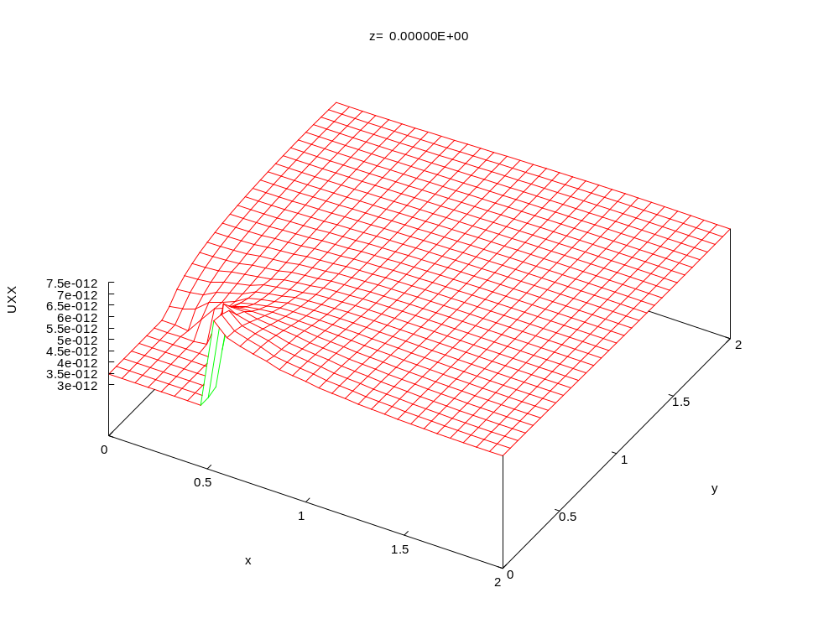
Figure 7: xx-component of strain
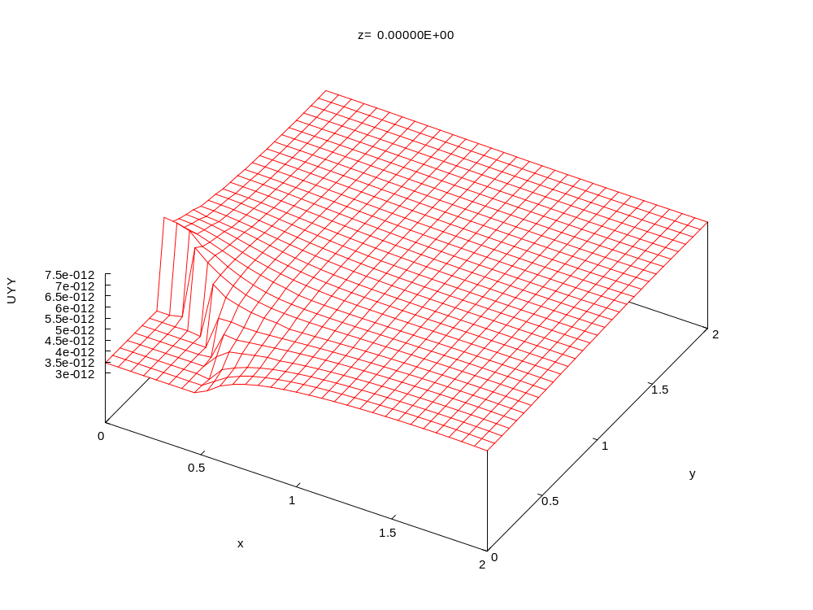
Figure 8: yy-component of strain
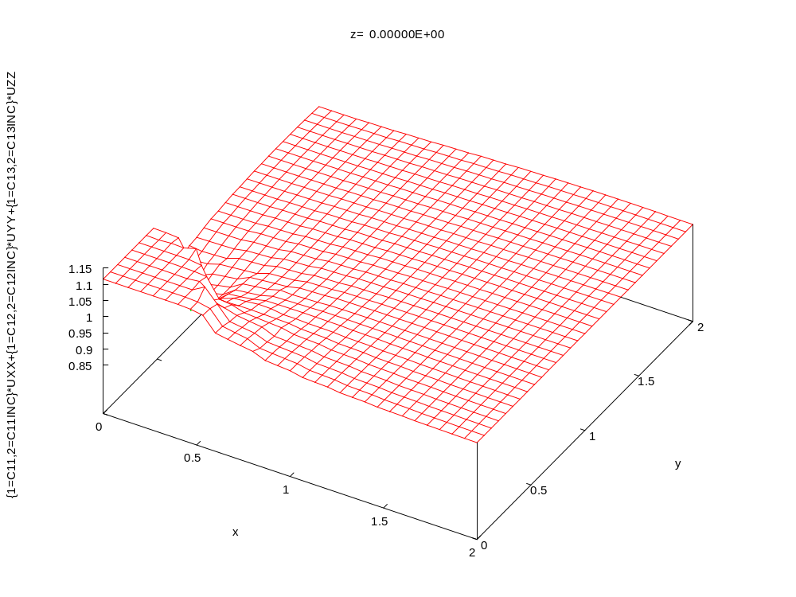
Figure 9: xx-component of stress

Comparison to analytical theory
The cylinder-in-a-cube system shown in Figure 1 can be solved analytically. The result is:

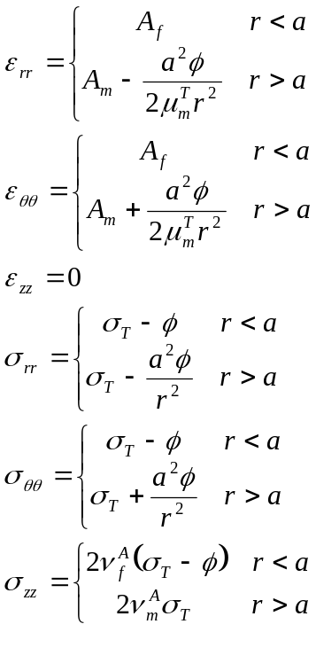
Where “a” is the radius of the inner inclusion, σ_{T} is the applied traction (assumed to be applied far from the inclusion) and

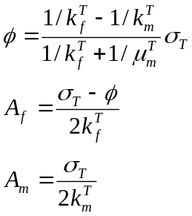
With

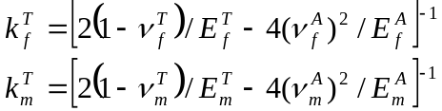

where “f” (fibre) and “m” (matrix) refer to the cylinder and the surrounding matrix respectively. E, ν, μ refer to Young’s modulus, Poisson’s ratio and the bulk modulus respectively. The superscripts “A” and “T” refer to the axial and transverse directions. These elastic properties may be derived from the stiffness matrix components c₁₁…c₆₆ simulated in Zinc. In fact, in this simulation we have assumed isotropic materials so that the distinction between axial and transverse directions vanishes.

These results are given in polar coordinates. Zinc and zpp output Cartesian components of stress and strain. It is possible to convert between the two using
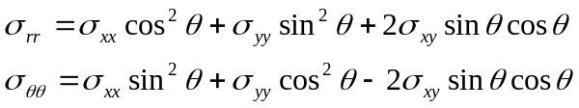

with identical conversion formulae for the strain. We have written a simple program (ss.f90) included in the example directory to perform the analytical-FE comparison. The program reads in the output plane scans generated by zpp (planealcu01.out etc) and converts stresses and strains to polar coordinates. Once converted, the above theory shows there is no variation with angle so that we can plot the various stresses and strains as functions only of radial distance, r. The resulting comparisons are shown in Figs 10-13. There is clearly good agreement. Note in particular that the required applied stress (traction) of 1 N/m² is indeed observed at the simulation boundary (Fig. 10). The stress (strain) shows continuity of normal (tangential) components as expected.

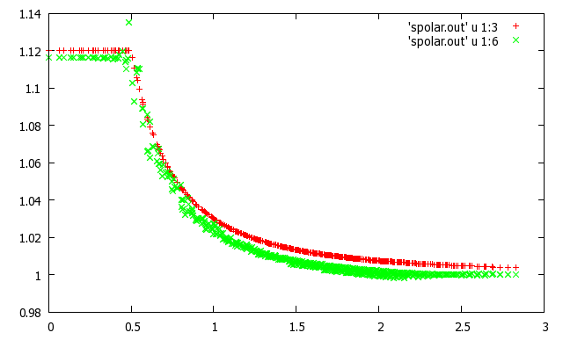
Stress (N/m²)
Figure 10: rr-component of stress. Red: analytical, green: Zinc result
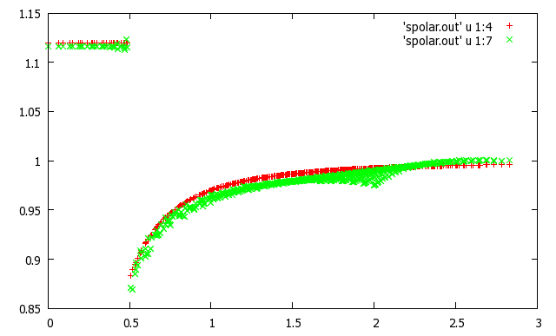
Stress (N/m²)
r (m)
r (m)
Figure 11: θθ-component of stress. Red: analytical, green: Zinc result

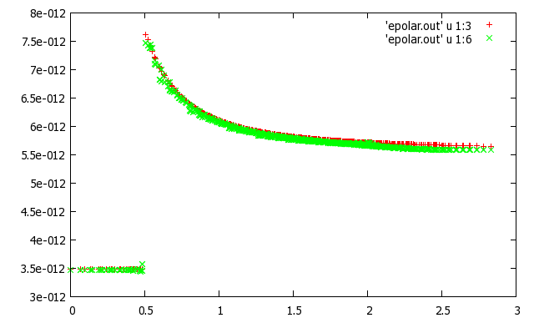
strain
r (m)
Figure 12: rr-component of strain. Red: analytical, green: Zinc result

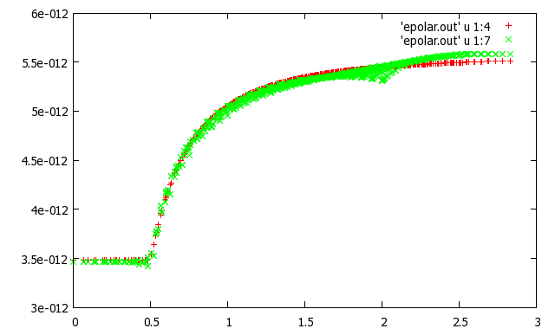
strain
r (m)
Figure 13: rr-component of strain. Red: analytical, green: Zinc result

Appendix A: Description of differential equations

The differential equations solved by ZINC have the form

,

which are written explicitly in component form as follows

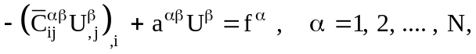

where summation over 1, 2, …. N is implied by repeated Greek superscripts, and where summation over 1, 2, 3 is implied by Arabic suffices. Here, 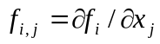. The structure of the (3N x 3N) C matrix when N = 2 is

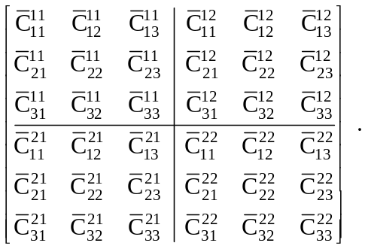

Note that

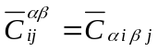

in the notation of the User Manual, Chapter 4. C components in the input ZIN file need to be entered in the order: α, i, β, j.

The general form of the matrix 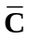 is an (N x N) array of (3 x 3) matrices. The term 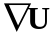 expands in component form as

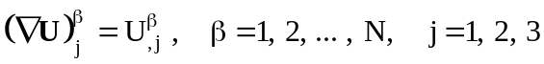.

The term is regarded as a (1 x 3N) column vector. When N = 2 it would be written

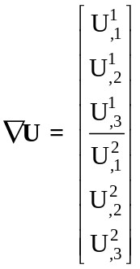 .

The term 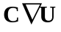 then expands in component form as follows

.

The term is regarded as a (1 x 3N) column vector. When N = 2 it would be written
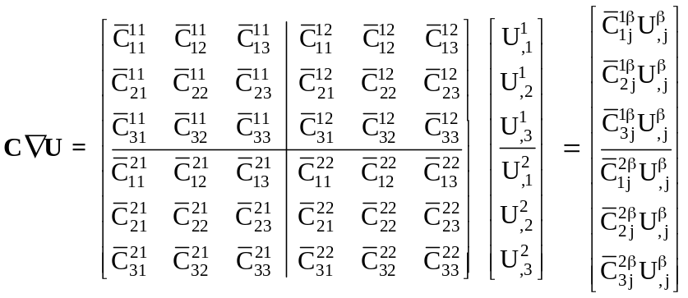 .

It then follows that

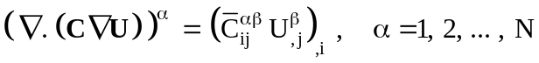.

The term 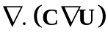 is regarded as an (1 x N) column vector. When N = 2 it would be written
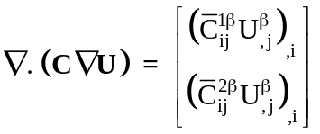 .

The matrix C used by the ZINC code has components of the form 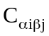 which are given by

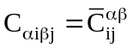 , 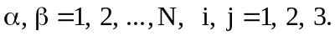

Boundary conditions

In order that the differential equations have a unique solution a set of boundary conditions must be imposed on the external boundary of the system. Such boundary conditions are assumed to be of the form (generalised Neumann condition)

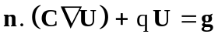,

where n is the outward unit vector on the external boundary, and where q is a prescribed scalar function and g is a prescribed vector function (dimension N). In component form this condition is written

