THE UNIVERSITY OFZAMBIA
SCHOOLOFNATURALANDAPPLIED SCIENCES
DEPARTMENTOFCOMPUTINGANDINFORMATICS

FINAL YEAR PROJECT REPORT
ACADEMIC YEAR 2026

ZAMMARKET: A PROGRESSIVE WEB APPLICATION FOR LOCAL CHARCOAL TRADING IN LUSAKA

A final Year Project Report Submitted to the Department of Computing and Informatics in partial fulfilment of the requirements for the award of
Bachelor’s Degree in Computer Science

Student Name: John CHOLA
Computer Number: 2021422054
Supervisor: MR. Martin PHIRI
Date of Submission: 23rd October, 2026.

DECLARATION
I declare that this final year project report is my own work and has been prepared in accordance with the academic requirements of the University of Zambia. All sources of information, ideas, data, software, images, and other material that are not my own have been appropriately acknowledged and referenced.
Student Name: ___________________________________________
Computer Number: _______________________________________
Signature: _______________________________________________
Date: ___________________________________________________

APPROVAL

This final year project report has been submitted for examination with the approval of the project supervisor.
Supervisor Name: _________________________________________
Signature: _______________________________________________
Date: ____________________________________________________

ABSTRACT
Charcoal is the most common main cooking fuel in urban Zambian households, yet most charcoal is sold informally. Buyers find sellers by word of mouth and have no reliable way to judge whether a seller they have not met is trustworthy. Sellers, for their part, have no record of good conduct that they can carry from one buyer to the next.
This project designed, built and evaluated ZamMarket, a mobile-first progressive web application (PWA) that connects charcoal sellers and buyers in Lusaka neighbourhoods. Sellers register with a Zambian phone number, publish listings by typing or by speaking in English through the browser's Web Speech API, and chat with buyers in real time. Buyers browse listings filtered by neighbourhood, price and quantity. Each seller carries a trust score derived from a SHA-256 hash chain of events: listings created, buyer ratings and administrator verification. Any edit to, deletion of or reordering of a recorded event breaks the chain and is detected; the most recent event is protected by a hash stored on the seller's account. Each rating must belong to a conversation the buyer held with the seller, with one rating per conversation. A service worker caches the application shell and listing responses, and chat messages and new listings (with photos) created offline are stored in IndexedDB and sent automatically on reconnection. Settlement is in person and in cash, by design.
The system was developed in four sprints with React, Redux Toolkit, Node.js, Express, MongoDB and Socket.io. An automated suite of 73 backend tests and 13 voice-parser tests passes, covering tamper detection (including the most recent event), authentication, rating rules, administrator rules and simultaneous writes; verifying a 1,000-block chain takes a few milliseconds. The voice parser handles spoken number words, prices with or without a currency word, bag sizes and the named neighbourhoods. The system is deployed on Vercel and Render (https://zam-market-khaki.vercel.app) and was tested end to end on an Android phone; a user usability study was not completed at the time of writing. The results show that a lightweight hash chain can give informal traders a verifiable reputation without online payment, which no reviewed platform offers in combination with local discovery and intermittent connectivity.
Keywords: progressive web application; informal trade; trust score; hash chain; offline-first; charcoal; Zambia

ACKNOWLEDGEMENTS
I would like to thank my supervisor, Mr. Martin Phiri, for his guidance throughout the development of this project. I also thank the charcoal sellers who shared their trading practices with me during the early observation phase and for allowing me take pictures of charcoal. I also want to thank my uncle Eng. Christopher Chomba for continuous encouragement through my entire academic life.

Contents
Declaration…………………………………………………………………………………………………………..1
Approval……………………………………………………………………………………………………………..3
Abstract…………………………………………………………………………………………….….…………….4
Acknowledgements……………………………………………………………………………….…………………5
List of Figures 8
List of Tables 9
List of Abbreviations and Acronyms 10
Chapter 1 11
Introduction 11
1.1 Background and Context 11
1.2 Problem Statement 11
1.3 Project Aim 12
1.4 Project Objectives 12
1.5 Research Questions 13
1.6 Scope of the Project 13
1.6.1 In Scope 13
1.6.2 Out of Scope 13
1.7 Significance of the Project 14
1.8 Limitations 14
1.9 Organisation of the Report 15
Chapter 2 16
Literature Review 16
2.1 Introduction 16
2.2 Key Concepts and Theories 16
2.2.2 Web Speech API 16
2.2.3 Hash Chains and Tamper Evidence 17
2.3 Existing Systems / Related Work 17
2.3.1 B-ne 17
2.3.2 Kaymu (now Jumia Market) 18
2.3.3 TreeMarket 18
2.3.4 Egatee 18
2.4 Comparative Analysis 19
2.5 Research / Knowledge Gap 20
2.6 Conceptual Framework 20
2.7 Chapter Summary 21
Chapter 3 22
Methodology 22
3.1 Introduction 22
3.2 Research / Development Approach 22
3.3 Requirements / Data Collection 23
3.4 System Architecture 23
3.5 Tools and Technologies 24
3.6 Ethical and Legal Considerations 25
3.7 Evaluation Method 26
3.8 Chapter Summary 26
Chapter 4 27
System Analysis and Design 27
4.1 Introduction 27
4.2 Stakeholder and User Analysis 27
4.3 Functional Requirements 28
4.4 Non-Functional Requirements 29
4.5 Use Cases / User Stories 29
4.6 System / Solution Architecture 31
4.7 Database Design 31
4.8 Interface / Interaction Design 32
4.9 Algorithms / Models / Technical Design 43
4.9.1 Trust chain 43
4.9.2 Trust score 44
4.9.3 Rating gate 44
4.9.4 Voice parsing 45
4.10 Chapter Summary 45
Chapter 5 46
Implementation / Development 46
5.1 Introduction 46
5.2 Development Environment 46
5.3 System Components / Modules 46
5.4 Key Implementation Details 48
5.5 Integration 49
5.6 Challenges and Solutions 50
5.7 Chapter Summary 52
Chapter 6 53
Testing, Results and Evaluation 53
6.1 Introduction 53
6.2 Testing Strategy 53
6.3 Test Cases and Results 54
6.4 Experimental / Performance Results 59
6.5 User Evaluation 60
6.6 Analysis of Results 60
6.7 Objective-by-Objective Evaluation 60
6.9 Chapter Summary 61
Chapter 7 61
Discussion 61
7.1 Introduction 61
7.2 Interpretation of Findings 61
7.3 Comparison with Existing Work 62
7.4 Contributions of the Project 62
7.5 Limitations and Implications 63
7.6 Chapter Summary 64
Chapter 8 65
Conclusion and Recommendations 65
8.1 Introduction 65
8.2 Summary of the Project 65
8.3 Conclusions 65
8.4 Achievement of Objectives 66
8.5 Recommendations 66
8.6 Future Work 67
References 68
Academic and technical sources 68
Web sources for existing platforms (Chapter 2) 69
Appendix A: Individual Contribution Statement (Group Projects) 69
Appendix B: User Manual / Installation Guide 69
Using ZamMarket 70

List of Figures
No. | Figure
3.1 | ZamMarket layered architecture
4.1 | Entity-Relationship diagram
4.2 | Login page
4.3 | Register page flow
4.4 | Browse with neighbourhood filters
4.5 | Listing detail with the seller's trust score
4.6 | Voice listing panel with editable transcript and extracted fields
4.7 | Listing form
4.8 | Chat with the rating prompt
4.9 | Trust score with a valid chain
4.10 | Chat with offline message
4.11 | Admin overview
4.12 | Trust-chain event flow from listing to verified score

List of Tables
No. | Table
2.1 | Comparison of reviewed platforms against ZamMarket
3.1 | Sprint plan and delivered increments
3.2 | Tools and technologies
4.1 | Stakeholders and user groups
4.2 | Functional requirements
4.3 | Non-functional requirements
4.4 | Use cases summary
4.5 | Data collections (MongoDB)
4.6 | Trust-score event weights
5.1 | REST API endpoints (main)
5.6 | Challenges and Solutions
6.1 | Backend automated test results
6.2 | Voice parser test results (English)
6.3 | System test cases
6.4 | Objective-by-objective evaluation

List of Abbreviations and Acronyms
Abbreviation | Meaning
API | Application Programming Interface
B2B / B2C / C2C | Business-to-Business / Business-to-Consumer / Consumer-to-Consumer
CORS | Cross-Origin Resource Sharing
GRASP | General Responsibility Assignment Software Patterns
JWT | JSON Web Token
ODM | Object Document Mapper
OTP | One-Time Password
PWA | Progressive Web Application
REST | Representational State Transfer
SHA-256 | Secure Hash Algorithm, 256-bit
SOLID | Single responsibility, Open–closed, Liskov substitution, Interface segregation, Dependency inversion
SUS | System Usability Scale
UI | User Interface
ZMW (K) | Zambian Kwacha

Chapter 1

Introduction

1.1 Background and Context
Charcoal is the most common main cooking fuel in urban Zambia. A national study of urban households found that about 44% cooked mainly with charcoal alone and a further 38% combined charcoal with electricity (Tembo, Mulenga and Sitko, 2015). In some low-income Lusaka neighbourhoods, the share of households relying on charcoal is higher still (Mtendere study, 2025). Households also kept using charcoal after they gained electricity, so demand is persistent rather than transitional.
Most of this charcoal reaches households through informal channels: roadside stalls, neighbourhood depots and sellers who move bags by bicycle or handcart. Trade happens face to face and in cash. Buyers find sellers by walking, asking neighbours or using contacts on general-purpose messaging apps. At the same time, smartphone ownership and mobile data have spread across Lusaka, although connectivity remains intermittent and data is costly for many users. This makes a lightweight web application, rather than a native app that must be downloaded from a store, a practical way to reach this market.
.

1.2 Problem Statement
Charcoal sellers in Lusaka neighbourhoods struggle to reach buyers beyond the people who pass their stall. Buyers have no reliable way to locate sellers near them, compare prices and quantities, or judge whether a seller they have not met will deliver the bag size and quality promised.
General-purpose channels such as WhatsApp groups and Facebook Marketplace help with discovery, but they keep no record of a seller's past conduct that a new buyer can check, and anyone can edit or delete what they post. Formal e-commerce platforms address trust through online payment held in escrow, but online payment is not reliably available to, or trusted by, informal traders who settle in cash. Their apps also assume steady connectivity.
The problem addressed by this project is therefore the absence of a tool that combines local discovery of charcoal sellers with a verifiable trust indicator, works for cash-settled, in-person transactions and keeps working under intermittent connectivity.

1.3 Project Aim
To design, develop and evaluate a mobile-first progressive web application that connects charcoal sellers and buyers within Lusaka neighbourhoods and gives each seller a tamper-evident trust score.

1.4 Project Objectives
- Objective 1: To implement listing creation and neighbourhood-based discovery, allowing buyers to filter charcoal listings by neighbourhood, price and quantity.
- Objective 2: To implement voice-based listing creation in English using the browser's Web Speech API, pre-filling price, quantity and neighbourhood for the seller to confirm.
- Objective 3: To implement a seller trust score backed by a SHA-256 hash chain, in which tampering with recorded events can be detected and only buyers who have contacted a seller can rate them.
- Objective 4: To provide real-time buyer–seller messaging and offline support, including cached browsing and queuing of messages and new listings created without a connection.
- Objective 5: To evaluate the system through functional testing, tamper-detection testing and a usability assessment.
Objective 2 originally included Nyanja and Bemba. It was narrowed to English during development; the reasons are given in Section 1.8.

1.5 Research Questions
Not applicable. This project is systems-development oriented rather than research-question driven; its goals are expressed as the objectives in Section 1.4.

1.6 Scope of the Project

1.6.1 In Scope
- Phone-number registration with a one-time password (OTP), and three roles: buyer, seller and administrator.
- Charcoal listings with title, charcoal type, price per unit (bag, tin or kg), quantity, neighbourhood, description and photo.
- Browsing with neighbourhood, text search, price range and minimum quantity filters across 11 named Lusaka neighbourhoods plus "Other".
- Voice-based listing creation in English.
- Real-time chat per listing, with offline message queuing.
- A hash-chain trust score with conversation-gated buyer ratings and administrator verification.
- An administrator panel for statistics, seller verification, suspension and listing removal.

1.6.2 Out of Scope
- Online payment, escrow or mobile-money integration; settlement remains in person and in cash.
- Delivery and logistics.
- Speech recognition in Nyanja, Bemba or other Zambian languages.
- Paid SMS delivery of OTP codes: sending through Africa's Talking or Twilio is built in but switched off, and codes are written to the server log.
- Areas outside Lusaka and goods other than charcoal.
- A distributed or public blockchain.

1.7 Significance of the Project
For sellers, ZamMarket offers a wider audience at no cost and a reputation that accumulates over time and travels with them to new buyers. For buyers, it shortens the search for nearby charcoal and gives them a trust signal before they commit to meeting a seller. Technically, the project shows that a tamper-evident record can be built with standard hashing on an ordinary database, without the cost of a public blockchain, and that a PWA can deliver useful features under poor connectivity. The approach could transfer to other informal goods traded locally in cash.

1.8 Limitations
- Language scope. The proposal promised voice listing in English, Nyanja and Bemba. During development it became clear that browsers' speech recognition does not support Nyanja or Bemba: the supported languages are set by each browser, and pages cannot query them in advance. A Nyanja/Bemba keyword map was prototyped, but it could not be evaluated reliably, so the scope was narrowed to English. The language selector and keyword map remain in the code as experimental features and are not claimed as results.
- No field study. Time did not allow testing with real charcoal sellers and buyers, so usability findings are pending (Section 6.5).
- Deployment. Attempts to deploy the system to Vercel and Render in July and September 2026 were unsuccessful, so most evaluation was carried out on a local installation. The causes were found and fixed (Section 5.6), and the system was deployed successfully on 12 October 2026. The free Render plan sleeps when idle, so the first request after a pause can take up to a minute.
- No paid SMS. SMS costs money with every provider, so the deployed system writes registration codes to the server log; real SMS through Africa's Talking or Twilio is implemented and tested, and is switched on with one setting.
- Single developer and a fixed academic timeline, which limited testing to automated unit tests and manual system tests; no end-to-end tests against a live database were written.

1.9 Organisation of the Report
Chapter 2 reviews relevant literature and theoretical frameworks. Chapter 3 describes the development methodology. Chapter 4 presents system analysis and design. Chapter 5 details implementation. Chapter 6 presents testing, results, and evaluation. Chapter 7 discusses the findings in relation to the problem and existing work. Chapter 8 concludes the report and states recommendations and future work.

Chapter 2

Literature Review

2.1 Introduction
This chapter sets out the concepts ZamMarket is built on and reviews existing platforms against which it can be compared. Section 2.2 explains progressive web applications, the Web Speech API and hash chains. Section 2.3 reviews four platforms that operate, or have operated, in Zambia or comparable markets, and Section 2.4 compares them with ZamMarket. Section 2.5 states the gap, Section 2.6 the frameworks that guided the work, and Section 2.7 summarises.

2.2 Key Concepts and Theories

2.2.1 Progressive Web Applications and Offline-First Design
A progressive web application is a website that uses modern browser features to behave like an installed app (Russell, 2015). Three features matter here. A web app manifest lets the user add the site to the home screen and open it full-screen. A service worker is a script that sits between the page and the network, so it can answer requests from a local cache when the network fails. IndexedDB is a database inside the browser that stores structured data across sessions.
Offline-first design treats the network as unreliable and plans for it. Static files are served from cache first, while data requests try the network first and fall back to the last cached copy. Writes made offline are stored locally and replayed when the connection returns. For users on costly, intermittent mobile data, this approach avoids both a store download and a blank screen when the signal drops.

2.2.2 Web Speech API
Modern browsers expose a Web Speech API that provides speech-to-text transcription. This project uses the API for voice-based listing creation in English. The transcript is parsed with pattern matching to extract the price and quantity, which are pre-filled into the listing form for the seller to review before submission. Language support is set by each browser, and a page cannot find out in advance which languages are available; it can only handle a language-not-supported error after the fact (MDN, n.d.). Chrome sends audio to a cloud service for transcription, so the feature also needs a connection.

2.2.3 Hash Chains and Tamper Evidence
A cryptographic hash function such as SHA-256 maps any input to a fixed 256-bit digest. Changing a single character of the input produces a completely different digest, and it is computationally infeasible to find a different input with the same digest. Haber and Stornetta (1991) showed that linking records by including each record's hash in the next one makes a history tamper-evident: altering an earlier record changes its hash and breaks every later link. Bitcoin's blockchain applies the same structure and adds distributed consensus and proof-of-work so that no single party controls the record (Nakamoto, 2008).
ZamMarket uses the hash chain without the distributed ledger. Each seller has a chain of event blocks stored in the application's own database. This gives tamper evidence, meaning modification is detectable, but not tamper resistance, because the database operator could in principle rewrite the whole chain. The trade-off is discussed in Section 7.5.

2.3 Existing Systems / Related Work
Four platforms were reviewed. Three are online marketplaces or classified services that operate, or have operated, in Zambia or comparable African markets. The fourth, Egatee, is a business-to-business platform included to show the wholesale end of the market. The review draws on public descriptions, company and press profiles, and app-store listings. These describe what each platform presents itself as doing. They are not hands-on evaluations.

2.3.1 B-ne
B-ne describes itself as a free classified platform connecting buyers and sellers in Zambia, offering goods and services through mobile and web access. Its stated aims are to help sellers reach a wider audience and to help buyers compare prices (B-ne, n.d.). The only description located in this review is an entry to a startup competition, which also states that the product had been used in East and West Africa rather than Zambia at the time of writing. Its current Zambian user base could not be confirmed.

2.3.2 Kaymu (now Jumia Market)
Kaymu was an online marketplace founded in 2013, offering consumer-to-consumer and business-to-consumer trade in 17 African countries, Zambia among them (Wikipedia, n.d.). It was rebranded as Jumia Market in 2016 (Dealroom, n.d.). Jumia later announced that Jumia Market would stop operating in favour of "one unified platform, Jumia" (TechCabal Radar, n.d.), so Kaymu no longer operates as an independent peer-to-peer marketplace.
Its 2016 marketplace description remains useful for comparison. It included a seller rating system and a SafePay arrangement, under which the platform held the buyer's payment until the buyer confirmed receipt of the goods (Jumia Market Overview, 2016). These are the closest existing analogues to ZamMarket's trust mechanism. However, they depend on online payment, which is not reliably available to the target community (Section 1.2).

2.3.3 TreeMarket
TreeMarket is a free service developed in Zambia that lets individuals advertise, buy, and sell new and used items within their own district. Transactions are arranged by meeting at a local spot (App Store, 2024). It is the closest existing system to ZamMarket in its local, face-to-face orientation. Its App Store listing offers a district filter, but it describes no seller rating, verification, or offline capability. At the time of review, the listing had too few ratings to display a summary. This suggests limited adoption, although a store listing alone cannot confirm it.

2.3.4 Egatee
Egatee is a business-to-business cross-border e-commerce platform founded in 2022. It connects suppliers, distributors, and retailers across Africa and provides logistics, customs clearance, and online payment services (Preqin, n.d.; Startup Seeker, n.d.). Its customers are retail businesses rather than individual sellers and buyers, so it falls outside the peer-to-peer segment ZamMarket targets. The sources reviewed do not confirm operations in Zambia, and they disagree on which countries it serves.

2.4 Comparative Analysis
Table 2.1 compares the four platforms with ZamMarket across eight criteria. "Not documented" means the sources reviewed did not describe that criterion. It does not establish that the platform lacks the feature, since hands-on testing of competitors was outside this project's scope.

Table 2.1: Comparison of reviewed platforms against ZamMarket
Criterion | B-ne | Kaymu (now Jumia Market) | TreeMarket | Egatee | ZamMarket
Target market | Buyers and sellers (classifieds) | Consumers and sellers (C2C and B2C) | Individuals within a district | Retail businesses (B2B) | Individual and small-scale charcoal sellers and buyers
Current status | Not confirmed | Discontinued as standalone | Listed on App Store (2024) | Operating in several countries | Working prototype, run locally; production deployment not yet successful
Location-based discovery | Not documented | Not documented | Yes (district filter) | No | Yes (neighbourhood filter)
Price and quantity filters | Not documented | Not documented | Not documented | Not applicable | Yes
Seller trust mechanism | Not documented | Seller ratings; escrow (2016) | Not documented | Not documented | Tamper-evident hash-chain score
Offline operation | Not documented | Not documented | Not documented | Not documented | Yes: cached browsing, queued messages, offline listing
Voice-based listing creation | Not documented | Not documented | Not documented | Not documented | Yes (English only)
Settlement | Not documented | Online, held by platform until receipt | In person at meet-up | Online payment | In person, cash, by design

Three patterns emerge. First, the only platform documented as operating locally and face-to-face, TreeMarket, describes no trust mechanism. Second, the platform with a documented trust mechanism, Kaymu, depends on online payment and no longer operates independently. Third, none of the four describes offline operation or voice-based listing creation. No reviewed platform is documented as combining locally based discovery, a verifiable seller trust indicator, offline operation, and cash settlement.

2.5 Research / Knowledge Gap
The gap is narrower than a general absence of digital trading tools. Local, in-person platforms such as TreeMarket address discovery but not trust. Platforms with trust mechanisms, such as Kaymu, rely on online payment and have been absorbed into larger retail operations. Egatee serves businesses rather than individuals. No reviewed platform combines locally based discovery, a verifiable seller trust indicator, and operation for cash-settled transactions under intermittent connectivity. ZamMarket was designed to address that combination.

2.6 Conceptual Framework
Two frameworks guided the project. The process framework is agile, iterative development (Beck et al., 2001): the system was built in short sprints, each delivering a working increment that was tested before the next began (Sommerville, 2016). This suited a single developer whose understanding of the problem, such as the limits of speech recognition, changed during the project.
The design framework is a three-layer architecture of presentation, application and data, refined with the SOLID principles (Martin, 2008) and GRASP responsibility patterns (Larman, 2004). Under the Information Expert pattern, the hash-chain utility alone owns hashing, verification and scoring; under Controller, each REST controller handles one resource; and Low Coupling keeps the trust mechanism behind a single addTrustEvent function that listing, rating and administrator code all call. The Observer pattern (Gamma et al., 1995) underlies the real-time chat, in which clients subscribe to conversation rooms and are notified of new messages.

2.7 Chapter Summary
The four platforms reviewed each address part of the problem of informal charcoal trading. The local platform provides discovery without a documented trust mechanism, the trust mechanisms depend on online payment, and the business platform serves a different segment. The agile process framework and the layered, SOLID/GRASP-guided design framework reviewed in Section 2.6 inform the methodology and design in Chapters 3 and 4.

Chapter 3

Methodology

3.1 Introduction
ZamMarket was built with an agile, sprint-based approach and evaluated by functional testing, targeted unit tests of the trust and voice components, and a planned usability study. This chapter describes the approach, how requirements were gathered, the architecture, the tools, ethical considerations and the evaluation method.

3.2 Research / Development Approach
An agile approach (Beck et al., 2001) was chosen over Waterfall because several requirements could only be settled by building and trying them. The clearest example is voice input: whether Nyanja and Bemba recognition was feasible only became clear once a prototype ran in real browsers. Each sprint delivered a working increment, which was tested manually before the next sprint started, and defects found later were fixed in place, as the repository history shows (for example, the trust-score fixes of 23 May 2026 and the rewrite of chain verification committed on 25 September 2026).

Table 3.1: Sprint plan and delivered increments
Sprint | Period (2026) | Increment delivered
1 | to early May | Project setup; phone and OTP registration; JWT login; roles
2 | May | Listings with Cloudinary image upload; browse and filters; voice listing input
3 | May | Real-time chat; offline message queue and service worker; hash-chain trust score and conversation-gated ratings
4 | late May | Administrator panel; mobile-first styling; transaction confirmation in chat
Stabilisation | June to September | Bug fixes, chain verification fix, voice parser rewrite, security hardening, automated tests and CI, deployment fixes

3.3 Requirements / Data Collection
Requirements were derived from three sources: informal observation of how charcoal is sold in Lusaka neighbourhoods, the review of existing platforms in Chapter 2, and the project proposal approved by the supervisor. No formal survey or interview of sellers and buyers was carried out before development; this is acknowledged as a limitation (Section 7.5). Requirements were recorded as user stories (Section 4.5) and prioritised at the start of each sprint.

3.4 System Architecture
The system follows a three-layer architecture (Figure 3.1). The presentation layer is a React PWA that runs in the phone's browser. The application layer is a Node.js and Express REST API with a Socket.io server for chat. The data layer is MongoDB, accessed through Mongoose, with listing photos stored on Cloudinary and offline data kept in the browser's cache and IndexedDB.

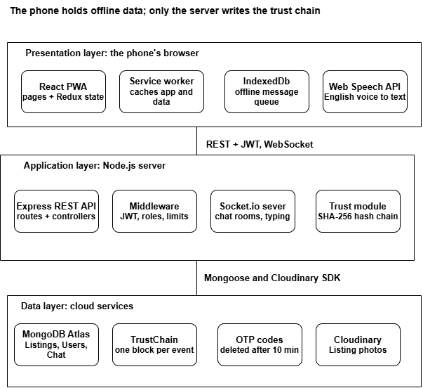
Figure 3.1: ZamMarket system architecture

The presentation layer communicates with the application layer through a RESTful API and a Socket.io WebSocket connection for real-time messaging. The application layer communicates with the data layer exclusively through the Mongoose object-data mapper, so no component outside the models directory constructs a raw database query. This workflow is elaborated further, with full database design, in Chapter 4.

3.5 Tools and Technologies
Table 3.2: Tools and technologies
Layer | Technology | Purpose
Presentation | React 19, Redux Toolkit, React Router 7, Vite 8 | Single-page PWA, state management, routing, build
Presentation | Service Worker, Web App Manifest, IndexedDB | Offline caching, installability, offline message queue
Presentation | Web Speech API | English voice-to-text for listings
Application | Node.js, Express 4 | REST API
Application | Socket.io 4 | Real-time chat, typing indicators, read status
Application | jsonwebtoken, bcryptjs, express-rate-limit | Authentication, password hashing (12 rounds), rate limiting
Application | Node crypto (SHA-256) | Hash-chain trust score
Data | MongoDB Atlas, Mongoose 8 | Persistent storage and schema validation
Data | Cloudinary, Multer | Image upload and hosting
Tooling | Git, GitHub, GitHub Actions, ESLint, Node test runner (node:test), Nodemon, Chrome DevTools, Playwright | Version control, continuous integration, linting, automated testing, debugging

3.6 Ethical and Legal Considerations
- Privacy. Only a phone number, name, neighbourhood and role are collected. Phone numbers are masked in public profiles (for example, +26097****123), and passwords are stored only as bcrypt hashes.
- Consent. Any future usability study will use informed consent, anonymised responses and voluntary participation, with approval from the department as required.
- Voice data. Speech is processed by the browser's speech service; ZamMarket stores only the transcript fields the seller chooses to submit, not audio. Users should be told that, in Chrome, audio is sent to Google for transcription.
- Security. Login, registration and OTP endpoints are rate-limited, protected routes require a valid token, and administrator accounts cannot be created through public sign-up.
- Legality of the product. Charcoal production and trade in Zambia is regulated under forestry law, including licensing requirements. The platform does not verify sellers' licences; this is noted as a recommendation (Section 8.5).
- Licensing. All libraries used are open source under permissive licences (MIT or similar).

3.7 Evaluation Method
Success was measured against the five objectives with four methods:
- Functional system testing of each user story through the user interface, recorded as test cases with expected and actual results.
- Unit tests of the trust chain, part of the repository's automated suite and run in Node.js against backend/utils/blockchain.js, covering verification of intact chains, detection of edited, deleted and reordered blocks, score calculation and clamping, and timing for a 1,000-block chain.
- Unit tests of the voice parser, applying the parser in parseListing.js to representative English phrases, including number words, prices without a currency word and bag sizes.
- Usability assessment with the System Usability Scale (Brooke, 1996), with a target mean score of at least 70, the commonly cited threshold for acceptable usability (Bangor, Kortum and Miller, 2008), plus a Lighthouse audit of the mobile build with a performance target of at least 70.

3.8 Chapter Summary
The project followed four agile sprints and a stabilisation period, built on a three-layer architecture using the MERN stack, Socket.io and a SHA-256 hash chain. Evaluation combines system tests, unit tests of the novel components and a usability assessment.

Chapter 4

System Analysis and Design

4.1 Introduction
This chapter presents the analysis and design work underlying ZamMarket: the stakeholders and users the system serves, the functional and non-functional requirements derived from Chapter 1’s problem statement, the use cases describing system interactions, the system and database architecture, the interface design approach, and the key algorithms and design principles applied.

4.2 Stakeholder and User Analysis
Table 4.1: Stakeholders and their interests
Stakeholder | Interest in the system
Individual charcoal sellers | Primary users; need to reach buyers beyond passers-by with minimal technical effort
Bulk sellers / market traders | Primary users; need to reach buyers beyond those who physically visit the market
Buyers | Primary users; need to discover nearby sellers, compare prices, and judge reliability before contact
Platform administrator | Secondary user; needs to moderate listings, verify trusted sellers, and manage accounts
Project supervisor / Department of Computing and Informatics | Academic stakeholder; requires a demonstrable, explainable, and defensible system
Infrastructure providers (MongoDB Atlas, Cloudinary) | Indirect stakeholders; provide the data persistence and media storage the system depends on
Sellers and buyers were not treated as a single undifferentiated “user” group, since their goals diverge significantly: a seller’s primary need is visibility and reputation-building, while a buyer’s primary need is discovery and risk reduction before an unverified cash transaction. This distinction directly shaped the decision to give each role its own dashboard and navigation, discussed in Section 4.8.

4.3 Functional Requirements
Table 4.2: Functional requirements
ID | Requirement | Objective
FR1 | Users register with a Zambian phone number verified by a 6-digit OTP, and log in with phone and password | All
FR2 | Users have one role: buyer, seller or administrator; sign-up offers only buyer and seller, and administrators are created by a command-line script | All
FR3 | Sellers create, edit, pause, mark as sold and delete listings with an optional photo | 1
FR4 | Buyers browse active listings by neighbourhood, keyword, price range and minimum quantity | 1
FR5 | Sellers can dictate a listing in English; the system pre-fills title, price, quantity and neighbourhood for review | 2
FR6 | Every listing creation, buyer rating and administrator verification is appended to the seller's hash chain | 3
FR7 | Anyone can view a seller's trust score, chain length and chain validity | 3
FR8 | A buyer may rate a seller from 1 to 5 only after a conversation with them, once per conversation | 3
FR9 | Buyer and seller exchange real-time messages about a listing, with typing and unread indicators | 4
FR10 | Messages and listings created offline are queued and sent automatically on reconnection | 4
FR11 | Previously viewed listings remain browsable offline | 4
FR12 | Administrators view statistics, verify sellers, suspend or reactivate users, change roles and remove listings | 3

4.4 Non-Functional Requirements
Table 4.3: Non-functional requirements
ID | Category | Requirement
NFR1 | Usability | Mobile-first layout usable on a 360 px-wide screen; SUS score of at least 70
NFR2 | Performance | Lighthouse mobile performance of at least 70; chain verification fast enough for every profile view
NFR3 | Security | Passwords hashed with bcrypt (12 rounds); JWT with 7-day expiry; OTP limited to 3 requests per 10 minutes and 3 attempts per code; login limited to 10 attempts per 15 minutes; registration limited to 10 per hour
NFR4 | Privacy | Phone numbers masked in public profiles
NFR5 | Integrity | Any change to a recorded trust event must be detectable
NFR6 | Availability | Core reading functions work offline after first visit
NFR7 | Maintainability | Layered structure with one controller per resource; linted code
NFR8 | Portability | Runs in any modern browser and installs to the home screen without an app store

4.5 Use Cases / User Stories
Table 4.4: Use cases summary
ID | Actor | Use case | Description
UC1 | Seller, Buyer | Register | Create an account via phone number and OTP verification
UC2 | Seller, Buyer | login | Authenticate using phone number and password
UC3 | Seller | Create listing | Post a charcoal listing by speaking or typing, with optional photo
UC4 | Buyer | Manage listing | Edit, pause, mark as sold, or delete an existing listing
UC5 | Buyer | Browse/search listings | View listings filtered by neighbourhood, price, and quantity
UC6 | Seller, Buyer | Message | Send and receive real-time messages about a specific listing
UC7 | Buyer | Rate seller | Submit a 1-5 star rating after confirming collection, recorded on the trust chain
UC8 | Admin | Verify seller | Grant a verified-seller badge, recorded as a trust chain event
UC9 | Admin | Moderate | Suspend/reactivate a user, change a user’s role, or remove a listing
A representative use case is expanded below to illustrate the level of detail considered during design:
UC7: Rate Seller
Actor: Buyer.
Precondition: Buyer has an existing conversation with the seller.
Main flow:
- Buyer opens the chat with the seller regarding the product
- Buyer chat with the seller about the listed product
- Buyer taps “Rate Seller” after being satisfied with the product
- Buyer selects a 1-5 star rating
- System verifies no prior rating exists from this buyer for this seller system appends a new block to the seller’s trust chain and recalculates the seller’s trust score.
Alternative flow: If the buyer has no conversation with this seller, or has already rated them, the rating is rejected with an explanatory message.
Post-condition: Seller’s trust score is updated and the rating is permanently recorded.

4.6 System / Solution Architecture
The final architecture is the three-layer design shown in Figure 3.1. On the backend, requests pass through route modules (auth, user, listing, chat, trust, admin) to middleware (protect verifies the JWT, restrictTo checks the role, rate limiters and Multer handle abuse and uploads), then to one controller per resource, which uses the Mongoose models. Cross-cutting utilities handle hashing (blockchain.js), tokens (jwt.js), OTP (otp.js), images (cloudinary.js) and sockets (socket.js). On the frontend, pages read and update three Redux slices (auth, listing, chat) through an Axios client, while the Socket.io client carries chat events.

4.7 Database Design
Table 4.5: Data collections (MongoDB)
Collection | Key fields | Relationships and indexes
User | phone (unique, Zambian format), name, password hash, role, neighbourhood, sellerProfile (isVerified, rating, ratingCount), trustScore (score, chainHash), isActive | One seller has many Listings and TrustChain blocks
Listing | seller, title, charcoalType, pricePerBag, unit, quantityAvailable, neighbourhood, description, image, status, views | Index on (neighbourhood, status, createdAt) and (seller, status)
Conversation | listing, buyer, seller, lastMessage, unreadBuyer, unreadSeller | Unique on (listing, buyer): one conversation per buyer per listing
Message | conversation, sender, text (max 1,000), readAt | Index on (conversation, createdAt)
TrustChain | seller, blockIndex, timestamp, event (type, sellerId, data), previousHash, hash | One document per block; index on (seller, blockIndex)
OTP | phone, code, attempts, expiresAt, verified | TTL index deletes the code at expiry (10 minutes)

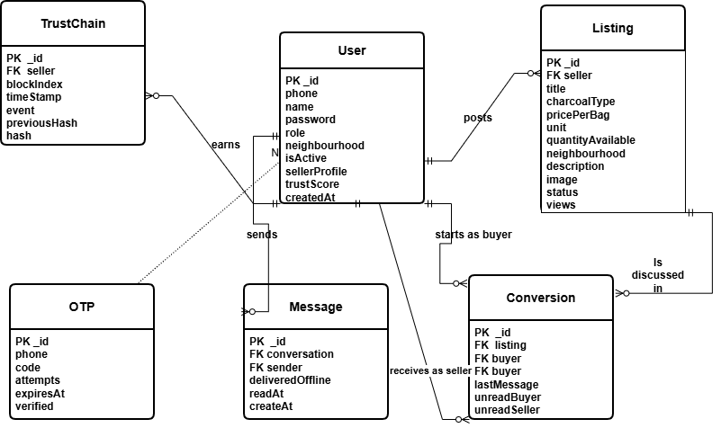
Figure 4. 1: Entity-Relationship diagram

4.8 Interface / Interaction Design
The interface is mobile-first: single-column cards, large tap targets and a bottom-weighted layout for one-handed use. Main screens are Login, Register (with OTP step), Dashboard, Browse (filters above a card grid, newest first), Listing Detail, Create Listing (with a microphone button that opens the voice panel), My Listings, Inbox, Chat and Trust Score. The voice panel moves through four states: idle, listening, done and error. In the done state, it shows the transcript in an editable box, each extracted field and any field not detected, and asks the seller to confirm with "Use This" or "Retry", so nothing is submitted without review. The chat screen shows an offline banner and marks queued messages, and the Trust Score page shows the score, the number of blocks and whether the chain verified.

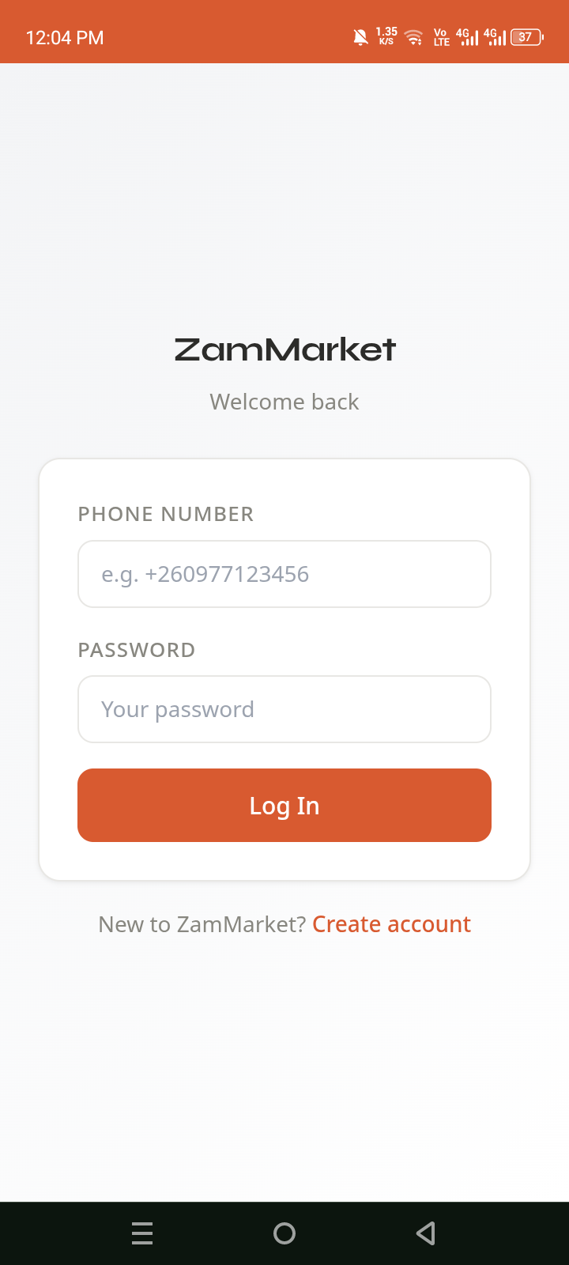
Figure 4.2: Login page

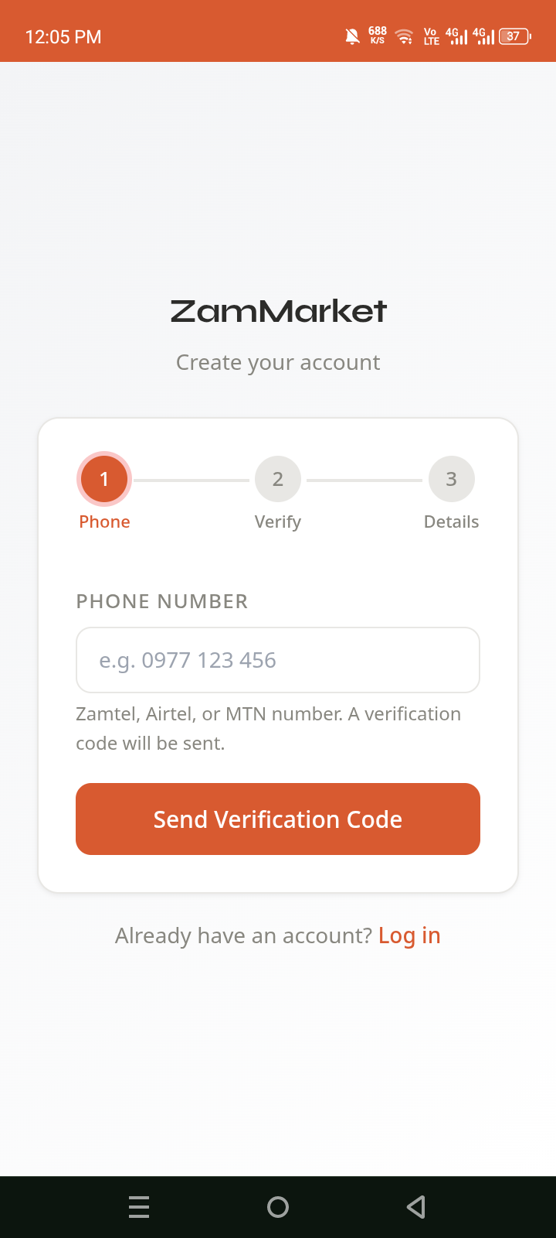
Figure 4.3: Register page flow
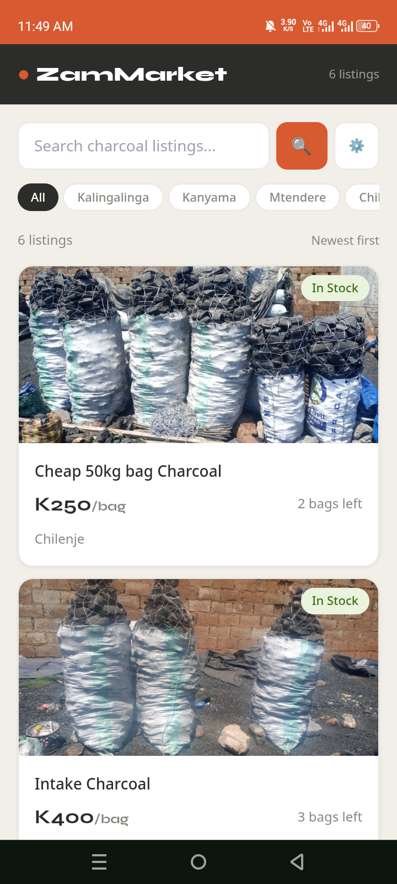
Figure 4.4: Browse with neighbourhood filters

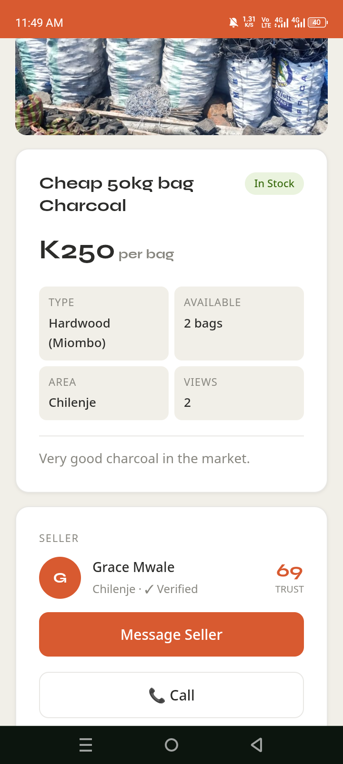
Figure 4.5: Listing detail with the seller's trust score
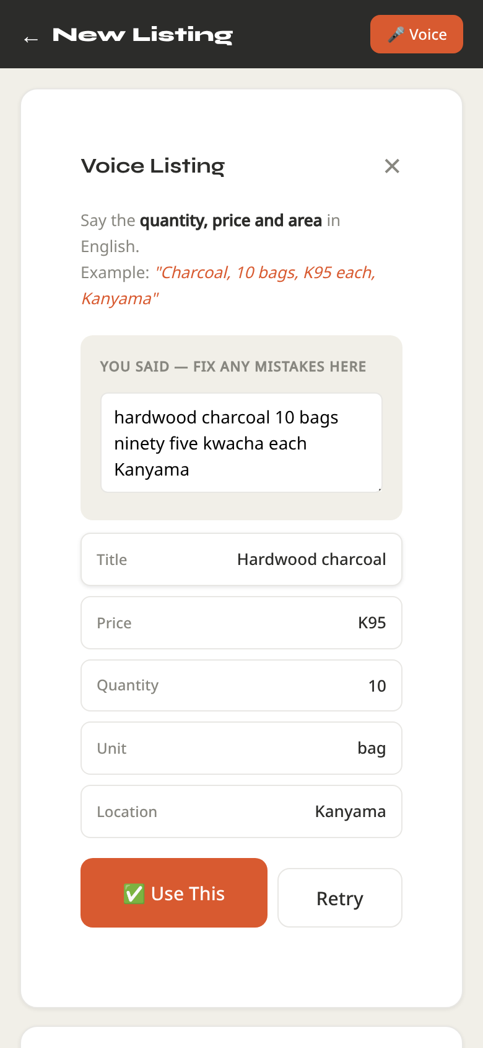
Figure 4.6: Voice listing panel with editable transcript and extracted fields
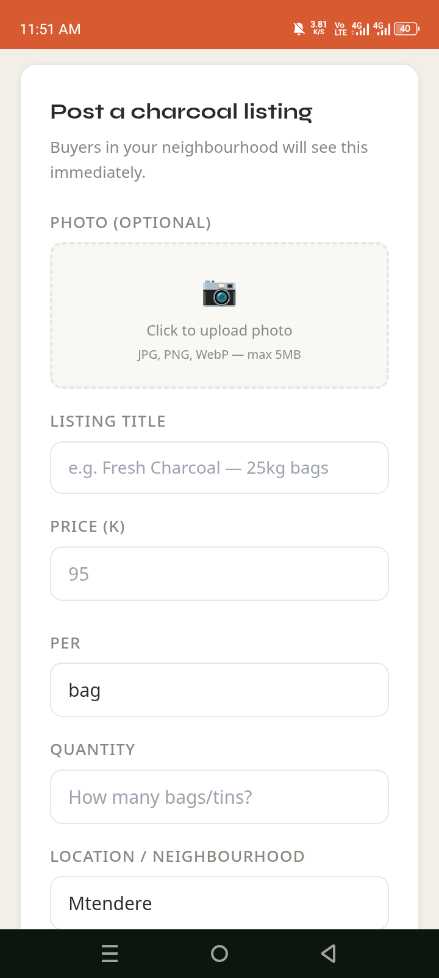
Figure 4.7: Listing form

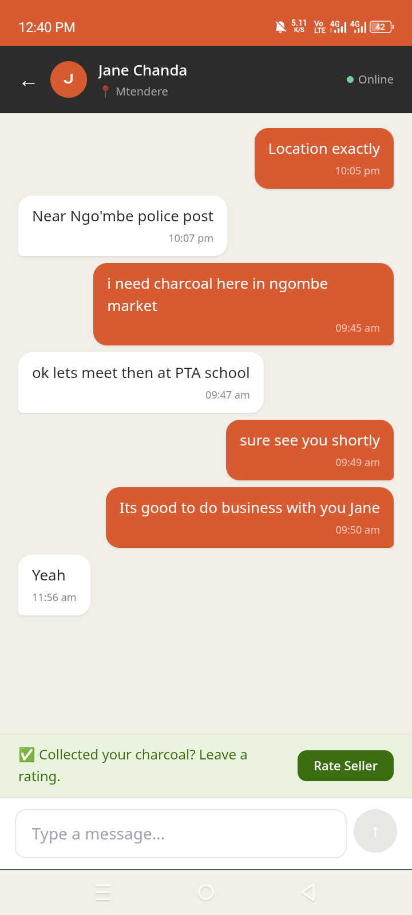
Figure 4.8: Chat with the rating prompt
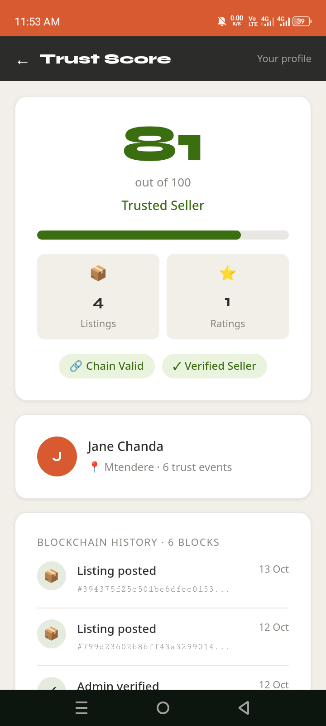
Figure 4.9: Trust score with a valid chain
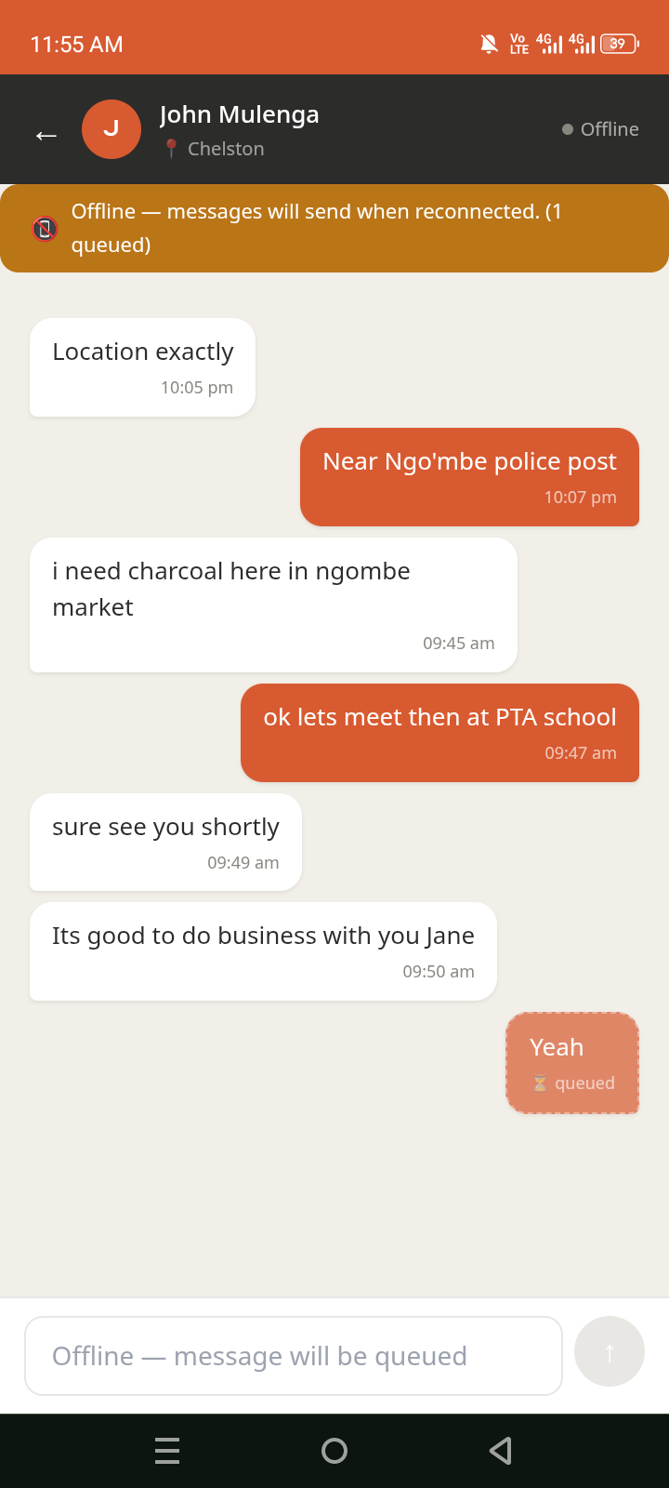
Figure 4.10: Chat with offline message
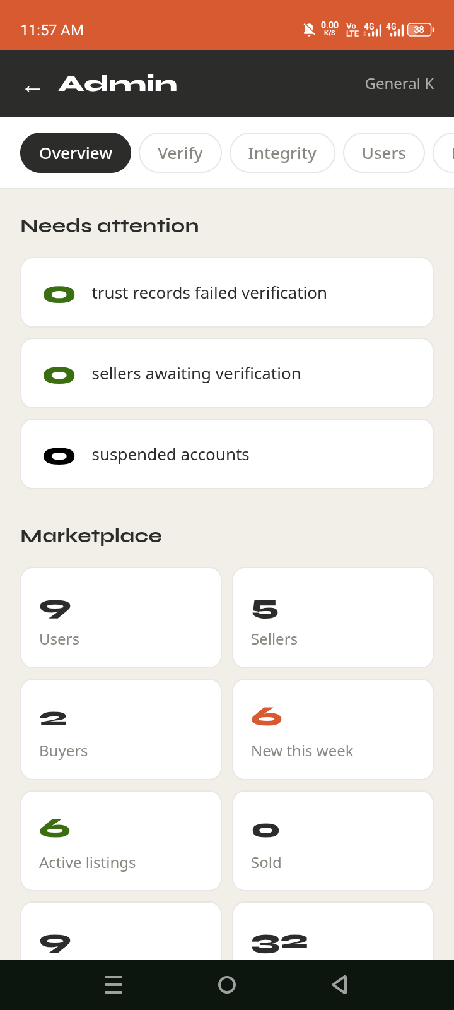
Figure4.11: Admin overview

4.9 Algorithms / Models / Technical Design

4.9.1 Trust chain
Each block stores a timestamp, an event (type, seller ID and data) and the previous block's hash. Its own hash is computed over exactly those three fields:
h_i = \mathrm{SHA256}(\,t_i \,\|\, e_i \,\|\, h_{i-1}\,), \qquad h_{-1} = 0^{64}
The first block links to a genesis value of 64 zeros. Verification walks the chain in order and fails if any block's recomputed hash differs from its stored hash, if the first block does not link to the genesis value, or if any block's previous-hash field differs from the hash of the block before it. Because verification rebuilds the canonical three-field object rather than hashing the stored database document, extra fields MongoDB adds (such as _id and __v) do not cause false alarms; an earlier version did hash those fields, so it reported untampered chains as invalid, and it also skipped checking the first block. Both faults were fixed during the stabilisation period. Verification also compares the hash of the last block with the head hash saved on the seller's User document each time a block is added. Links alone cannot detect an edit to the most recent block, because no later block points to it; the stored head hash closes that gap and also detects a chain deleted outright. Blocks are indexed uniquely by seller and position, so two events written at the same moment cannot both take the same position and fork the chain; the second write is retried after the first.

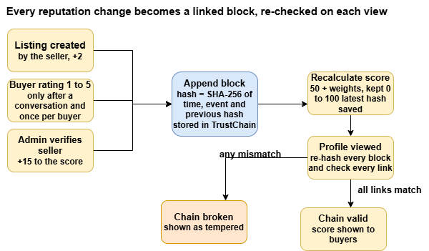

Figure 4.12: Trust-chain event flow from listing to verified score

Figure 4.11 traces a trust event. The three sources all enter through one append step, and every profile view re-checks the whole chain before the score is shown.

4.9.2 Trust score
The score starts at 50 and is the clamped sum of event weights:
S = \min\!\left(100,\; \max\!\left(0,\; 50 + \sum_{i} w(e_i)\right)\right)

Table 4.6: Trust-score event weights
Event | Weight
BUYER_RATING_5 | +8
BUYER_RATING_4 | +5
BUYER_RATING_3 | +2
LISTING_CREATED | +2
BUYER_RATING_2 | −2
BUYER_RATING_1 | −5
ADMIN_VERIFIED | +15

Weights favour independent evidence (verification and ratings) over activity the seller controls (listings). A two-star rating counts slightly against the seller, less than a one-star rating. The score buyers see is recomputed from the chain on every view, so editing the stored score field has no effect.

4.9.3 Rating gate
A rating is accepted only if the rater is not the seller, a Conversation exists between the rater and the seller, and that conversation has not already been rated. A conversation belongs to one listing, so a buyer can rate a seller again after contacting them about a different listing, but not twice for the same one. The block records the buyer and conversation IDs, so every rating can be traced to a real contact.

4.9.4 Voice parsing
The parser (parseListing.js) works in four steps. It normalises the transcript (lower case, punctuation removed, "K95" split into "K 95"), converts spoken number words to digits ("ninety five" to 95, "one hundred and twenty" to 120), and sets aside bag-size phrases such as "25 kg bags" so they are not read as quantities. It then extracts the price (a number next to "K" or "kwacha", or after "for", "at" or "price" when no unit follows), the quantity (a number before a unit word), the unit (bag, tin or kg) and the neighbourhood, matched against aliases such as "town" for the CBD and returned as the exact value the database accepts. The browser offers up to three recognition alternatives; the one that fills the most fields is used, and the seller can edit the transcript, which is re-parsed as they type.

4.10 Chapter Summary
The design serves three user groups through twelve functional and eight non-functional requirements. A layered REST and socket architecture over six MongoDB collections supports them, and two small algorithms carry the project's novelty: a hash chain that makes a seller's history tamper-evident, and a pattern-based parser that turns an English sentence into a listing.

Chapter 5

Implementation / Development

5.1 Introduction
ZamMarket was implemented as two applications in one repository: a Node.js/Express backend (backend/) and a React PWA frontend (frontend/). This chapter describes the environment, the modules, the key implementation details, how the parts were integrated, and the problems met along the way.

5.2 Development Environment
- Hardware: a personal laptop for development, and an Android phone running Chrome for mobile and voice testing.
- Software: Node.js 18, npm, Visual Studio Code, Git and GitHub, Chrome DevTools (device emulation, Application panel for service worker and IndexedDB, network throttling to simulate going offline).
- Services: MongoDB Atlas (free tier) and Cloudinary (free tier). Development servers run on localhost:5000 (API) and localhost:5173 (Vite).
- Configuration: secrets such as the database URI, JWT secret and Cloudinary keys are held in .env files that are excluded from version control.

5.3 System Components / Modules
- Authentication module (authController, otp.js, jwt.js, auth.js middleware): two-step registration in which a 6-digit OTP is generated, stored with a 10-minute TTL and printed to the server console, then checked with a three-attempt limit before the account is created. Login returns a JWT; protect and restrictTo guard routes by token and role. Sign-up accepts only the buyer and seller roles; the first administrator is created with the command npm run create-admin, which creates a new admin account or promotes an existing one.
- Listing module (listingController, upload.js, cloudinary.js): create, read, update, delete and status changes, with the photo streamed to Cloudinary from memory. Only the owning seller can modify a listing. Every new listing also calls addTrustEvent(..., 'LISTING_CREATED').
- Browse module (BrowsePage.jsx): the API filters by neighbourhood and keyword with pagination (12 per page, newest first); price range and minimum quantity are applied on the client.
- Voice input module (VoiceListingInput.jsx): wraps the browser's SpeechRecognition (or webkitSpeechRecognition), shows the live transcript, passes the transcript to the separately tested parser module (Section 4.9.4) and hands the result to CreateListingForm, which marks pre-filled fields "from voice". Browsers without the API see a message and fall back to typing.
- Chat module (socket.js on both sides, chatController, ChatPage.jsx): Socket.io connections are authenticated with the JWT in the handshake. Users join a room per conversation; the server checks the sender is a participant, saves the message, updates the last-message preview and unread counter, and broadcasts to the room. The chat screen also hosts the "Collected your charcoal? Leave a rating" prompt.
- Offline module (sw.js, pwa.js, offlineQueue.js): a service worker serves static files cache-first and API GET requests network-first with cache fallback; messages typed while offline go to an IndexedDB store, as do listings created offline (photo included), which are posted automatically when the connection returns and are flushed when the browser fires online.
- Trust module (blockchain.js, trustController, TrustChain model, TrustScorePage.jsx): appends blocks, recalculates the score, stores the latest hash on the User, verifies the chain against that hash on every profile view, recomputes the score from the chain, and enforces the per-conversation rating gate.
- Administration module (adminController, AdminPage.jsx): platform statistics, verification (which appends an ADMIN_VERIFIED block), suspension toggle (which also pauses a suspended seller's listings), role changes and listing removal, which also deletes the listing's photo from Cloudinary.

Table 5.1: REST API endpoints (main)
Method | Endpoint | Purpose | Access
POST | /api/auth/request-otp | Send OTP | Public, rate-limited
POST | /api/auth/register | Create account | Public
POST | /api/auth/login | Log in | Public, rate-limited
GET | /api/auth/me | Current user | JWT
GET / POST | /api/listings | Browse / create listing | Public / seller
PUT / DELETE | /api/listings/:id | Update / delete listing | Owning seller
GET / POST | /api/chat/conversations | Inbox / start conversation | JWT
GET | /api/chat/conversations/:id/messages | Message history | Participant
GET | /api/trust/:sellerId | Score, chain, validity, canRate | Public
POST | /api/trust/rate | Rate seller | JWT, conversation required
GET | /api/admin/stats, /api/admin/users | Statistics, users | Administrator
PUT | /api/admin/users/:id/verify | Verify seller | Administrator

5.4 Key Implementation Details
Appending a trust event. addTrustEvent reads the seller's latest block, creates a new block linked to its hash, saves it, recalculates the score from all blocks and writes the score and latest hash to the User document:
const createBlock = (event, previousHash = '0'.repeat(64)) => {
const block = { timestamp: new Date().toISOString(), event, previousHash };
block.hash = sha256(block);
return block;
};
Verifying a chain. verifyChain rebuilds the canonical {timestamp, event, previousHash} object for each block before hashing, checks the genesis link for block 0, and checks each later block's link to its predecessor (Section 4.9.1).
Voice listing input. The recogniser runs in single-utterance mode with interim results, so the seller sees words appear as they speak, and it asks for three alternatives. A new recognition object is created for each attempt, which avoids sessions getting stuck on Android Chrome, and listening stops after 15 seconds if the browser does not end it. Errors keep their specific message (for example, microphone access denied), and the panel warns before starting if the phone is offline, because Chrome's recognition needs a connection. The language selector offers English (UK) and English (US) only. Parsing is described in Section 4.9.4.
Offline message replay. When the connection returns, flushOfflineQueue sends queued messages one at a time through the REST endpoint, deleting each from IndexedDB only after the server confirms it; if one fails, it stops so that order is preserved, and the pending count is updated for the banner.

5.5 Integration
The frontend talks to the backend through one Axios instance whose base URL comes from VITE_API_URL and which attaches the JWT to every request. Socket.io uses VITE_SOCKET_URL with the same token. In development both fall back to the page's own address, and Vite forwards /api and /socket.io to the local server. The API and Socket.io server accept browser requests from the local development addresses and from the addresses listed in FRONTEND_URL. Listing, rating and verification code paths are integrated with the trust module only through addTrustEvent, so the hashing logic exists in one place. Cloudinary is integrated through its Node SDK with in-memory uploads from Multer, and MongoDB through Mongoose models that also enforce validation, such as the Zambian phone pattern ^(\+260|0)(9[5-7]|7[6-9])\d{7}$.

5.6 Challenges and Solutions
Challenge | Solution
Every chain reported as tampered, because MongoDB documents carry extra fields that were not hashed at creation | Rebuild the exact canonical object before re-hashing; also verify block 0 against the genesis value
An edit to the most recent block could not be detected | Compare the last block with the head hash stored on the seller's account
A tampered chain still displayed a green "Trusted Seller" score | The trust page now switches to a red warning: "Record has been altered"
Two trust events at the same moment could take the same block position and fork the chain | Unique index on (seller, block position), with automatic retry
Sellers registered before the trust module existed had no chain | Back-fill a LISTING_CREATED block for each existing listing on first view
Anyone could rate any seller, including themselves | Require an existing conversation, block self-rating and allow one rating per conversation
Anyone could become an administrator by sending the role "admin" at sign-up, and there was no way to create the first administrator | Sign-up restricted to buyer and seller; npm run create-admin script creates or promotes an administrator
Verifying a seller twice added a second +15 block, so an administrator could inflate a score by repeated clicks | Verification is refused (409) once a seller is verified, and suspended sellers cannot be verified
An administrator could demote or suspend another administrator, and actions left no record | Administrator accounts are protected in the panel; suspensions and removals require a reason; every action is written to the AdminLog collection
Tampering was visible only when someone opened that seller's trust page | Integrity check in the admin panel re-verifies every seller's chain at once and lists the ones that fail
Buyers viewing their own profile were treated as sellers | Corrected the isSelf check; trust scores are shown only for sellers
"Message seller" button did not open a conversation | Fixed the conversation-creation call
Location typed as free text could fail database validation | Location is now a drop-down of the accepted neighbourhoods
Voice parser missed number words and prices said without "K" | Rewrote the parser as a separate, tested module (Section 4.9.4)
Nyanja and Bemba recognition not available in browsers | Narrowed voice listing to English (Section 1.8)
Production deployment failed (July and September 2026) | Causes found and fixed: the frontend ignored VITE_API_URL and hard-coded the chat server to localhost:5000; the API accepted only localhost origins; the service worker pre-cached development-only files; and refreshing a page on Vercel returned 404. Deployed successfully on 12 October 2026
In production the OTP code was neither sent nor logged, so nobody could register on the hosted system | SMS gateway module with a one-setting choice of provider (SMS_PROVIDER: console, Africa's Talking or Twilio); the console option writes the code to the server log, which works in production at no cost
Accounts created in the app could not log in when the number was typed as 0977… instead of +260977… | Numbers are stored in one form (+260) and login accepts either form
After new neighbourhoods were added, the backend, the form and the voice parser held different lists, so some listings were rejected | One list in all three places, with a test that fails if they ever differ
Chrome on Android did not offer to install the app | Added 192 and 512 pixel PNG icons to the manifest; Android does not accept an SVG-only icon
Creating a listing failed in production with only "Failed to create listing" | Phone photos over 5 MB are now shrunk in the browser; the request waits up to 90 seconds for a sleeping free-tier server; the app shows the specific cause; /api/health reports database and Cloudinary status
Creating a listing without a connection failed | Offline listing drafts: saved with the photo in IndexedDB and posted automatically on reconnection
Two test styles (Node's runner and Jest) could not run together | All backend tests run under Jest: 73 tests

5.7 Chapter Summary
Eight modules were implemented across a REST and socket backend and a React PWA. The trust module is the most distinctive: a few dozen lines of hashing code, reached from every place that changes a seller's reputation. The main open task is to redeploy with the fixes in Section 5.6 and confirm the hosted system works end to end.

Chapter 6

Testing, Results and Evaluation

6.1 Introduction
The automated test suite passes in full: 73 backend tests and 13 voice-parser tests. System tests of each user story and the usability study are reported below; where a test has not yet been run, its result is left blank rather than assumed. This chapter sets out the strategy, the results, their analysis and an evaluation against each objective.

6.2 Testing Strategy
- Automated unit tests, kept in the repository and run by GitHub Actions on every push. npm test in backend/ runs 73 Jest tests: the trust chain and block creation, authentication middleware, registration, the User model (phone validation, password checks, phone masking), rating rules, simultaneous trust events, allowed origins, upload errors, search escaping, the administrator rules, SMS sending (with the gateways stubbed) and phone-number handling. Database models are replaced by stubs, so no database is needed. npm run test:voice in frontend/ runs 13 tests of the voice parser, including one that checks the parser, the listing form and the backend use the same neighbourhood list. The frontend is also linted and built on every push.
- Browser checks with Playwright and Chromium: the voice panel driven by a simulated speech engine, and the main pages loaded with mocked API responses to confirm they render without errors.
- System testing of each functional requirement through the user interface on Chrome (desktop device emulation and an Android phone), with offline behaviour simulated with Chrome DevTools' Offline setting.
- Security checks of rate limits, role restrictions and the rating gate.
- Usability testing with the System Usability Scale, and a Lighthouse audit of the mobile build.

6.3 Test Cases and Results
Table 6.1: Backend automated test results
ID | Area | Test case | Expected result | Status
B01 | Authentication | Request without a token | 401 | Pass
B02 | Authentication | Invalid token | 401 | Pass
B03 | Authentication | Valid token, suspended user | 401 | Pass
B04 | Authentication | Valid token, active user | Request continues with the user attached | Pass
B05 | Roles | Buyer calls an admin route | 403; administrator allowed | Pass
B06 | Sign-up | Role "admin" requested | 400 | Pass
B07 | Sign-up | Required fields missing | 400 | Pass
B08 | Trust events | Two events written at the same moment | Second retried and appended after the first; head hash updated | Pass
B09 | Rating | Stars 0, 6, 2.5, text, missing | 400 | Pass
B10 | Rating | Buyer rates themselves | 400 | Pass
B11 | Rating | No conversation with the seller | 403 | Pass
B12 | Rating | Every conversation already rated | 409 | Pass
B13 | Rating | New conversation (second purchase) | Rating recorded against that conversation | Pass
B14 | Chain | Empty chain | Valid; score 50 | Pass
B15 | Chain | Intact chain, with and without head hash | Valid | Pass
B16 | Chain | Edited, re-hashed, deleted and reordered blocks | Invalid | Pass
B17 | Chain | Last block edited and re-hashed | Missed by links alone; caught with head hash | Pass
B18 | Chain | Last block deleted; whole chain wiped | Invalid with head hash | Pass
B19 | Chain | Blocks carrying MongoDB fields (_id, __v) | Valid (no false alarm) | Pass
B20 | Score | Each event weight; clamping | 77 for 2 listings + 5 stars + verification; 48 for one 2-star rating; limits 0 and 100 | Pass
B21 | Speed | Verify 1,000 blocks | Under 100 ms | Pass
B22 | CORS | Allowed origins from FRONTEND_URL | Local addresses kept; configured URLs added | Pass
B23 | Search | Special characters in search text | Matched literally | Pass
B24 | Admin | Verify a seller; verify again; verify a suspended seller | One ADMIN_VERIFIED block and one log entry; then 409 with no new block; 400 | Pass
B25 | Admin | Suspend without a reason; with a reason; reactivate; suspend an administrator | 400; seller's listings paused and reason logged; allowed without reason; 403 | Pass
B26 | Admin | Change an administrator's role; assign "admin"; buyer to seller | 403; 400; changed and logged as "buyer → seller" | Pass
B27 | Admin | Remove a listing without a reason; integrity check with one edited chain among two sellers | 400; only the edited seller flagged | Pass

Rows B24 to B27 group the 12 administrator tests. A further 25 tests, in backend/__tests__ and for upload errors, cover block creation, the User model (phone validation, password checks and phone masking) and photo-upload error messages. Test B17 shows why the head hash was added. Checking links alone cannot detect an edit to the most recent block, because no later block points to it; comparing that block with the hash saved on the seller's account catches the edit.

Table 6.2: Voice parser test results (English)
ID | Spoken phrase (example) | Extracted | Status
V01 | "charcoal 10 bags K95 each Kanyama" | K95, 10 bags, Kanyama | Pass
V02 | "I am selling 5 bags of charcoal for 120 kwacha in Mtendere" | K120, 5, Mtendere | Pass
V03 | "hardwood charcoal 20 tins K40 Chilenje" | K40, 20 tins, Chilenje; title "Hardwood charcoal by the tin" | Pass
V04 | "charcoal K150 per bag 3 bags Matero" | K150, 3, Matero | Pass
V05 | "charcoal for sale ninety five kwacha ten bags" | K95, 10 | Pass (failed before the rewrite)
V06 | "charcoal 8 bags at 100 Libala" | K100, 8, Libala | Pass (failed before the rewrite)
V07 | "one hundred and twenty", "a hundred", "five ten" | 120; 100; 5 and 10 kept separate | Pass
V08 | "price is 80", "60 each", "K1,200 for the lot" and five other price forms | 80; 60; 1,200 | Pass
V09 | "selling charcoal for 5 bags" | Quantity 5, no price | Pass
V10 | "25kg bags of charcoal, 6 bags, K200 each, Kabwata" | K200, 6 bags; title "Charcoal — 25kg bags" | Pass
V11 | "charcoal K15 per kg 100 kg available Bauleni" | K15, 100, unit kg | Pass
V12 | "in town", "city center", an unknown place | Lusaka CBD; Lusaka CBD; none | Pass
V13 | Empty or nonsense input; "K5000000" | No fields, no crash; absurd price rejected | Pass
V14 | Three recognition alternatives | The one filling the most fields is chosen | Pass

Rows group the cases of the 13 automated parser tests.
These tests start from text, so they test the parser, not speech recognition itself. In the browser, the voice panel was also exercised with a simulated speech engine. The best of three alternatives was chosen, editing the transcript re-parsed the fields, and the result filled the real listing form, including unit and neighbourhood. The microphone-denied, offline and missing-field messages appeared as designed. Recognition accuracy with a real phone microphone depends on the browser, accent and background noise, and should be recorded under system testing (TC-06).

Table 6.3: System test cases
ID | Test case | Expected result | Status
TC-01 | Register with valid Zambian number and correct OTP | Account created; logged in | Pass (hosted; code read from the server log)
TC-02 | Register with a non-Zambian number | Rejected with format message | Pass
TC-03 | Enter wrong OTP four times | Code invalidated after 3 attempts | Pass
TC-04 | Seller creates listing with photo | Listing appears in Browse; LISTING_CREATED block added | Pass (hosted, Android phone)
TC-05 | Buyer filters by Kanyama, K80–K120, minimum 5 bags | Only matching listings shown | Fail
TC-06 | Seller dictates a listing on Android Chrome | Fields pre-filled and marked "from voice" | Pass (hosted, Android phone)
TC-07 | Buyer messages seller | Message appears instantly for both | Pass (laptop to phone)
TC-08 | Buyer sends message while offline, then reconnects | Message queued, then delivered once | Pass
TC-09 | Open App offline after an earlier visit | Cached listings shown | Pass
TC-10 | Buyer with no conversation tries to rate | Rejected (403) | Pass
TC-11 | Buyer rates the same conversation twice | Second rating rejected (409) | Pass
TC-12 | Edit a TrustChain document in MongoDB Atlas, then open Trust Score page | Red warning: record has been altered | Pass
TC-13 | Admin verifies a seller from the Verify tab | Badge shown; score +15; seller leaves the queue | Pass (hosted)
TC-14 | Run npm run create-admin, then log in | Admin panel opens | Pass (hosted)
TC-15 | Hosted frontend (Vercel) loads listings and chat from hosted API (Render) | Pages load; chat connects | Pass (12 October 2026, Android phone on mobile data)
TC-16 | Seller creates a listing with a photo while offline, then reconnects | Saved as a draft; posted automatically on reconnection | Fail, “Post now” button was clicked after network recovery.
TC-17 | Seller uploads a photo over 5 MB from a phone | Photo shrunk on the phone; listing created | Pass
TC-18 | Admin suspends a seller, giving a reason | Seller's listings paused; entry with the reason in the Activity tab | Pass
TC-19 | Install the hosted app from Chrome on Android | "Install app" offered; app opens from the home screen | Pass (after PNG icons were added)

6.4 Experimental / Performance Results
Verifying a 1,000-block chain took a mean of 2.2 to 3.6 ms per verification across two runs of ten repetitions. A seller would need a thousand listings and ratings to reach that length, so verifying the full chain on every profile view adds no noticeable delay. Lighthouse mobile score for Trust Score page: Performance = %, Accessibility = 91%, Best Practices = 100%, SEO = 100%.

6.5 User Evaluation
The SUS study planned in Section 3.7 had not been conducted at the time of writing.

6.6 Analysis of Results
The trust chain meets its integrity requirement (NFR5) in every tested case, including the most recent block, which the stored head hash now covers. Edits, deletions and reordering are all caught, the score rules behave as specified, simultaneous events can no longer fork a chain, and the rating rules hold at the API level.
The rewritten voice parser handles the common ways of stating price, quantity, unit and area in English, including number words and prices without a currency word, and always returns a neighbourhood the database accepts. Its remaining weakness lies upstream: if the recogniser mishears a word, the parser cannot recover it. That is why the seller can correct the transcript, and must confirm every field, before the listing is created.

6.7 Objective-by-Objective Evaluation
Table 6.4: Objective-by-objective evaluation
Objective | Evidence | Status
1. Listing creation and neighbourhood, price and quantity discovery | FR3–FR4 implemented; browse and listing pages checked in the browser; TC-04, TC-05 | Achieved in implementation; system test results to be recorded
2. English voice-based listing creation | Voice module and parser; 13 of 13 parser tests pass; dictation tested on an Android phone (TC-06) | Achieved for English
3. Tamper-evident trust score with gated ratings | 73 of 73 backend tests pass, including the head-hash check and per-conversation rating | Achieved
4. Real-time messaging and offline support | Socket.io chat; IndexedDB queue; service worker caching | Achieved: chat, cached reading and offline listing drafts; ratings still need a connection
5. Evaluation, including usability | Automated tests run in CI; SUS pending | Partly achieved

6.9 Chapter Summary
The trust chain, the rating rules and the voice parser all pass their automated tests, which now run on every push. System test results, usability scores and Lighthouse figures still need to be recorded before the evaluation is complete.

Chapter 7

Discussion

7.1 Introduction
This chapter interprets the results against the problem in Section 1.2, compares ZamMarket with the platforms in Chapter 2, states the project's contributions, and examines the limitations that affect how far the results can be trusted.

7.2 Interpretation of Findings
The problem had three parts: finding nearby sellers, judging their trustworthiness, and doing both under poor connectivity for cash trades.
Discovery. Neighbourhood, price and quantity filters address the first part directly. Because neighbourhoods are a fixed list rather than GPS coordinates, discovery matches how residents describe location and works without location permissions, at the cost of precision.
Trust. A hash chain kept in an ordinary database detects edits, deletions and reordering of a seller's history, and verification is cheap enough to run on every view. Combined with the rating gate, the score reflects real contacts rather than anonymous votes. Two caveats limit the claim. The chain proves that the record has not been changed since it was written, not that what was written is true: a buyer and seller who collude can still create a conversation and a five-star rating. And because the head hash is stored in the same database, someone with full database access could still rewrite a whole chain together with that hash.
Connectivity. A PWA can cache what the user has already seen, queue chat messages and hold new listings, photo included, until the connection returns, which covers the moments a trader most needs. What cannot happen offline is anything that needs the server at that moment: a listing enters the trust chain only when it reaches the server, ratings need a connection, and speech recognition in Chrome itself needs a connection.
Voice. The rewritten parser handles the common English ways of stating price, quantity and area, including number words, but the main audience the voice feature was meant to serve, sellers more comfortable in Nyanja or Bemba, is not served, because browsers do not recognise those languages.

7.3 Comparison with Existing Work
Compared with the platforms in Table 2.1, ZamMarket is the only one documented as combining local discovery with a trust mechanism that does not depend on online payment. Kaymu's 2016 SafePay protected the buyer by holding money, which ZamMarket cannot do with cash. Instead, ZamMarket protects the next buyer by making each seller's history visible and hard to falsify, so the two mechanisms complement rather than replace each other. TreeMarket shares ZamMarket's district-level, meet-in-person model but documents no trust signal. Unlike Bitcoin-style blockchains (Nakamoto, 2008), ZamMarket's chain has a single operator; it borrows Haber and Stornetta's (1991) linking idea without the cost of distributed consensus, which is appropriate for a small platform but means users must trust the operator not to rewrite whole chains.

7.4 Contributions of the Project
- Practical: a working, installable marketplace prototype aimed at a large but digitally under-served informal trade.
- Technical: a compact, reusable pattern for tamper-evident reputation on a conventional database, including the canonical-object technique that avoids false alarms from database metadata.
- Methodological: evidence that the Web Speech API cannot currently support Zambian languages, which should shape future projects that plan local-language voice input.

7.5 Limitations and Implications
- No user evaluation yet. Without SUS results or field testing with sellers, claims about usability and usefulness to the target community remain untested. The design rests on observation and the literature rather than on surveyed needs.
- English-only voice input. The proposal promised Nyanja and Bemba; the delivered feature supports English only (Section 1.8). This excludes some of the sellers who would gain most from voice input.
- Tamper evidence, not tamper resistance. The head hash closes the last-block gap, but it lives in the same database. Anyone with full database access can rewrite a whole chain together with its head hash. Publishing or anchoring each seller's latest hash outside the database would close this gap.
- Score design. The weights were chosen by judgement, not calibrated on data. Listings raise the score without any sale, and collusion between accounts is not detected.
- Rating gate. The gate checks that a conversation exists, not that a sale took place. Because one rating is allowed per conversation, colluding accounts could open conversations about several listings to add ratings.
- Offline limits. Ratings and voice input need a connection; a listing created offline is posted, and enters the trust chain, only when the connection returns.
- Limited field testing. The hosted system was verified by the developer on one Android phone and a laptop; performance with many users on real Zambian networks has not been measured.
- Tests use stubs, not a live database. The automated tests replace database models with stubs, so database-specific behaviour, such as the unique index that prevents forked chains, is tested only indirectly.
The implication is that the results establish technical feasibility, especially of the trust mechanism, but not yet adoption or real-world benefit.
The implication is that the results establish technical feasibility, especially of the trust mechanism, but not yet adoption or real-world benefit.

7.6 Chapter Summary
ZamMarket addresses discovery and trust for cash-settled charcoal trading in a combination no reviewed platform documents. The trust chain is the strongest result. Voice input and offline support are partial, and the absence of user evaluation is the main limit on the conclusions.

Chapter 8

Conclusion and Recommendations

8.1 Introduction
This chapter summarises the project, states its conclusions, records which objectives were achieved and recommends next steps.

8.2 Summary of the Project
Informal charcoal sellers in Lusaka lack a way to reach nearby buyers, and buyers lack a way to judge sellers they have not met. Existing platforms offer either local discovery without trust or trust that depends on online payment. Over four agile sprints and a stabilisation period, this project built ZamMarket, a mobile-first PWA with neighbourhood-based discovery, English voice-based listing creation, real-time chat with offline queuing, and a seller trust score backed by a SHA-256 hash chain with conversation-gated ratings. Unit tests confirmed that the chain detects edited, deleted and reordered history and verifies 1,000 blocks in a few milliseconds. An automated suite of 86 tests, run on every push, confirms the trust chain (including the most recent event), the rating rules and the voice parser. The system is deployed at https://zam-market-khaki.vercel.app usability testing remains outstanding.

8.3 Conclusions
- A hash chain on a conventional database is enough to make a seller's reputation tamper-evident for a small marketplace, without a distributed blockchain.
- Tying ratings to real conversations gives the score a stronger basis than open voting, though it cannot prevent collusion.
- Browser speech recognition is usable for English listings but cannot yet serve Nyanja or Bemba speakers; local-language voice input needs another approach.
- A PWA can keep reading, messaging and listing creation working through connection drops by holding writes on the phone until the connection returns.

8.4 Achievement of Objectives
- Objective 1 (discovery): achieved in implementation; system test results to be recorded.
- Objective 2 (voice listing): achieved for English, including spoken number words; a test with a real phone microphone is still to be recorded.
- Objective 3 (trust score): achieved; tamper detection covers every block, including the most recent.
- Objective 4 (messaging and offline): achieved: chat, cached browsing and offline listing drafts.
- Objective 5 (evaluation): partly achieved; automated tests run on every push, while usability and Lighthouse evaluation are outstanding.

8.5 Recommendations
- Keep the hosted system verified after every change, using the checklist in Appendix B: set FRONTEND_URL on Render and VITE_API_URL and VITE_SOCKET_URL on Vercel, then confirm registration, listings, chat and ratings work on the hosted system (TC-17).
- Run the usability study with at least five sellers and five buyers in one or two neighbourhoods, using SUS and observed tasks, before any wider release.
- Anchor the trust chain outside the database by periodically publishing each seller's latest hash, so the operator cannot silently rewrite a chain.
- Calibrate the score weights with real rating data and cap the contribution of listings.
- Add end-to-end tests against a test database, for example with an in-memory MongoDB server, to cover database behaviour that the stubbed tests cannot.
- Switch on real SMS for OTP before real use: top up an Africa's Talking account, which reaches MTN, Airtel and Zamtel, and set SMS_PROVIDER, AT_USERNAME and AT_API_KEY on the server.
- Consider seller licensing: allow sellers to record a forestry licence number, which administrators check before granting verification.

8.6 Future Work
- Local-language voice input through a speech model trained or fine-tuned on Nyanja and Bemba, run on a server, with the keyword map extended and validated by native speakers.
- Tolerant matching of misheard neighbourhood names, and parsing of colloquial prices such as "two fifty" for K250.
- Offline ratings queued like messages, so a buyer can rate a seller straight after collection without a signal.
- Optional mobile-money confirmation that adds a transaction-verified rating without forcing online payment.
- Map-based discovery using approximate locations for buyers who allow it.
- Extension to other informal goods traded locally in cash, such as vegetables or building sand.

References

Academic and technical sources
- Bangor, A., Kortum, P.T. and Miller, J.T. (2008). An empirical evaluation of the System Usability Scale. International Journal of Human–Computer Interaction, 24(6), 574–594.
- Beck, K. et al. (2001). Manifesto for Agile Software Development. https://agilemanifesto.org
- Brooke, J. (1996). SUS: A "quick and dirty" usability scale. In P.W. Jordan et al. (eds), Usability Evaluation in Industry. London: Taylor & Francis, 189–194.
- Gamma, E., Helm, R., Johnson, R. and Vlissides, J. (1995). Design Patterns: Elements of Reusable Object-Oriented Software. Addison-Wesley.
- Haber, S. and Stornetta, W.S. (1991). How to time-stamp a digital document. Journal of Cryptology, 3(2), 99–111.
- Larman, C. (2004). Applying UML and Patterns (3rd ed.). Prentice Hall.
- Martin, R.C. (2008). Clean Code: A Handbook of Agile Software Craftsmanship. Prentice Hall.
- MDN Web Docs (n.d.). SpeechRecognition: lang property. Mozilla. https://developer.mozilla.org/docs/Web/API/SpeechRecognition/lang
- Nakamoto, S. (2008). Bitcoin: A Peer-to-Peer Electronic Cash System. https://bitcoin.org/bitcoin.pdf
- Russell, A. (2015). Progressive Web Apps: Escaping tabs without losing our soul. Infrequently Noted. https://infrequently.org/2015/06/progressive-apps-escaping-tabs-without-losing-our-soul/
- Sommerville, I. (2016). Software Engineering (10th ed.). Pearson.
- Tembo, S.T., Mulenga, B.P. and Sitko, N. (2015). Cooking Fuel Choice in Urban Zambia: Implications on Forest Cover. IAPRI Working Paper No. 94. Lusaka: Indaba Agricultural Policy Research Institute. https://ageconsearch.umn.edu/record/202883
- Mtendere study (2025). [Authors and title to be completed] — mixed-methods study of 395 households in Mtendere, Lusaka. https://www.ajol.info/index.php/ejpds/article/view/335680

Web sources for existing platforms (Chapter 2)
- App Store (2024). TreeMarket. https://apps.apple.com/mx/app/treemarket/id1581571176
- B-ne (n.d.). B-ne startup entry. TotalEnergies Startupper. https://startupper.totalenergies.com/en/juries/22GxJil0jTmm6RM2x8E28w/participations/5272/vote
- Dealroom (n.d.). Jumia Market (Kaymu) company profile. https://app.dealroom.co/companies/kaymu
- Jumia Market Overview (2016). NaijaTechGuide. https://www.naijatechguide.com/2016/07/jumia-market-online-marketplace-overview.html
- Preqin (n.d.). Egatee profile. https://www.preqin.com/data/profile/asset/egatee/517254
- Startup Seeker (n.d.). Egatee. https://startup-seeker.com/company/egatee~net
- TechCabal Radar (n.d.). What happened to Jumia Market (Kaymu). https://radar.techcabal.com/t/what-happened-to-jumia-market-kaymu/13613
- Wikipedia (n.d.). Kaymu. https://en.wikipedia.org/wiki/Kaymu

Appendix A: Individual Contribution Statement (Group Projects)
Not applicable: ZamMarket was an individual project.

Appendix B: User Manual / Installation Guide
Installation (developer)
- Install Node.js 18 or later and Git, and create free MongoDB Atlas and Cloudinary accounts.
- Clone the repository and run npm install in both backend/ and frontend/.
- Copy backend/.env.example to backend/.env and fill in MONGODB_URI, JWT_SECRET, the three CLOUDINARY_* values and FRONTEND_URL.
- For a hosted backend, create frontend/.env with VITE_API_URL and VITE_SOCKET_URL; for local development these can be left out.
- Run npm run dev in backend/ and npm start in frontend/, then open http://localhost:5173. OTP codes appear in the backend terminal.
- Create the first administrator from backend/: npm run create-admin -- --phone 0971234567 --name "Site Admin" --password "your-password", then log in with that number and open /admin. In MongoDB Atlas, the app's data is in the database named in MONGODB_URI (for example zammarket), not in the system database called admin.

Using ZamMarket
- Register: enter your phone number, type the 6-digit code, then your name, password, role and neighbourhood.
- Sell: tap Create Listing. Type the details, or tap the microphone and say, for example, "charcoal, 10 bags, K95 each, Kanyama"; check the filled-in fields, add a photo and publish.
- Buy: open Browse, choose your neighbourhood and price range, open a listing and tap Message Seller to arrange collection.
- Rate: after collecting your charcoal, use the rating prompt in the chat. You can rate each seller once.
- Install: in Chrome, use "Add to Home screen". Listings you have opened stay viewable without a connection, and messages and listings you create offline are sent when you reconnect.

