Assignment 3
ISAN 5355 with Dr. Zhao
John Courtright

ERR Diagram (for my own sake):
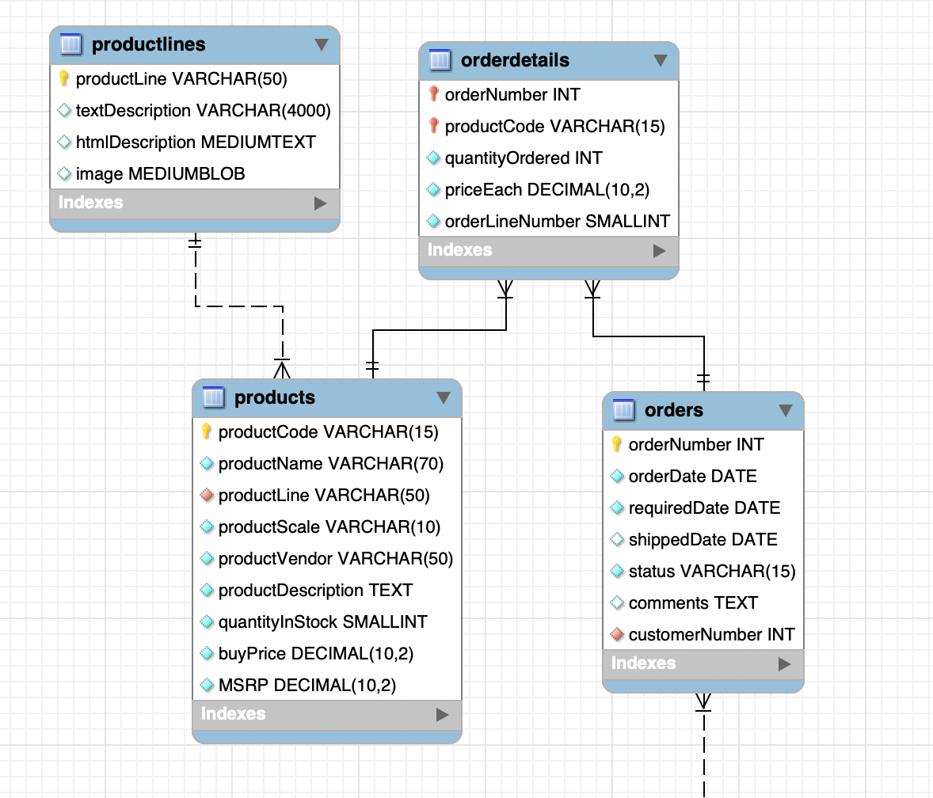

Question 1) Display orderNumber, quantityOrdered, priceEach, productName for all orders

SELECT od.orderNumber, od.quantityOrdered, od.priceEach, p.productName
FROM orderdetails as od
JOIN products as p USING(productCode);

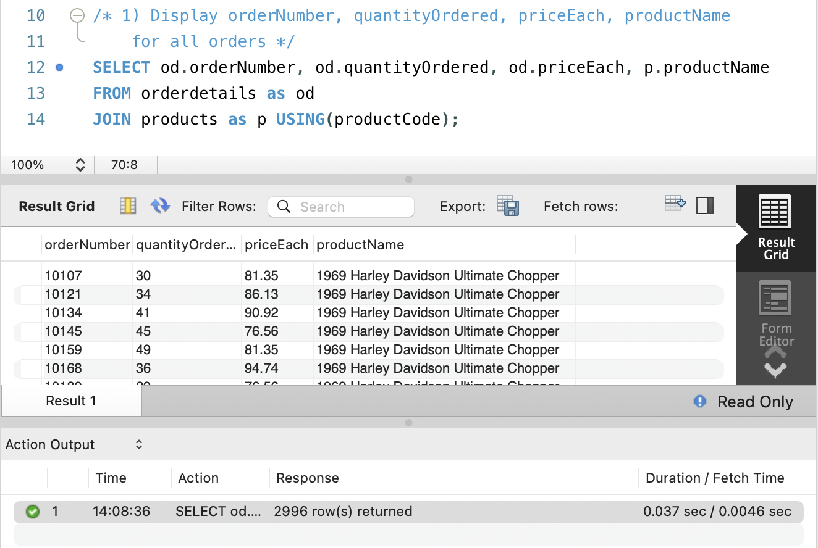
Question 2) Modify Q1) to use inline view to display the orderNumber, cost per each order (using an alias ‘CostPerOrder’), and the productName

SELECT
sub.orderNumber, sub.CostPerOrder, p.productName
FROM (
SELECT
orderNumber,
productCode,
(quantityOrdered * priceEach) AS CostPerOrder
FROM orderdetails
) AS sub
JOIN products AS p USING (productCode);

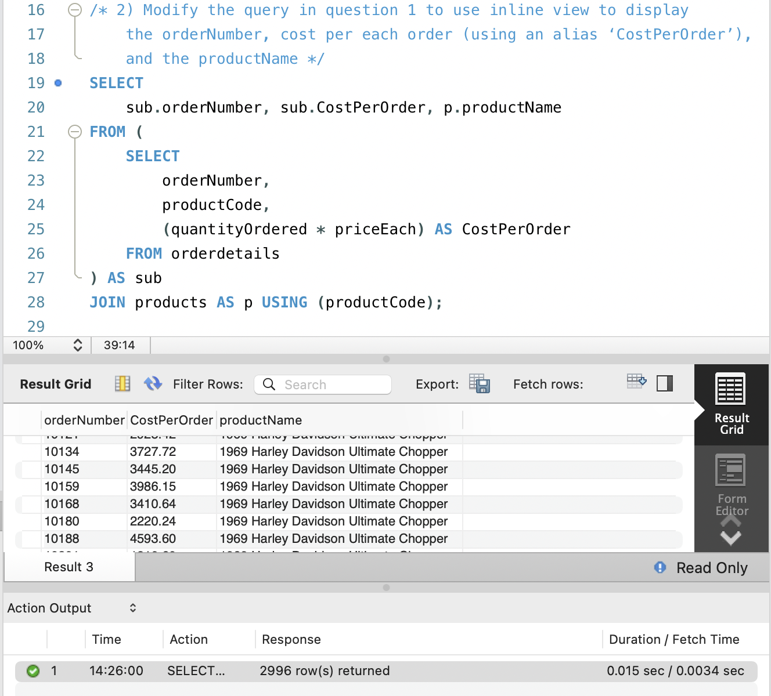
Question 3) Display orderNumber, productName, orderDate for all orders placed after May 30th, 2005 (orderDate > 2005-05-30)

SELECT od.orderNumber, o.orderDate, p.productName
FROM orderdetails as od
INNER JOIN orders as o ON od.orderNumber = o.orderNumber
INNER JOIN products as p ON od.productCode = p.productCode
WHERE o.orderDate > '2005-05-30';

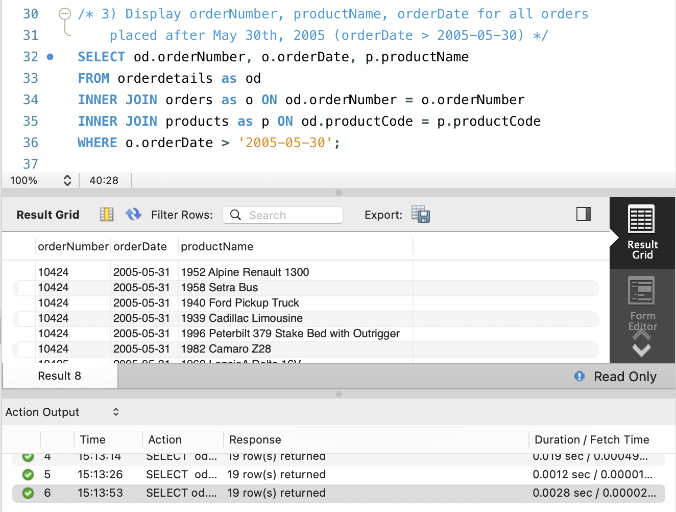
Question 4) Modify the query above to use a subquery to obtain the same output only with the columns orderNumber, productName

SELECT od.orderNumber, p.productName
FROM orderdetails AS od
JOIN products AS p USING (productCode)
WHERE od.orderNumber IN (
SELECT orderNumber
FROM orders
WHERE orderDate > '2005-05-30'
)

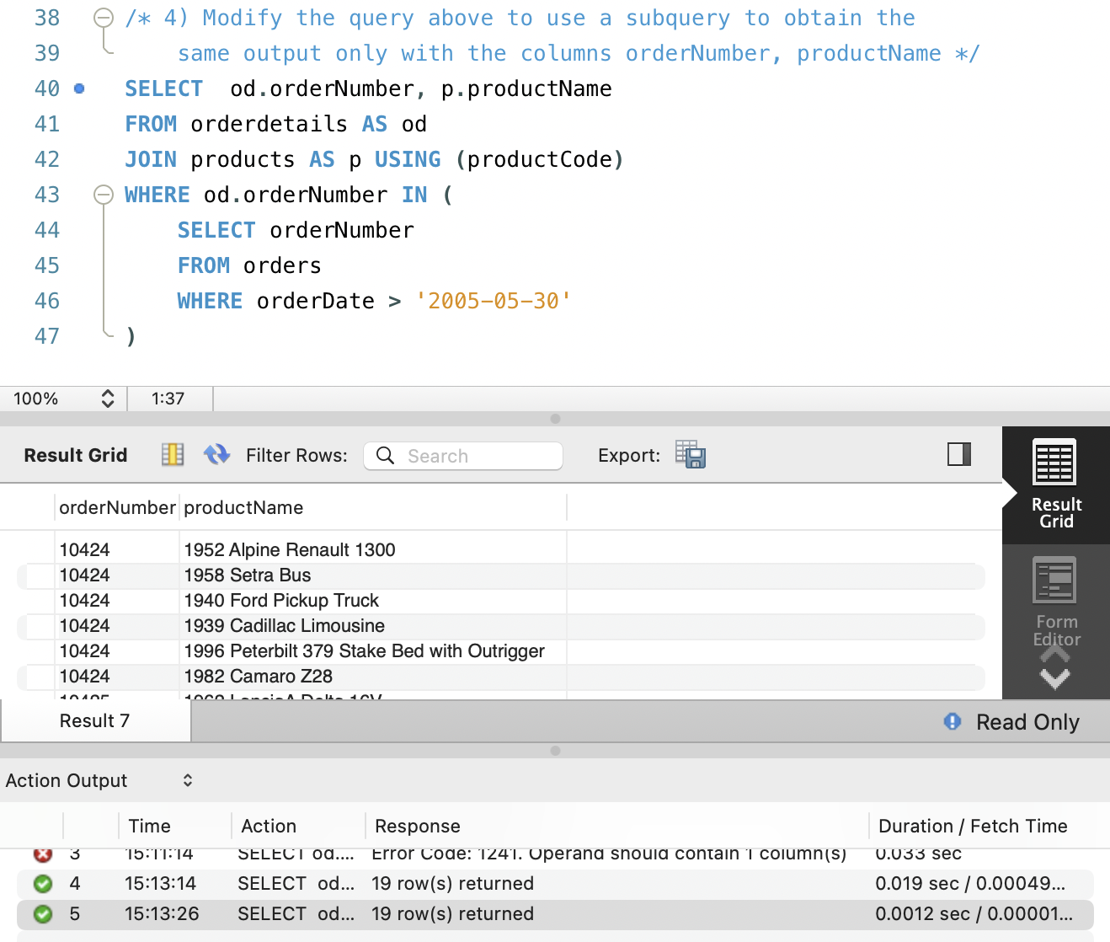
Question 5) Select the productName and compute the corresponding TotalPerProduct (i.e., sum product of quantityOrdered and priceEach), grouping the outcome by the productName, for all the totals greater than 180000 using a join statement.

SELECT p.productName,
SUM(od.quantityOrdered * od.priceEach) as TotalPerProduct
FROM products as p
JOIN orderdetails as od USING (productCode)
GROUP BY p.productName
HAVING SUM(od.quantityOrdered * od.priceEach) > 180000;

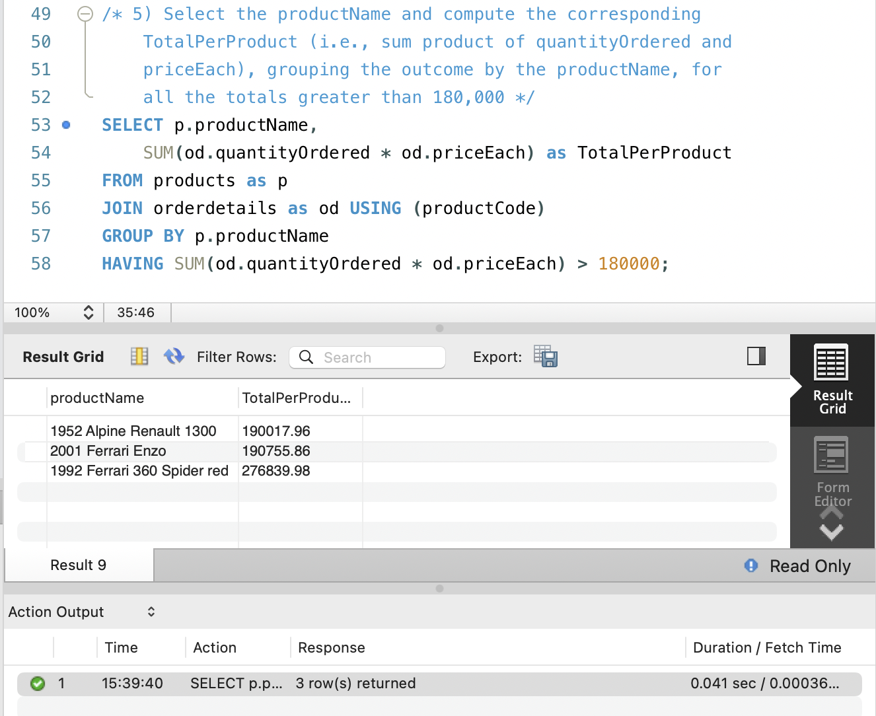
Question 6) Update the orderDate for the order with orderNumber as 10100 to be 3 days later than the current value.

UPDATE orders
SET orderDate = DATE_ADD(orderDate, INTERVAL 3 DAY)
WHERE orderNumber = 10100;

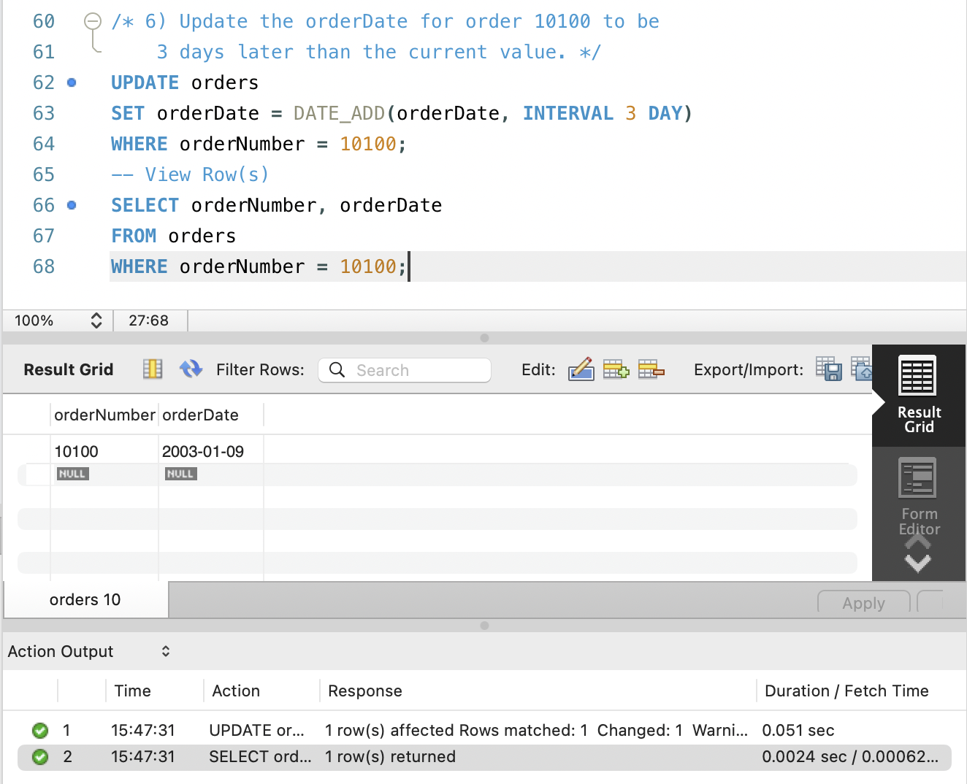
Question 7) ​​Find all the orders that were placed in July

SELECT *
FROM orders
WHERE MONTH(orderDate) = 7;

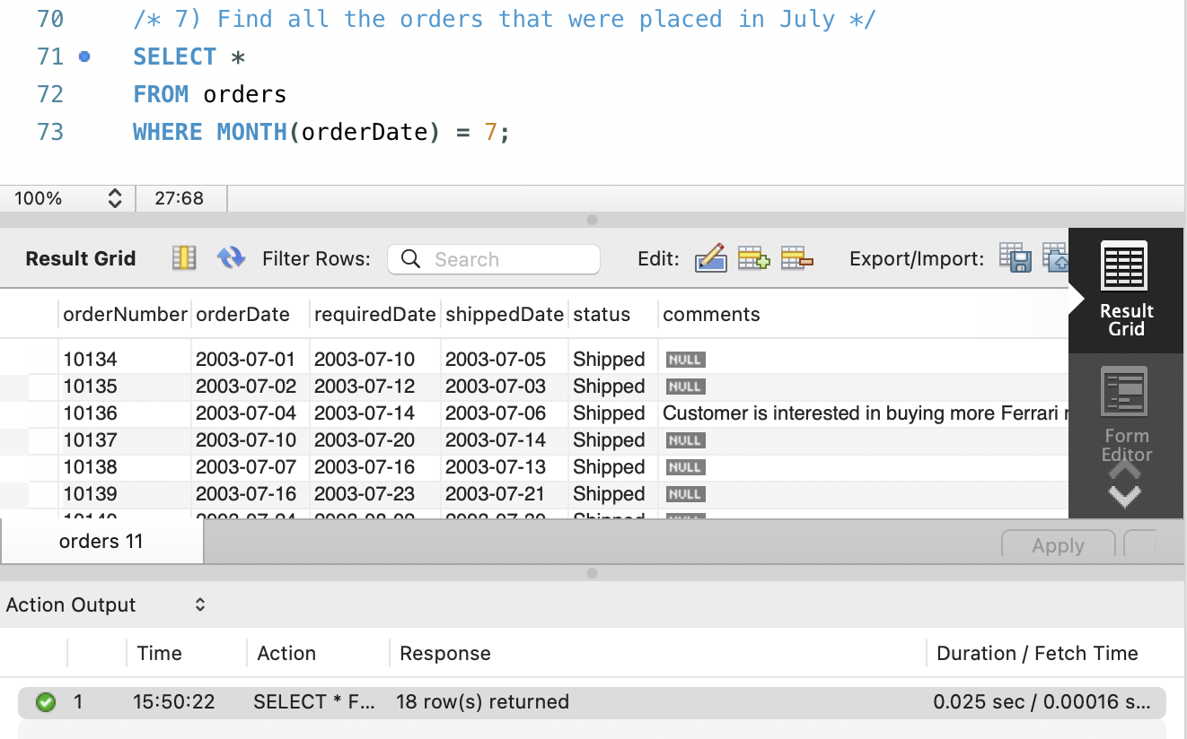
Question 8) Find all the orders that were placed on the 26th day of any month in 2003.

SELECT *
FROM orders
WHERE DAYOFMONTH(orderDate) = 26
AND YEAR(orderDate) = 2003;

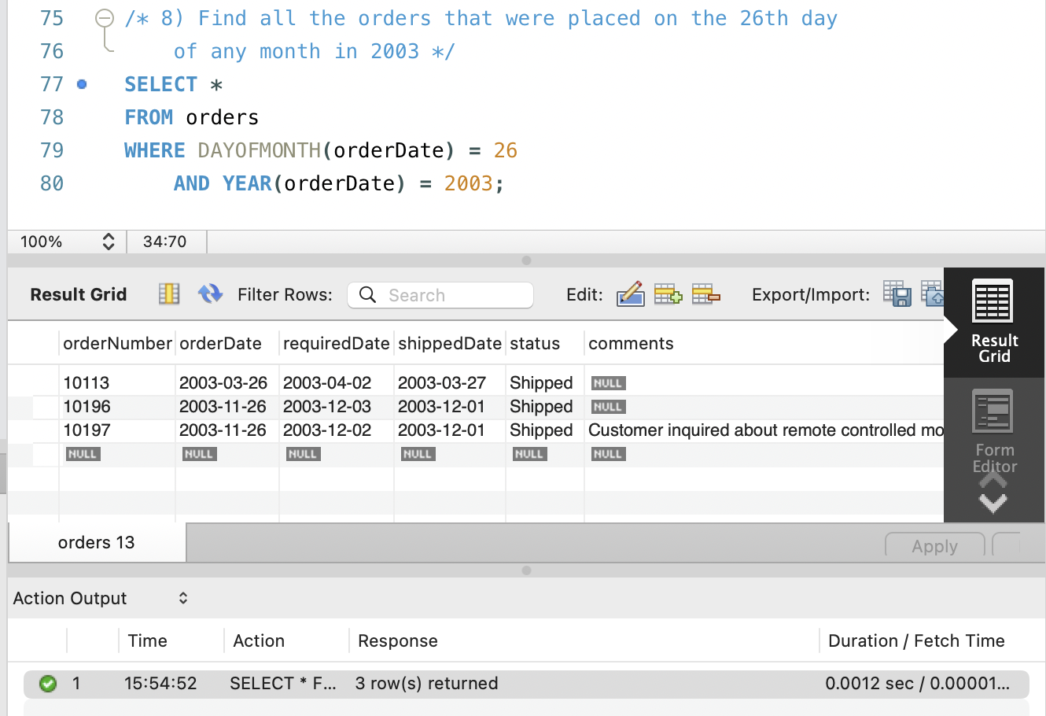
Question 9) Find the productName and TotalPerProduct (i.e., sum product of quantityOrdered and priceEach) for all products whose names start with 1957, followed by a space, and then a letter from A to G.

SELECT p.productName,
SUM(od.quantityOrdered * od.priceEach) AS TotalPerProduct
FROM products AS p
JOIN orderdetails AS od USING (productCode)
WHERE p.productName REGEXP '^1957 [A-G]'
GROUP BY p.productName;

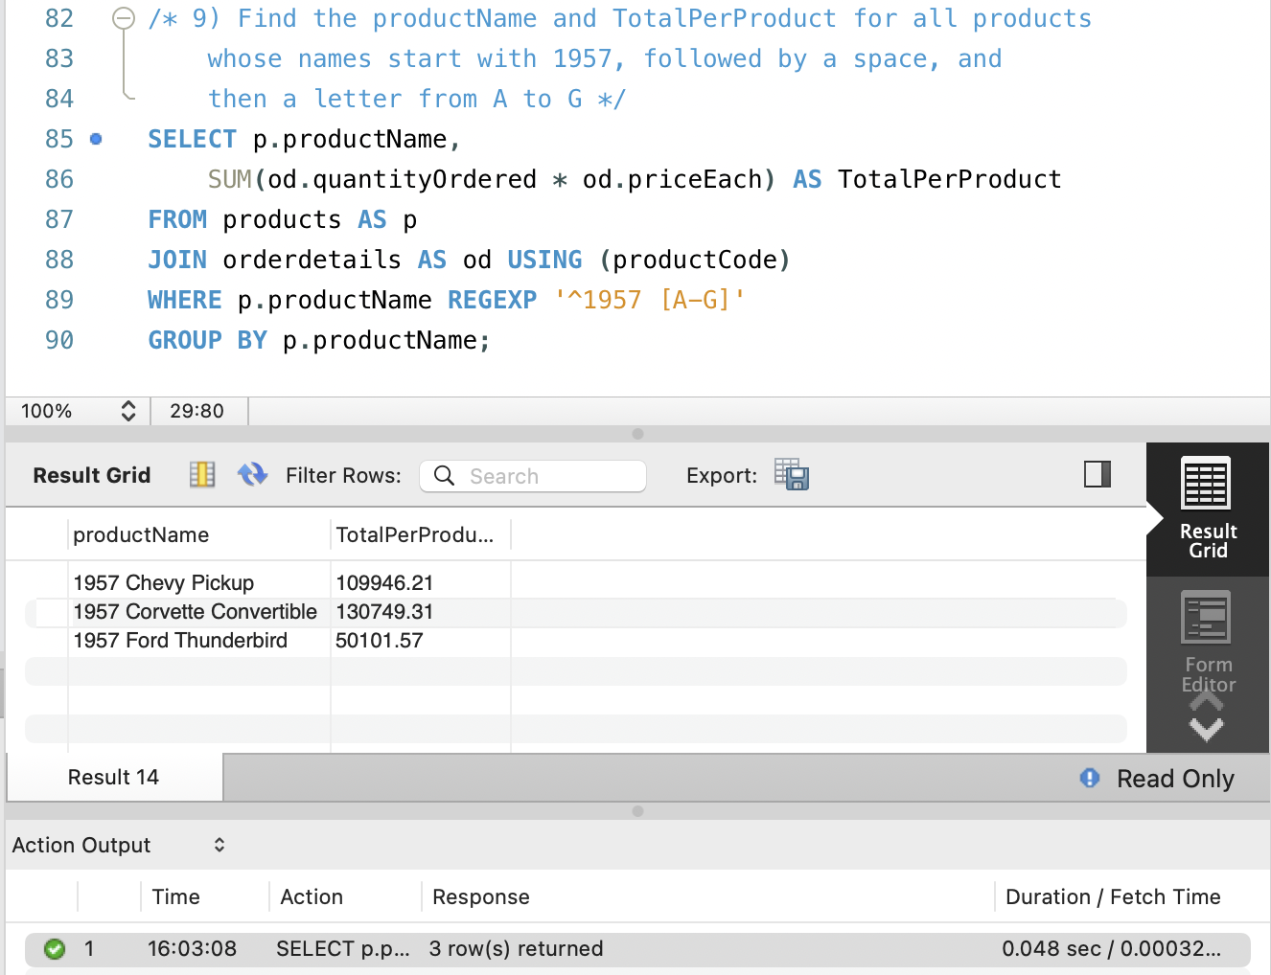
Question 10) Convert all orderNumber from integers to strings with a length of 10 characters

-- Create new columns in orders and orderdetails
ALTER TABLE orders
ADD orderNumberChar Char(10);
ALTER TABLE orderdetails
ADD orderNumberChar Char(10);

Add New Rows
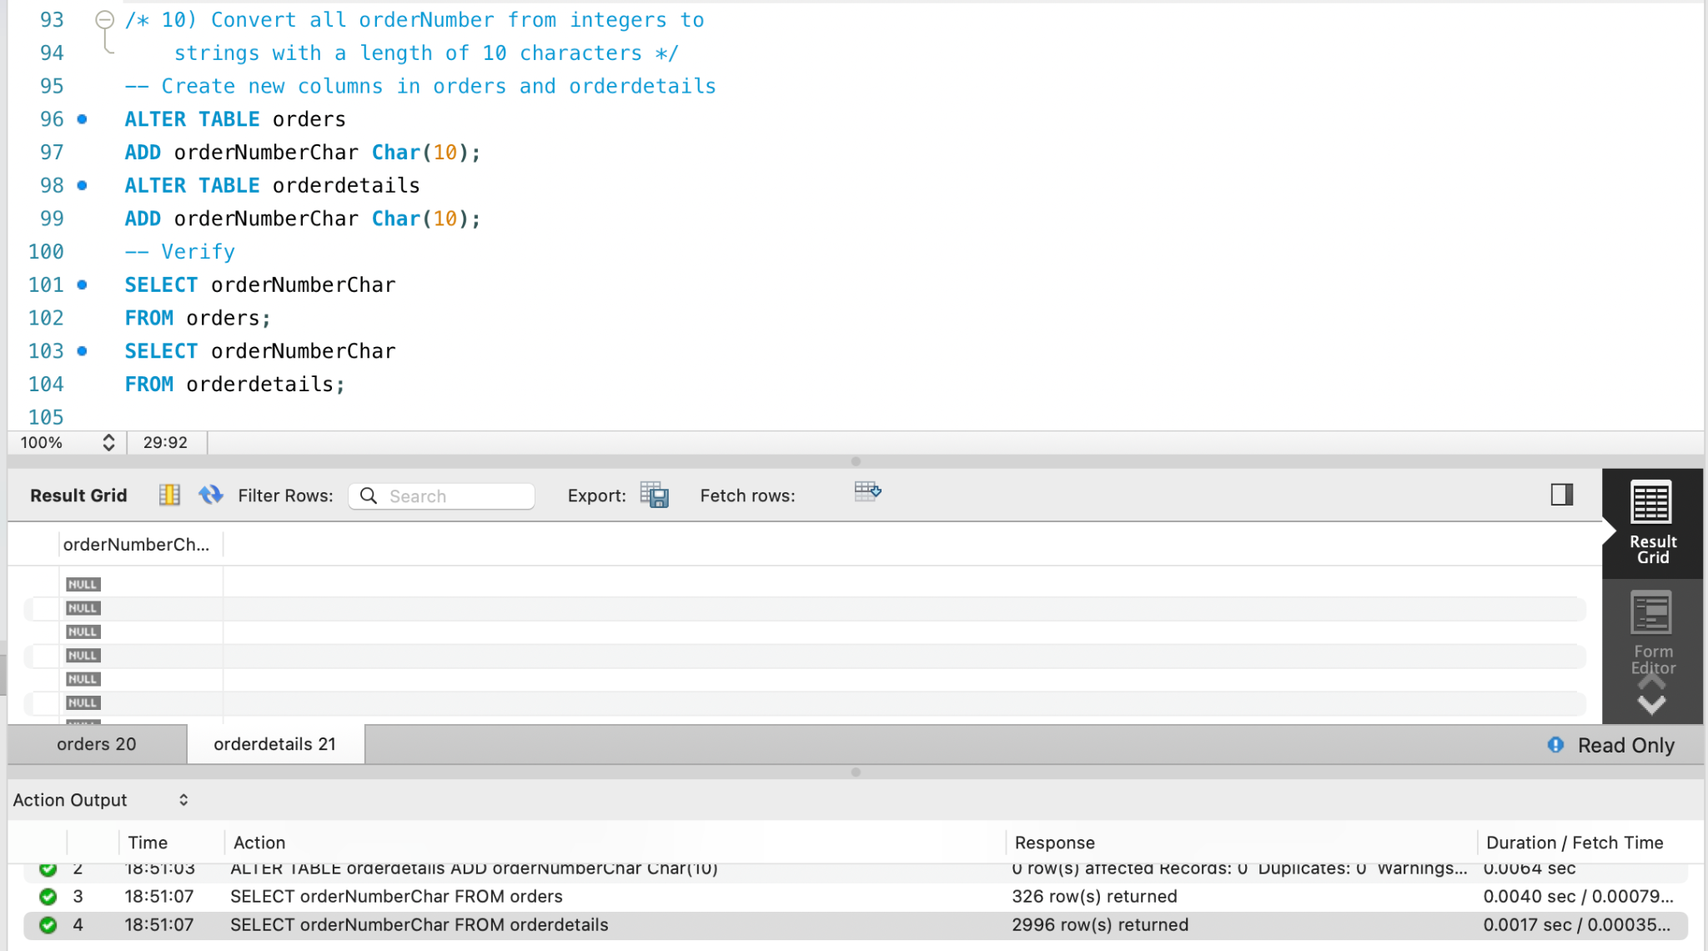
Insert new, converted orderNumbers with LPAD to add 0’s to pad out the value

UPDATE orderdetails
SET orderNumberChar = LPAD(CONVERT(orderNumber, Char(10)), 10, 0);
UPDATE orders
SET orderNumberChar = LPAD(CONVERT(orderNumber, Char(10)), 10, 0);

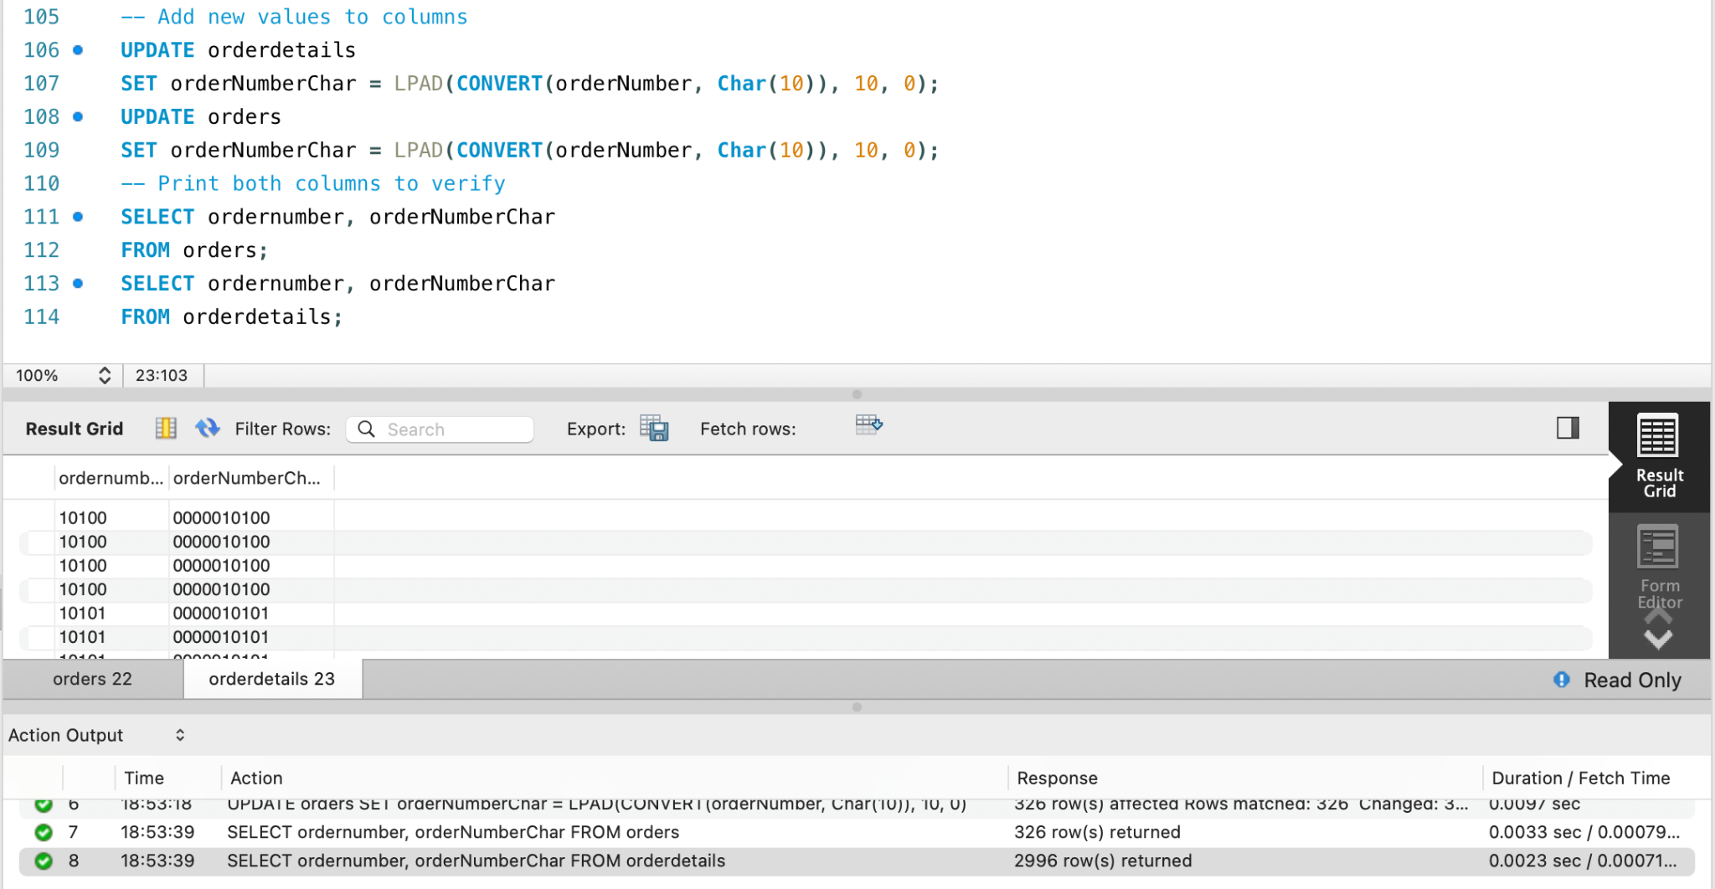
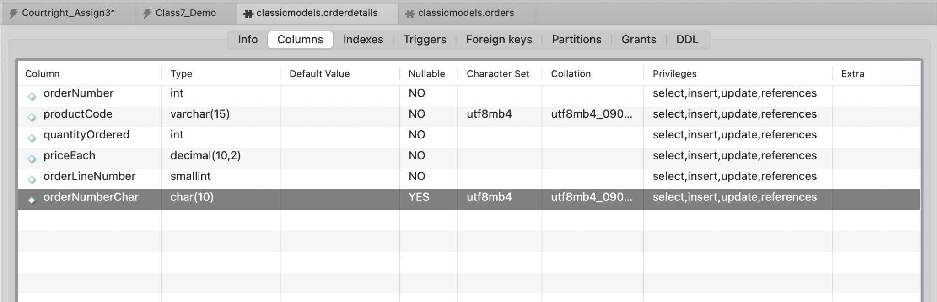
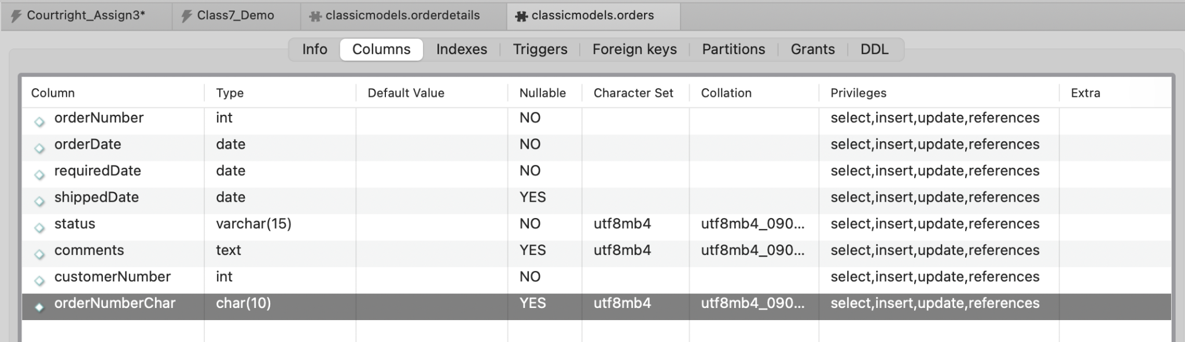
Full SQL Script:

/*
ISAN 5355: Database Management Systems
Assignment 3: Due 10/29
Author: John Courtright
Instructor: Dr. Zhao
*/

-- SET sql_mode=(SELECT REPLACE(@@sql_mode,'ONLY_FULL_GROUP_BY',''));

/* 1) Display orderNumber, quantityOrdered, priceEach, productName
for all orders */
SELECT od.orderNumber, od.quantityOrdered, od.priceEach, p.productName
FROM orderdetails as od
JOIN products as p USING(productCode);

/* 2) Modify the query in question 1 to use inline view to display
the orderNumber, cost per each order (using an alias ‘CostPerOrder’),
and the productName */
SELECT
sub.orderNumber, sub.CostPerOrder, p.productName
FROM (
SELECT
orderNumber,
productCode,
(quantityOrdered * priceEach) AS CostPerOrder
FROM orderdetails
) AS sub
JOIN products AS p USING (productCode);

/* 3) Display orderNumber, productName, orderDate for all orders
placed after May 30th, 2005 (orderDate > 2005-05-30) */
SELECT od.orderNumber, o.orderDate, p.productName
FROM orderdetails as od
INNER JOIN orders as o ON od.orderNumber = o.orderNumber
INNER JOIN products as p ON od.productCode = p.productCode
WHERE o.orderDate > '2005-05-30';

/* 4) Modify the query above to use a subquery to obtain the
same output only with the columns orderNumber, productName */
SELECT od.orderNumber, p.productName
FROM orderdetails AS od
JOIN products AS p USING (productCode)
WHERE od.orderNumber IN (
SELECT orderNumber
FROM orders
WHERE orderDate > '2005-05-30'
);

/* 5) Select the productName and compute the corresponding
TotalPerProduct (i.e., sum product of quantityOrdered and
priceEach), grouping the outcome by the productName, for
all the totals greater than 180,000 */
SELECT p.productName,
SUM(od.quantityOrdered * od.priceEach) as TotalPerProduct
FROM products as p
JOIN orderdetails as od USING (productCode)
GROUP BY p.productName
HAVING SUM(od.quantityOrdered * od.priceEach) > 180000;

/* 6) Update the orderDate for order 10100 to be
3 days later than the current value. */
UPDATE orders
SET orderDate = DATE_ADD(orderDate, INTERVAL 3 DAY)
WHERE orderNumber = 10100;
-- View Row(s)
SELECT orderNumber, orderDate
FROM orders
WHERE orderNumber = 10100;

/* 7) Find all the orders that were placed in July */
SELECT *
FROM orders
WHERE MONTH(orderDate) = 7;

/* 8) Find all the orders that were placed on the 26th day
of any month in 2003 */
SELECT *
FROM orders
WHERE DAYOFMONTH(orderDate) = 26
AND YEAR(orderDate) = 2003;

/* 9) Find the productName and TotalPerProduct for all products
whose names start with 1957, followed by a space, and
then a letter from A to G */
SELECT p.productName,
SUM(od.quantityOrdered * od.priceEach) AS TotalPerProduct
FROM products AS p
JOIN orderdetails AS od USING (productCode)
WHERE p.productName REGEXP '^1957 [A-G]'
GROUP BY p.productName;

-- SET SQL_SAFE_UPDATES = 0;
/* 10) Convert all orderNumber from integers to
strings with a length of 10 characters */
-- Create new columns in orders and orderdetails
ALTER TABLE orders
ADD orderNumberChar Char(10);
ALTER TABLE orderdetails
ADD orderNumberChar Char(10);
-- Verify
SELECT orderNumberChar
FROM orders;
SELECT orderNumberChar
FROM orderdetails;
-- Add new values to columns
UPDATE orderdetails
SET orderNumberChar = LPAD(CONVERT(orderNumber, Char(10)), 10, 0);
UPDATE orders
SET orderNumberChar = LPAD(CONVERT(orderNumber, Char(10)), 10, 0);
-- Print both columns to verify
SELECT ordernumber, orderNumberChar
FROM orders;
SELECT ordernumber, orderNumberChar
FROM orderdetails;

