Assignment 4
ISAN 5355 with Dr. Zhao
John Courtright

1) ‘book’, ‘branch’, and ‘branch_has_book’ tables (in order)

The tables use the utf8mb4 character set by default and utf8mb4_0900_ai_ci for collation.
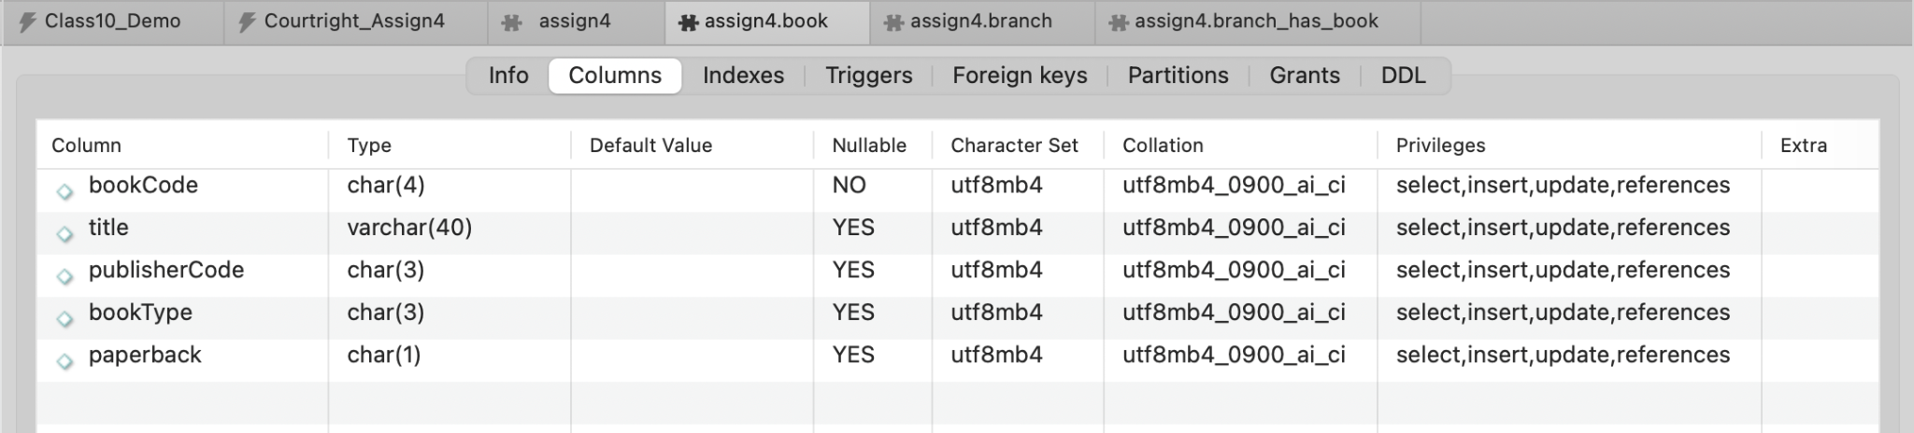
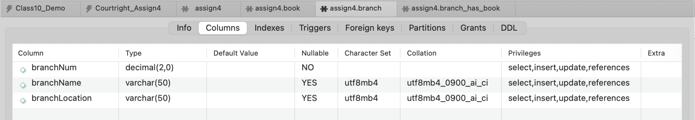
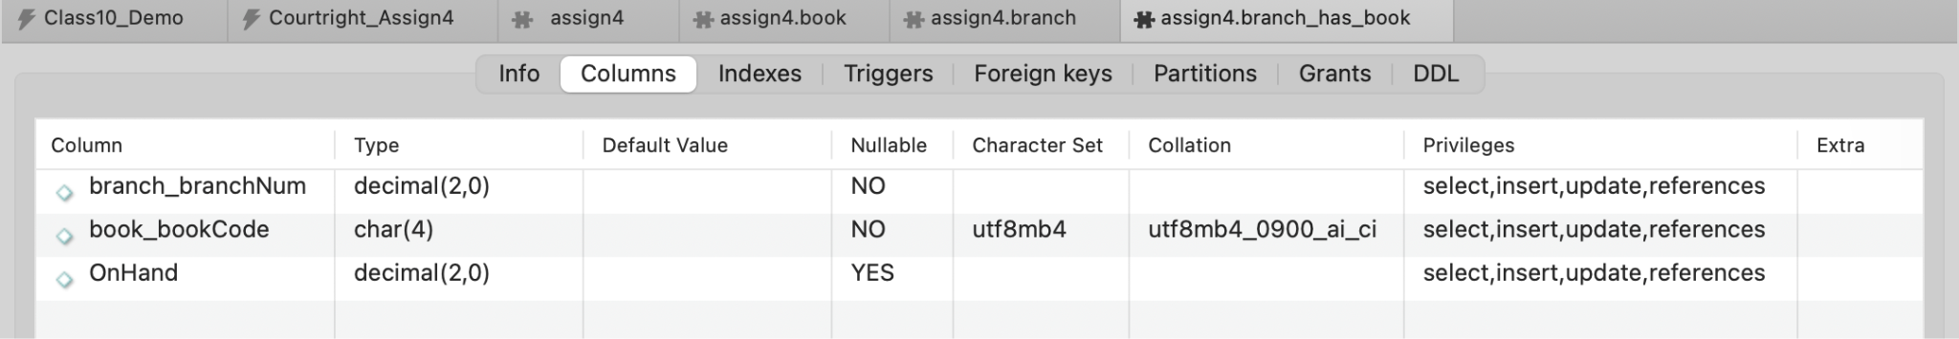

The tables use the InnoDB engine, done by setting the session default engine:
SET SESSION default_storage_engine = InnoDB;

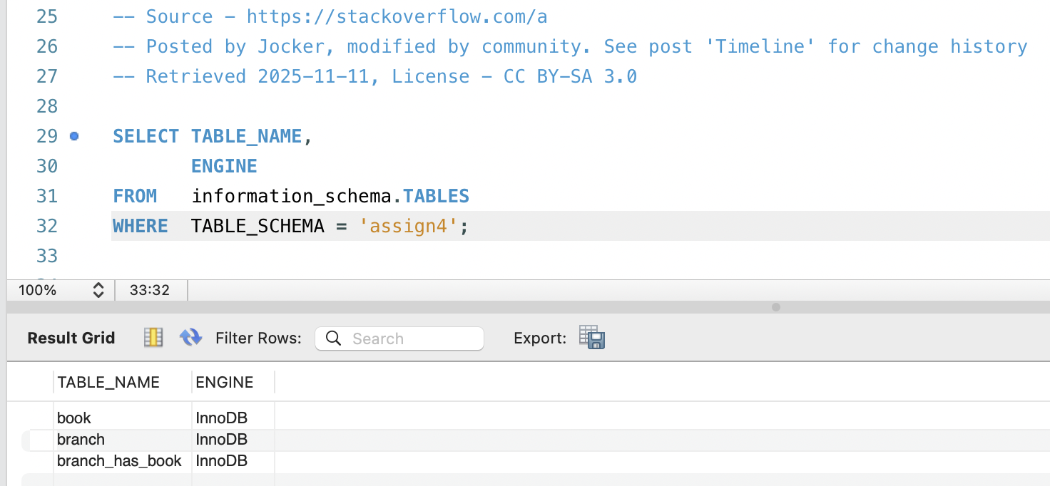

2) ERR Diagram of new ‘assign4’ database
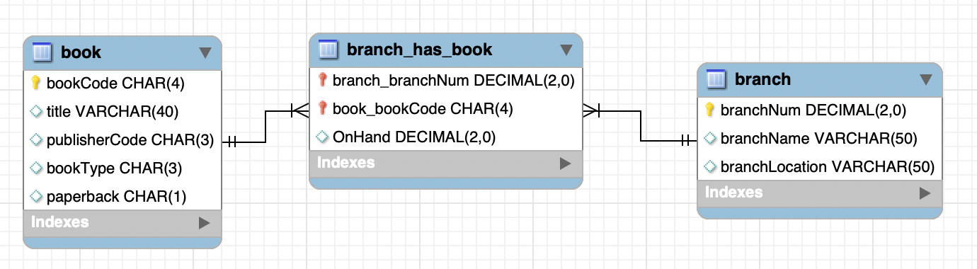

bookCode is the primary key for the ‘book’ table. branchNum is the primary key for the ‘branch’ table. branch_branchNum and book_bookCode are foreign keys in the ‘branch_has_book’ table that reference the ‘branch’ and ‘book’ tables, respectively.

3) Table creation script

-- 1) Create the database
CREATE DATABASE assign4;

-- 2) Set collation and default character set for db
ALTER DATABASE assign4 CHARSET utf8mb4
COLLATE utf8mb4_0900_ai_ci;

-- 3) Set storage engine to be InnoDB
-- Will apply to newly created tables for the new db
SET SESSION default_storage_engine = InnoDB;

-- 4) Activate schema
USE assign4;

/* 5) Create the 'book' table w/:
bookCode CHAR(4) as the PK
title VARCHAR(40)
publisherCode CHAR(3)
bookType CHAR(3)
paperback CHAR(1) */

CREATE TABLE book
(
bookCode CHAR(4) PRIMARY KEY,
title VARCHAR(40),
publisherCode CHAR(3),
bookType CHAR(3),
paperback CHAR(1)
);

/* 6) Create the 'branch' table w/:
branchNum DECIMAL(2,0) as the PK
branchName VARCHAR(50)
branchLocation VARCHAR(50) */
CREATE TABLE branch
(
branchNum DECIMAL(2,0) PRIMARY KEY,
branchName VARCHAR(50),
branchLocation VARCHAR(50)
);

/* 7) Create the 'branch_has_book' table w/:
branch_branchNum DECIMAL(2,0)
book_bookCode CHAR(4)
OnHand DECIMAL(2,0) */
CREATE TABLE branch_has_book
(
branch_branchNum DECIMAL(2,0),
book_bookCode CHAR(4),
OnHand DECIMAL(2,0),
PRIMARY KEY (branch_branchNum, book_bookCode),
FOREIGN KEY (branch_branchNum) REFERENCES branch(branchNum),
FOREIGN KEY (book_bookCode) REFERENCES book(bookCode)
);

4a) Insert Records

/* 8) Insert 3 records into each table */
INSERT INTO book (bookCode, title, publisherCode, bookType, paperback)
VALUES
('B001', 'Data Science Essentials', 'P01', 'TEC', 'Y'),
('B002', 'Modern SQL Design', 'P02', 'TEC', 'N'),
('B003', 'Marketing Analytics 101', 'P03', 'BUS', 'Y');

INSERT INTO branch (branchNum, branchName, branchLocation)
VALUES
(10, 'Downtown Library', 'Austin'),
(20, 'Campus Library', 'San Marcos'),
(30, 'Westside Library', 'Dallas');

INSERT INTO branch_has_book (branch_branchNum, book_bookCode, OnHand)
VALUES
-- Downtown Library carries all three books
(10, 'B001', 4),
(10, 'B002', 2),
(10, 'B003', 5),

-- Campus Library carries two books
(20, 'B001', 3),
(20, 'B002', 6),

-- Westside Library carries two books
(30, 'B002', 4),
(30, 'B003', 3);

4b) Retrieve records with an inner join on the tables

SELECT
br.branchName,
br.branchLocation,
bk.title,
bk.bookType,
bhb.OnHand
FROM branch_has_book AS bhb
INNER JOIN branch AS br
ON bhb.branch_branchNum = br.branchNum
INNER JOIN book AS bk
ON bhb.book_bookCode = bk.bookCode
ORDER BY br.branchName, bk.bookCode;
