Assignment 5
ISAN 5355 with Dr. Zhao
John Courtright

Original Table:
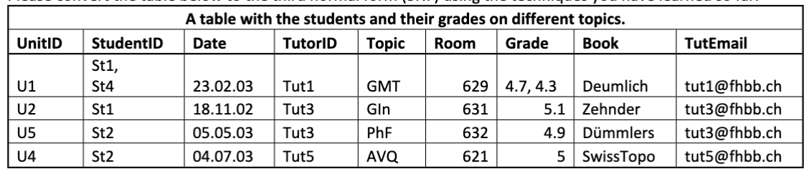

Variables:
- UnitID : Unique identifier for each instructional course session
- StudentID : Unique ID for each student participating in a session
- Date : Date of session
- TutorID : Unique ID for the tutor hosting the unit
- Topic : Subject or topic covered in session
- Room : Room # where session was held
- Grade : Student’s grade received for the session
- Book : Book or learning material associated with session
- TutEmail: Email address of the tutor hosting the session

Create Database
-- Create database
CREATE DATABASE assign5;

-- Set collation and default character set for db
ALTER DATABASE assign5 CHARSET utf8mb4
COLLATE utf8mb4_0900_ai_ci;

-- Set storage engine to be InnoDB
-- Will apply to newly created tables for the new db
SET SESSION default_storage_engine = InnoDB;

-- Activate schema
USE assign5;

We’re going to take this original table and take it through normalization steps to produce 1st, 2nd, and 3rd normalization forms of the database structure.
Original Table Creation Script

CREATE TABLE 0NF
(
UnitID VARCHAR(10),
-- Two students in 0NF U1
StudentID VARCHAR(10),
-- DD-MM-YY format
Date VARCHAR(10),
TutorID VARCHAR(10),
Topic VARCHAR(10),
-- Room could be INT, but we shouldn't need to do any computation with it
Room VARCHAR(10),
-- In 0NF, U1 has two grades, separated by comma
Grade VARCHAR (10),
Book VARCHAR(20),
TutEmail VARCHAR(30)
);

-- Insert original records
INSERT INTO 0NF (UnitID, StudentID, Date, TutorID, Topic, Room, Grade, Book, TutEmail)
VALUES ('U1', 'St1, St4', '23.02.03', 'Tut1', 'GMT', '629', '4.7, 4.3', 'Deumlich', 'tut1@fhbb.ch');
INSERT INTO 0NF (UnitID, StudentID, Date, TutorID, Topic, Room, Grade, Book, TutEmail)
VALUES ('U2', 'St1', '18.11.02', 'Tut3', 'Gin', '631', '5.1', 'Zehnder', 'tut3@fhbb.ch');
INSERT INTO 0NF (UnitID, StudentID, Date, TutorID, Topic, Room, Grade, Book, TutEmail)
VALUES ('U3', 'St2', '05.05.03', 'Tut3', 'PhF', '632', '4.9', 'Dummlerw', 'tut3@fhbb.ch');
INSERT INTO 0NF (UnitID, StudentID, Date, TutorID, Topic, Room, Grade, Book, TutEmail)
VALUES ('U1', 'St2', '04.07.03', 'Tut5', 'AVQ', '621', '5', 'SwissTopo', 'tut5@fhbb.ch');

0NF (Original) Table in MySQL

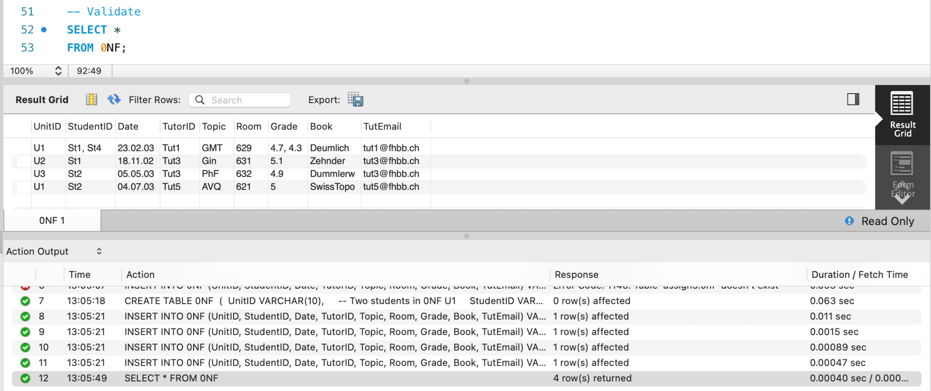
In 0NF form, this table has a few issues. StudentID can contain multiple students (U1 -> St1, St4). Grade contains multiple grades (U1 -> 4.7, 4.3). If the session (each row) has multiple students, it stores their ID and grade in a comma separated string rather than an atomic value.

To convert this table to 1NF, we’ll need to break the multivalued fields into multiple rows. Each row in the 1NF table will represent a session and the individual student was in that session. The StudentID and Grade columns will only hold one value that matches their respective student. We’re creating some more problems with UnitID and StudentID both being a primary key and partial dependencies (some rows only pertaining to Unit and not Student, or vice versa), but we’ll solve those later.

1NF Table Creation Script

CREATE TABLE 1NF (
UnitID VARCHAR(10),
StudentID VARCHAR(10),
Date VARCHAR(10),
TutorID VARCHAR(10),
Topic VARCHAR(10),
Room VARCHAR(10),
-- Changing grade to be numeric
Grade DECIMAL(2,1),
Book VARCHAR(20),
TutEmail VARCHAR(30)
);

INSERT INTO 1NF VALUES
('U1', 'St1', '23.02.03', 'Tut1', 'GMT', '629', 4.7, 'Deumlich', 'tut1@fhbb.ch'),
('U1', 'St4', '23.02.03', 'Tut1', 'GMT', '629', 4.3, 'Deumlich', 'tut1@fhbb.ch'),
('U2', 'St1', '18.11.02', 'Tut3', 'Gin', '631', 5.1, 'Zehnder', 'tut3@fhbb.ch'),
('U3', 'St2', '05.05.03', 'Tut3', 'PhF', '632', 4.9, 'Dummlerw', 'tut3@fhbb.ch'),
('U4', 'St2', '04.07.03', 'Tut5', 'AVQ', '621', 5.0, 'SwissTopo', 'tut5@fhbb.ch');
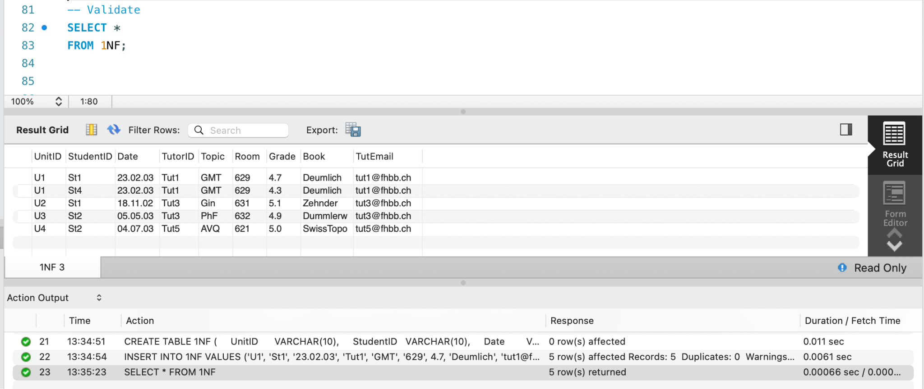

We’ve now converted the original table to 1NF. StudentID and Grade now just represent a single student. Each row represents a student in a tutoring session.

However, we now have an issue where we have a composite key with UnitID and StudentID. We can create two separate tables: one where each record is a tutoring session with the relevant variables and one where each record represents a student using the UnitID as a foreign key. Separating this information will also solve our issue of partial dependencies in our records.

2NF Tables Creation Script

CREATE TABLE Unit2NF (
UnitID VARCHAR(10) PRIMARY KEY,
Date VARCHAR(10),
TutorID VARCHAR(10),
Topic VARCHAR(10),
Room VARCHAR(10),
Book VARCHAR(20)
);

-- Student Table
CREATE TABLE StudentUnit2NF (
UnitID VARCHAR(10),
StudentID VARCHAR(10),
Grade DECIMAL(2,1),
– Declare both as primary keys to avoid student-unit duplication
PRIMARY KEY (UnitID, StudentID),
FOREIGN KEY (UnitID) REFERENCES Unit2NF(UnitID)
);

-- Insert Records into both tables
INSERT INTO Unit2NF VALUES
('U1', '23.02.03', 'Tut1', 'GMT', '629', 'Deumlich'),
('U2', '18.11.02', 'Tut3', 'Gin', '631', 'Zehnder'),
('U3', '05.05.03', 'Tut3', 'PhF', '632', 'Dummlerw'),
('U4', '04.07.03', 'Tut5', 'AVQ', '621', 'SwissTopo');

INSERT INTO StudentUnit2NF VALUES
('U1', 'St1', 4.7),
('U1', 'St4', 4.3),
('U2', 'St1', 5.1),
('U3', 'St2', 4.9),
('U4', 'St2', 5.0);
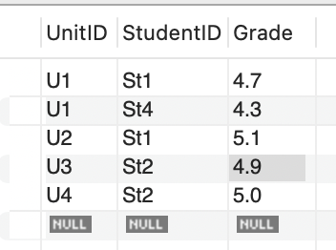
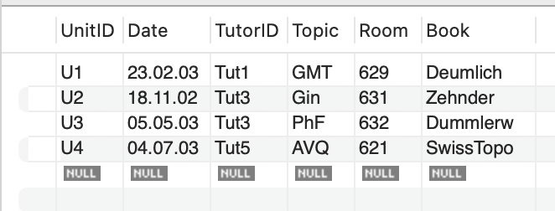
Unit2NF, StudentUnit2NF Tables and Response
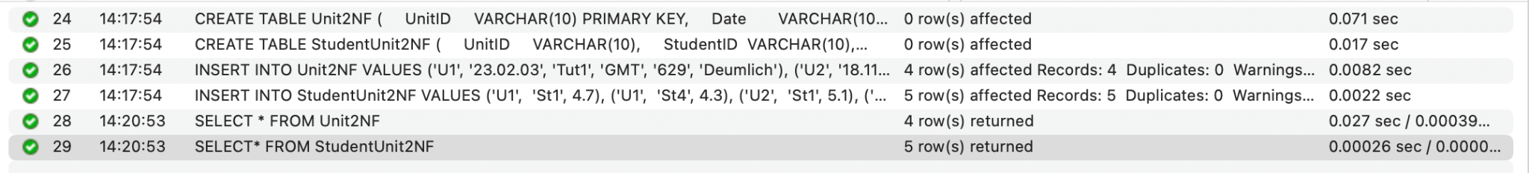
We now have a 2NF table structure for our tutoring session records. Table Unit2NF represents each unit, where each row is a different unit. We include the date, the TutorID for the tutor that hosted the session, the topic, room, and book used. These columns do not have anything to do with the student, so we separate them out. StudentUnit2NF represents the students that received tutoring. Each row is a different student, using StudentID as the primary key. We also store what unit that student attended (the same UnitID can be used for multiple students) and their grade for the session.

To normalize into 3rd normal form, we need to ensure no transitive dependency, or that our non-key columns don’t have a dependency on another column.

TutEmail is in the Unit2NF table and uses UnitID as its primary key. However, a tutor’s email would depend on the tutor, in this case TutorID, so we’ll need to create another Tutor table.
3NF Table Creation Script

CREATE TABLE Tutor3NF (
TutorID VARCHAR(10) PRIMARY KEY,
TutEmail VARCHAR(30)
);

CREATE TABLE Unit3NF (
UnitID VARCHAR(10) PRIMARY KEY,
Date VARCHAR(10),
TutorID VARCHAR(10),
Topic VARCHAR(10),
Room VARCHAR(10),
Book VARCHAR(20),
FOREIGN KEY (TutorID) REFERENCES Tutor3NF(TutorID)
);

CREATE TABLE StudentUnit3NF (
UnitID VARCHAR(10),
StudentID VARCHAR(10),
Grade DECIMAL(2,1),
PRIMARY KEY (UnitID, StudentID),
FOREIGN KEY (UnitID) REFERENCES Unit3NF(UnitID)
);

-- Insert Records
INSERT INTO Tutor3NF VALUES
('Tut1', 'tut1@fhbb.ch'),
('Tut3', 'tut3@fhbb.ch'),
('Tut5', 'tut5@fhbb.ch');

INSERT INTO Unit3NF VALUES
('U1', '23.02.03', 'Tut1', 'GMT', '629', 'Deumlich'),
('U2', '18.11.02', 'Tut3', 'Gin', '631', 'Zehnder'),
('U3', '05.05.03', 'Tut3', 'PhF', '632', 'Dummlerw'),
('U4', '04.07.03', 'Tut5', 'AVQ', '621', 'SwissTopo');

INSERT INTO StudentUnit3NF VALUES
('U1', 'St1', 4.7),
('U1', 'St4', 4.3),
('U2', 'St1', 5.1),
('U3', 'St2', 4.9),
('U4', 'St2', 5.0);

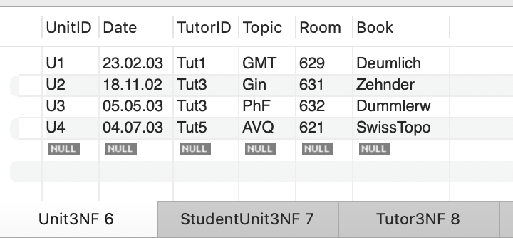
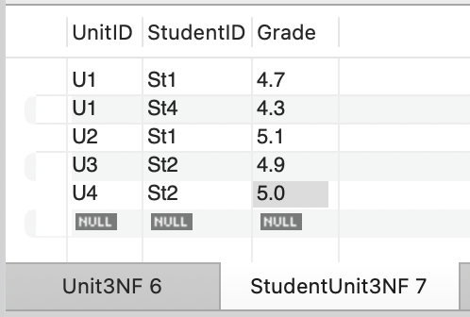
3NF Tables and Response
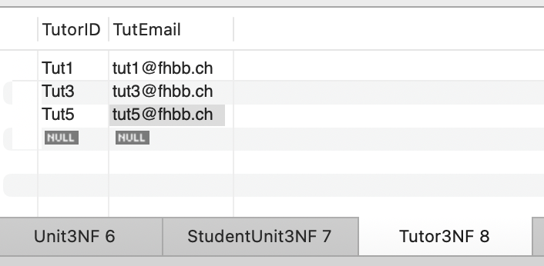
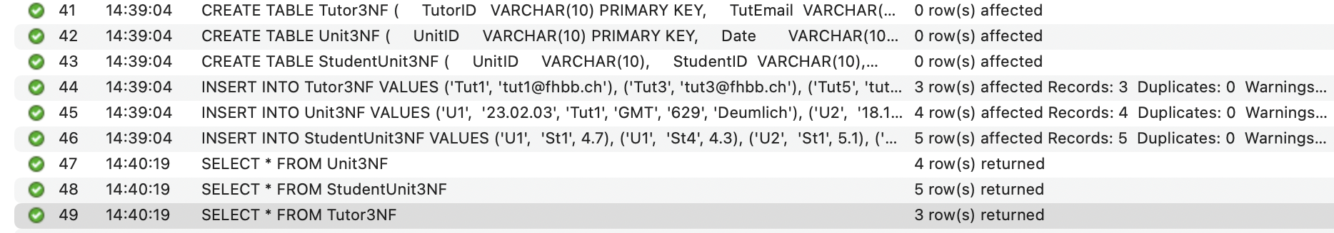

With those steps, we were able to create a 3rd normalization form table set based on our original records. Each table has it’s own primary key and represents its own “unit” (tutoring unit, student, tutor) where the features are solely dependent on the primary key and no other record. Values are atomic as well.

Let’s test out the system by inserting 3 new records into each table (3 new sessions, 3 new students, 3 new tutors).

New Record Insert Queries

INSERT INTO Tutor3NF (TutorID, TutEmail) VALUES
('Tut7', 'tut7@fhbb.ch'),
('Tut8', 'tut8@fhbb.ch'),
('Tut9', 'tut9@fhbb.ch');

INSERT INTO Unit3NF (UnitID, Date, TutorID, Topic, Room, Book) VALUES
('U5', '12.03.04', 'Tut7', 'MLB', '640', 'Data Mining 101'),
('U6', '28.09.04', 'Tut8', 'STAT', '645', 'Applied Statistics'),
('U7', '15.01.05', 'Tut9', 'DSA', '650', 'Data Structures');

INSERT INTO StudentUnit3NF (UnitID, StudentID, Grade) VALUES
('U5', 'St10', 4.8),
('U6', 'St11', 5.2),
('U7', 'St12', 4.4);

SELECT Statement for all 3 Tables

SELECT
su.UnitID,
su.StudentID,
u.Date,
u.TutorID,
u.Topic,
u.Room,
su.Grade,
u.Book,
t.TutEmail
FROM StudentUnit3NF su
JOIN Unit3NF u
ON su.UnitID = u.UnitID
JOIN Tutor3NF t
ON u.TutorID = t.TutorID
ORDER BY su.UnitID, su.StudentID;

Joined Tables

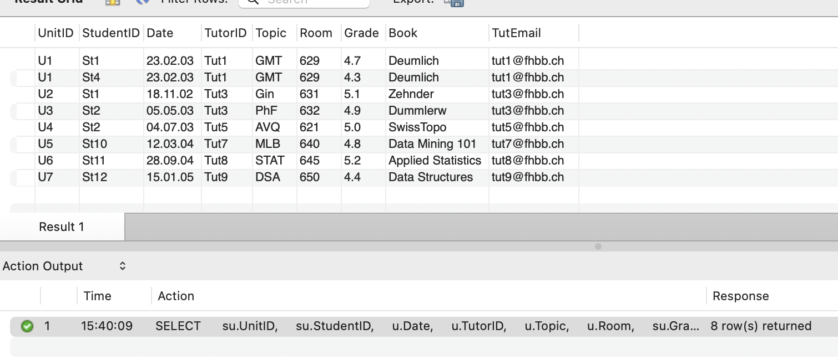

ERR Diagram of Database (inc 0NF, 1NF, 2NF, and 3NF)
