John Edovia

Project Name: Salesforce Clone

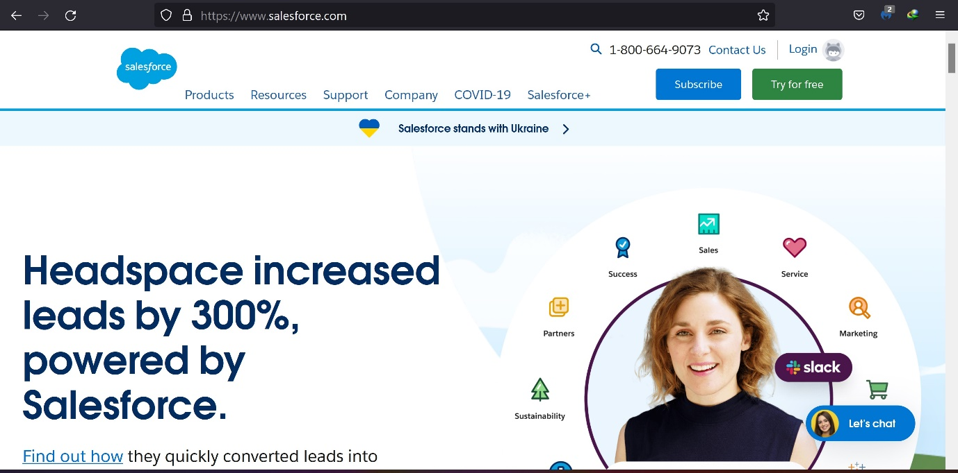

Overview
Salesforce is an American cloud-based software company headquartered in San Francisco, California. It provides customer relationship management (CRM) software and applications focused on sales, customer service, marketing automation, analytics, and application development.

Website structure
Homepage
The website homepage is made up of the following sessions
- Header
- Main
- Footer

Header Section
The header section comprises of the following
- Logo
- Navigation tool bar
- Search Icon
- Login and contact us link
- Two buttons (subscribe and try for free)

Main Section
The main session consists of a mix of banners, rows, columns, reverse columns, big box design, multiple call to actions, and fun images. It also includes links and buttons.

Footer Section
The footer section consists of links to important pages on the website, logo, and social icons

