**Open Weather API Homework**

John Goebel

Using the Open Weather API, I was able to pull weather data for 577 random cities throughout the world. Using this data, the temperature, humidity, wind speed and cloudiness of each of these cities was then plotted against latitude.

The following was observed:

* **Temperature**: There is a clear trend between maximum temperature for the day and latitude. Cities closer to the equator (0 degrees latitude) tend to have a higher temperature than those further away. With that said, many cities within ~-20 degrees and +40 degrees latitude tended to cluster in the 20 – 30 degree Celsius level. The highest temperatures were found in cities in around +10 to +30 degrees latitude. This is consistent with expectations, as the data was ran in June, a summer month for the northern hemisphere.

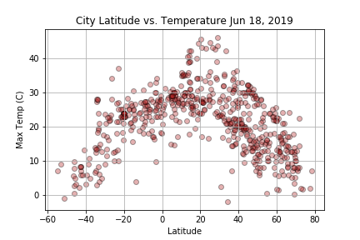

* **Wind Speed**: There’s no clear correlation between wind speed and latitude. However, at any given latitude, there does seem to be a similar dispersion of windspeeds. Generally, more cities have lower windspeeds at any given latitude but there are cities at each latitude with higher wind speeds. While I did not perform any statistical measure of this directly, there does seem to be slightly higher windspeeds on average nearer to the equator.

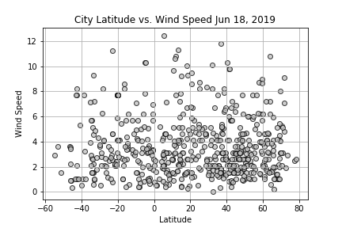

* **Humidity**: Overall, there is no overwhelming correlation between latitude and humidity. However, there does seem to be two groupings of lower humidity between ~-35 degrees and ~-15 degrees latitude and ~+15 and ~+40 degrees latitude. These are likely associated with specific geographical regions, although I did not dive into the specific data points to plot this out. Adding color scales by continent or some sub grouping (i.e. Central America, Northern Africa, Middle East, Western Australia) may make some of these patterns more obvious.

