**CNT3004  
Assignment #1**

**Points: 100**

1. **What are the differences between HTTP 1, HTTP 2 and HTTP 3? (10)**

HTTP 1 sends files in the sequence they were requested by the client

HTTP 2 can split up files into frames that are sent separately

HTTP 3 has security and can be used over UDP

1. **Describe the hierarchical structure of the DNS domain name system. Discuss the**

**significance of the root DNS servers in the DNS hierarchy. (15)**

There are a few root servers, which direct clients to the TLD servers (.com, .org, etc), which then direct clients to authoritative nameservers for domains.

There are also DNS servers in ISP and organization networks, which cache recent DNS requests for quicker name resolution.

The root DNS servers are the beginning of a chain which a client can use to find a DNS server for any domain.

1. **Explain the structure of a DNS message, including the main components and their**

**functions. (15)**

A DNS message includes an ID number, a flag indicating whether it is a request from a client or a response from a DNS server, and either the request from the client, which contains several record keys, or the response from the server, which contains the values of the requested records and possibly some other records.

The identification field contains a unique number used to identify a request/response pair.

The flags identify a message as query or reply, request a recursive query, and show whether a reply is authoritative.

The four “#” fields are the number of questions or records in their respective sections.

Each question in a query is a pair of record type and record key used to request a record from the DNS server.

Each answer record in a reply corresponds to a question from the corresponding query.

Each authority record in a reply is an authority server that may know the answers to the questions in the query.

Each additional record in a reply is an extra record that may be related to the query.

1. **How do the "HELO," "MAIL FROM," "RCPT TO," and "QUIT" commands contribute**

**to the SMTP conversation, and when are they commonly employed? (15)**

**The HELO command opens an SMTP session.**

**The MAIL FROM command specifies the source of the email message.**

**The RCPT TO command specifies the destination of the email message.**

**The QUIT command ends an SMTP session.**

1. **Suppose an HTTP client makes a request to the floridapoly.edu. web server.**

**The client has never before requested a given base object, nor has it communicated recently with the floridapoly.edu server. You can assume, however, that the client host knows the IP address of cs.floridapoly.edu.**

**Suppose also that after downloading the base file, the browser encounters a jpeg object in the base html file that is stored on floridapoly.edu., and therefore makes another GET request to floridapoly.edu. for that referenced jpeg object.**

***How many round trip times (RTTs) are needed from when the client first makes the request to when the base page and the jpeg file are completely downloaded, assuming the time needed by the server to transmit the base file, or the jpeg file into the server's link is (each) equal to 1/2 RTT and that the time needed to transmit the HTTP GET into the client's link is zero? You should assume that persistent HTTP 1.1 is being used.* (You should take into account any TCP setup time required before an HTTP GET is actually sent by the client, the time needed for the server to transmit the requested object, and any propagation delays not accounted for in these amounts of time.) (15)**

1. **Consider an HTTP 1.1 client and server. The RTT delay between the client and server is 2 seconds. Suppose the time a server needs to transmit an object into its outgoing link is 3 seconds, as shown below for the *first* of these 100 requests.**

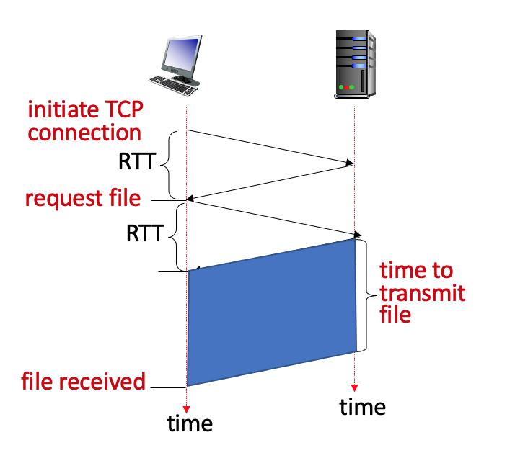

**You can assume that any other HTTP message not containing an object sent by the client and server has a negligible (zero) transmission time. Suppose the client makes 100 requests, one after the other, waiting for a reply to a request before sending the next request.**

**Using HTTP 1.1, how much time elapses between the client transmitting the first request, and the receipt of the last requested object?(15)**

**7. Consider a client and a server, separated by an RTT of 4 time units. The client makes a request for 4 objects at t=0. O1 consists of 10 frames, O2 and O4 each consist of 1 frame, and O3 consists of 2 frames. In the HTTP 1.1 example shown below, the server is transmitting frames to the client in the order O1, O2, O3, O4 . Each frame takes 1 time unit to transmit.**

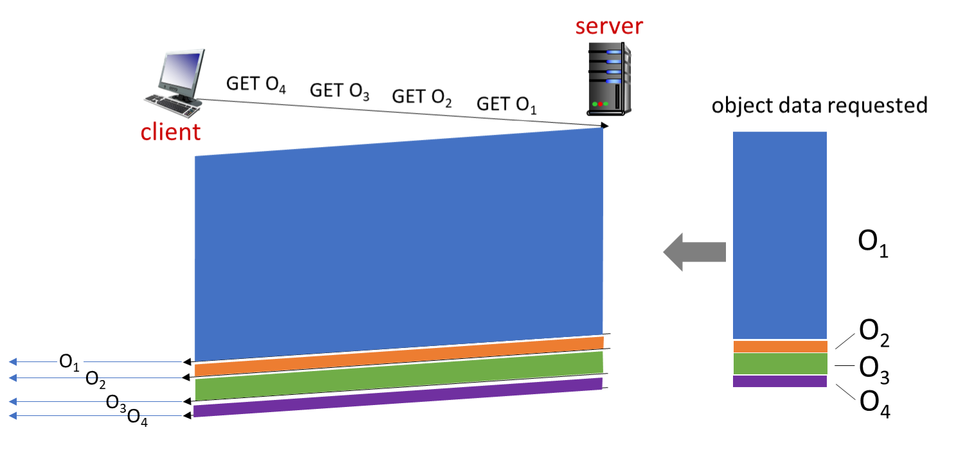

**Under HTTP 1.1, the server would send O1, O2, O3, O4 in that first-come-first-served (FCFS) order, sending each object in its entirety before moving on to send the next object in that order.**

**Let’s define the object download delay as the time from when an object is requested (at t=0 below) to the time that object is received in its entirety. What is the average object download delay (the sum of the four object download delays divided by 4) under HTTP/1.1 O1, O2, O3, O4 object transmission order? (15)**