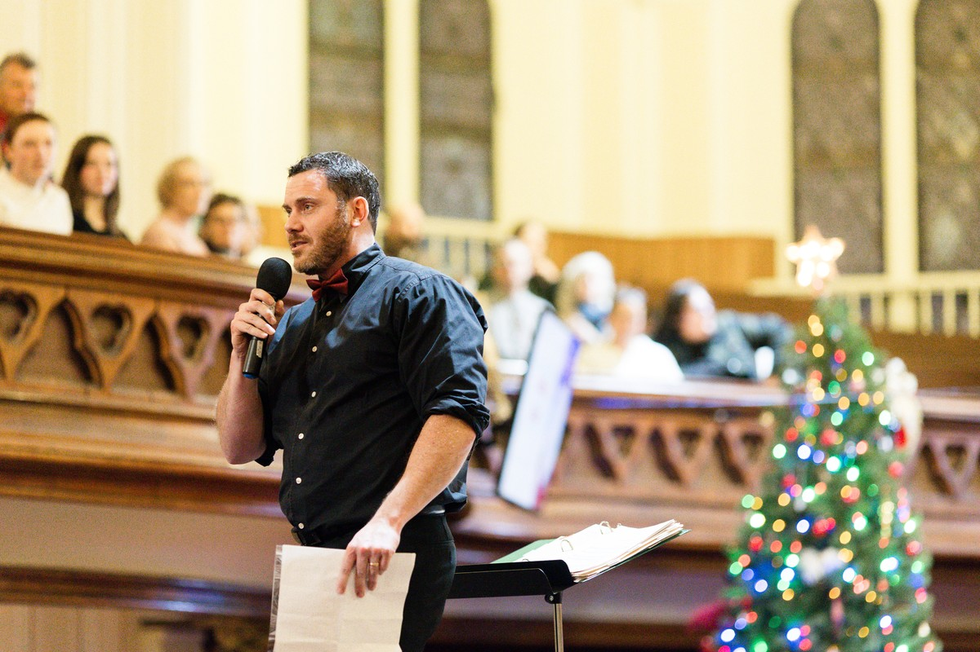

APOLLO ADVANCEMENT
Fundraising That Starts with Story.
Development consulting for arts, education, and community nonprofits across Canada and the United States.
apolloadvancement.com john@apolloadvancement.com (705) 313-1588

A LETTER FROM JOHN JALSEVAC
Why I do this work.

If you’re reading this, it’s probably because your organization does meaningful work in the world and you know you could be raising more money to support it. You’re right. You can.
I’ve spent twenty years in nonprofit leadership, communications, and fundraising. Along the way I learned something that most people find hard to believe: I love fundraising. Not because I love asking for money, but because I love what fundraising actually is when it’s done well. It’s the art of finding people who genuinely care about your mission, building real relationships with them, and inviting them to become partners in the story of how your organization is changing lives.
I came to this work through philosophy, theatre, teaching, and running an independent school. That background gives me something most fundraising consultants don’t have: a writer’s instinct for story and a teacher’s patience for building understanding. When I write your case for support, your donor newsletter, or your appeal letter, it sounds like a human being wrote it. Because one did.
My approach is simple. I listen before I strategize. I write before I pitch. And I build things that last. I’m not the consultant who drops a binder and sends an invoice. I sit at your table, learn the names of your board members, and care about your mission because I choose to work with organizations whose missions I genuinely believe in.
Most of my clients are arts, education, and community organizations with annual revenues between $500K and $5M. They’re at the inflection point where a serious, professional fundraising program would change everything. If that sounds like you, I’d love to talk.
Every engagement starts the same way: with an honest conversation about where you are and where you want to go. No pitch. No obligation.

John Jalsevac
Founder, Apollo Advancement

SERVICES
How we work together.

Every organization is different. Most engagements combine more than one of the services below. We design something that fits your needs and budget.

01 Fractional Development Leadership
Senior fundraising leadership on a monthly retainer. I embed with your team, manage donor relationships, oversee campaigns, and build the program – without the cost of a full-time hire.

02 Fundraising Audit & Strategic Plan
A clear-eyed assessment of your donor base, communications, systems, and untapped potential, followed by a written strategic plan with honest priorities and a realistic roadmap.

03 Campaign Development
Annual funds, capital campaigns, legacy giving programs, and special initiatives – designed from strategy through execution, with storytelling at the core.

04 Board & Staff Training
Practical workshops that reframe fundraising as relationship-building and give your board and staff the confidence, language, and skills to participate.

05 Content & Communications Strategy
Cases for support, donor newsletters, appeal letters, annual reports, and digital strategy – the communications that make fundraising work.

06 Website Strategy & SEO
Clear positioning, compelling copy, and search visibility that gets the right people to your door. For nonprofits and professional organizations.

CASE STUDY
Wayside Academy: Building a fundraising program from nothing.

Wayside Academy was a small independent school with a powerful educational mission and almost no fundraising infrastructure. When I came on board, the school had roughly 50 donors and annual fundraising revenue of about $250,000. There was no development plan, no donor communications program, no systematic approach to cultivation or stewardship.
I built the development program from scratch: the case for support, donor communications, newsletters, appeal letters, direct mail campaigns. I developed the donor pipeline, identified and cultivated new prospects, and professionalized every aspect of how the school engaged its supporters. I met with major donor prospects who were simply waiting to be asked, successfully earning multiple six-figure gifts.
300+  donors (from 50) | $600K+  annual revenue (from $250K) | 1 year  to transform the program

“When John came on board, we had about 50 donors and no real fundraising infrastructure. Within a year, he’d grown our donor base to over 300 and more than doubled our annual revenue. He developed our case for support, launched our first direct mail campaign in years, and professionalized every aspect of how we engaged supporters.”
Frank Callaghan Former Board Chair, Wayside Academy

[Insert Wayside Academy photo here]

CASE STUDY
Peterborough Singers: A campaign built on honouring a community’s story.

The Peterborough Singers are one of Ontario’s most beloved community choral organizations, founded 35 years ago by Syd Birrell. When the organization decided to launch the Syd Birrell Legacy Fund to mark Syd’s retirement, they needed someone who could handle both the strategic demands of an ambitious campaign and the deeply personal nature of what it represented.
This was not a standard fundraising project. The choir Syd founded is not just one of the best community choirs in Canada – it has been transformational in the lives of countless people. The campaign needed deep sensitivity to the unique heart and history of this choir.
The work began not with spreadsheets but with stories: conversations with Syd and his family, with long-time choir members, with supporters who had been part of the Singers’ journey for decades. I developed the campaign strategy, crafted the donor communications, and managed the engagement. But the heart of the work was storytelling: finding the language that honoured what the Peterborough Singers meant to the people who built it, and making that story compelling enough to inspire a new generation of supporters.
325  donors (from 80) | Legacy Fund  endowment campaign | Story-led  campaign strategy

“The heart of the work was storytelling – finding the language that honoured what the Peterborough Singers meant to the people who built it, and making that story compelling enough to inspire a new generation of supporters.”
John Jalsevac

[Insert Peterborough Singers photo here]

ABOUT JOHN JALSEVAC
A philosopher who builds fundraising programs. A fundraiser who tells stories.

John Jalsevac has spent twenty years in nonprofit leadership, communications, and fundraising. He came to this work through philosophy, theatre, teaching, and running an independent school – a background that gives him a writer’s instinct for story and a teacher’s patience for building understanding.  As headmaster of a small academy, John built a fundraising program from scratch while also teaching and running the school. In one year, he grew the donor base from 50 to over 300 and more than doubled annual revenue to over $600,000.  John’s approach to fundraising is rooted in the conviction that donors give when they feel genuinely invited into the story of your mission – not just solicited for their money. He writes cases for support that donors can’t put down. He writes newsletters that get forwarded. He writes appeal letters that get handwritten notes back. | 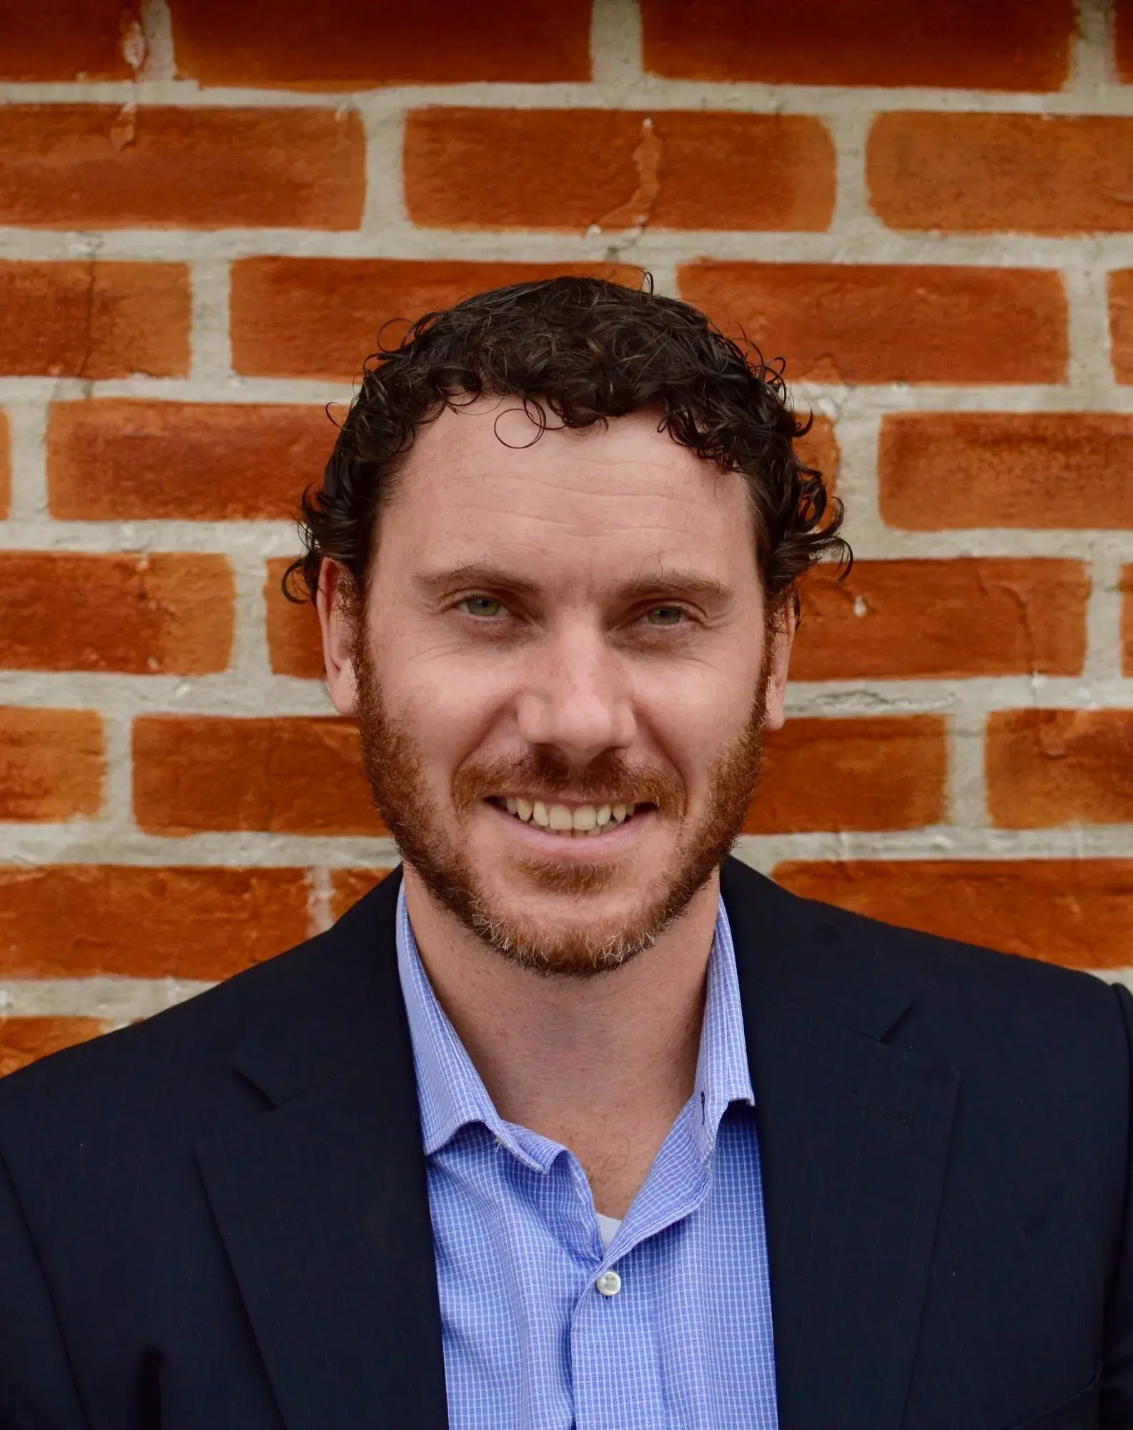
John is also an experienced executive who has led teams of up to 30, directed plays and choirs, trained in martial arts, and performed on stage. He believes that a full life makes you better at everything – including fundraising – because fundraising, at its core, is about understanding people.
He lives in the Kawartha Lakes region of Ontario with his family and works with nonprofits across Canada and the United States.

Areas of Expertise
Fundraising Strategy & Execution | Donor Communications & Copywriting
Major Gift Cultivation | Capital & Annual Fund Campaigns
Board & Staff Training | Website Strategy & SEO

Apollo
ADVANCEMENT
Let’s start a conversation.
Every engagement begins the same way: with an honest discussion about your organization, your mission, and where you want to go. No pitch. No obligation.
PHONE
(705) 313-1588
EMAIL
john@apolloadvancement.com
WEB
apolloadvancement.com
LOCATION
Kawartha Lakes, Ontario

