Problem 7.1: Network Topologies 1/2 + 1/2 + 1 + 1 = 3 points
Consider the following four network topologies, each with n nodes: Specify formulas to calculate the minimum, maximum, and average number of hops between any two nodes for any number n.
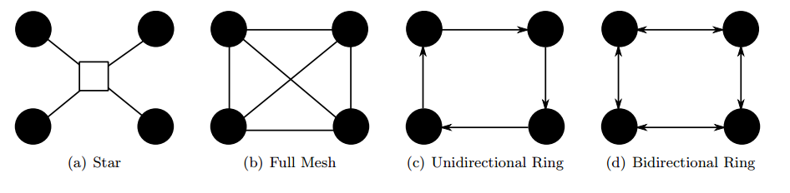
 | min | max | avg
(a) | 2 | 2 | 2
(b) | 1 | 1 | 1
(c) | 1 | n-1
(d) | 1 |  | for n=3 or 2 the avg is 1

7.2: Transmission with HDLC 1+4 = 5 points
The High Level Data Link Protocol (HDLC) is a protocol of the data link layer (DLL). One of its tasks besides flow control is to enable the detection of errors by check-summing.
a) Consider the bit sequence 110111110101. This sequence is to be transmitted including its CRC checksum. Compute the checksum by using the following generator polynomial instead of CCITT CRC-16: G(x) = x^4 + x + 1 (10011)

110111110101 : 10011 = 11010101
10011
10001
10011
10110
10011
10110
10011
1011

checksum: 1011

b) Sketch the HDLC frame that is created to transfer the bit sequence from a) from host A to B. Assume that the sequence number counters have been initialized with the value zero. The frame shall also be used to signal host B that the first two frames from B to A were received successfully. The address of host B is 111111112. Ignore the P/F bit and set it to 0. Use the checksum calculated in a).

Control: 1 0 Type P/F Next
1 0 001 0 003 (A is sending the first packet 001 and received 001 and 002)

01111110 | 111111112 | 100010003 | 110111110101 | 0000000000001011 | 01111110
Address Control Data Checksum

Problem 7.3: HDLC vs. PPP 3 points
Compare the HDLC and PPP protocols. Specify appropriate metrics for the comparison.

HDLC | PPP
Vendor specific | Standard protocol
Point-to-Point-Connection
No Multiplexing | Multiplexing possible
Doesn’t support authentication | Supports authentication
Bit oriented | Byte oriented
Operates on layer 2 | Operates on Layer 2 and 3
Error detection not possible | Error detection possible
Doesn’t uses byte stuffing | Uses Byte stuffing
Supports synchronous and asynchronous links

Problem 7.4: Verification: Finite State Machine Models 1+1+1 = 3 points
a) Which property do FSM states have, that are considered as a deadlock state?
There can be a state with no possible transition to another state which will leave the state
machine in a deadlock
b) Is it possible that “protocol 3” (see chapter 4 slides 51) enters a deadlock state? Use the FSM model of this protocol (chapter 4 slide 103) to proof your answer.
No, in case a frame is lost the transition 0 is taken (asuming that a frame loss is always detected). Afterwards a counter is started which always leads to a new state after a certain time and the frame is being retransmitted. If the frames are received correctly the transmissions 1,2,3 and 4 will be called cyclically.
At all times there will be a transition that can be called.
c) Is it possible that “protocol 3” enters a livelock, in which no further data is transmitted? Prove that no livelock exists, or give a counter example of a livelock.
There can be a livelock. In the case that a connection is completely lost the FSM can be locked swapping from [000] to [00-] never using another transition because the frame will never be received.

Problem 7.5: Finite State Machine to Petri Net 3 points
How can you transform a finite state machine into a petri net? Explain your idea.

FSM = (S,M,I,T)
Petri Net = (P,T,F,W,M₀)

Every variable that describes a state will be represented by a number of places. Transitions will go from places to places that represent connected states in the state machine. The weight function is not needed. The initial marking includes all the places that represent the states that were part of the initial state in the state machine.

Problem 7.6: ALOHA 1+1+1 = 3 points
In chapter 5 beginning with slide 21 the ALOHA protocol was presented.
a) Is it possible to reduce/prevent collisions, if the transmitter blocks sending when it detects another transmission?
Yes, otherwise it would always cause a collision if someone starts transmitting if someone else is also transmitting.
b) What is the advantage of Slotted ALOHA over ALOHA
Collisions can only happen on the start of a time block which reduces the vulnerability period. This results in less collisions.
c) With static channel allocation (TDMA, FDMA, . . . ) it is possible to completely prevent collisions. What is the point in using ALOHA instead of static allocation?
For TDMA and FDMA you have to split resources. Someone can only send for a specifc amount of time or on a specific frequency. ALOHA allows you to send all the time using the full bandwith. The static channel allocation cannot adapt to changing environments.

