Our Mission

**“To proactively contribute towards the creation of intellectually dynamic society which is committed to excellence, human dignity and the realization of human potential.”**

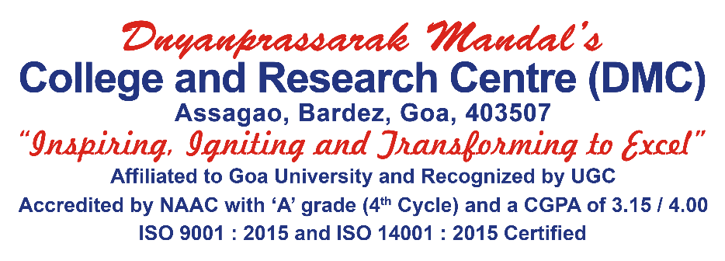

This article is about Dnyanprassarak Mandal’s College and Research Centre.

Ranked amongst the best colleges in India and a premiere institution of Higher Education in Goa, Dnyanprassarak Mandal's College and Research Centre, popularly known as DMC has been popularising the generation and dissemination of knowledge to the students from North Goa and is regarded the best college in terms of NAAC rankings (3.15/4.00 in the 4th Cycle of accreditation) in the state of Goa. DMC, one of the most premiere colleges in Goa stands on remarkably rich support from the parent body i.e., Dnyanprassarak Mandal and with the support of a holistic ecosystem, the college has been able to start courses ranging from B.A., B.Com., B.Sc., B.B.A., B.C.A., M.Com., M.Sc. and PhD (in Chemistry & Commerce). With its glorious history and commendable laurels, DMC welcomes all!