Cloud Resource Performance Report

Report Period: 2025-02-24 00:43:19 to 2025-03-10 00:43:19

# Executive Summary

ECS CPU Utilization Range: 1.17% to 3.78% (Average: 1.48%)

RDS CPU Utilization Range: 0.63% to 0.74% (Average: 0.66%)

# Critical Anomalies Detected

No critical anomalies detected during the reporting period.

# Performance Charts

## ECS CPU Utilization

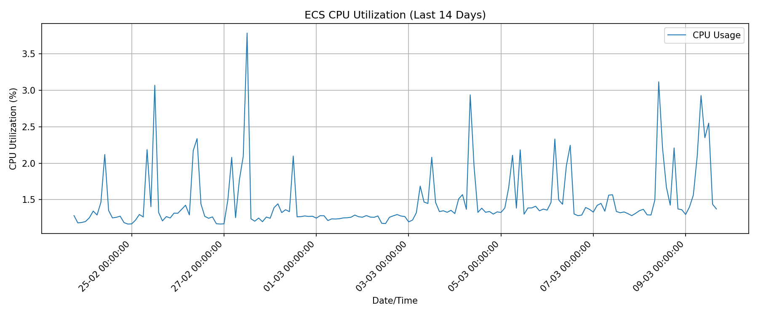

## RDS CPU Utilization

