Terminal Challenge--The Name Game (part 3)

# Exploitation

The SQLite article from the hints suggests using this: sqlite3 dbname.db .dump  
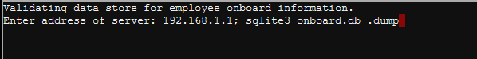

That returns a lot of data. Since this is Linux, maybe we can use grep. In the opening screen of the terminal, Minty tells us she wants the first name for Chan.  
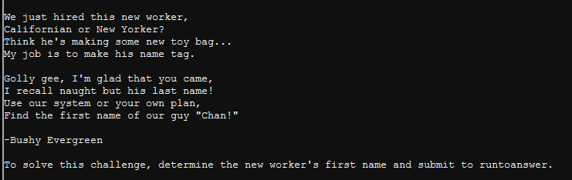

So, we can try 10.0.0.1; sqlite3 dbname.db .dump | grep "Chan"  
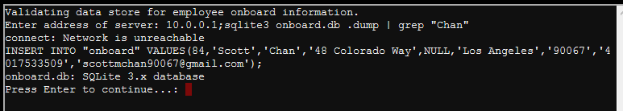

So, the answer is ‘Scott’. Note: I was trying random IP addresses in the entry for fun--any text would have done.

Note: Most of the terminals allow copy and paste with Control-C and Control-V, and selection of large areas of text with shift-click. You could have copied the entire database to your terminal.

The last step is to answer the terminal’s question. To do that, we need to execute the file runtoanswer that we saw in the directory listing from the last lesson. That file is in our working directory so we have to put ./runtoanswer in our statement. We will use:   
10.0.2.2; ./runtoanswer.  
  
  
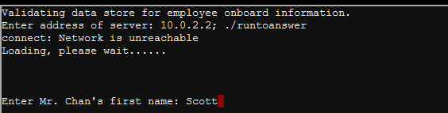  
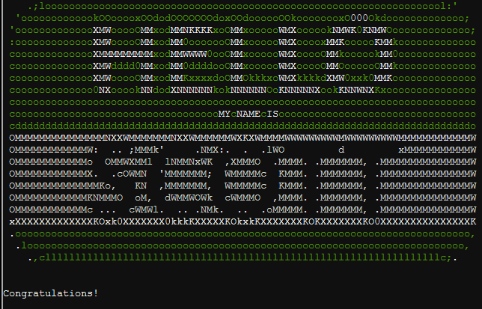

Now you will get additional hints if you click on Minty, and hints will also appear in your badge.  
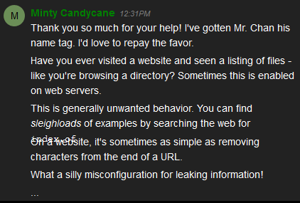 

# Up Next--The Directory Browsing Objective

