Objective--Web Directory Browsing (part 1)

# Objective

The hints for this objective can be found in the dialog from Minty Candycane, and in Minty Candycane’s hints on your badge. Once you are armed with those hints, this challenge should be easy. Go to <https://cfp.kringlecastle.com/>, download the necessary file, and you are done.  
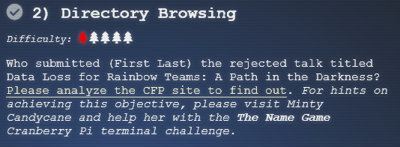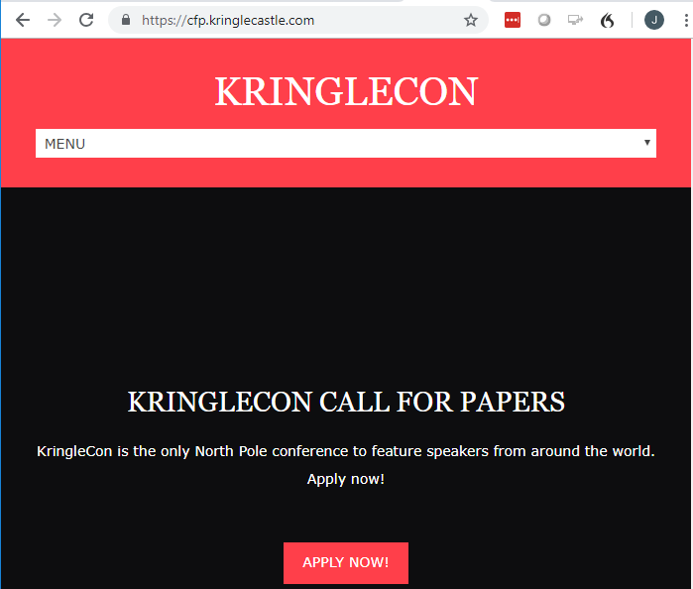

# Hand in

1. What URL allowed you to download the file?
2. Who submitted the rejected talk in the objective?