Objective--Web Directory Browsing (part 2)

# Solution

Based on the hints, we want to find a URL that we can remove the last characters from. The only other page on the site is reached by clicking on the Apply button, which is <https://cfp.kringlecastle.com/cfp/cfp.html>.   
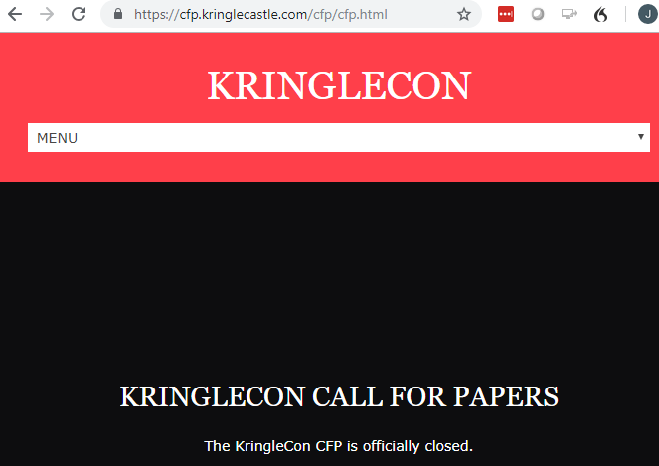

Remove the last characters to get <https://cfp.kringlecastle.com/cfp/> and voila!  
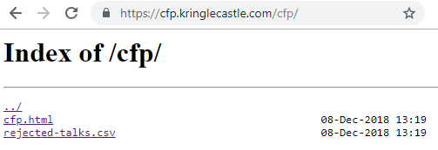

Click on rejected-talks.csv and you have the answer.  
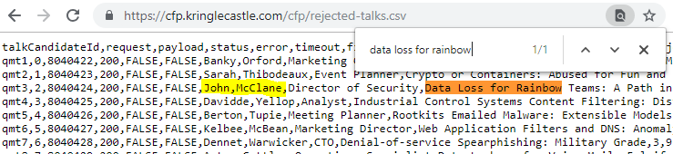

All that’s left is to submit the answer.  
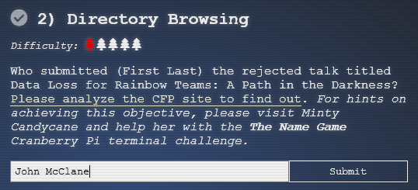

# Up Next

The next objective tells us we will need visit Tangle Coalbox and help him with his LethalForensicELFication terminal challenge. Off we go!  
