Terminal Challenge--LethalForensics (part 1)

# Get the Hints

Tangle Coalbox lives on the right side of the second floor, where the music is the Brandenburg Concerto.  
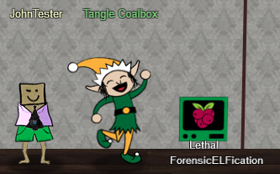 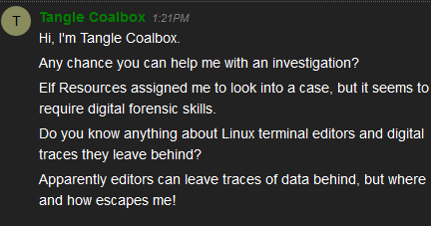

The hint that Tangle puts on your badge is essential.   
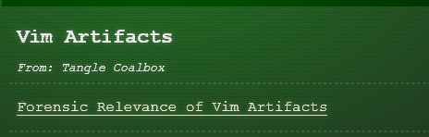 <https://tm4n6.com/2017/11/15/forensic-relevance-of-vim-artifacts/>

# The Terminal

Here is what the LethalForensicELFication terminal shows you.   
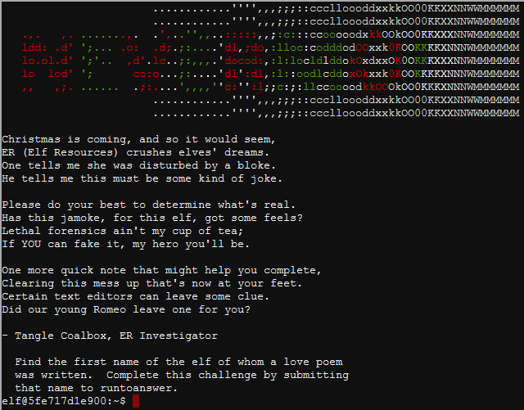

You can find the file that caused the complaint easily, but that will not solve the challenge for you. You will have to study the link Tangle gave you in the hints. Here is another link that will help you if you are not familiar with vi and some of the Linux command line tools. <http://www.linfo.org/vi/search.html> Also it helps to know what the -a option in the ls command does.

# Hand in

1. What is the first name of the elf of whom the love poem was written?
2. What forensics evidence do you have to justify that conclusion?