Terminal Challenge--LethalForensics (part 2)

# Finding vim artifacts

The article in the hints mentioned a hidden file, .viminfo. Let’s use ls -la to see what else is there.  
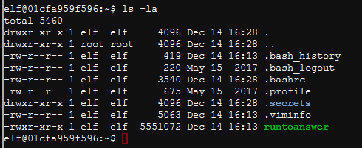

I always like to spy on secrets, especially when they are hidden files. Remember that in Linux, adding a period to the front of a file name makes it “hidden” so it won’t appear in normal directory listings. The -a option in ls shows those hidden files.  
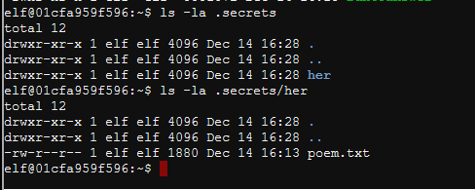

Let’s examine poem.txt just for fun.  
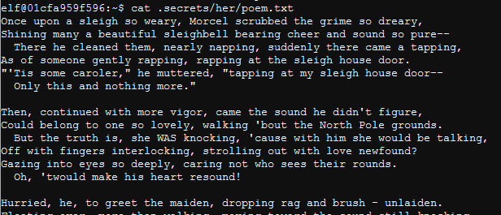

Hmm, it’s not very original, just stolen from a famous poem. You don’t see the name of the lady he’s writing about, but there is one place where “NEVERMORE” is in a place that could hold a name.

Let’s get back to forensics. The article said we should look at .viminfo. It appears someone has removed the less command, which is not surprising since it is powerful. It’s older brother more will work for our purposes.

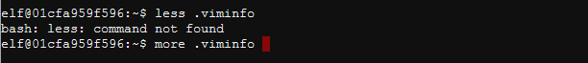

There is some interesting information in .viminfo. It appears that the “author” of the poem, Marcel Nougat removed all instances of Elinore, replaced them with NEVERMORE, and saved the file (:wq).  
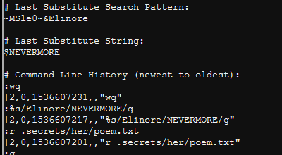

We will submit Elinore as the answer. Again, remember the period before runtoanswer. The period is the abbreviation for “the current directory” and tells BASH we specifically want to run the file and not another with the same name that may be in our path. That way if someone puts an evil ls in our directory, we will not run the evil file by mistake when we type ls. Microsoft finally caught on after many years and incorporated the same feature into PowerShell.

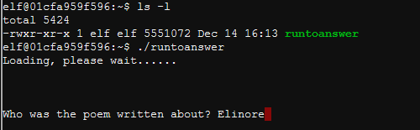

Woot, woot! We were right!  
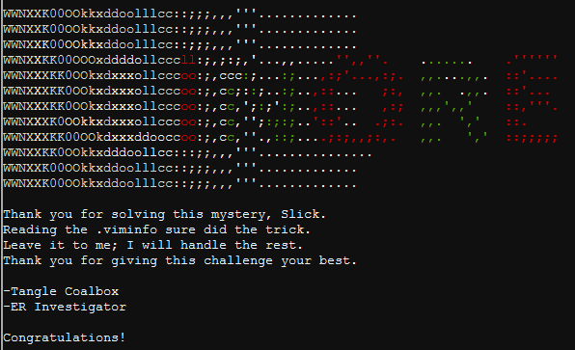

Now talk to Tangle to get hints (in his dialog and in your badge) about the next Objective.

# Up Next

We will use the hints Tangle gave us to solve the de Bruijn sequence problem.