Objective--de Bruijn Sequences (part 1)

# Hints from Tangle Coalbox

Here is a selfie of John Tester at the Speaker UNpreparedness room with some random players and the hints from Tangle Coalbox. The door lock is four pushbuttons but since it lets you enter a stream of pushes instead of resetting after each failure, it is easy to open it with a brute force attack.

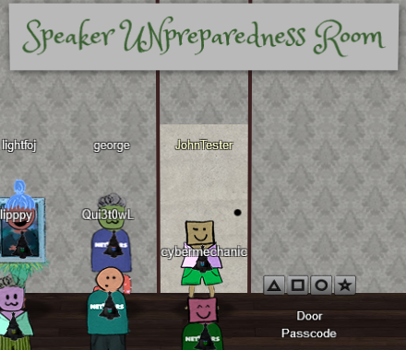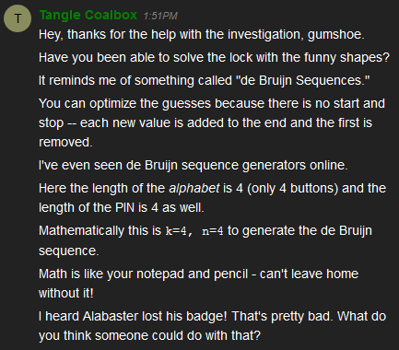

It is scary that the doors on Ford cars are/were vulnerable to this attack. I hope they fixed it.  
 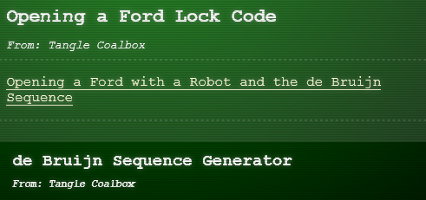

I found the explanation in the Wikipedia page more helpful than the links (I like math.) The main concept is that you can construct a stream of input that tries all possibilities much faster than entering the codes one after another. If the lock just looks at the last four entries and doesn’t reset after a failure, the number of presses it takes to brute force the lock is reduced by about a factor of four.

The Wikipedia page also has a nifty python script for generating a de Bruijn sequence in the “Algorithm” paragraph. Python is cool, so let’s run the script. Copy the program into a text file and name it with a .py extension. The first input to the script is the alphabet you are using. The symbols are funky, so “abcd” will work. The second parameter is the length of the pin, which Tangle says is four (n = 4). By the way, current versions of Windows 10 now include Python inside PowerShell. All you do is open PowerShell and run python debruijn.py (or whatever you named your file.) You will have to edit the last line to have the parameters you want, though.

If you have trouble with the Python, the [link](http://www.hakank.org/comb/debruijn.cgi) from the hint will calculate the sequence for you.

# Hand In

Once you have the door open, our “poet” Marcel Nougat will be there to give you the passphrase for the Objective.

1. What was the sequence that opened the door (just four characters, not the whole sequence).
2. What did Marcel Nougat say to you?