Objective--de Bruijn Sequences (part 1)

Solution

There is not much to write about this one, except to give the answers. This is the output of my Python script, and the passphrase from Marcel. The key to the door is abca, where a is the triangle on the left, b is the square, and c is the circle. It is easy to be punching numbers and realized that the door opened several punches ago.

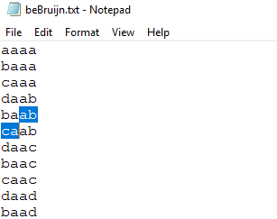 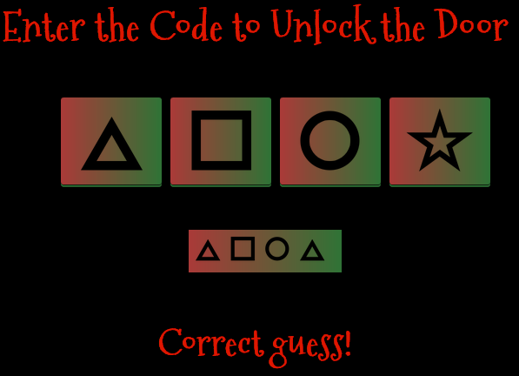

Once we enter the room there’s time for a selfie opportunity with Marcel. In the early days of the game there was a bug that caused Marcel to disappear at times, but he seems to be reliable now.  
 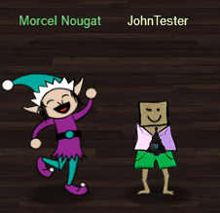 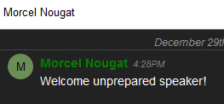

The passphrase is Welcome unprepared speaker!  
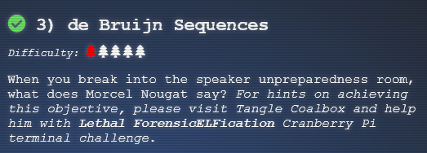

# Next Up

The next challenge, Data Repo Analysis, says that we need to help Wunorse Openslae with his stall mucking report. Wunorse is on the first floor, right side just past the Swag Booth.