Terminal--Stall Mucking Report (part 1)

# Getting Started

First, find Wunorse on the right side of the first floor. Talk to him so you can get his instructions and a hint in your badge.  
 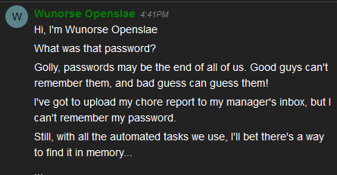

The hint sends you to this link. The second paragraph tells where commands are saved in different operating systems. You can quickly determine what OS the terminal is running .  
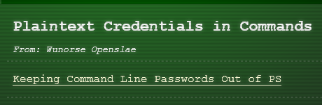  
<https://blog.rackspace.com/passwords-on-the-command-line-visible-to-ps>

One note: for Linux, ps truncates commands when the line is full. You may need more help. Once you determine the user name and password, you’ll need to use your favorite search engine to learn how to use Linux Samba to connect to Windows file shares.

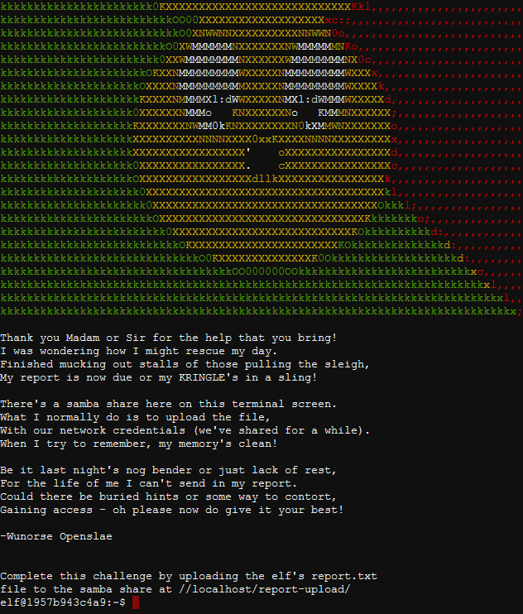

# Hand In

1. What is the user name and password to access the share?
2. What command did you use to connect to the share?