Terminal--Stall Mucking Report (part 2)

# The Password

The terminal is running Linux, so the command we want should be the standard ps aux. That command roughly the equivalent of the task list in Windows. More information can be found [here](http://www.linfo.org/ps.html).

One problem is that ps aux by itself does not show the entire command line unless it is very short. You can get the entire command by piping the output into less. Since less is blocked, we’ll use more.

This does not help much (ps aux)  
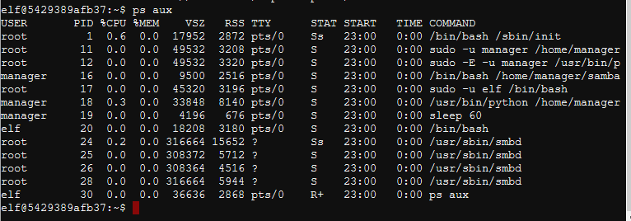

This does help (ps aux | more ).  
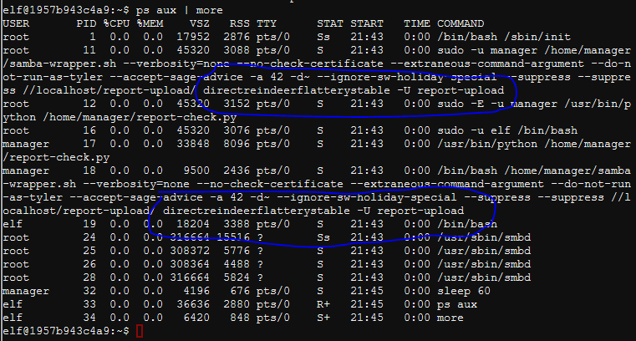

The script is using the user name report-upload and the password directreindeerflatterystable.

# Accessing the File Share

[This article](https://www.tldp.org/HOWTO/SMB-HOWTO-8.html) is a basic guide to using Samba (the executable is called smbclient.) A simple way to connect to a share is  
smbclient //localhost/report-upload/ directreindeerflatterystable -U report-upload  
The -U gives the user name and the password is just there by itself. The “?” brings up help.  
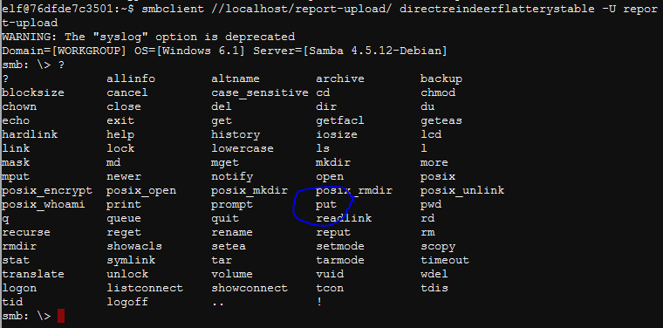

The next thing we need is put, as in put report.txt  
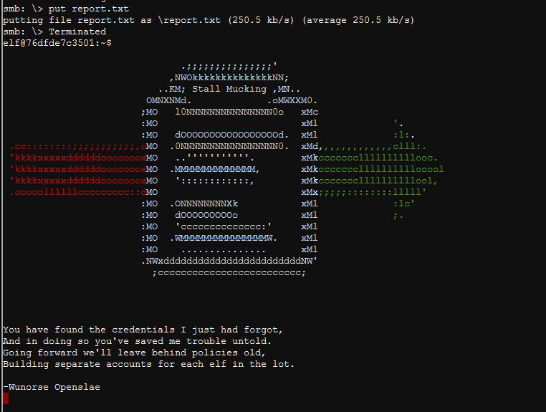

# Up Next

Talk to Wunorse now that you have fixed his problem, and he will give you hints in his dialog and on your badge. We will need them to complete the Data Repo Analysis Challenge.