Objective--Data Repo Analysis (part 2)

# Solution

It just takes a second to find the zip file, and it is indeed encrypted. Note that the schematics directory is hidden (starts with a period) so it won’t be seen by normal browsing.  
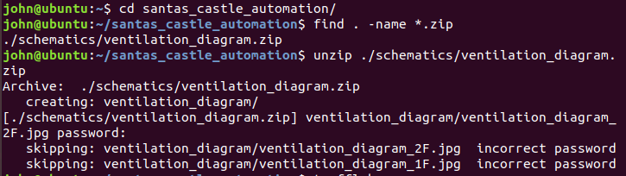

A search with Trufflehog (used cd .. to go back to my home directory) leads us to some notes in a comment:  
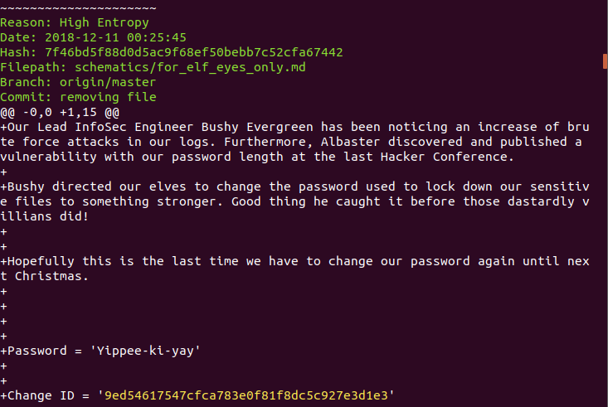

Using Yippee-ki-yay as a password unzips the files.  
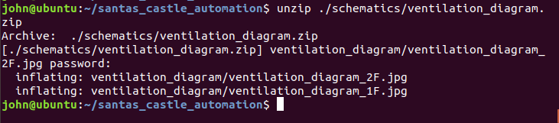

The ventilation diagrams appear to be maps:  
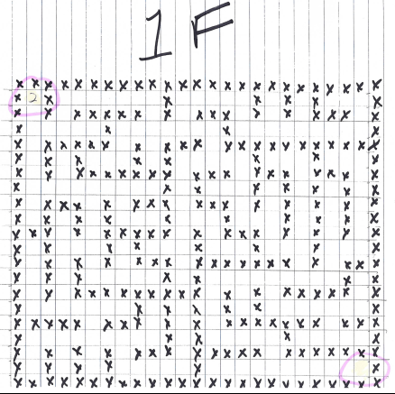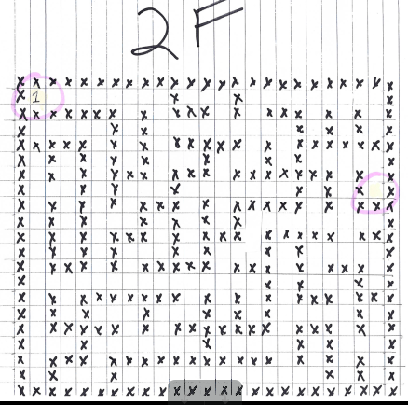

In fact, those maps are very handy if you decide to attempt the Google ventilation maze.  
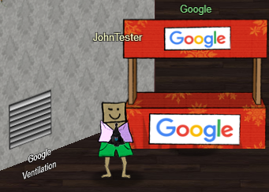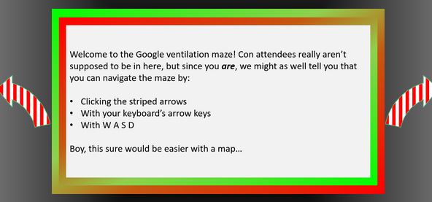

The maze is not necessary to complete the challenges, but it is fun.

Google provided SANS and CounterHack free access to Google Cloud to host this year’s challenge!

# Up Next

The next Objective, AD Privilege Discovery, tells us to visit Holly Evergreen to help her with the CURLing Master terminal. She’s on the left side of the first floor, so off we go.