Terminal--CURLing Master (Part 1)

# What you can learn from this

The Linux commands curl and wget are useful because they can issue web requests from the command line. This challenge will use curl.

A new protocol, HTTP2, was designed to make web transactions more efficient and is in widespread use. If you are used to examining web requests in Wireshark, you have probably only seen HTTP 1.1 because HTTP2 is almost always encrypted. It’s time to learn about HTTP2, and [this link from Google](https://developers.google.com/web/fundamentals/performance/http2/) does an excellent job of explaining why HTTP2 was developed and how it works. Also watch the talk by Chris Elgee and Chris Davis, [HTTP/2--Because 1 is the Loneliest Number](http://www.youtube.com/watch?v=PC6-mn9g9Cs).

# Hints

Holly Evergreen and the CURLing Master terminal are in the wing on right side of the first floor.  
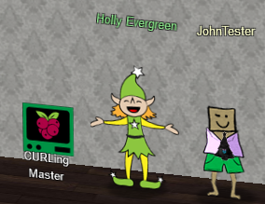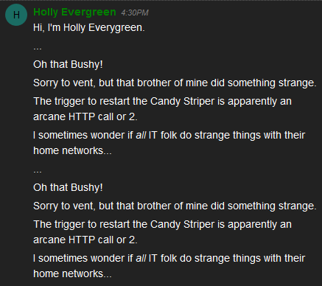

The hint that Holly put in your badge contains the Google link describing HTTP2.  
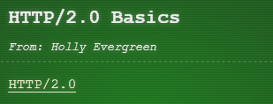

If you haven’t used curl before, [this link will be helpful](https://gist.github.com/subfuzion/08c5d85437d5d4f00e58).

One last hint: when I look at a terminal, I like to check the BASH history to see what the other user has been doing.

# Get Started

Here is the terminal.  
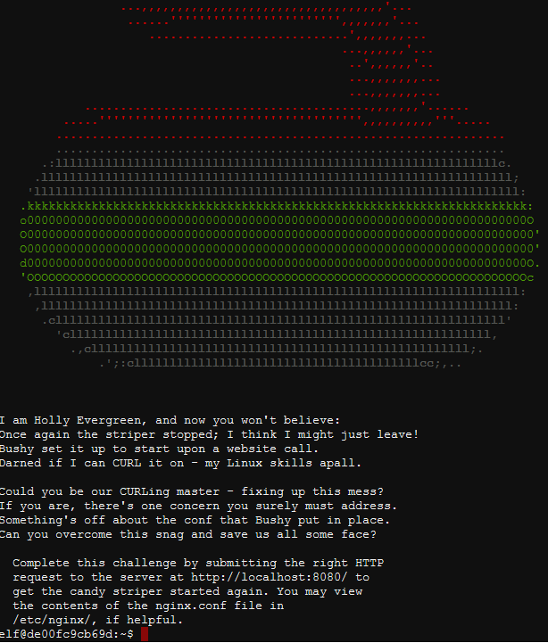

# Hand In

1. What is the command that will start the striper?