Terminal--CURLing Master (part 2)

# Solution

Normally HTTP2 connections may start with HTTP 1.1 and negotiate a change to HTTP2. However, Bushy’s application only accepts HTTP2, which makes the curl command a little more difficult. If you look at the terminal’s BASH history, you get a helpful clue.  
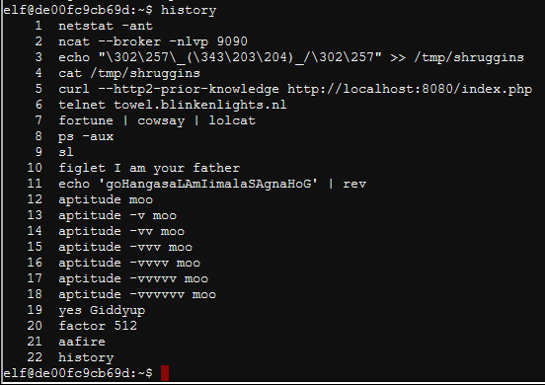

On line 5, someone used the command  
curl --http2-prior-knowledge http://localhost:8080/index.php

If you use curl --http2, the command will fail on this server since curl will start with HTTP 1.1 and attempt to negotiate a transition to HTTP2.  


The flag --http2-prior-knowledge tells curl to skip the negotiation because we already know that the server is running HTTP2.  
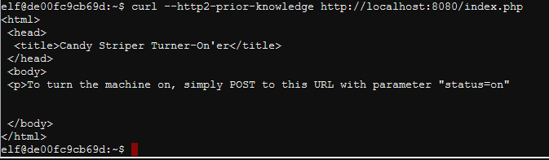  
This tells us we need to POST “status=on” to the server.

The [link with curl POST examples](https://gist.github.com/subfuzion/08c5d85437d5d4f00e58) shows us that the proper format to issue a POST request is to use -d followed by the data we want to POST, and then -X POST to tell curl we want a POST request.  
curl -d "status=on" -X POST --http2-prior-knowledge http://localhost:8080/index.php  


That does the trick!  
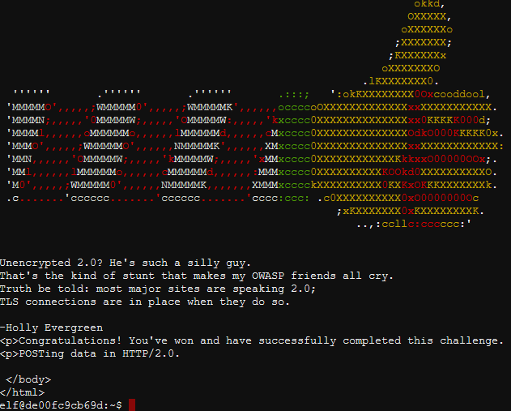

# Up Next

After talking to Holly to collect her hints, move on to