Terminal--Yule Log (Part 3)

# Solution for the Python script

This is the Python script that I used. Yours may be different.  
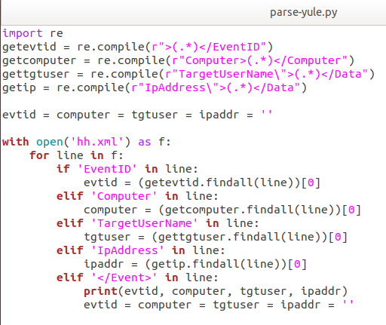

import re

getevtid = re.compile(r">(.*)</EventID")

getcomputer = re.compile(r"Computer>(.*)</Computer")

gettgtuser = re.compile(r"TargetUserName\">(.*)</Data")

getip = re.compile(r"IpAddress\">(.*)</Data")

evtid = computer = tgtuser = ipaddr = ''

with open('hh.xml') as f:

for line in f:

if 'EventID' in line:

evtid = (getevtid.findall(line))[0]

elif 'Computer' in line:

computer = (getcomputer.findall(line))[0]

elif 'TargetUserName' in line:

tgtuser = (gettgtuser.findall(line))[0]

elif 'IpAddress' in line:

ipaddr = (getip.findall(line))[0]

elif '</Event>' in line:

print(evtid, computer, tgtuser, ipaddr)

evtid = computer = tgtuser = ipaddr = ''

The command below runs the script. Again, note that the XML data from the server is stored in hh.xml. I didn’t bother to use an argument to read the file from the command line.  


As I looked through the log with less, I found that there were large numbers of entries for “HealthMailbox”. Let’s get rid of those.  
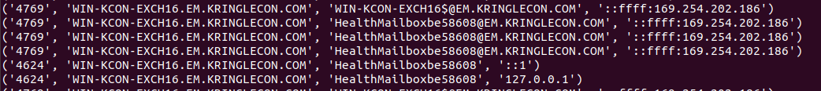

The -v option in grep tells it to omit lines that match, instead of selecting them.  


# Password Spraying vs. Brute Forcing

In a brute force password attack, different passwords from a list are tried against one account until the account is locked or the attack is successful. A successful attack will appear in the logs as a series of unsuccessful attempts against an account followed by a successful login.

In password spraying, one password is tried against a series of accounts and then another round starts with a new password. Each account with have either one failure or one success for each round. So, looking for a failed attempt on Alabaster’s followed by a successful login to Alabaster’s account will not help.

# Hand In

Scan through the file you generated (mine was noHealthMbx.txt) and see if you can spot a suspicious login.

1. Who fell victim to the password spraying attack?