Objective--Badge Manipulation (Part 3)

# Solution (so far)

Here is the query we will work with:

SELECT first_name,last_name,enabled FROM employees WHERE authorized = 1 AND uid = '{}' LIMIT 1

The query will return three things to the application. It will return strings with the first and last names, and a value for enabled, likely TRUE or 1 if we want to get in the door. Our modified query must return the same thing: two strings and a 1.

The value on Alabaster’s badge must be the uid. (In part 1, we found that the QR code on Alabaster’s badge contains “oRfjg5uGHmbduj2m.” Our input will replace the curly braces ( {} ). When Alabaster scans his badge, this query is executed:  
SELECT first_name,last_name,enabled FROM employees WHERE authorized = 1 AND uid = 'oRfjg5uGHmbduj2m' LIMIT 1

It searches the employees table and if it finds a row with Alabaster’s uid and a value of 1 for authorized, it returns something like Alabaster, Snowball, 1. Alabaster’s card has been disabled, so authorized must be set to 0.

A Google search for “mariadb comment” takes us to [this link](https://mariadb.com/kb/en/library/comment-syntax/), which shows us:  
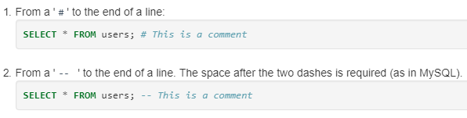

# Build the SQLI input

We know that our input, which we can represent by xxxxxx, will make the query look like this:  
SELECT first_name,last_name,enabled FROM employees WHERE authorized = 1 AND uid = 'xxxxxx' LIMIT 1

If we end our input with a comment (xxxxxx#) we will have this, where the blue text is a comment:  
SELECT first_name,last_name,enabled FROM employees WHERE authorized = 1 AND uid = 'xxxxxx#' LIMIT 1

Now we have a problem. Our input belongs to the uid statement, and we may get an error because we removed a single quote and the remaining quote no longer matches. So, let’s begin our input with a single quote to close out the first single quote after uid=. Now we have 'xxxxxx# and the query looks like this.  
SELECT first_name,last_name,enabled FROM employees WHERE authorized = 1 AND uid = ''xxxxxx#' LIMIT 1

All we (i.e., you) need to do now is fill in the xxxxxx.

# Hand In

We need to add something that will overwrite the values since the first part,  
SELECT first_name,last_name,enabled FROM employees WHERE authorized = 1 AND uid = '' will execute no matter what we do. One way to make the query return our data instead of data from the table is to use either UNION or UNION ALL. In the [link to OWASP](https://www.owasp.org/index.php/SQL_Injection_Bypassing_WAF#Auth_Bypass) that Pepper gave us, look at the paragraph “An example of signature bypass.” A link that I found helpful was from [Netsparker](https://www.netsparker.com/blog/web-security/sql-injection-cheat-sheet/#UnionLanguageIssues), especially the paragraph about “Bypassing second MD5 hash check login screens.” Notice in that example that the input to the new SELECT statement includes single quotes,  
SELECT ‘admin’ instead of SELECT admin. The one with the quotes will just return the string, admin in this case. The one without the quotes will return values for the variable admin.

1. What is the SQLI that opens the door for you?