Terminal--Dev Ops Fail (Part 1)

# What you can learn from this

Git repositories keep track of the current state of the software, as well as keeping previous versions and logs of changes. If you have a password in Git, you cannot just remove it from the current version as the traces will remain. The only solution is to treat the password as exposed and change it.

# Getting Started

In order to solve the HR Incident Response objective, we need to get hints from Sparkle Redberry and her Dev Ops Fail terminal.  
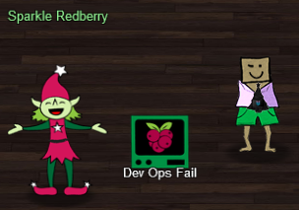 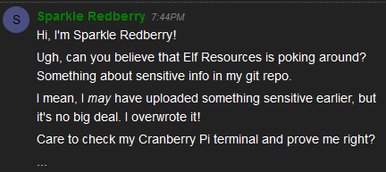

# Hints

Sparkle will put two hints into your badge after you talk to her.  
 

The first hint is a [link to an article](https://en.internetwache.org/dont-publicly-expose-git-or-how-we-downloaded-your-websites-sourcecode-an-analysis-of-alexas-1m-28-07-2015/) describing this problem, as well as how to make a local copy of a Git repository. Please read the article. In this case, though, the terminal already has a local copy of the repository, so we won’t have to copy it.

The second hint is a [cheat sheet of Git commands](https://gist.github.com/hofmannsven/6814451), which is useful in this challenge. The cheat sheet shows you how to examine Git logs, as well as how to revert to a previous version. The logs are helpful, but you will not need to revert the Git repository to a previous version. However, the format is very similar to that of the show command, which is not well explained in the cheat sheet and is helpful.

# Hand In

1. What is the path to the Git repository in the terminal?
2. Examine the logs. What command did you use, and what did you find?
3. What command did you use to show the changes that Sparkle made?
4. What is the password that Sparkle exposed?
5. What should Sparkle have done to correct this?